a) Make a time series plot of the data and verify that it is seasonal. Why do you think
seasonality is present in these data?

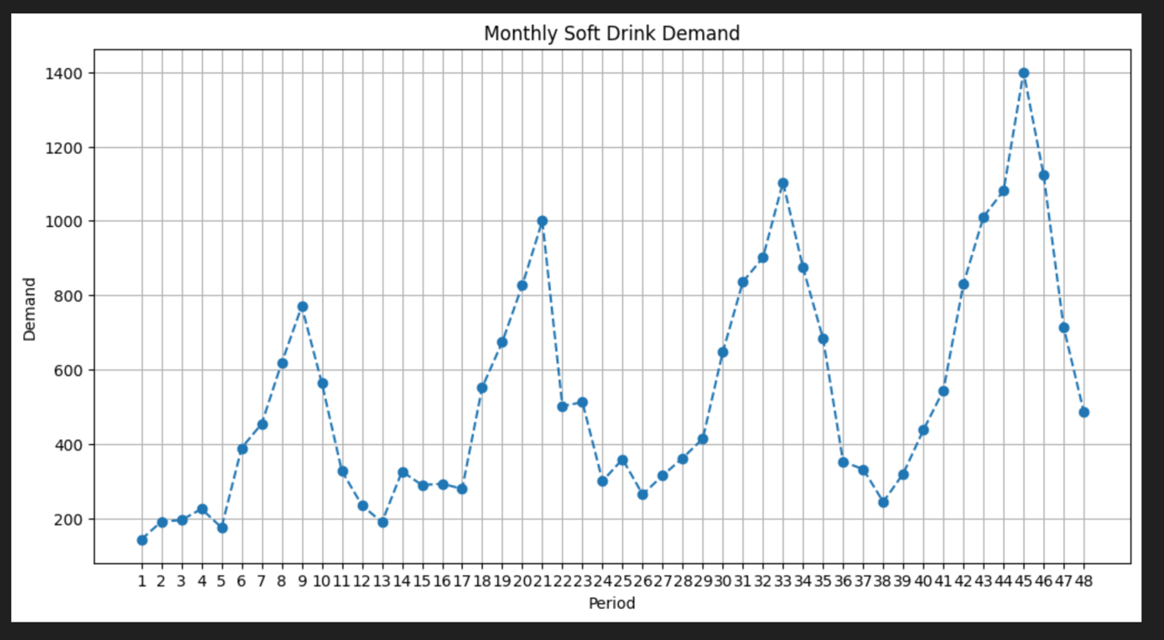

The time series plot reveals a distinct and strong seasonal pattern with a 12-month cycle. The data shows consistent peaks occurring annually (around periods 9, 21, 33, and 45), followed by regular troughs. Seasonality is clearly present in these data because soft drink consumption is highly correlated with weather and temperature. Demand naturally surges during warmer months due to the need for hydration and refreshment, while it declines significantly during cooler winter months.

b) Use Winters’ multiplicative method for the first 3 years to develop a forecasting method
for this data. How well does this smoothing procedure work?
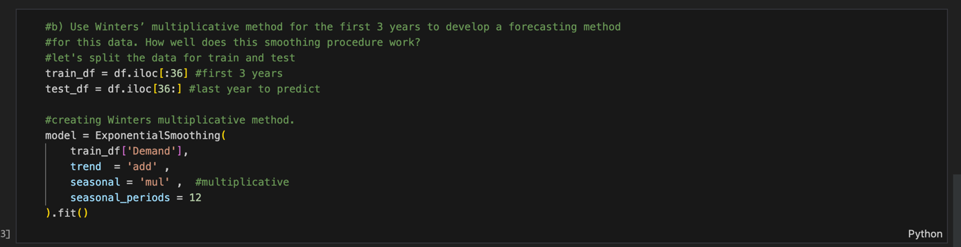
Winters’ Multiplicative method was applied to the first 3 years (36 periods) to capture the expanding seasonal fluctuations. This smoothing procedure works very well for the historical data. The fitted values track the actual demand closely, successfully capturing both the underlying upward trend and the seasonal peaks that grow in magnitude each year. The model effectively learns the historical patterns without significant deviations in the training set.

c) Make one-step-ahead forecasts for the last 12 months. Determine the forecast errors. How well did your procedure work in forecasting the new data?
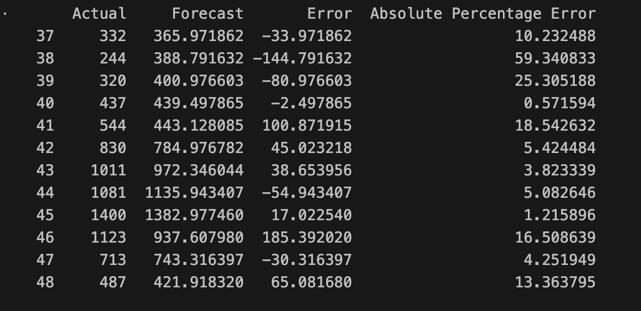
The procedure performed moderately well on the new data, resulting in a Mean Absolute Percentage Error (MAPE) of approximately 13.6%. The model demonstrated excellent accuracy during high-demand periods, predicting the peak in Period 45 with a remarkable error of only 1.2%. However, the model struggled significantly during the transition to the low season, particularly in Period 38, where it overestimated demand with a 59.3% error. This suggests that while the model captures the summer peaks perfectly, it lags in adjusting to the sharp demand drops in off-peak months.
