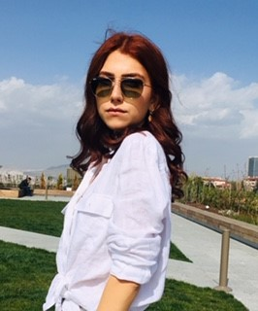

PELİNSU DEMİRCİ

# Personal Information

**Name Surname** PELİNSU DEMİRCİ

**Date Of Birth** 03.06.1996

**Place Of Birth** ANKARA

# Contact Information

**Addresss** Kardelen mahallesi 2164. cadde Anıl sitesi B blok Daire:6,

ANKARA/YENİMAHALLE

**Phone** 0534 360 3294

**E-Mail** [pelinsu_demirci@hotmail.com](mailto:pelinsu_demirci@hotmail.com)

# Job Experience

**Jun 2018 - Jul 2018 INTERN / Ministry of Forestry(Orman Genel Müdürlüğü ), ANKARA**

This institution is a government agency. I worked in Photogrammetry ,

Geographic Information System and Remote Sending Departments

**Jul 2019 - Aug 2019 INTERN / GEOGIS, ANKARA**

I worked as a summer internship at GEOGIS company, which is one of the

important institutions in the field of geomatic engineering, which is my own

department . My department was Geographic Information System. In addition

to my engineering skills, that was an intern focused on engineering ethics and

working discipline in general.

# Education Information

**Sep 2015 - May 2020 GEOMATİC ENGINEERING Hacettepe University, ANKARA**

**Sep 2010 - Jul 2014 HIGH SCHOOL**

**Yıldırım Beyazıt Anatolian High School, ANKARA**

Page 1 / 2

# Seminars And Courses

**Sep 2018 – Sep 2018** Occupational Health and Safety Course

**Sep 2018 – Sep 2018** 16. Turkey Scientific and Technical Conference - Geoinformation Technologies and

Software

**Sep 2019 – Sep 2019** 17. Turkey Scientific and Technical Conference - Geoinformation Technologies and

Software

# Foreign Language

**English** Fluent

**German** Basic

**Spanish** Basic

# Competencies

Microsoft Office Programs Good

Project Design and Implementation Good

MATLAB Programming Language Good

Image Processing Good

Phyton Programming Language Average

PostgreSQL Moderate

HTML Moderate

ArcMap Good

QGIS Good

NETCAD Good

SuperMap Good

# Interests

YOGA - PILATES, Playing Piano, Outdoor Sports, Writing Blog and other things, Self- Improvement / Wellness, Meditation,

Fashion, Social Skills Development, Dealing with hand skills such as clay, ceramics, knitting, Dance, Swimming, Painting

Sayfa 2 / 2