Who wants to Censor?
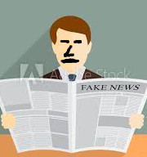Government, and politicians want to censor to protect us from Fake News.
Or do they want to protect Fake News from being discovered?

Big Media

Google, Facebook and Twitter all want to protect us from ourselves, by regulating what we can see and think!
We can defeat Google, Facebook, and Twitter, by exposing their advertisers to boycotts!

Free Speech is Sine Qua Non. Without it, we are pigs living in a palace!
©Paul Elliott

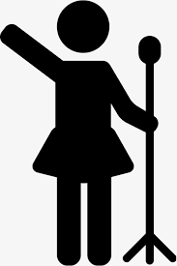Free Speech
Sine Qua Non
With Free Speech we may influence others in
our move toward the spirit. Without it, we are
pigs living in a palace!
There is no Hate Speech exception to Free Speech!
Matal v. Tam
R.A.V. v City of St. Paul
Whitney v. California
Iota Xi Chapter of Signma Chi Fraternity v. George Mason University

Free Speech in Civil Society
“But the First Amendment only applies to government censorship.”
Free speech is universal moral law, (Dharma), that applies to everyone. Law is not the only discipline in civil society. No one wants to associate with a censor. Censors may be exposed to market discipline in the form of boycotts.
Facebook, Google, and Twitter are practicing corporate censorship, therefore do not buy from those who advertises with Facebook, Google and Twitter.

“During times of universal deceit, telling the truth becomes a revolutionary act.”

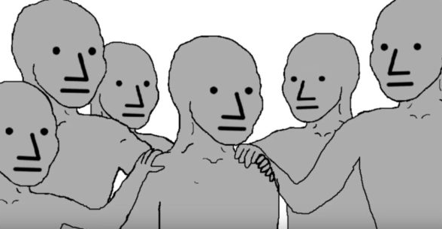Wrong Think Bad

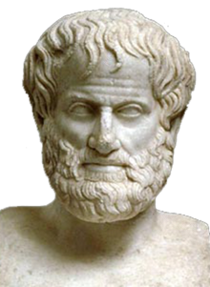Things that could not have happened without Free Speech.
- Philosophy.
- The abolition of Slavery in
Great Britain and its
colonies.
- The Song “Amazing Grace”.
- All Scientific advancement.
- Rock and Roll.
- The Civil Rights Movement.
- The Liberation of Women.
- The prevention of War, to the limited extent that has been successful.
- The use of disinfectant in childbirth.
All culture results from sordid intellectual combat.
Good ideas are always offensive. --Paul Elliott

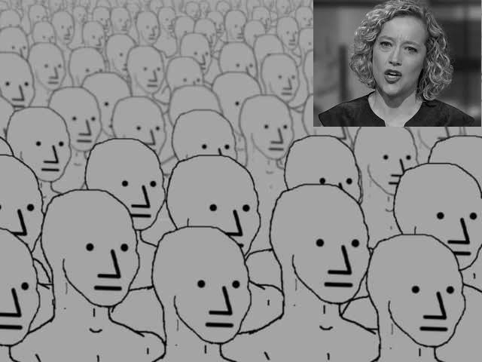So you’re saying…..

Fake reasons for censorship
The “Carthago delenda est” excuse.
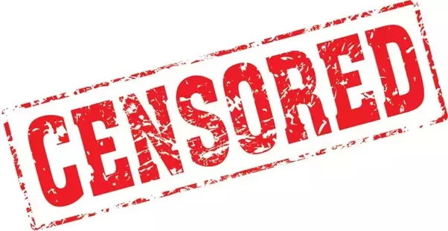Our enemies, they say, are so evil, that any lie expedient is acceptable to defeat them. But our necessary lies may be exposed by truth, therefore, we are justified in censoring our opponents and enemies. This is also the Marxist definition of truth defense.

Do you trust those who want to censor?
Whenever a censorship regime is instituted, there is a mass scramble of reprehensible people, struggling for the evil power of censorship. Do you trust them?
