**RESULTS**

**SOCIO-DEMOGRAPHIC CHARACTERISTICS**

A total of 2378 responses were gotten from the participants out of 2379. Majority of the participants (23%) were within the age 26-33 years, the population was predominantly male (51%) and married (71%). The ethnic distribution of all the participants from the state in this study is as follows: Hausa 48.6%, Bura 9.5%, Kanuri 7.5%, Fulani 5.5%, Rukuba 4.8%, Tangale 2.1%, Nupe 1.7%, Pero 1.7%, Waja 1.7% and other minority ethnic groups. The distribution of the northern states in this study were: Borno 459 (19%), Gombe 406 (17%), Jigawa 407 (17%), Kano 473 (20%), Niger 232 (9.8%) and Plateau 401 (17%). Majority of the participants were in the urban settlements (59%), as the most dominant household size was 1-5. The 3 most common occupation in this study were: farmer (24%), trading (23%) and student (16%). Majority of the participants (29%) earn 30,000 and above, secondary education was reported to be the most common (40%) highest level of education.

The age-sex distribution in the population pyramid in figure 1 shows a population growth of a declining birth rate and a high population growth, with a low dependency ratio, where the children and elderly age group are the minority. The age structure as shown with a bulge in the middle indicates a relatively large population of middle-age, this is the youth to young adult demography.

**Table 1: Socio-Demographic Characteristics**

|  |  |
| --- | --- |
| **Socio-demographic Characteristic** | **N = 2,378** |
| **Age** |  |
| 10 to 17 | 119 (5.0%) |
| 18 to 25 | 379 (16%) |
| 26 to 33 | 543 (23%) |
| 34 to 41 | 522 (22%) |
| 42 to 49 | 392 (16%) |
| 50 to 57 | 237 (10.0%) |
| 58 to 65 | 104 (4.4%) |
| 65 and above | 82 (3.4%) |
| **Gender** |  |
| Female | 973 (41%) |
| Male | 1,405 (59%) |
| **Settlemen**t |  |
| Rural | 977 (41%) |
| Urban | 1,401 (59%) |
| **Household Size** |  |
| 1 - 5 | 1,079 (45%) |
| 6 - 10 | 854 (36%) |
| 11 - 15 | 234 (9.8%) |
| 16 and above | 211 (8.9%) |
| **Average Income/Month** |  |
| Less than 5,000 | 402 (17%) |
| 5,000 to 10,000 | 413 (17%) |
| 10,000 to 20,000 | 416 (17%) |
| 20,000 to 30,000 | 466 (20%) |
| 30,000 and above | 681 (29%) |
| **Highest Level of Education** |  |
| No schooling completed | 424 (18%) |
| Primary education | 345 (15%) |
| Secondary education | 940 (40%) |
| Technical/Vocational training | 263 (11%) |
| Bachelor’s degree | 283 (12%) |
| Master’s/Professional degree | 65 (2.7%) |
| Doctorate degree | 11 (0.5%) |
| Others | 47 (2.0%) |
| **Marital status** |  |
| Divorced | 56 (2.5%) |
| Married | 1,694 (71%) |
| Single | 548 (23%) |
| Widowed | 80 (3.5%) |

**Table 1.2: Ethnic and State Distribution of the Participants**

|  |  |  |
| --- | --- | --- |
| **Variables** | **N= 2378** | **%** |
| **Ethnic group** |  |  |
| Hausa | 1156 | 48.6 |
| Bura | 225 | 9.5 |
| Kanuri | 178 | 7.5 |
| Fulani | 130 | 5.5 |
| Rukuba | 113 | 4.8 |
| Tangale | 49 | 2.1 |
| Nupe | 41 | 1.7 |
| Pero | 40 | 1.7 |
| Waja | 40 | 1.7 |
| Yoruba | 39 | 1.6 |
| Other | 367 | 15.4 |
| **State** |  |  |
| Borno | 459 | 19 |
| Gombe | 406 | 17 |
| Jigawa | 407 | 17 |
| Kano | 473 | 20 |
| Niger | 232 | 9.8 |
| Plateau | 401 | 17 |
| **Occupation** |  |  |
| Artisan | 129 | 5.4 |
| Civil servant | 367 | 15 |
| Farmer | 569 | 24 |
| House Wife | 340 | 14 |
| Nomad | 37 | 1.6 |
| Student | 389 | 16 |
| Traders | 547 | 23 |

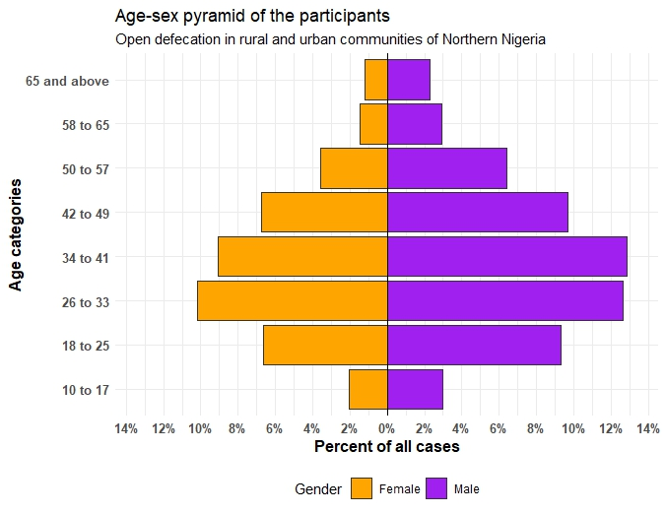

**Figure 1: Population pyramid/Age-sex pyramid of the participants in this study**

**GEO-SPATIAL MAPPING ON RURAL AND URBAN COMMUNITIES THAT PRACTICE OPEN DEFECATION IN SELECTED STATES OF NORTHERN NIGERIA**

This map uses a dot to indicate the presence of the practice of open defecation in a location. The dots show a clustering spatial pattern when viewed at a low zoomed out view. However, when the map is zoomed in an interactive plot, all the dots are separated out and seen as single elements.

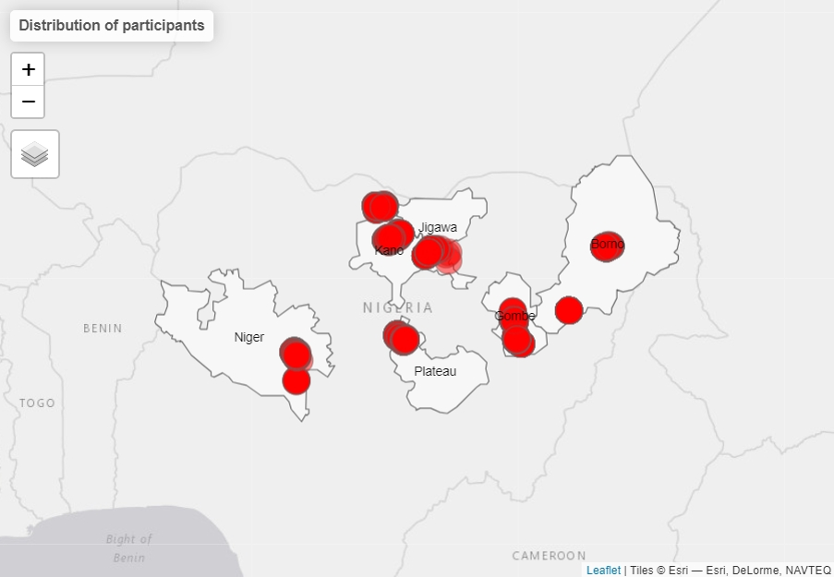

**Figure 2: Geospatial representation of the practice of open defecation in the communites**

**FACTORS THAT ENCOURAGE OPEN DEFECATION IN THE IDENTIFIED COMMUNITIES**

The factors that encourage open defecation in the identified communities were assessed. It was observed that the lack of toilet facilities was mostly common in Kano state (23.4%), poor understanding of the effect of open defecation was mostly common in Kano state (22.9%), cultural practice was most common in Kano State (31.8%), religious practice was most common in Kano state (32.6%), nonchalant attitude was common in Kano State (22.1), peer group pressure was common in Kano state (26.8%) and taboo attached to the use of toilet was most common in Gombe state (37.4%).

The chi-square test of association was used to determine the significant association between the sociodemographic factors and the factors that encourage open defecation in the identified communities. For lack of toilet facilities, the following were significantly associated: Age (<0.001), settlement (<0.001), average income (<0.001), educational level (<0.001), married status (<0.001), occupation (0.001). Multiple regression analysis was used to find the predictors of these association, it showed that age group 10-17 were 2 times likely to practice open defecation due to lack of toilets (AOR = 2.174, p-value = 0.046), rural dwellers were 2 times to practice OD (AOR = 2.026, p-value = 0.000), master’s degree holder were 0.4 likely to practice OD (AOR = 0.404, p-value = 0.004), single were 2.8 times likely to practice OD (AOR = 2.841, p-value = 0.000), housewives were 3 times more likely to practice OD (AOR = 3.180, p-value< 0.001).

As for poor understanding of the effects of open defecation, the following were significantly associated: Age (<0.001), settlement (<0.001), average income (0.004), educational level (0.002), married status (<0.001), occupation (<0.001). Multiple regression analysis was used to find the predictors of these association, it showed that age group 10-17 were 2.7 times likely to practice open defecation (AOR = 2.717, p-value = 0.008), Female were less likely (AOR = 0.650, p-value < 0.001), rural dwellers were 1.8 times to practice OD (AOR = 1.840, p-value < 0.001), 20,000 to 30,000 monthly salary were 1.5 time likely to practice OD (AOR = 1.556, p-value = 0.014), primary education degree holder were 1.8 likely to practice OD (AOR = 1.768, p-value = 0.005), single were 1.9 times likely to practice OD (AOR = 1.891, p-value = 0.031), housewives were 2.7 times more likely to practice OD (AOR = 2.686, p-value< 0.001).

As for cultural practices as a factor for open defecation, the following were significantly associated: Age (<0.001), Gender (0.003), settlement (<0.001), household size (<0.001), average income (0.004), educational level (0.001), married status (<0.001), occupation (<0.001). Multiple regression analysis was used to find the predictors of these association, it showed that age group 26-33years were 0.4 times likely to practice open defecation (AOR = 0.435, p-value = 0.006), Female were more likely (AOR = 1.700, p-value < 0.001), rural dwellers were 0.3 times likely to practice OD (AOR = 0.313, p-value < 0.001), 11-15 household size were 1.4 time more likely to practice OD (AOR = 1.424, p-value = 0.045) 10,000 to 20,000 monthly salary were 1.5 times likely to practice OD (AOR = 1.487, p-value = 0.017), No schooling completed were 2.5 likely to practice OD (AOR = 2.534, p-value <0.001), married were 0.4 times likely to practice OD (AOR = 0.469, p-value = 0.016), artisans were 5 times more likely to practice OD (AOR = 5.548, p-value< 0.001).

As for religious practices as a factor for open defecation, the following were significantly associated: Gender (0.017), settlement (<0.001), household size (0.001), average income (<0.001), educational level (<0.001), married status (0.001), occupation (<0.001). Multiple regression analysis was used to find the predictors of these association, female were 0.6 times likely (AOR = 0.646, p-value < 0.001), rural dwellers were 4.9 times likely to practice OD (AOR = 4.910, p-value < 0.001), 5,000 to 10,000 monthly salary were 1.6 times likely to practice OD (AOR = 1.628, p-value = 0.004), the other educational level were 0.2 likely to practice OD (AOR = 0.179, p-value = 0.001), married were 2.9 times likely to practice OD (AOR = 2.889, p-value = 0.003), housewives were 2.2 times more likely to practice OD (AOR = 2.183, p-value< 0.001).

As for nonchalant attitude as a factor for open defecation, the following were significantly associated: Age (<0.001), settlement (<0.001), average income (<0.001), educational level (<0.001), married status (<0.001), occupation (<0.001). Multiple regression analysis was used to find the predictors of these association, it showed that age group 18-25years were 2.2 times likely to practice open defecation (AOR = 2.218, p-value = 0.004), rural dwellers were 1.7 times likely to practice OD (AOR = 1.772, p-value < 0.001), 5,000 to 10,000 monthly salary were 1.9 times likely to practice OD (AOR = 1.952, p-value < 0.001), No schooling completed were 0.5 likely to practice OD (AOR = 0.596, p-value = 0.005), house wives were 2.6 times more likely to practice OD (AOR = 2.633, p-value< 0.001).

As for peer pressure as a factor for open defecation, the following were significantly associated: Age (<0.001), settlement (<0.001), household size (<0.001), average income (<0.001), educational level (<0.001), married status (<0.001), occupation (<0.001). Multiple regression analysis was used to find the predictors of these association, it showed that age group 26-33years were 1.8 times likely to practice open defecation (AOR = 1.780, p-value = 0.032), female were 0.8 time likely to practice OD (AOR = 0.735, p-value = 0.002), rural dwellers were 1.4 times likely to practice OD (AOR = 1.384, p-value < 0.001), 11-15 household size were 0.6 times likely to practice OD (AOR = 0.633, p-value = 0.004), 10,000 to 20,000 monthly salary were 1.4 times likely to practice OD (AOR = 1.389, p-value = 0.036), Master degree were 0.4 likely to practice OD (AOR = 0.441, p-value = 0.008), divorced were 2.6 times more likely to practice OD (AOR = 2.601, p-value = 0.014) house wives were 3 times more likely to practice OD (AOR = 3.021, p-value< 0.001).

As for taboo attached to toilet use as a factor for open defecation, the following were significantly associated: Age (0.048), Gender (<0.001), settlement (<0.001), household size (<0.001), average income (<0.001), educational level (<0.001), married status (<0.001), occupation (<0.001). Multiple regression analysis was used to find the predictors of these association, it showed that female were 0.5 times likely to practice OD (AOR = 0.449, p-value < 0.001), rural dwellers were 1.2 times likely to practice OD (AOR = 1.245, p-value = 0.037), 1-5 household size were 1.3 times likely to practice OD (AOR = 1.329, p-value = 0.011), 10,000 to 20,000 monthly salary were 0.6 times likely to practice OD (AOR = 0.651, p-value = 0.012), doctorate degree were 0.2 likely to practice OD (AOR = 0.177, p-value = 0.021), nomads were 1.5 times more likely to practice OD (AOR = 1.496, p-value = 0.023).

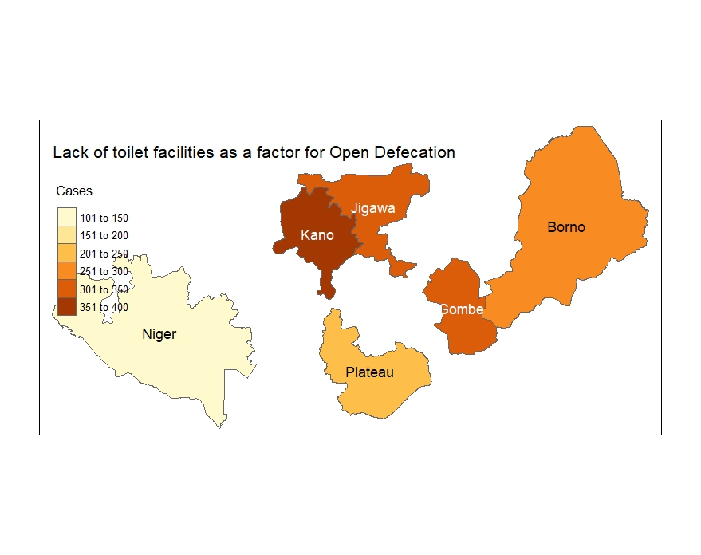

**Figure 3: lack of toilet facilities**

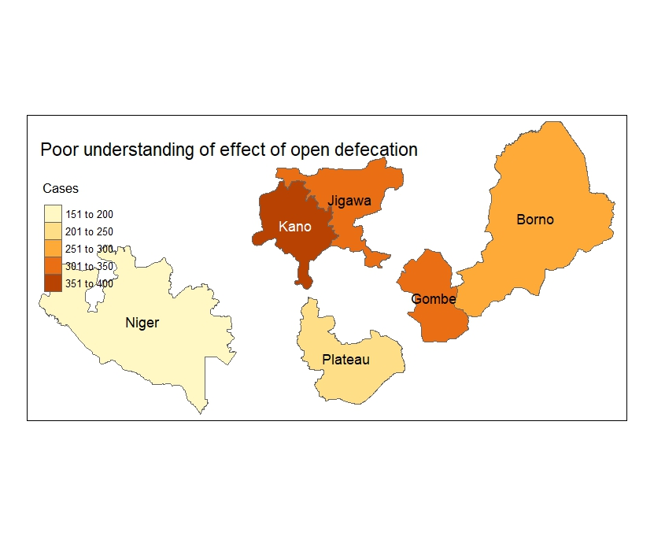

**Figure 4:** Poor understanding of effect of open defecation

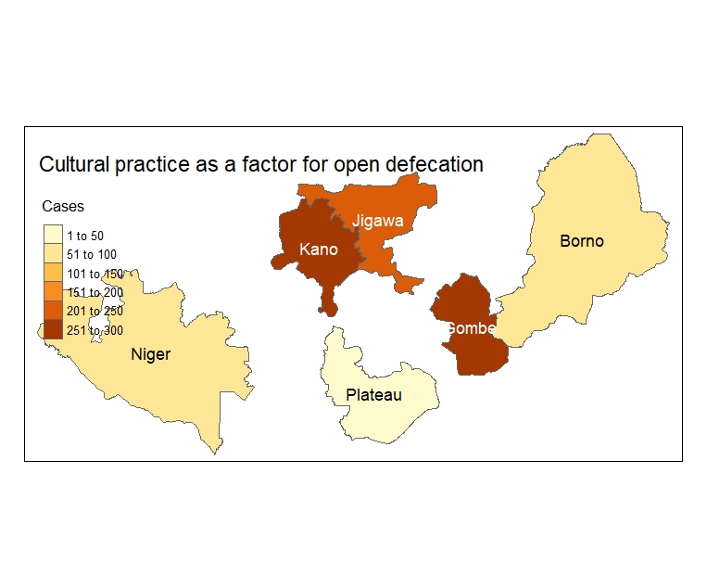

**Figure 5: Cultural practices**

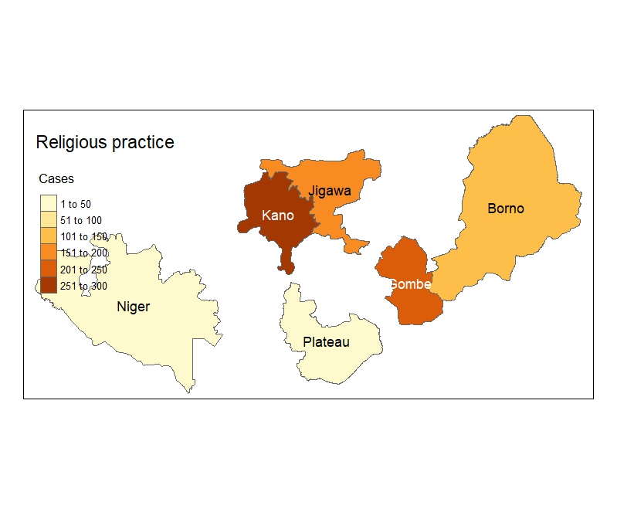

**Figure 6: Religious practices**

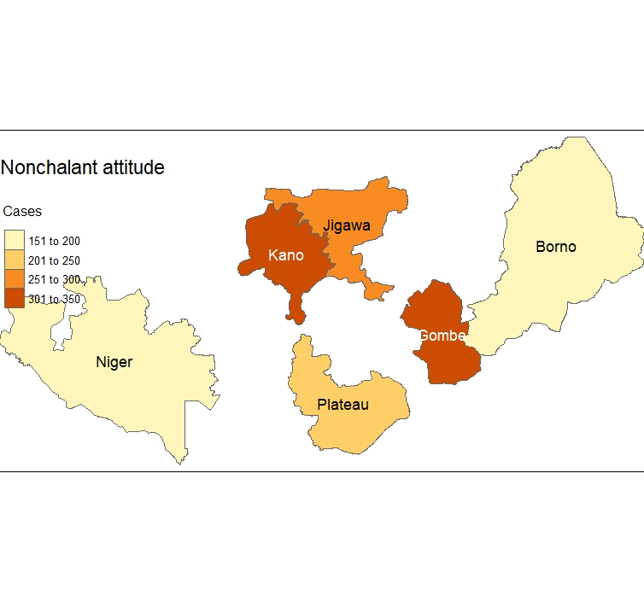

**Figure 7: Nonchallant attitude**

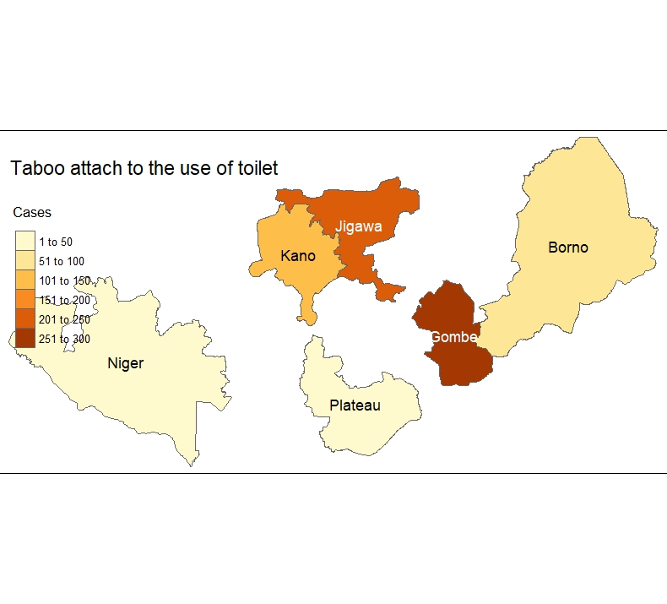

**Figure 8: Taboo attached to the use of toilet**

**Table 2: factors that encourage open defecation in the identified communities**

|  |  |  |  |  |  |  |  |
| --- | --- | --- | --- | --- | --- | --- | --- |
| **Factors** | **Borno** | **Gombe** | **Jigawa** | **Kano** | **Niger** | **Plateau** | **p-value** |
| Lack of toilet facilities |  |  |  |  |  |  | **<0.001** |
| Yes | 264 (15.7) | 309 (18.4) | 347 (20.7) | 392 (23.4) | 126 (7.5) | 240 (14.3) |  |
| No | 195 (27.9) | 97 (13.9) | 60 (8.6) | 81 (11.6) | 106 (15.1) | 161 (23.0) |  |
| Poor understanding of effect of open defecation |  |  |  |  |  |  | **<0.001** |
| Yes | 265 (15.2) | 326 (18.7) | 347 (19.9) | 399 (22.9) | 184 (10.6) | 222 (12.7) |  |
| No | 194 (30.6) | 80 (12.6) | 60 (9.4) | 74 (11.7) | 48 (7.6) | 179 (28,2) |  |
| Cultural practice |  |  |  |  |  |  | **<0.001** |
| Yes | 58 (6.3) | 260 (28.3) | 225 (24.5) | 292 (31.8) | 57 (6.2) | 26 (2.8) |  |
| No | 401 (27.5) | 146 (10.0) | 182 (12.5) | 181 (12.4) | 175 (12.0) | 375 (25.7) |  |
| Religious practice |  |  |  |  |  |  | **<0.001** |
| Yes | 111 (13.5) | 249 (30.3) | 163 (19.8) | 268 (32.6) | 25 (3.0) | 7 (0.9) |  |
| No | 348 (22.4) | 157 (10.1) | 244 (15.7) | 205 (13.2) | 207 (13.3) | 394 (25.3) |  |
| Nonchalant attitude |  |  |  |  |  |  | **<0.001** |
| Yes | 191 (12.5) | 305 (20.0) | 264 (17.3) | 338 (22.1) | 181 (11.8) | 249 (16.3) |  |
| No | 268 (31.5) | 101 (11.9) | 143 (16.8) | 135 (15.9) | 51(6.0) | 152(17.9) |  |
| Peer group pressure |  |  |  |  |  |  | **<0.001** |
| Yes | 161(13.1) | 294(23.9) | 197(16.0) | 330(26.8) | 95(7.7) | 155(12.6) |  |
| No | 298(26.0) | 112(9.8) | 210(18.3) | 143(12.5) | 137(12.0) | 246(21.5) |  |
| taboo attach to the use of toilet |  |  |  |  |  |  | **<0.001** |
| Yes | 90(12.8) | 263(37.4) | 218(31.0) | 117(16.6) | 10(1.4) | 5(0.7) |  |
| No | 369(22.0) | 143(8.5) | 189(11.3) | 356(21.3) | 222(13.3) | 396(23.6) |  |

Table 3a The Association between socio-demographic factors and the lack of toilet facilities

| Characteristic | No  N = 700 | Yes  N = 1,678 | p-value |
| --- | --- | --- | --- |
| Age group |  |  | <0.001 |
| 10 to 17 | 18 (2.6%) | 101 (6.0%) |  |
| 18 to 25 | 111 (16%) | 268 (16%) |  |
| 26 to 33 | 155 (22%) | 388 (23%) |  |
| 34 to 41 | 154 (22%) | 368 (22%) |  |
| 42 to 49 | 104 (15%) | 288 (17%) |  |
| 50 to 57 | 89 (13%) | 148 (8.8%) |  |
| 58 to 65 | 37 (5.3%) | 67 (4.0%) |  |
| 65 and above | 32 (4.6%) | 50 (3.0%) |  |
| Gender |  |  | 0.066 |
| Female | 307 (44%) | 666 (40%) |  |
| Male | 393 (56%) | 1,012 (60%) |  |
| Settlement |  |  | <0.001 |
| Rural | 202 (29%) | 775 (46%) |  |
| Urban | 498 (71%) | 903 (54%) |  |
| Household |  |  | 0.8 |
| 1 - 5 | 318 (45%) | 761 (45%) |  |
| 11 - 15 | 68 (9.7%) | 166 (9.9%) |  |
| 16 and above | 56 (8.0%) | 155 (9.2%) |  |
| 6 - 10 | 258 (37%) | 596 (36%) |  |
| Average Income/Month |  |  | <0.001 |
| 10,000 to 20,000 | 113 (16%) | 303 (18%) |  |
| 20,000 to 30,000 | 132 (19%) | 334 (20%) |  |
| 30,000 and above | 260 (37%) | 421 (25%) |  |
| 5,000 to 10,000 | 96 (14%) | 317 (19%) |  |
| Less than 5,000 | 99 (14%) | 303 (18%) |  |
| Educational level |  |  | <0.001 |
| Bachelor’s degree | 107 (15%) | 176 (10%) |  |
| Doctorate degree | 2 (0.3%) | 9 (0.5%) |  |
| Master’s/Professional degree | 36 (5.1%) | 29 (1.7%) |  |
| No schooling completed | 118 (17%) | 306 (18%) |  |
| Others | 16 (2.3%) | 31 (1.8%) |  |
| Primary education | 89 (13%) | 256 (15%) |  |
| Secondary education | 258 (37%) | 682 (41%) |  |
| Technical/Vocational training | 74 (11%) | 189 (11%) |  |
| Marital status |  |  | <0.001 |
| Divorced | 24 (3.4%) | 32 (1.9%) |  |
| Married | 517 (74%) | 1,177 (70%) |  |
| Single | 123 (18%) | 425 (25%) |  |
| Widowed | 36 (5.1%) | 44 (2.6%) |  |
| Occupation |  |  | <0.001 |
| Artisan | 46 (6.6%) | 83 (4.9%) |  |
| Civil servant | 126 (18%) | 241 (14%) |  |
| Farmer | 166 (24%) | 403 (24%) |  |
| House Wife | 62 (8.9%) | 278 (17%) |  |
| Nomad | 9 (1.3%) | 28 (1.7%) |  |
| Student | 84 (12%) | 305 (18%) |  |
| Traders | 207 (30%) | 340 (20%) |  |

Table 3b Multiple regression analysis of lack of toilet facilities as a factor for open defecation

|  |  |  |  |  |
| --- | --- | --- | --- | --- |
| Variables | P-value | Adjusted OR | 95 CI lower | 95 CI Upper |
| 10 to 17 | 0.046* | 2.174 | 1.013 | 4.668 |
| 18 to 25 | 0.736 | 1.103 | 0.625 | 1.946 |
| 26 to 33 | 0.345 | 1.293 | 0.759 | 2.205 |
| 34 to 41 | 0.190 | 1.421 | 0.840 | 2.402 |
| 42 to 49 | 0.059 | 1.675 | 0.980 | 2.862 |
| 50 to 57 | 0.748 | 1.095 | 0.631 | 1.899 |
| 58 to 65 | 0.628 | 1.169 | 0.621 | 2.199 |
| 65 and above |  | 1 |  |  |
| Rural | 0.000* | 2.026 | 1.634 | 2.512 |
| Urban |  | 1 |  |  |
| 10,000 to 20,000 | 0.611 | 1.094 | 0.774 | 1.545 |
| 20,000 to 30,000 | 0.397 | 1.162 | 0.821 | 1.644 |
| 30,000 and above | 0.562 | 0.899 | 0.626 | 1.290 |
| 5,000 to 10,000 | 0.422 | 1.152 | 0.816 | 1.625 |
| Less than 5,000 |  | 1 |  |  |
| Bachelor’s degree | 0.167 | 0.754 | 0.505 | 1.126 |
| Doctorate degree | 0.307 | 2.301 | 0.464 | 11.404 |
| Master’s/Professional degree | 0.004* | 0.404 | 0.219 | 0.744 |
| No schooling completed | 0.445 | 1.161 | 0.792 | 1.701 |
| Others | 0.798 | 1.095 | 0.547 | 2.193 |
| Primary education | 0.620 | 1.104 | 0.746 | 1.634 |
| Secondary education | 0.723 | 1.061 | 0.765 | 1.470 |
| Technical/Vocational training |  | 1 |  |  |
| Divorced | 0.949 | 0.976 | 0.465 | 2.050 |
| Married | 0.038* | 1.699 | 1.031 | 2.801 |
| Single | 0.000* | 2.841 | 1.593 | 5.067 |
| Widowed |  | 1 |  |  |
| Artisan | 0.725 | 1.078 | 0.710 | 1.635 |
| Civil servant | 0.002* | 1.724 | 1.229 | 2.417 |
| Farmer | 0.625 | 1.072 | 0.811 | 1.418 |
| House Wife | 0.000* | 3.180 | 2.211 | 4.575 |
| Nomad | 0.495 | 1.320 | 0.595 | 2.927 |
| Student | 0.047* | 1.472 | 1.006 | 2.155 |
| Traders |  | 1 |  |  |

*-significant at p.value<0.05

Table 4a The Association between socio-demographic factors and poor understanding of the effects of open defecation

| Characteristic | No  N = 700 | Yes  N = 1,678 | p-value |
| --- | --- | --- | --- |
| Age group |  |  | <0.001 |
| 10 to 17 | 21 (3.3%) | 98 (5.6%) |  |
| 18 to 25 | 96 (15%) | 283 (16%) |  |
| 26 to 33 | 126 (20%) | 417 (24%) |  |
| 34 to 41 | 137 (22%) | 385 (22%) |  |
| 42 to 49 | 99 (16%) | 293 (17%) |  |
| 50 to 57 | 81 (13%) | 156 (9.0%) |  |
| 58 to 65 | 40 (6.3%) | 64 (3.7%) |  |
| 65 and above | 35 (5.5%) | 47 (2.7%) |  |
| Gender |  |  | 0.009 |
| Female | 288 (45%) | 685 (39%) |  |
| Male | 347 (55%) | 1,058 (61%) |  |
| Settlement |  |  | <0.001 |
| Rural | 195 (31%) | 782 (45%) |  |
| Urban | 440 (69%) | 961 (55%) |  |
| Household |  |  | 0.3 |
| 1 - 5 | 295 (46%) | 784 (45%) |  |
| 11 - 15 | 60 (9.4%) | 174 (10.0%) |  |
| 16 and above | 66 (10%) | 145 (8.3%) |  |
| 6 - 10 | 214 (34%) | 640 (37%) |  |
| Average Income/Month |  |  | 0.004 |
| 10,000 to 20,000 | 105 (17%) | 311 (18%) |  |
| 20,000 to 30,000 | 113 (18%) | 353 (20%) |  |
| 30,000 and above | 219 (34%) | 462 (27%) |  |
| 5,000 to 10,000 | 95 (15%) | 318 (18%) |  |
| Less than 5,000 | 103 (16%) | 299 (17%) |  |
| Educational level |  |  | 0.002 |
| Bachelor’s degree | 83 (13%) | 200 (11%) |  |
| Doctorate degree | 3 (0.5%) | 8 (0.5%) |  |
| Master’s/Professional degree | 30 (4.7%) | 35 (2.0%) |  |
| No schooling completed | 107 (17%) | 317 (18%) |  |
| Others | 17 (2.7%) | 30 (1.7%) |  |
| Primary education | 72 (11%) | 273 (16%) |  |
| Secondary education | 247 (39%) | 693 (40%) |  |
| Technical/Vocational training | 76 (12%) | 187 (11%) |  |
| Marital status |  |  | <0.001 |
| Divorced | 18 (2.8%) | 38 (2.2%) |  |
| Married | 461 (73%) | 1,233 (71%) |  |
| Single | 121 (19%) | 427 (24%) |  |
| Widowed | 35 (5.5%) | 45 (2.6%) |  |
| Occupation |  |  | <0.001 |
| Artisan | 40 (6.3%) | 89 (5.1%) |  |
| Civil servant | 111 (17%) | 256 (15%) |  |
| Farmer | 157 (25%) | 412 (24%) |  |
| House Wife | 64 (10%) | 276 (16%) |  |
| Nomad | 6 (0.9%) | 31 (1.8%) |  |
| Student | 74 (12%) | 315 (18%) |  |
| Traders | 183 (29%) | 364 (21%) |  |

Table 4b Multiple regression analysis of poor understanding of the effect of open defecation as a factor for open defecation

|  |  |  |  |  |
| --- | --- | --- | --- | --- |
| Variables | P-value | Adjusted OR | 95 CI lower | 95 CI Upper |
| 10 to 17 | 0.008* | 2.717 | 1.297 | 5.693 |
| 18 to 25 | 0.018* | 1.980 | 1.127 | 3.478 |
| 26 to 33 | 0.002* | 2.273 | 1.340 | 3.856 |
| 34 to 41 | 0.008* | 2.023 | 1.206 | 3.395 |
| 42 to 49 | 0.007* | 2.056 | 1.215 | 3.481 |
| 50 to 57 | 0.213 | 1.412 | 0.820 | 2.431 |
| 58 to 65 | 0.663 | 1.147 | 0.619 | 2.126 |
| 65 and above |  | 1 |  |  |
| Female | 0.000* | 0.650 | 0.526 | 0.805 |
| Male |  | 1 |  |  |
| Rural | 0.000* | 1.840 | 1.478 | 2.289 |
| Urban |  | 1 |  |  |
| 10,000 to 20,000 | 0.177 | 1.271 | 0.897 | 1.799 |
| 20,000 to 30,000 | 0.014* | 1.556 | 1.093 | 2.214 |
| 30,000 and above | 0.137 | 1.320 | 0.916 | 1.903 |
| 5,000 to 10,000 | 0.229 | 1.235 | 0.876 | 1.741 |
| Less than 5,000 |  | 1 |  |  |
| Bachelor’s degree | 0.455 | 1.169 | 0.776 | 1.761 |
| Doctorate degree | 0.559 | 1.521 | 0.373 | 6.207 |
| Master’s/Professional degree | 0.149 | 0.639 | 0.347 | 1.174 |
| No schooling completed | 0.010* | 1.669 | 1.133 | 2.460 |
| Others | 0.835 | 1.076 | 0.541 | 2.141 |
| Primary education | 0.005* | 1.768 | 1.183 | 2.642 |
| Secondary education | 0.185 | 1.246 | 0.900 | 1.726 |
| Technical/Vocational training |  | 1 |  |  |
| Divorced | 0.384 | 1.403 | 0.655 | 3.005 |
| Married | 0.056 | 1.629 | 0.987 | 2.687 |
| Single | 0.031* | 1.891 | 1.058 | 3.380 |
| Widowed |  | 1 |  |  |
| Artisan | 0.786 | 1.061 | 0.690 | 1.632 |
| Civil servant | 0.041* | 1.429 | 1.014 | 2.014 |
| Farmer | 0.867 | 1.025 | 0.769 | 1.365 |
| House Wife | 0.000* | 2.686 | 1.865 | 3.867 |
| Nomad | 0.189 | 1.848 | 0.739 | 4.625 |
| Student | 0.001* | 1.983 | 1.338 | 2.940 |
| Traders |  | 1 |  |  |

*-significant at p.value<0.05

Table 5a The Association between socio-demographic factors and cultural practices

| Characteristic | No  N = 700 | Yes  N = 1,678 | p-value |
| --- | --- | --- | --- |
| Age group |  |  | 0.001 |
| 10 to 17 | 63 (4.3%) | 56 (6.1%) |  |
| 18 to 25 | 226 (15%) | 153 (17%) |  |
| 26 to 33 | 302 (21%) | 241 (26%) |  |
| 34 to 41 | 332 (23%) | 190 (21%) |  |
| 42 to 49 | 249 (17%) | 143 (16%) |  |
| 50 to 57 | 157 (11%) | 80 (8.7%) |  |
| 58 to 65 | 69 (4.7%) | 35 (3.8%) |  |
| 65 and above | 62 (4.2%) | 20 (2.2%) |  |
| Gender |  |  | 0.003 |
| Female | 632 (43%) | 341 (37%) |  |
| Male | 828 (57%) | 577 (63%) |  |
| Settlement |  |  | <0.001 |
| Rural | 437 (30%) | 540 (59%) |  |
| Urban | 1,023 (70%) | 378 (41%) |  |
| Household |  |  | <0.001 |
| 1 - 5 | 630 (43%) | 449 (49%) |  |
| 11 - 15 | 169 (12%) | 65 (7.1%) |  |
| 16 and above | 111 (7.6%) | 100 (11%) |  |
| 6 - 10 | 550 (38%) | 304 (33%) |  |
| Average Income/Month |  |  | <0.001 |
| 10,000 to 20,000 | 270 (18%) | 146 (16%) |  |
| 20,000 to 30,000 | 303 (21%) | 163 (18%) |  |
| 30,000 and above | 458 (31%) | 223 (24%) |  |
| 5,000 to 10,000 | 217 (15%) | 196 (21%) |  |
| Less than 5,000 | 212 (15%) | 190 (21%) |  |
| Educational level |  |  | <0.001 |
| Bachelor’s degree | 192 (13%) | 91 (9.9%) |  |
| Doctorate degree | 5 (0.3%) | 6 (0.7%) |  |
| Master’s/Professional degree | 44 (3.0%) | 21 (2.3%) |  |
| No schooling completed | 290 (20%) | 134 (15%) |  |
| Others | 37 (2.5%) | 10 (1.1%) |  |
| Primary education | 177 (12%) | 168 (18%) |  |
| Secondary education | 581 (40%) | 359 (39%) |  |
| Technical/Vocational training | 134 (9.2%) | 129 (14%) |  |
| Marital status |  |  | 0.001 |
| Divorced | 39 (2.7%) | 17 (1.9%) |  |
| Married | 1,038 (71%) | 656 (71%) |  |
| Single | 319 (22%) | 229 (25%) |  |
| Widowed | 64 (4.4%) | 16 (1.7%) |  |
| Occupation |  |  | <0.001 |
| Artisan | 118 (8.1%) | 11 (1.2%) |  |
| Civil servant | 254 (17%) | 113 (12%) |  |
| Farmer | 318 (22%) | 251 (27%) |  |
| House Wife | 165 (11%) | 175 (19%) |  |
| Nomad | 18 (1.2%) | 19 (2.1%) |  |
| Student | 200 (14%) | 189 (21%) |  |
| Traders | 387 (27%) | 160 (17%) |  |

Table 5b Multiple regression analysis of cultural practices as a factor for open defecation

|  |  |  |  |  |
| --- | --- | --- | --- | --- |
| Variables | P-value | Adjusted OR | 95 CI lower | 95 CI Upper |
| 10 to 17 | 0.040* | 0.464 | 0.224 | 0.964 |
| 18 to 25 | 0.068 | 0.559 | 0.300 | 1.043 |
| 26 to 33 | 0.006* | 0.435 | 0.240 | 0.787 |
| 34 to 41 | 0.116 | 0.624 | 0.347 | 1.124 |
| 42 to 49 | 0.137 | 0.637 | 0.351 | 1.154 |
| 50 to 57 | 0.260 | 0.700 | 0.377 | 1.301 |
| 58 to 65 | 0.313 | 0.698 | 0.347 | 1.403 |
| 65 and above |  | 1 |  |  |
| Female | 0.000* | 1.700 | 1.370 | 2.108 |
| Male |  | 1 |  |  |
| Rural | 0.000* | 0.313 | 0.255 | 0.382 |
| Urban |  | 1 |  |  |
| 1- 5 ho | 0.682 | 0.956 | 0.773 | 1.183 |
| 11-15 ho | 0.045* | 1.424 | 1.008 | 2.013 |
| 16 above ho | 0.001* | 0.557 | 0.396 | 0.781 |
| 6 10 ho |  | 1 |  |  |
| 10,000 to 20,000 | 0.017* | 1.487 | 1.073 | 2.062 |
| 20,000 to 30,000 | 0.260 | 1.209 | 0.869 | 1.683 |
| 30,000 and above | 0.957 | 1.010 | 0.708 | 1.442 |
| 5,000 to 10,000 | 0.617 | 1.083 | 0.793 | 1.480 |
| Less than 5,000 |  | 1 |  |  |
| Bachelor’s degree | 0.072 | 1.446 | 0.968 | 2.162 |
| Doctorate degree | 0.342 | 0.526 | 0.139 | 1.980 |
| Master’s/Professional degree | 0.631 | 1.170 | 0.616 | 2.225 |
| No schooling completed | 0.000* | 2.534 | 1.737 | 3.697 |
| Others | 0.020* | 2.533 | 1.157 | 5.546 |
| Primary education | 0.262 | 1.239 | 0.852 | 1.801 |
| Secondary education | 0.001* | 1.750 | 1.276 | 2.401 |
| Technical/Vocational training |  | 1 |  |  |
| Divorced | 0.418 | 0.698 | 0.292 | 1.668 |
| Married | 0.016* | 0.469 | 0.253 | 0.870 |
| Single | 0.029* | 0.467 | 0.236 | 0.925 |
| Widowed |  | 1 |  |  |
| Artisan | 0.000* | 5.548 | 2.828 | 10.881 |
| Civil servant | 0.729 | 1.064 | 0.750 | 1.508 |
| Farmer | 0.016* | 0.704 | 0.529 | 0.936 |
| House Wife | 0.000* | 0.309 | 0.219 | 0.435 |
| Nomad | 0.008* | 0.375 | 0.181 | 0.774 |
| Student | 0.004* | 0.587 | 0.408 | 0.845 |
| Traders |  | 1 |  |  |

*-significant at p.value<0.05

Table 6a The Association between socio-demographic factors and religious practices

| Characteristic | No  N = 700 | Yes  N = 1,678 | p-value |
| --- | --- | --- | --- |
| Age group |  |  | 0.3 |
| 10 to 17 | 79 (5.1%) | 40 (4.9%) |  |
| 18 to 25 | 249 (16%) | 130 (16%) |  |
| 26 to 33 | 335 (22%) | 208 (25%) |  |
| 34 to 41 | 343 (22%) | 179 (22%) |  |
| 42 to 49 | 257 (17%) | 135 (16%) |  |
| 50 to 57 | 159 (10%) | 78 (9.5%) |  |
| 58 to 65 | 71 (4.6%) | 33 (4.0%) |  |
| 65 and above | 62 (4.0%) | 20 (2.4%) |  |
| Gender |  |  | 0.017 |
| Female | 664 (43%) | 309 (38%) |  |
| Male | 891 (57%) | 514 (62%) |  |
| Settlement |  |  | <0.001 |
| Rural | 431 (28%) | 546 (66%) |  |
| Urban | 1,124 (72%) | 277 (34%) |  |
| Household |  |  | 0.001 |
| 1 - 5 | 666 (43%) | 413 (50%) |  |
| 11 - 15 | 173 (11%) | 61 (7.4%) |  |
| 16 and above | 140 (9.0%) | 71 (8.6%) |  |
| 6 - 10 | 576 (37%) | 278 (34%) |  |
| Average Income/Month |  |  | <0.001 |
| 10,000 to 20,000 | 267 (17%) | 149 (18%) |  |
| 20,000 to 30,000 | 334 (21%) | 132 (16%) |  |
| 30,000 and above | 492 (32%) | 189 (23%) |  |
| 5,000 to 10,000 | 204 (13%) | 209 (25%) |  |
| Less than 5,000 | 258 (17%) | 144 (17%) |  |
| Educational level |  |  | <0.001 |
| Bachelor’s degree | 211 (14%) | 72 (8.7%) |  |
| Doctorate degree | 3 (0.2%) | 8 (1.0%) |  |
| Master’s/Professional degree | 48 (3.1%) | 17 (2.1%) |  |
| No schooling completed | 327 (21%) | 97 (12%) |  |
| Others | 42 (2.7%) | 5 (0.6%) |  |
| Primary education | 189 (12%) | 156 (19%) |  |
| Secondary education | 593 (38%) | 347 (42%) |  |
| Technical/Vocational training | 142 (9.1%) | 121 (15%) |  |
| Marital status |  |  | 0.001 |
| Divorced | 36 (2.3%) | 20 (2.4%) |  |
| Married | 1,082 (70%) | 612 (74%) |  |
| Single | 369 (24%) | 179 (22%) |  |
| Widowed | 68 (4.4%) | 12 (1.5%) |  |
| Occupation |  |  | <0.001 |
| Artisan | 125 (8.0%) | 4 (0.5%) |  |
| Civil servant | 260 (17%) | 107 (13%) |  |
| Farmer | 330 (21%) | 239 (29%) |  |
| House Wife | 187 (12%) | 153 (19%) |  |
| Nomad | 31 (2.0%) | 6 (0.7%) |  |
| Student | 227 (15%) | 162 (20%) |  |
| Traders | 395 (25%) | 152 (18%) |  |

Table 6b Multiple regression analysis of religious practices as a factor for open defecation

|  |  |  |  |  |
| --- | --- | --- | --- | --- |
| Variables | P-value | Adjusted OR | 95 CI lower | 95 CI Upper |
| Female | 0.000* | 0.646 | 0.514 | 0.811 |
| Male |  | 1 |  |  |
| Rural | 0.000* | 4.910 | 3.970 | 6.071 |
| Urban |  | 1 |  |  |
| 1- 5 ho | 0.611 | 1.061 | 0.845 | 1.331 |
| 11-15 ho | 0.083 | 0.721 | 0.498 | 1.044 |
| 16 above ho | 0.809 | 1.046 | 0.725 | 1.509 |
| 6 10 ho |  | 1 |  |  |
| 10,000 to 20,000 | 0.881 | 1.027 | 0.729 | 1.446 |
| 20,000 to 30,000 | 0.207 | 0.795 | 0.557 | 1.135 |
| 30,000 and above | 0.532 | 1.129 | 0.772 | 1.650 |
| 5,000 to 10,000 | 0.004* | 1.628 | 1.174 | 2.258 |
| Less than 5,000 |  | 1 |  |  |
| Bachelor’s degree | 0.005* | 0.545 | 0.355 | 0.835 |
| Doctorate degree | 0.029* | 0.484 | 0.117 | 1.978 |
| Master’s/Professional degree | 0.234 | 0.659 | 0.332 | 1.309 |
| No schooling completed | 0.000* | 0.290 | 0.194 | 0.435 |
| Others | 0.001* | 0.179 | 0.064 | 0.496 |
| Primary education | 0.195 | 0.773 | 0.523 | 1.141 |
| Secondary education | 0.020* | 0.676 | 0.487 | 0.940 |
| Technical/Vocational training |  | 1 |  |  |
| Divorced | 0.030* | 2.763 | 1.102 | 6.930 |
| Married | 0.003* | 2.889 | 1.446 | 5.771 |
| Single | 0.046* | 2.178 | 1.013 | 4.681 |
| Widowed |  | 1 |  |  |
| Artisan | 0.000* | 0.061 | 0.021 | 0.172 |
| Civil servant | 0.578 | 1.110 | 0.768 | 1.604 |
| Farmer | 0.226 | 1.203 | 0.892 | 1.623 |
| House Wife | 0.000* | 2.183 | 1.528 | 3.119 |
| Nomad | 0.060 | 0.400 | 0.154 | 1.041 |
| Student | 0.006* | 1.744 | 1.176 | 2.585 |
| Traders |  | 1 |  |  |

*-significant at p.value<0.05

Table 7a The Association between socio-demographic factors and nonchalant attitude

| Characteristic | No  N = 700 | Yes  N = 1,678 | p-value |
| --- | --- | --- | --- |
| Age group |  |  | <0.001 |
| 10 to 17 | 38 (4.5%) | 81 (5.3%) |  |
| 18 to 25 | 111 (13%) | 268 (18%) |  |
| 26 to 33 | 167 (20%) | 376 (25%) |  |
| 34 to 41 | 198 (23%) | 324 (21%) |  |
| 42 to 49 | 143 (17%) | 249 (16%) |  |
| 50 to 57 | 99 (12%) | 138 (9.0%) |  |
| 58 to 65 | 48 (5.6%) | 56 (3.7%) |  |
| 65 and above | 46 (5.4%) | 36 (2.4%) |  |
| Gender |  |  | 0.8 |
| Female | 351 (41%) | 622 (41%) |  |
| Male | 499 (59%) | 906 (59%) |  |
| Settlement |  |  | <0.001 |
| Rural | 287 (34%) | 690 (45%) |  |
| Urban | 563 (66%) | 838 (55%) |  |
| Household |  |  | 0.061 |
| 1 - 5 | 365 (43%) | 714 (47%) |  |
| 11 - 15 | 101 (12%) | 133 (8.7%) |  |
| 16 and above | 76 (8.9%) | 135 (8.8%) |  |
| 6 - 10 | 308 (36%) | 546 (36%) |  |
| Average Income/Month |  |  | <0.001 |
| 10,000 to 20,000 | 154 (18%) | 262 (17%) |  |
| 20,000 to 30,000 | 152 (18%) | 314 (21%) |  |
| 30,000 and above | 270 (32%) | 411 (27%) |  |
| 5,000 to 10,000 | 112 (13%) | 301 (20%) |  |
| Less than 5,000 | 162 (19%) | 240 (16%) |  |
| Educational level |  |  | <0.001 |
| Bachelor’s degree | 92 (11%) | 191 (13%) |  |
| Doctorate degree | 3 (0.4%) | 8 (0.5%) |  |
| Master’s/Professional degree | 29 (3.4%) | 36 (2.4%) |  |
| No schooling completed | 206 (24%) | 218 (14%) |  |
| Others | 15 (1.8%) | 32 (2.1%) |  |
| Primary education | 118 (14%) | 227 (15%) |  |
| Secondary education | 305 (36%) | 635 (42%) |  |
| Technical/Vocational training | 82 (9.6%) | 181 (12%) |  |
| Marital status |  |  | <0.001 |
| Divorced | 19 (2.2%) | 37 (2.4%) |  |
| Married | 623 (73%) | 1,071 (70%) |  |
| Single | 165 (19%) | 383 (25%) |  |
| Widowed | 43 (5.1%) | 37 (2.4%) |  |
| Occupation |  |  | <0.001 |
| Artisan | 57 (6.7%) | 72 (4.7%) |  |
| Civil servant | 127 (15%) | 240 (16%) |  |
| Farmer | 232 (27%) | 337 (22%) |  |
| House Wife | 86 (10%) | 254 (17%) |  |
| Nomad | 21 (2.5%) | 16 (1.0%) |  |
| Student | 102 (12%) | 287 (19%) |  |
| Traders | 225 (26%) | 322 (21%) |  |

Table 7b Multiple regression analysis of nonchallant attitude as a factor for open defecation

|  |  |  |  |  |
| --- | --- | --- | --- | --- |
| Variables | P-value | Adjusted OR | 95 CI lower | 95 CI Upper |
| 10 to 17 | 0.027* | 2.149 | 1.092 | 4.227 |
| 18 to 25 | 0.004* | 2.218 | 1.280 | 3.843 |
| 26 to 33 | 0.004* | 2.125 | 1.270 | 3.555 |
| 34 to 41 | 0.043* | 1.684 | 1.017 | 2.789 |
| 42 to 49 | 0.029* | 1.771 | 1.062 | 2.953 |
| 50 to 57 | 0.103 | 1.560 | 0.915 | 2.659 |
| 58 to 65 | 0.303 | 1.374 | 0.750 | 2.517 |
| 65 and above |  | 1 |  |  |
| Rural | 0.000* | 1.772 | 1.450 | 2.166 |
| Urban |  | 1 |  |  |
| 1- 5 ho | 0.160 | 0.863 | 0.702 | 1.060 |
| 11-15 ho | 0.206 | 0.820 | 0.603 | 1.115 |
| 16 above ho | 0.363 | 1.168 | 0.836 | 1.634 |
| 6 10 ho |  | 1 |  |  |
| 10,000 to 20,000 | 0.022* | 1.447 | 1.055 | 1.985 |
| 20,000 to 30,000 | 0.000* | 1.856 | 1.415 | 2.706 |
| 30,000 and above | 0.012* | 1.548 | 1.101 | 2.175 |
| 5,000 to 10,000 | 0.000* | 1.952 | 1.420 | 2.684 |
| Less than 5,000 |  | 1 |  |  |
| Bachelor’s degree | 0.540 | 1.132 | 0.761 | 1.686 |
| Doctorate degree | 0.506 | 1.604 | 0.398 | 6.464 |
| Master’s/Professional degree | 0.372 | 0.761 | 0.418 | 1.387 |
| No schooling completed | 0.005* | 0.596 | 0.416 | 0.855 |
| Others | 0.333 | 1.411 | 0.702 | 2.837 |
| Primary education | 0.843 | 0.963 | 0.665 | 1.396 |
| Secondary education | 0.811 | 0.962 | 0.702 | 1.318 |
| Technical/Vocational training |  | 1 |  |  |
| Divorced | 0.120 | 1.819 | 0.856 | 3.868 |
| Married | 0.131 | 1.468 | 0.892 | 2.416 |
| Single | 0.060 | 1.728 | 0.978 | 3.054 |
| Widowed |  | 1 |  |  |
| Artisan | 0.354 | 0.827 | 0.554 | 1.236 |
| Civil servant | 0.137 | 1.281 | 0.925 | 1.776 |
| Farmer | 0.790 | 0.964 | 0.737 | 1.261 |
| House Wife | 0.000* | 2.633 | 1.872 | 3.704 |
| Nomad | 0.091 | 0.547 | 0.272 | 1.101 |
| Student | 0.011* | 1.613 | 1.118 | 2.326 |
| Traders |  | 1 |  |  |

*-significant at p.value<0.05

Table 8a The Association between socio-demographic factors and peer group pressure

| Characteristic | No  N = 700 | Yes  N = 1,678 | p-value |
| --- | --- | --- | --- |
| Age group |  |  | <0.001 |
| 10 to 17 | 55 (4.8%) | 64 (5.2%) |  |
| 18 to 25 | 176 (15%) | 203 (16%) |  |
| 26 to 33 | 231 (20%) | 312 (25%) |  |
| 34 to 41 | 243 (21%) | 279 (23%) |  |
| 42 to 49 | 186 (16%) | 206 (17%) |  |
| 50 to 57 | 131 (11%) | 106 (8.6%) |  |
| 58 to 65 | 69 (6.0%) | 35 (2.8%) |  |
| 65 and above | 55 (4.8%) | 27 (2.2%) |  |
| Gender |  |  | 0.8 |
| Female | 472 (41%) | 501 (41%) |  |
| Male | 674 (59%) | 731 (59%) |  |
| Settlement |  |  | <0.001 |
| Rural | 413 (36%) | 564 (46%) |  |
| Urban | 733 (64%) | 668 (54%) |  |
| Household |  |  | <0.001 |
| 1 - 5 | 470 (41%) | 609 (49%) |  |
| 11 - 15 | 145 (13%) | 89 (7.2%) |  |
| 16 and above | 107 (9.3%) | 104 (8.4%) |  |
| 6 - 10 | 424 (37%) | 430 (35%) |  |
| Average Income/Month |  |  | <0.001 |
| 10,000 to 20,000 | 187 (16%) | 229 (19%) |  |
| 20,000 to 30,000 | 218 (19%) | 248 (20%) |  |
| 30,000 and above | 371 (32%) | 310 (25%) |  |
| 5,000 to 10,000 | 171 (15%) | 242 (20%) |  |
| Less than 5,000 | 199 (17%) | 203 (16%) |  |
| Educational level |  |  | <0.001 |
| Bachelor’s degree | 148 (13%) | 135 (11%) |  |
| Doctorate degree | 6 (0.5%) | 5 (0.4%) |  |
| Master’s/Professional degree | 41 (3.6%) | 24 (1.9%) |  |
| No schooling completed | 250 (22%) | 174 (14%) |  |
| Others | 26 (2.3%) | 21 (1.7%) |  |
| Primary education | 144 (13%) | 201 (16%) |  |
| Secondary education | 426 (37%) | 514 (42%) |  |
| Technical/Vocational training | 105 (9.2%) | 158 (13%) |  |
| Marital status |  |  | <0.001 |
| Divorced | 20 (1.7%) | 36 (2.9%) |  |
| Married | 826 (72%) | 868 (70%) |  |
| Single | 247 (22%) | 301 (24%) |  |
| Widowed | 53 (4.6%) | 27 (2.2%) |  |
| Occupation |  |  | <0.001 |
| Artisan | 75 (6.5%) | 54 (4.4%) |  |
| Civil servant | 176 (15%) | 191 (16%) |  |
| Farmer | 297 (26%) | 272 (22%) |  |
| House Wife | 112 (9.8%) | 228 (19%) |  |
| Nomad | 23 (2.0%) | 14 (1.1%) |  |
| Student | 160 (14%) | 229 (19%) |  |
| Traders | 303 (26%) | 244 (20%) |  |

Table 8b Multiple regression analysis of peer group pressure as a factor for open defecation

|  |  |  |  |  |
| --- | --- | --- | --- | --- |
| Variables | P-value | Adjusted OR | 95 CI lower | 95 CI Upper |
| 10 to 17 | 0.271 | 1.455 | 0.746 | 2.835 |
| 18 to 25 | 0.185 | 1.457 | 0.836 | 2.541 |
| 26 to 33 | 0.032* | 1.780 | 1.051 | 3.015 |
| 34 to 41 | 0.049* | 1.687 | 1.003 | 2.838 |
| 42 to 49 | 0.040* | 1.737 | 1.026 | 2.939 |
| 50 to 57 | 0.260 | 1.372 | 0.792 | 2.377 |
| 58 to 65 | 0.771 | 0.910 | 0.482 | 1.717 |
| 65 and above |  | 1 |  |  |
| Female | 0.002* | 0.735 | 0.606 | 0.891 |
| Male |  | 1 |  |  |
| Rural | 0.001* | 1.384 | 1.146 | 1.673 |
| Urban |  | 1 |  |  |
| 1- 5 ho | 0.332 | 1.102 | 0.906 | 1.342 |
| 11-15 ho | 0.004* | 0.633 | 0.466 | 0.862 |
| 16 above ho | 0.579 | 1.095 | 0.795 | 1.509 |
| 6 10 ho |  | 1 |  |  |
| 10,000 to 20,000 | 0.036* | 1.389 | 1.022 | 1.888 |
| 20,000 to 30,000 | 0.052 | 1.361 | 0.998 | 1.856 |
| 30,000 and above | 0.407 | 1.151 | 0.826 | 1.602 |
| 5,000 to 10,000 | 0.026 | 1.405 | 1.042 | 1.894 |
| Less than 5,000 |  | 1 |  |  |
| Bachelor’s degree | 0.018* | 0.634 | 0.435 | 0.924 |
| Doctorate degree | 0.396 | 0.579 | 0.163 | 2.048 |
| Master’s/Professional degree | 0.008* | 0.441 | 0.240 | 0.807 |
| No schooling completed | 0.001* | 0.562 | 0.396 | 0.797 |
| Others | 0.227 | 0.669 | 0.348 | 1.285 |
| Primary education | 0.853 | 1.034 | 0.726 | 1.474 |
| Secondary education | 0.228 | 0.833 | 0.618 | 1.121 |
| Technical/Vocational training |  | 1 |  |  |
| Divorced | 0.014* | 2.601 | 1.215 | 5.568 |
| Married | 0.079 | 1.587 | 0.947 | 2.658 |
| Single | 0.062 | 1.731 | 0.972 | 3.083 |
| Widowed |  | 1 |  |  |
| Artisan | 0.439 | 0.853 | 0.571 | 1.276 |
| Civil servant | 0.001* | 1.689 | 1.230 | 2.321 |
| Farmer | 0.539 | 1.086 | 0.835 | 1.412 |
| House Wife | 0.000* | 3.021 | 2.186 | 4.174 |
| Nomad | 0.531 | 0.796 | 0.390 | 1.625 |
| Student | 0.005* | 1.627 | 1.158 | 2.286 |
| Traders |  | 1 |  |  |

*-significant at p.value<0.05

Table 9a The Association between socio-demographic factors and taboo attach to the use of toilet

| Characteristic | No  N = 700 | Yes  N = 1,678 | p-value |
| --- | --- | --- | --- |
| Age group |  |  | 0.048 |
| 10 to 17 | 79 (4.7%) | 40 (5.7%) |  |
| 18 to 25 | 250 (15%) | 129 (18%) |  |
| 26 to 33 | 367 (22%) | 176 (25%) |  |
| 34 to 41 | 372 (22%) | 150 (21%) |  |
| 42 to 49 | 288 (17%) | 104 (15%) |  |
| 50 to 57 | 182 (11%) | 55 (7.8%) |  |
| 58 to 65 | 76 (4.5%) | 28 (4.0%) |  |
| 65 and above | 61 (3.6%) | 21 (3.0%) |  |
| Gender |  |  | <0.001 |
| Female | 767 (46%) | 206 (29%) |  |
| Male | 908 (54%) | 497 (71%) |  |
| Settlement |  |  | <0.001 |
| Rural | 641 (38%) | 336 (48%) |  |
| Urban | 1,034 (62%) | 367 (52%) |  |
| Household |  |  | <0.001 |
| 1 - 5 | 716 (43%) | 363 (52%) |  |
| 11 - 15 | 173 (10%) | 61 (8.7%) |  |
| 16 and above | 143 (8.5%) | 68 (9.7%) |  |
| 6 - 10 | 643 (38%) | 211 (30%) |  |
| Average Income/Month |  |  | <0.001 |
| 10,000 to 20,000 | 312 (19%) | 104 (15%) |  |
| 20,000 to 30,000 | 339 (20%) | 127 (18%) |  |
| 30,000 and above | 507 (30%) | 174 (25%) |  |
| 5,000 to 10,000 | 251 (15%) | 162 (23%) |  |
| Less than 5,000 | 266 (16%) | 136 (19%) |  |
| Educational level |  |  | <0.001 |
| Bachelor’s degree | 201 (12%) | 82 (12%) |  |
| Doctorate degree | 4 (0.2%) | 7 (1.0%) |  |
| Master’s/Professional degree | 48 (2.9%) | 17 (2.4%) |  |
| No schooling completed | 320 (19%) | 104 (15%) |  |
| Others | 41 (2.4%) | 6 (0.9%) |  |
| Primary education | 213 (13%) | 132 (19%) |  |
| Secondary education | 654 (39%) | 286 (41%) |  |
| Technical/Vocational training | 194 (12%) | 69 (9.8%) |  |
| Marital status |  |  | <0.001 |
| Divorced | 41 (2.4%) | 15 (2.1%) |  |
| Married | 1,208 (72%) | 486 (69%) |  |
| Single | 357 (21%) | 191 (27%) |  |
| Widowed | 69 (4.1%) | 11 (1.6%) |  |
| Occupation |  |  | <0.001 |
| Artisan | 117 (7.0%) | 12 (1.7%) |  |
| Civil servant | 251 (15%) | 116 (17%) |  |
| Farmer | 378 (23%) | 191 (27%) |  |
| House Wife | 251 (15%) | 89 (13%) |  |
| Nomad | 28 (1.7%) | 9 (1.3%) |  |
| Student | 242 (14%) | 147 (21%) |  |
| Traders | 408 (24%) | 139 (20%) |  |

Table 9b Multiple regression analysis of taboo attached to toilet as a factor for open defecation

|  |  |  |  |  |
| --- | --- | --- | --- | --- |
| Variables | P-value | Adjusted OR | 95 CI lower | 95 CI Upper |
| 10 to 17 | 0.471 | 0.766 | 0.372 | 1.580 |
| 18 to 25 | 0.985 | 1.006 | 0.547 | 1.850 |
| 26 to 33 | 0.820 | 1.069 | 0.599 | 1.908 |
| 34 to 41 | 0.977 | 0.991 | 0.560 | 1.757 |
| 42 to 49 | 0.760 | 0.913 | 0.511 | 1.633 |
| 50 to 57 | 0.367 | 0.755 | 0.409 | 1.392 |
| 58 to 65 | 0.843 | 0.933 | 0.467 | 1.864 |
| 65 and above |  | 1 |  |  |
| Female | 0.000* | 0.449 | 0.359 | 0.562 |
| Male |  | 1 |  |  |
| Rural | 0.037* | 1.245 | 1.013 | 1.530 |
| Urban |  | 1 |  |  |
| 1- 5 ho | 0.011* | 1.329 | 1.068 | 1.653 |
| 11-15 ho | 0.933 | 1.015 | 0.719 | 1.432 |
| 16 above ho | 0.154 | 1.289 | 0.909 | 1.827 |
| 6 10 ho |  | 1 |  |  |
| 10,000 to 20,000 | 0.012* | 0.651 | 0.466 | 0.910 |
| 20,000 to 30,000 | 0.211 | 0.807 | 0.578 | 1.129 |
| 30,000 and above | 0.041* | 0.685 | 0.476 | 0.984 |
| 5,000 to 10,000 | 0.298 | 1.179 | 0.865 | 1.605 |
| Less than 5,000 |  | 1 |  |  |
| Bachelor’s degree | 0.957 | 1.011 | 0.667 | 1.534 |
| Doctorate degree | 0.021* | 0.177 | 0.266 | 1.057 |
| Master’s/Professional degree | 0.825 | 0.928 | 0.476 | 1.807 |
| No schooling completed | 0.434 | 0.855 | 0.577 | 1.267 |
| Others | 0.034* | 0.366 | 0.145 | 0.925 |
| Primary education | 0.054 | 1.457 | 0.993 | 2.137 |
| Secondary education | 0.543 | 1.108 | 0.796 | 1.542 |
| Technical/Vocational training |  | 1 |  |  |
| Divorced | 0.248 | 1.703 | 0.690 | 4.204 |
| Married | 0.096 | 1.776 | 0.903 | 3.493 |
| Single | 0.076 | 1.941 | 0.933 | 4.041 |
| Widowed |  | 1 |  |  |
| Artisan | 0.000* | 0.298 | 0.158 | 0.562 |
| Civil servant | 0.819* | 0.960 | 1.057 | 1.917 |
| Farmer | 0.115 | 1.262 | 0.945 | 1.685 |
| House Wife | 0.057 | 1.415 | 0.990 | 2.025 |
| Nomad | 0.023* | 1.496 | 0.407 | 2.034 |
| Student | 0.162 | 1.298 | 0.900 | 1.872 |
| Traders |  | 1 |  |  |

*-significant at p.value<0.05

**PERCEIVED HEALTH EFFECTS OF OPEN DEFECATION AMONG COMMUNITY MEMBERS**

Majority of the participants claimed they agree that the following are the perceived health effects of open defecation among the community members: Diarrhoeal disease (51.9%), death (48.7%), malnutrition (49.4%), respiratory infections (56.1%), worm infection (50.9%), typhoid fever (49.2%), hepatitis (42.8%), trachoma (38.6%), schistosomiasis (47.0%), violence of women/sexual assault (45.5%), psychological trauma (48.2%), stunted growth (46.3%), mental health (42.2%), physical alertness (46.7%), pneumonia (42.2%) and anaemia (44.8%). Figure 3 shows the distribution of the perceived health effects of open defecation by states

**Table 3: Perceived health effects of open defecation among community members**

|  |  |  |  |  |  |
| --- | --- | --- | --- | --- | --- |
| **Variables** | **SD%** | **D%** | **U%** | **A%** | **SA%** |
| Diarrhoeal disease | 0.5 | 6.7 | 3.1 | 51.9 | 37.8 |
| Death | 2.9 | 12.0 | 10.6 | 48.7 | 25.8 |
| Malnutrition | 1.6 | 15.1 | 11.3 | 49.4 | 22.6 |
| Respiratory infections | 1.1 | 12.0 | 10.2 | 56.1 | 12.0 |
| Worm infection | 1.2 | 13.2 | 8.8 | 50.9 | 25.9 |
| Typhoid fever | 0.7 | 11.9 | 6.2 | 49.2 | 31.9 |
| Hepatitis | 2.1 | 19.5 | 16.6 | 42.8 | 19.0 |
| Trachoma | 3.4 | 24.3 | 23.4 | 38.6 | 10.3 |
| Schistosomiasis | 3.6 | 20.6 | 16.4 | 47.0 | 12.4 |
| Violence of women/ Sexual Assault | 3.0 | 18.3 | 9.8 | 45.5 | 18.3 |
| Psychological trauma | 2.8 | 19.7 | 17.5 | 48.2 | 19.7 |
| Stunted growth | 3.1 | 23.8 | 16.5 | 46.3 | 10.3 |
| Mental health challenge | 2.9 | 27.8 | 14.7 | 42.2 | 12.4 |
| Physical alertness | 1.8 | 24.1 | 14.9 | 46.7 | 12.5 |
| Pneumonia | 3.0 | 22.2 | 20.8 | 42.2 | 11.8 |
| Anaemia | 2.1 | 26.1 | 16.3 | 44.8 | 10.8 |

SD- strongly disagree, D- disagree, U- Undecided, A- Agree, SA- Strongly agree

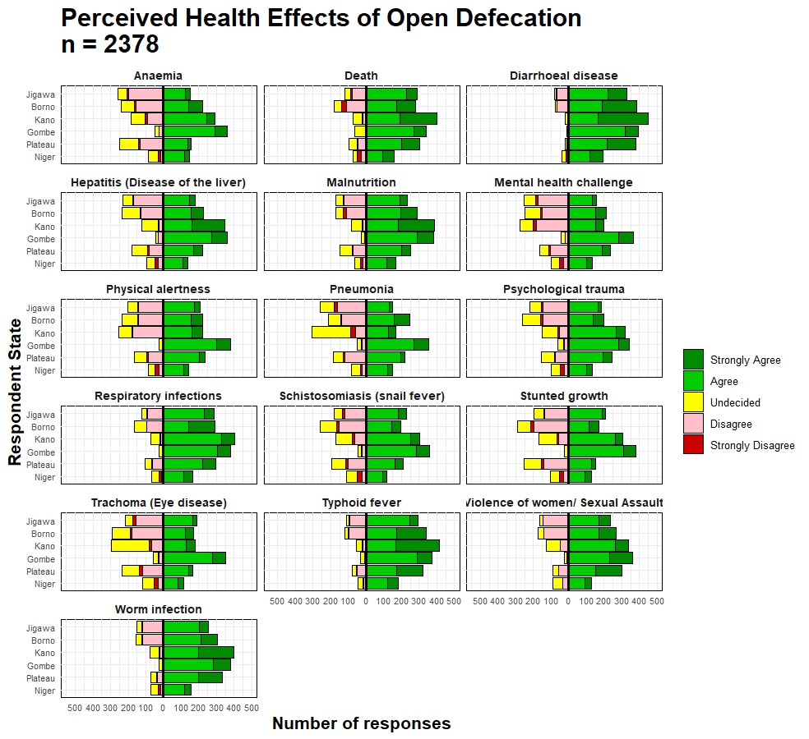

**Figure 3: The distribution of the perceived health effects of open defecation by states**