**RESULTS**

A total of 2378 responses were gotten from the participants out of 2379. Majority of the participants (23%) were within the age 26-33 years, the population was predominantly male (51%) and married (71%). The ethnic distribution of all the participants from the state in this study is as follows: Hausa 48.6%, Bura 9.5%, Kanuri 7.5%, Fulani 5.5%, Rukuba 4.8%, Tangale 2.1%, Nupe 1.7%, Pero 1.7%, Waja 1.7% and other minority ethnic groups. The distribution of the northern states in this study were: Borno 459 (19%), Gombe 406 (17%), Jigawa 407 (17%), Kano 473 (20%), Niger 232 (9.8%) and Plateua 401 (17%). Majority of the participants were in the urban settlements (59%), as the most dominant household size was 1-5. The 3 most common occupation in this study were: farmer (24%), trading (23%) and student (16%). Majority of the participants (29%) earn 30,000 and above, secondary education was reported to be the most common (40%) highest level of education

**SOCIO-DEMOGRAPHIC CHARACTERISTICS**

|  |  |
| --- | --- |
| **Socio-demographic Characteristic** | **N = 2,378** |
| **Age** |  |
| 10 to 17 | 119 (5.0%) |
| 18 to 25 | 379 (16%) |
| 26 to 33 | 543 (23%) |
| 34 to 41 | 522 (22%) |
| 42 to 49 | 392 (16%) |
| 50 to 57 | 237 (10.0%) |
| 58 to 65 | 104 (4.4%) |
| 65 and above | 82 (3.4%) |
| **Gender** |  |
| Female | 973 (41%) |
| Male | 1,405 (59%) |
| **State** |  |
| Borno | 459 (19%) |
| Gombe | 406 (17%) |
| Jigawa | 407 (17%) |
| Kano | 473 (20%) |
| Niger | 232 (9.8%) |
| Plateau | 401 (17%) |
| **Settlemen**t |  |
| Rural | 977 (41%) |
| Urban | 1,401 (59%) |
| **Household Size** |  |
| 1 - 5 | 1,079 (45%) |
| 6 - 10 | 854 (36%) |
| 11 - 15 | 234 (9.8%) |
| 16 and above | 211 (8.9%) |
| **Occupation** |  |
| Artisan | 129 (5.4%) |
| Civil servant | 367 (15%) |
| Farmer | 569 (24%) |
| House Wife | 340 (14%) |
| Nomad | 37 (1.6%) |
| Student | 389 (16%) |
| Traders | 547 (23%) |
| **Average Income/Month** |  |
| Less than 5,000 | 402 (17%) |
| 5,000 to 10,000 | 413 (17%) |
| 10,000 to 20,000 | 416 (17%) |
| 20,000 to 30,000 | 466 (20%) |
| 30,000 and above | 681 (29%) |
| **Highest Level of Education** |  |
| No schooling completed | 424 (18%) |
| Primary education | 345 (15%) |
| Secondary education | 940 (40%) |
| Technical/Vocational training | 263 (11%) |
| Bachelor’s degree | 283 (12%) |
| Master’s/Professional degree | 65 (2.7%) |
| Doctorate degree | 11 (0.5%) |
| Others | 47 (2.0%) |
| **Marital status** |  |
| Divorced | 56 (2.5%) |
| Married | 1,694 (71%) |
| Single | 548 (23%) |
| Widowed | 80 (3.5%) |

|  |  |  |
| --- | --- | --- |
| **Ethnic group** | **N= 2378** | **%** |
| Hausa | 1156 | 48.6 |
| Bura | 225 | 9.5 |
| Kanuri | 178 | 7.5 |
| Fulani | 130 | 5.5 |
| Rukuba | 113 | 4.8 |
| Tangale | 49 | 2.1 |
| Nupe | 41 | 1.7 |
| Pero | 40 | 1.7 |
| Waja | 40 | 1.7 |
| Yoruba | 39 | 1.6 |
| Other | 367 | 15.4 |

**Age-sex distribution of the participants**

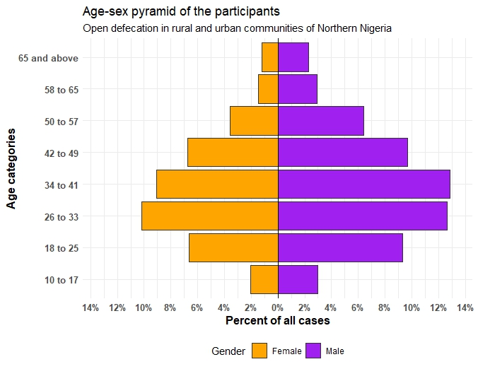

**Geo-spatial mapping on rural and urban communities that practice open defecation in selected States of Northern Nigeria**

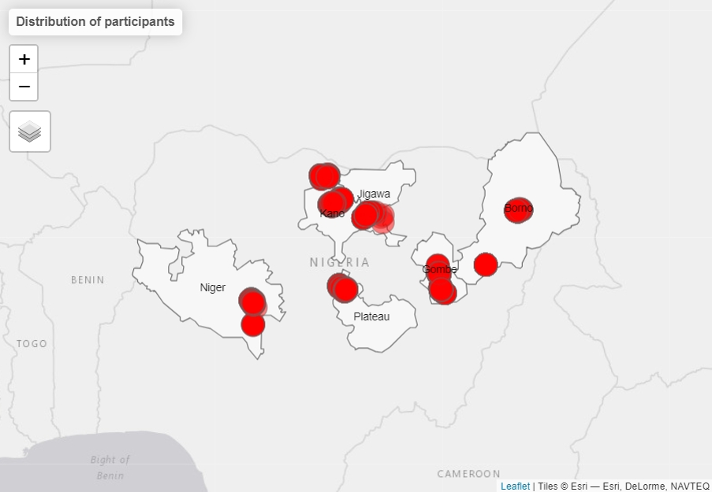

**factors that encourage open defecation in the identified communities**

**The factors that encourage open defecation in the identified communities were assessed, it was observed that the lack of toilet facilities was mostly common in Kano state (23.4%), poor understanding of the effect of open defecation was mostly common in Kano state (22.9%), cul**

**Table 2: factors that encourage open defecation in the identified communities**

|  |  |  |  |  |  |  |  |
| --- | --- | --- | --- | --- | --- | --- | --- |
| **Factors** | **Borno** | **Gombe** | **Jigawa** | **Kano** | **Niger** | **Plateau** | **p-value** |
| Lack of toilet facilities |  |  |  |  |  |  | **<0.001** |
| Yes | 264 (15.7) | 309 (18.4) | 347 (20.7) | 392 (23.4) | 126 (7.5) | 240 (14.3) |  |
| No | 195 (27.9) | 97 (13.9) | 60 (8.6) | 81 (11.6) | 106 (15.1) | 161 (23.0) |  |
| Poor understanding of effect of open defecation |  |  |  |  |  |  | **<0.001** |
| Yes | 265 (15.2) | 326 (18.7) | 347 (19.9) | 399 (22.9) | 184 (10.6) | 222 (12.7) |  |
| No | 194 (30.6) | 80 (12.6) | 60 (9.4) | 74 (11.7) | 48 (7.6) | 179 (28,2) |  |
| Cultural practice |  |  |  |  |  |  | **<0.001** |
| Yes | 58 (6.3) | 260 (28.3) | 225 (24.5) | 292 (31.8) | 57 (6.2) | 26 (2.8) |  |
| No | 401 (27.5) | 146 (10.0) | 182 (12.5) | 181 (12.4) | 175 (12.0) | 375 (25.7) |  |
| Religious practice |  |  |  |  |  |  | **<0.001** |
| Yes | 111 (13.5) | 249 (30.3) | 163 (19.8) | 268 (32.6) | 25 (3.0) | 7 (0.9) |  |
| No | 348 (22.4) | 157 (10.1) | 244 (15.7) | 205 (13.2) | 207 (13.3) | 394 (25.3) |  |
| Nonchalant attitude |  |  |  |  |  |  | **<0.001** |
| Yes | 191 (12.5) | 305 (20.0) | 264 (17.3) | 338 (22.1) | 181 (11.8) | 249 (16.3) |  |
| No | 268 (31.5) | 101 (11.9) | 143 (16.8) | 135 (15.9) | 51(6.0) | 152(17.9) |  |
| Peer group pressure |  |  |  |  |  |  | **<0.001** |
| Yes | 161(13.1) | 294(23.9) | 197(16.0) | 330(26.8) | 95(7.7) | 155(12.6) |  |
| No | 298(26.0) | 112(9.8) | 210(18.3) | 143(12.5) | 137(12.0) | 246(21.5) |  |
| taboo attach to the use of toilet |  |  |  |  |  |  | **<0.001** |
| Yes | 90(12.8) | 263(37.4) | 218(31.0) | 117(16.6) | 10(1.4) | 5(0.7) |  |
| No | 369(22.0) | 143(8.5) | 189(11.3) | 356(21.3) | 222(13.3) | 396(23.6) |  |

**perceived health effects of open defecation among community members**

**perceived health effects of open defecation among community members**

|  |  |  |  |  |  |
| --- | --- | --- | --- | --- | --- |
| **Variables** | **SD%** | **D%** | **U%** | **A%** | **SA%** |
| Diarrhoeal disease | 0.5 | 6.7 | 3.1 | 51.9 | 37.8 |
| Death | 2.9 | 12.0 | 10.6 | 48.7 | 25.8 |
| Malnutrition | 1.6 | 15.1 | 11.3 | 49.4 | 22.6 |
| Respiratory infections | 1.1 | 12.0 | 10.2 | 56.1 | 12.0 |
| Worm infection | 1.2 | 13.2 | 8.8 | 50.9 | 25.9 |
| **Typhoid fever** | 0.7 | 11.9 | 6.2 | 49.2 | 31.9 |
| **Hepatitis** | 2.1 | 19.5 | 16.6 | 42.8 | 19.0 |
| **Trachoma** | 3.4 | 24.3 | 23.4 | 38.6 | 10.3 |
| **Schistosomiasis** | 3.6 | 20.6 | 16.4 | 47.0 | 12.4 |
| **Violence of women/ Sexual Assault** | 3.0 | 18.3 | 9.8 | 45.5 | 18.3 |
| **Psychological trauma** | 2.8 | 19.7 | 17.5 | 48.2 | 19.7 |
| **Stunted growth** | 3.1 | 23.8 | 16.5 | 46.3 | 10.3 |
| **Mental health challenge** | 2.9 | 27.8 | 14.7 | 42.2 | 12.4 |
| **Physical alertness** | 1.8 | 24.1 | 14.9 | 46.7 | 12.5 |
| **Pneumonia** | 3.0 | 22.2 | 20.8 | 42.2 | 11.8 |
| **Anaemia** | 2.1 | 26.1 | 16.3 | 44.8 | 10.8 |

