**CHAPTER FOUR**

**RESULT**

4**.1 SOCIODEMOGRAPHIC CHARACTERISTICS OF THE PARTICIPANTS**

In this study, most of the participants (48%) were within the 19-22 years’ category, more than half were male (53%), the majority of them (44%) were 300 level year of study, single (95%). Most of the participants were in the Natural and Applied science (46%), as most of the parent/guardian’s level of education had tertiary education (76%).

Table 4.1 Sociodemographic characteristics of the participants

| **Sociodemographic Characteristic** | **\*\*N = 422\*\*** |
| --- | --- |
| **Age category** |  |
| 15-18years | 39 (9.2%) |
| 19-22years | 203 (48%) |
| 23-25years | 154 (36%) |
| Above 25years | 26 (6.2%) |
| **Gender** |  |
| Female | 198 (47%) |
| Male | 224 (53%) |
| **Year of study level** |  |
| 200 level | 61 (14%) |
| 300 level | 187 (44%) |
| 400 level | 174 (41%) |
| **Marital status** |  |
| Single | 401 (95%) |
| Married | 20 (4.7%) |
| Cohabiting | 1 (0.3%) |
| **Parents guardians level of education** |  |
| Primary | 60 (14%) |
| Secondary | 43 (10%) |
| Tertiary | 319 (76%) |

Figure 4.1 Faculty of the participants in this study

**4.2 PREVALENCE OF HBV IN THIS STUDY**

In this study, the prevalence of HBV was 8.1%, the faculty with the highest prevalence of HBV was the Natural and applied Sciences 58.8%.

Table 4.2 Prevalence of HBV in this study

| HBV Status | n | percent | Total |
| --- | --- | --- | --- |
| NEGATIVE | 388 (0.9) | 91.9% | 388 (91.9%) |
| POSITIVE | 34 (0.1) | 8.1% | 34 (8.1%) |

Figure 4.2a Prevalence of HBV in this study

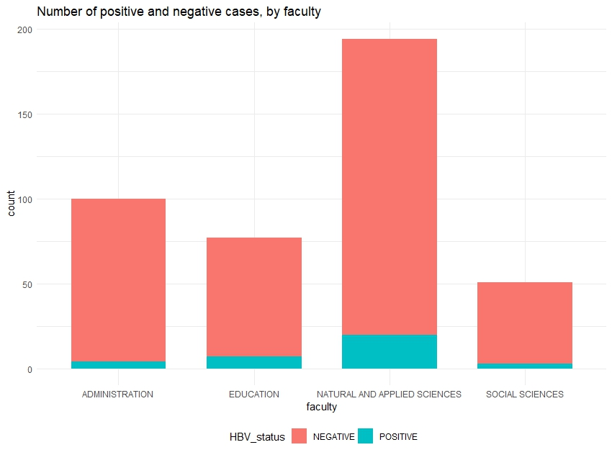

**4.3 KNOWLEDGE OF HBV IN THIS STUDY**

Most of the participants (77%) claimed they had heard HBV infection before this study, many of the participants (61.2%) did not know what causes HBV. Figure 4.3 presents a combination analysis of the multiple sources of information from the participants, where the seven most common sources of information is as follows: family/ friend 89 (21.1%), health professionals 77 (18.2%), school/university 76 (18.1%), other 39 (9.2%), Media TV/radio 33 (7.8%), school/university + health professional + family/ friend 3(0.7%), Media + school/university + health professional + family/ friend 3(0.7%). As regards the symptoms of HBV, most of them claimed that they did not know if they can have HBV and not be aware of it (49%), have it for years without symptoms (63%). Majority (53.2%) claimed they did not know if there is a cure for HBV while more than half (51%) claimed that HBV can be prevented by a vaccine. An overall knowledge score was calculated by scoring 1 for each correct response in this section, the scores were presented in percentage for each participants and graded into good (score = >50%) and poor (score = <49%). Therefore, the overall knowledge was Good (47.4%) and Poor (52.6%).

Table 4.3 Knowledge of HBV in this study

| Variable | N = 422 |
| --- | --- |
| Have you ever heard about HBV infection before this survey |  |
| Yes | 326 (77%) |
| No | 96 (23%) |
| What causes HBV |  |
| Bacteria | 23 (5.5%) |
| Virus | 135 (32%) |
| Fungus | 4 (0.9%) |
| I dont know | 260 (61.2%) |
| Can i have HBV and not be aware of it |  |
| Yes | 197 (47%) |
| No | 19 (4.5%) |
| I dont know | 205 (49%) |
| Unknown | 1 |
| Can i have HBV for years without symptoms |  |
| Yes | 95 (23%) |
| No | 58 (14%) |
| I dont know | 28 (63%) |
| 33 | 1 (0.2%) |
| Unknown | 1 |
| Is there a cure for HBV |  |
| Yes | 160 (38%) |
| No | 38 (9.0%) |
| I dont know | 224 (53.2%) |
| Can HBV be prevented by a vaccine |  |
| Yes | 215 (51%) |
| No | 6 (1.4%) |
| I dont know | 201 (47.2%) |
| Overall Knowledge |  |
| Good | 200 (47.4) |
| Poor | 222 (52.6) |

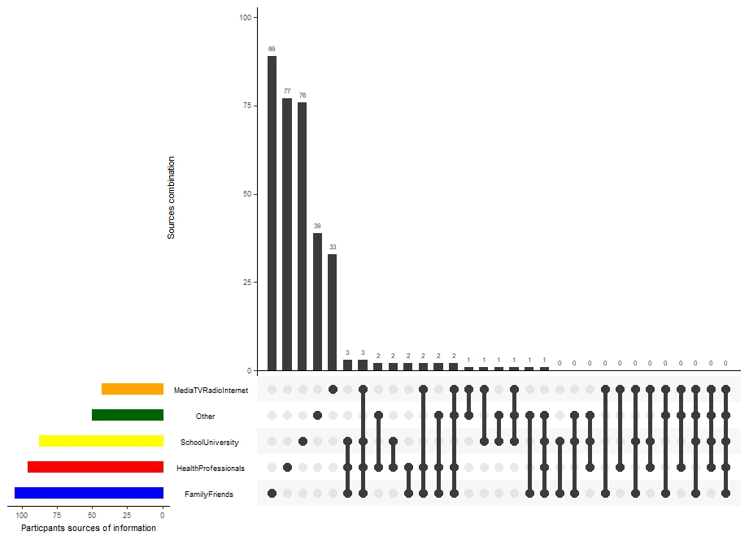

Figure 4.3 Combination analysis showing the multiple sources of information of the participants

**4.4 PRACTICE REGARDING HBV**

Few of the participants (21%) claimed they had been tested for HBV, majority of them (60%) were tested over 1 year ago. Most of them (77%) would go for further investigation and treatment if they are diagnosed with HBV, very few of them claimed they have been vaccinated (8.5%), majority of those vaccinated (39%) took one dose of the vaccine. Most of them claimed they had never engaged in the following activities: Use shared needles or syringes (70%), Tattoos or piercings from unlicensed facilities (88%), Share personal items e.g (razors toothbrushes) (64%), Unprotected sexual intercourse (66%). Most of them (32%) rated their knowledge about HBV fair. Most of them (83%) claimed that HBV awareness programs are necessary in Universities. Figure 4.4a presents a combination analysis of the multiple reasons why participants are not testing for HBV, the seven most common reasons are as follows: lack of information 110 (26.1%), not considered necessary 72 (17.1%), don’t know 44 (10.4%), lack of time 39 (9.2%), insufficient money 19 (4.5%), not considered necessary + lack of information 7 (1.7%), not considered necessary + lack of time 5 (1.2%). Figure 4.4b presents a combination analysis of the multiple reasons why participants are not vaccinated, the seven most common reasons are as follows: unaware of the vaccine 126 (29.9%), don’t know 69 (16.4%), not considered necessary 64 (15.2%), insufficient money 24 (5.7%), not considered necessary + unaware of the vaccine 17 (4.0%), fear of needles 11 (2.6%), fear of side effects 8(1.9%). An overall practice score was calculated by scoring 1 for each correct response in this section, the scores were presented in percentage for each participants and graded into good (score = >50%) and poor (score = <49%). Therefore, the overall practice was Good (67.5%) and Poor (32.5%).

Table 4.4 Practice regarding HBV

| Variable | **n = 422** |
| --- | --- |
| Have you ever been tested for HBV (Yes) | 89 (21%) |
| If yes when was your last test |  |
| < 6 months ago | 19 (21%) |
| 6months - 1 year ago | 18 (20%) |
| > 1 year ago | 55 (60%) |
| If you are diagnosed with HBV would you go for further investigation and treatment (Yes) | 323 (77%) |
| Have you been vaccinated against HBV (Yes) | 36 (8.5%) |
| If yes how many doses |  |
| One | 14 (39%) |
| Two | 12 (33%) |
| Three | 1 (28%) |
| Use shared needles or syringes |  |
| Never | 295 (70%) |
| Rarely | 67 (16%) |
| Sometimes | 52 (12%) |
| Often | 6 (1.4%) |
| Always | 2 (0.5%) |
| Tattoos or piercings from unlicensed facilities |  |
| Never | 372 (88%) |
| Rarely | 33 (7.8%) |
| Sometimes | 15 (3.6%) |
| Always | 1 (0.2%) |
| Share personal items e.g (razors toothbrushes) |  |
| Never | 270 (64%) |
| Rarely | 75 (18%) |
| Sometimes | 64 (15%) |
| Often | 8 (1.9%) |
| Always | 5 (1.2%) |
| Unprotected sexual intercourse |  |
| Never | 278 (66%) |
| Rarely | 54 (13%) |
| Sometimes | 69 (16%) |
| Often | 12 (2.8%) |
| Always | 9 (2.1%) |
| How would you rate your knowledge about HBV |  |
| Very poor | 66 (16%) |
| Poor | 102 (24%) |
| Fair | 137 (32%) |
| Good | 88 (21%) |
| Excellent | 29 (6.9%) |
| Do you think HBV awareness programs are necessary in universities? (Yes) | 352 (83%) |
| Overall Practice |  |
| Good | 285 (67.5) |
| Poor | 137 (32.5) |

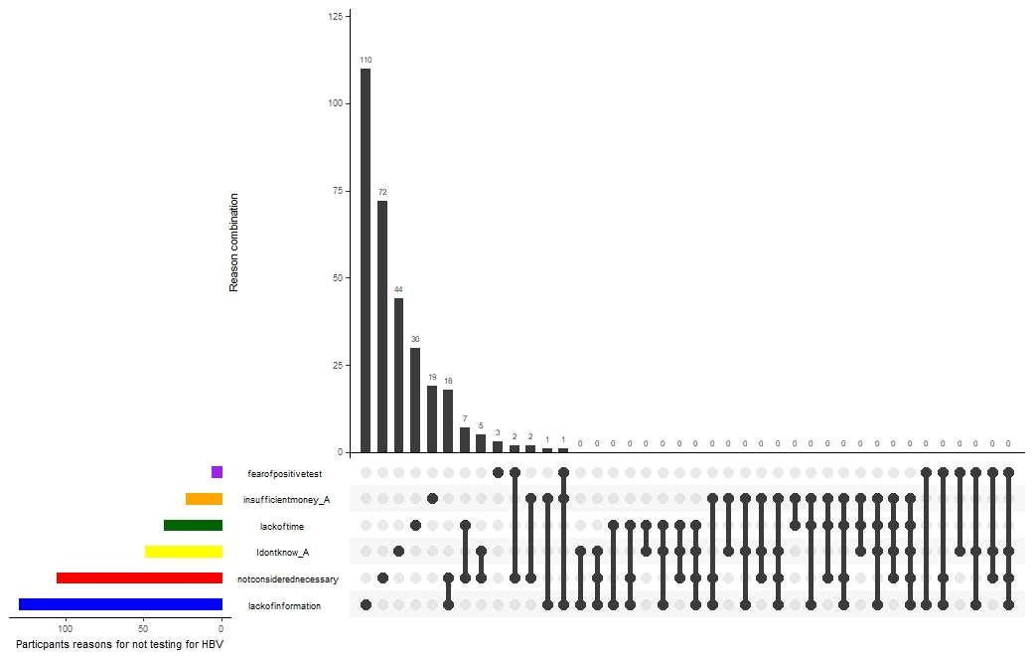

Figure 4.4a Combination analysis showing the multiple reasons why participants are not testing for HBV

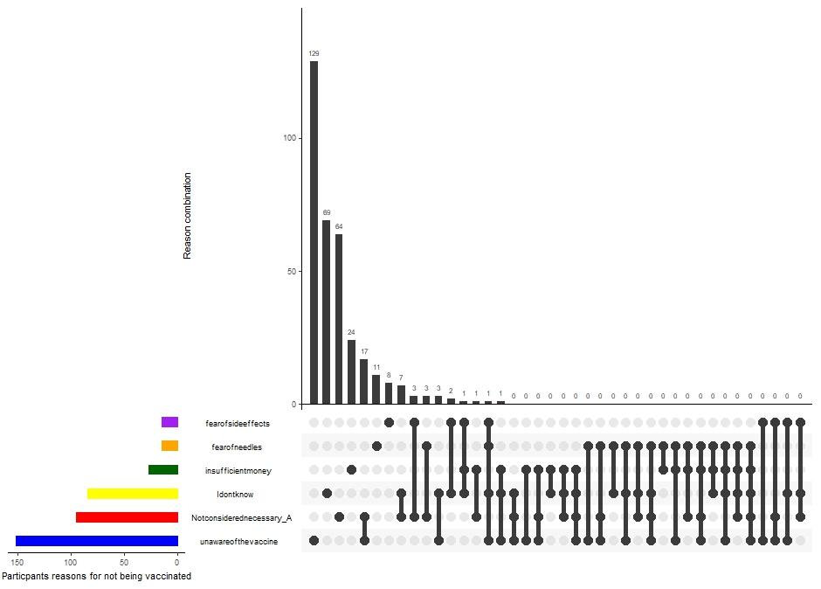

Figure 4.4b Combination analysis showing the multiple reasons why participants are not being vaccinated for HBV

**4.5 ASSOCIATION BETWEEN SOCIODEMOGRAPHIC FACTORS, PREVALENCE, KNOWLEDGE AND PRACTICE**

The association between different variables were conducted using the Chi-square bivariate analysis and multivariate regression analysis, while assuming statistical significance at P-value < 0.05. There were significant association of prevalence of HBV with gender (chi-square = 8.123, P-value = 0.004, OR female = 0.321, male = 1 (reference)), this means that the female category were 0.3 times less likely to have HBV in this study.

There were significant association of knowledge of HBV and year of study (chi-square = 10.05, p-value = 0.018, OR 200 level = 2.524, OR 300 level = 1.697, 400 level = 1 (reference)), the odd ratio and likelihood of having a poor knowledge of HBV was highest for 200 level student, they were 2.5 times likely to have poor knowledge as compared to 400 level.

Table 4.5.1 Sociodemographic characteristics of the participants vs prevalence of HBV

| Sociodemographic Characteristic | Negative | Positive | Chi-square | P-value |
| --- | --- | --- | --- | --- |
| **Age category** |  |  | 1.913 | 0.591 |
| 15-18years | 36 (92.3%) | 3 (7.7%) |  |  |
| 19-22years | 183 (90.1%) | 20 (9.9%) |  |  |
| 23-25years | 145 (94.2%) | 9 (5.8) |  |  |
| Above 25years | 24 (92.3%) | 2 (7.7%) |  |  |
| **Gender** |  |  | 8.123 | 0.004* |
| Female | 190 (96.0%) | 8 (4.0%) |  |  |
| Male | 198 (88.4) | 26 (11.6%) |  |  |
| **Year of study level** |  |  | 2.585 | 0.460 |
| 200 level | 59 (96.7%) | 2 (3.3%) |  |  |
| 300 level | 169 (90.4%) | 18 (9.6%) |  |  |
| 400 level | 160 (92%) | 14 (8%) |  |  |
| **Faculty of study** |  |  | 3.987 | 0.263 |
| Administration | 96 (96.0%) | 4 (4.0%) |  |  |
| Education | 70 (90.9) | 7 (9.1%) |  |  |
| Natural and applied science | 174 (89.7%) | 20 (10.3%) |  |  |
| Social sciences | 48 (94.1%) | 3 (5.9%) |  |  |
| **Marital status** |  |  | 0.356 | 0.837 |
| Single | 368 (91.8%) | 33 (8.2%) |  |  |
| Married | 19 (95.0%) | 1 (5.0%) |  |  |
| Cohabiting | 1 (100%) | 0 |  |  |
| **Parents guardians level of education** |  |  | 1.502 | 0.472 |
| Primary | 57 (95.0%) | 3 (5.0%) |  |  |
| Secondary | 38 (88.4%) | 5 (11.6%) |  |  |
| Tertiary | 293 (91.8%) | 26 (8.2%) |  |  |

Table 4.5.2 Bivariate analysis of Sociodemographic characteristics vs knowledge

| Sociodemographic Characteristic | Good | Poor | Chi-square | P-value |
| --- | --- | --- | --- | --- |
| **Age category** |  |  | 2.288 | 0.515 |
| 15-18years | 17 (43.6%) | 22 (56.4%) |  |  |
| 19-22years | 91 (44.8%) | 112 (55%) |  |  |
| 23-25years | 77 (50%) | 77 (50%) |  |  |
| Above 25years | 15 (57.7%) | 11 (42.3%) |  |  |
| **Gender** |  |  | 0.051 | 0.821 |
| Female | 95 (48.0%) | 103 (52%) |  |  |
| Male | 105 (46.9) | 119(53.1%) |  |  |
| **Year of study level** |  |  | 10.05 | 0.018* |
| 200 level | 21 (34.4%) | 40 (65.6%) |  |  |
| 300 level | 82 (43.9%) | 105(56.1%) |  |  |
| 400 level | 97 (55.7%) | 77 (44.3%) |  |  |
| **Faculty of study** |  |  | 1.942 | 0.584 |
| Administration | 42 (42.0%) | 58 (58.0%) |  |  |
| Education | 39 (50.6) | 38 (49.4%) |  |  |
| Natural and applied science | 96 (45.1%) | 98 (50.5%) |  |  |
| Social sciences | 23 (45.1%) | 28 (54.9%) |  |  |
| **Marital status** |  |  | 0.955 | 0.620 |
| Single | 190 (47.4%) | 211(52.6%) |  |  |
| Married | 10 (50.0%) | 10 (50.0%) |  |  |
| Cohabiting | 0 | 1 (100%) |  |  |
| **Parents guardians level of education** |  |  | 4.851 | 0.088 |
| Primary | 21 (35.0%) | 39 (65.0%) |  |  |
| Secondary | 19 (44.2%) | 24 (55.8%) |  |  |
| Tertiary | 160 (50.2%) | 159(49.8%) |  |  |

Table 4.5.3 Bivariate analysis of Sociodemographic characteristics vs practice regarding HBV

| Sociodemographic Characteristic | Good | Poor | Chi-square | P-value |
| --- | --- | --- | --- | --- |
| **Age category** |  |  | 5.668 | 0.129 |
| 15-18years | 29 (74.4%) | 10 (25.6%) |  |  |
| 19-22years | 127 (62.6%) | 76 (37.4%) |  |  |
| 23-25years | 108 (70.1%) | 46 (29.9%) |  |  |
| Above 25years | 21 (80.8%) | 5 (19.2%) |  |  |
| **Gender** |  |  | 0.226 | 0.635 |
| Female | 136 (68.7%) | 62 (31.3%) |  |  |
| Male | 149 (66.5) | 75(33.5%) |  |  |
| **Year of study level** |  |  | 0.772 | 0.856 |
| 200 level | 40 (65.6%) | 21 (34.4%) |  |  |
| 300 level | 126 (67.4%) | 61(32.6%) |  |  |
| 400 level | 119 (68.5%) | 55 (31.6%) |  |  |
| **Faculty of study** |  |  | 1.690 | 0.639 |
| Administration | 71 (71.0%) | 29 (29.0%) |  |  |
| Education | 51 (66.2) | 26 (33.8%) |  |  |
| Natural and applied science | 132 (68.0%) | 62 (32.0%) |  |  |
| Social sciences | 31 (60.8%) | 20 (39.2%) |  |  |
| **Marital status** |  |  | 0.544 | 0.762 |
| Single | 270 (67.3%) | 131(32.7%) |  |  |
| Married | 14 (70.0%) | 6 (30.0%) |  |  |
| Cohabiting | 1 (100%) | 0 |  |  |
| **Parents guardians level of education** |  |  | 1.385 | 0.500 |
| Primary | 37 (61.7%) | 23 (38.3%) |  |  |
| Secondary | 31 (72.1%) | 12 (27.9%) |  |  |
| Tertiary | 217 (68.0%) | 102(32.0%) |  |  |

Table 4.5.4 Bivariate analysis of Sociodemographic characteristics vs knowledge

| Variables | Negative | Positive | Chi-square | P-value |
| --- | --- | --- | --- | --- |
| **Knowledge** |  |  | 0.101 | 0.751 |
| Good | 183 (91.5%) | 17 (8.5%) |  |  |
| Poor | 205 (92.3%) | 17 (7.5%) |  |  |
| **Practice** |  |  | 1.347 | 0.246 |
| Good | 259 (90.9%) | 26 (9.1%) |  |  |
| Poor | 129 (94.2) | 8(5.8%) |  |  |

Table 4.5.4 Multivariate analysis of Sociodemographic characteristics vs knowledge

| Variables | Odd Ratio | P-value | 95% CI |
| --- | --- | --- | --- |
| **Gender vs prevalence** |  |  |  |
| Female | 0.321 | 0.006* | 0.142-0726 |
| male | 1 (reference) |  |  |
| **Year of study vs Poor knowledge** |  |  |  |
| 200 level | 2.524 | 0.007* | 1.293-4.927 |
| 300 level | 1.697 | 0.039* | 1.027-2.803 |
| 400 level | 1 (reference) |  |  |

**CHAPTER FIVE**

**DISCUSSION, CONCLUSION AND RECOMMENDATION**

**5.1 DISCUSSION**

In terms of socio-demographic characteristics, this study included a diverse group of university students, with the majority being male (53%), within the age range of 19-22 years (48%) and were single (95%). The modal age group in this study being 19-22 years indicates that they students were mostly late teens and young adults. The female dominance and marital staus in this study corresponds to the study of Agbesanwa et al., (2023), Okwori et al. (2022) and Al-Shamiri et al., (2018). Most participants were in the Natural and Applied Sciences faculty (46%) The study also considered the educational level of the participants' parents/guardians, with the majority having attained tertiary education (76%). These socio-demographic factors provide valuable insights into the characteristics of the study population and can help inform the development of tailored interventions.

The prevalence of HBV (8.1%) in this study aligns with previous reports indicating a high prevalence of HBV in Nigeria. Nigeria carries a substantial portion (8.3%) of the global burden of chronic HBV infections (FMOH, 2016). In some study, the prevalence was as low as 6.1% in Abeokuta (Okonko et al., 2010) whereas, in the study of Olasinde et al. (2022), a prevalence of 0.8% for males and 1.8% for females in six secondary schools and a prevalence of 1.0% for children was reported in Calabar. The average prevalence rate for HBV in Nigeria ranges between 11% and 13.7%, with an estimated 20 million people chronically infected (FMOH, 2018). More recent estimates suggest that approximately 22.6 million Nigerians are infected with HBV, which translates to about 1 in every 12 people (FMOH, 2018). This high prevalence places Nigeria in the hyper-endemic region for HBV infection, indicating a severe public health concern. The prevalence in this study is slightly lower than the 9.5% prevalence found in a study some non-medical undergraduate student, Ekiti state (Elegbede et al., 2022). The variation in prevalence across these studies could be attributed to differences in the study populations and their risk factors. For instance, the study on sexually active young people focused on a specific group with potential high-risk behaviors, while the study on medical students involved a population with possible occupational exposure to the virus. Notably, the higher prevalence of HBV in the Natural and Applied Sciences faculty (58.8%) compared to the overall prevalence (8.1%) in this study is a key finding. This observation may be due to the students in this faculty having more potential exposure to blood and bodily fluids during their academic and research activities, highlighting the need for targeted interventions within specific faculties to address the disproportionate burden of HBV. This difference in prevalence across faculties emphasizes the importance of considering specific risk factors within different academic disciplines when designing prevention and intervention strategies.

The significant knowledge gap regarding HBV observed in this study is a critical concern. A majority of the participants (61.2%) were unaware of the cause of HBV, indicating a need for educational initiatives to improve understanding of the virus and its transmission. This finding is consistent with other studies that have reported low levels of knowledge and awareness about HBV among various populations 70.9% poor knowledge prevalence in Agbesanwa et al. (2023). For instance, a study conducted in Jigawa State, Nigeria, also found a low level of knowledge about HBV infection among the general population (64.9%), despite half of the respondents having attained a higher level of education (Yakudima et al., 2022). This suggests that the public education system may not be giving adequate attention to health issues, particularly infectious diseases.The importance of educational interventions in improving knowledge and awareness of HBV is highlighted by several studies. A study conducted among dental students in Saudi Arabia revealed that continued education about HBV is necessary to improve knowledge, attitudes, and practices regarding the virus (Al-shamiri et al., 2018). Another study emphasized the need for health education to be offered to undergraduates to increase the uptake of the hepatitis B vaccine (Olaoye et al., 2024). These findings underscore the importance of implementing targeted educational programs in university settings to address the knowledge gap and promote healthy behaviors related to HBV.

In alignment with the poor knowledge of HBV in this study, there practice as regard HBV vaccination was very poor as only 8.5% had taken the vaccine with majority taking only a single dose, this is lower than the 10.3% practice of vaccination among student of the University of Abuja (Okwori et al., 2022)

Interestingly, there was a significant association between the year of study and knowledge of HBV, with 200-level students being 2.5 times more likely to have poor knowledge compared to 400-level students. This suggests that knowledge of HBV may increase with progression through university, possibly due to greater exposure to health-related information or educational programs. This finding aligns with a study conducted among dental students in Saudi Arabia, which revealed that final-year students were significantly more knowledgeable about HBV than interns (Al-shamiri). The study suggests that integrating interactive approaches like peer education into school curriculums can effectively influence positive change in adolescents' preventive practices. The association between the year of study and knowledge of HBV has important implications for the design and implementation of educational interventions. It suggests that targeting younger students with early and accurate information about HBV can help establish a foundation of knowledge that can guide healthy behaviors and reduce the risk of transmission.

**5.2 CONCLUSION**

The World Health Organization (WHO) categorizes countries into three groups based on how common chronic Hepatitis B Virus (HBV) infection is in their general population. These groups are determined by looking at the results of surveys that measure the presence of HBV in the population, these are: **High Endemicity,** in these countries, 8% or more of the general population has a chronic HBV infection**; Intermediate Endemicity**, these countries have a chronic HBV infection prevalence between 2% and 7% in their general population**; Low Endemicity, t**hese countries have a chronic HBV infection prevalence of less than 2% in their general population (Omatola et al., 2020). Vaccination remains a cornerstone of HBV prevention, and this study's findings reinforce the need to promote and improve access to vaccination services. Despite the availability of safe and effective vaccines, vaccination rates remain suboptimal in many regions, including Nigeria. Research conducted among clinical medical students in Southeast Nigeria revealed that only a small percentage had received the complete three doses of the hepatitis B vaccine (Eze et al., 2020). This highlights the need to strengthen vaccination programs and address barriers to vaccine uptake, such as cost, access, and awareness.

The significant knowledge gap regarding HBV identified in this study aligns with observations from numerous other studies conducted across different populations and regions. This recurring theme highlights a critical need for comprehensive and targeted educational interventions to address misconceptions, improve understanding, and ultimately curb the spread of HBV. Several studies have emphasized the importance of education in HBV prevention and control. For instance, research among healthcare workers in Sokoto, Nigeria, revealed that a considerable proportion had poor knowledge of HBV, highlighting the necessity for continuing education programs to enhance their understanding and practices (Hassan et al., 2016). Similarly, a study among dental students in Saudi Arabia underscored the importance of continued education about HBV to improve knowledge, attitudes, and practices regarding the virus (Al-shamiri et al., 2018).

These findings collectively point towards a need for sustained efforts to integrate HBV education into various settings, including schools, universities, and healthcare facilities. Such initiatives should aim to dispel myths, provide accurate information about transmission and prevention, and encourage healthy behaviors to reduce the risk of infection.

**5.3 RECOMMENDATION**

Based on the convergence of evidence from this study and others, several key recommendations emerge for public health interventions:

1. **Targeted Educational Programs:** Develop and implement educational programs tailored to specific populations, such as university students, healthcare workers, and the general public, to improve knowledge and awareness of HBV.
2. **Increased Access to Testing**: Collaborate with student health services and community health organizations to organize on-campus HBV testing and vaccination clinics
3. **Increased Access to Vaccination:** Strengthen vaccination programs and improve access to HBV vaccines, particularly for high-risk groups and in underserved areas.
4. **Advocacy Programmes:** Advocate for policies that support HBV prevention efforts, such as mandatory vaccination for incoming students or the integration of HBV education into the curriculum
5. **Community Engagement and Awareness Campaigns:** Utilize diverse channels, including mass media, social media, and community outreach programs, to raise awareness about HBV and promote healthy behaviors.
6. **Further Research:** Conduct further research to explore the underlying factors contributing to the prevalence of HBV and identify effective strategies for prevention and control.

**REFERENCES**

Agbesanwa, T. A., Aina, F. O., & Ibrahim, A. O. (2023). Knowledge and awareness of Hepatitis B infection among young adults in Ekiti, Nigeria: Implications for education and vaccination. *Cureus*, *15*(12).

Al-Shamiri, H. M., AlShalawi, F. E., AlJumah, T. M., AlHarthi, M. M., AlAli, E. M., & AlHarthi, H. M. (2018). Knowledge, attitude and practice of hepatitis B virus infection among dental students and interns in Saudi Arabia. *Journal of clinical and experimental dentistry*, *10*(1), e54.

Elegbede, O. E., Alabi, A. K., Alao, T. A., & Sanni, T. A. (2022). Knowledge and associated factors for the uptake of hepatitis B vaccine among nonmedical undergraduate students in a private university in Ekiti State, Nigeria.

Eze NC, Egba EC, Ogbonna JE, Nwamini SN, Nweke PU, Amasianya JS. Knowledge, attitude and uptake of Hepatitis B vaccine among Clinical Medical students of a tertiary institution in Southeast, Nigeria. Asian J Immunol 2020;4:31-6

Federal Ministry of Health (2016) *National guidelines for the prevention, treatment and care of viral hepatitis B and C in Nigeria*. Federal Ministry of Health Abuja, Nigeria

Federal Ministry of Health, (2018). *Federal Government commits to elimination viral hepatitis in Nigeria.* Retrieved from www.health.gov.ng/.../571-fg-commits-to-elemination-of-viral-hepatitis

Hassan M, Awosan KJ, Nasir S, Tunau K, Burodo A, Yakubu A, Oche MO. Knowledge, risk perception and hepatitis B vaccination status of healthcare workers in Usmanu Danfodiyo University Teaching Hospital, Sokoto, Nigeria. J Pub Heal Epidemiol. 2016;8(4):53-9.

*Nigeria*

Okonko F, Alli J, Ojezele M, Udeze A, Nwanze J, Adewale O et al. Seroprevalence of Hbsag Antigenaemia among Patients in Abeokuta, South Western Nigeria. Glob. J. Med. Res, 2010; 10 (2), 40–49

Okwori, J. E., Yalma, R. M., Egenti, B. N., & Nwankwo, B. B. An Assessment of the Practice of Hepatitis B Infection and Vaccination among Undergraduate Students of the University of Abuja.

Olaoye, T., Osie-Efietie, B., Ogunsanmi, O. O., Mustapha, A. M., Asekun-Olarinmoye, I., & Atulomah, N. O. (2024). Evaluation of a school-based health education program on hepatitis B virus infection prevention practice in rural South-Western, Nigeria. *BMC Public Health*, *24*(1), 591.

Olasinde YT, Odeyemi AO, Abolarin A, Agelebe E, Olufemi-Aworinde KJ, Akande J, Idowu O, Alao M, Kofoworade OO, Owolabi J, Gbadero D. Prevalence of hepatitis B virus infection among children attending the outpatient clinic of a tertiary health centre in Southwest Nigeria. Pan Afr Med J. 2022;43:153

Omatola, O.A.; Onoja, B.A. and Agama, J. (2020) Detection of hepatitis B surface antigen

among febrile patients in Ankpa, Kogi State, Nigeria. *Journal of Tropical Medicine* , volume 2020, article ID 5136785,

Yakudima II, Magaji Y, Abdulkarim IA,. (2022).Knowledge, Attitude and Practice Towards Hepatitis B Infection of People in Part of Jigawa State, Nigeria. *Dutse Journal of pure and applied sciences volume 8.No.1a*. DOI: [10.4314/dujopas.v8i1a.13](https://doi.org/10.4314/dujopas.v8i1a.13)