**CHAPTER FOUR**

**RESULTS**

**4.1 The Sociodemographic Characteristics and Clinical History of the Participants**

This study reported the mean age to be 50 ±10.9 years, where the minimum and maximum age of the participants were 21years and 77years respectively, the age-sex pyramid revealed a young adult population, see Figure 4.1. The 40-49years age group was the most dominant (30%) age group as majority of the participants were female (71%), more than half of them (59%) were married. Majority of the participants resided in Lagos (87.5%) as most of the participants claimed there were Yoruba (59%). Most of them practiced Christianity (70%), most of them attained secondary education (43%), while about half (51%) were employed.

The socio-economic status of the majority of the participants is as follows: Average monthly income was #51,409, middle income earners (53%) and they mostly finance their healthcare through other unpopular sources (60%).

The medical history revealed that majority of them (55%) had known their status for more than 10 years, majority of them (37%) claimed they may have been infected through blood product, majority (55%) had been on ART for more than 10 years. A number of them (10%) claimed they are experiencing adverse effects of their ART drugs, while few of them (3.4%) claimed they have other chronic medical conditions. Most of them (95%) were in the WHO HIV Stage 1 clinical staging. The average viral load after 6 months of ART was 70.5 copies/mL as their average present viral load was 32.5 copies/mL.

Table 4.1a The Sociodemographic Characteristics of the Participants

| **Characteristic** | **N = 319** |
| --- | --- |
| **Age, mean**±**SD (min, max)** | 50 ±10.9 (21, 77) |
| **Age group** |  |
| 20-29 years | 11 (3.7%) |
| 30-39 years | 40 (13%) |
| 40-49 years | 87 (29%) |
| 50-59 years | 90 (30%) |
| 60-69 years | 66 (23%) |
| 70-79 years | 4 (1.3%) |
| **Sex** |  |
| Female | 228 (71%) |
| Male | 91 (29%) |
| **Residence** |  |
| Lagos | 274 (87.5%) |
| Outside Lagos | 39 (12.5%) |
| **Marital status** |  |
| Divorced | 11 (3.1%) |
| Married | 187 (59%) |
| Separated | 9 (2.6%) |
| Single | 70 (22%) |
| Widowed | 41 (13%) |
| **Ethnicity** |  |
| Hausa | 10 (4%) |
| Igbo | 57 (18%) |
| Others | 61 (19%) |
| Yoruba | 186 (59%) |
| **Religion** |  |
| Atheist | 12 (3.8%) |
| Christianity | 224 (70%) |
| Islam | 82 (26%) |
| Traditional | 1 (0.2%) |
| **Educational** |  |
| Informal | 6 (2%) |
| Primary | 76 (24%) |
| Secondary | 137 (43%) |
| Tertiary | 100 (31%) |
| **Employment** |  |
| Employed | 154 (51%) |
| Unemployed | 147 (49%) |
| **Source of finance** |  |
| Family contributions | 31 (10%) |
| Others | 184 (60%) |
| pension | 25 (8.5%) |
| Profits from investment | 53 (17%) |
| Social welfare | 13 (4.5%) |
| **Average monthly income, mean**±SD **(Median, )** | 51,409±38,616 (10,000, 350,000) |
| **Income range** (Nigerian Bureau of Statistics) |  |
| Below Poverty Line | 18 (6.7%) |
| High income | 3 (1.2%) |
| low income | 87 (32%) |
| Middle income | 144 (53%) |
| Poverty Line | 19 (7.0%) |

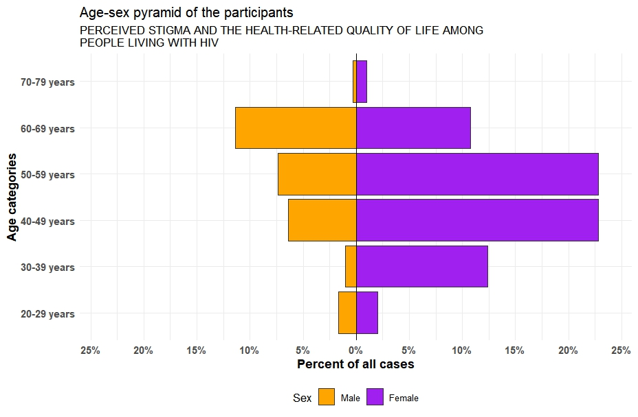

Figure 4.1 Age-sex pyramid of the participants

Table 4.1b The Clinical History of the Participants

| **Characteristic** | **N = 319** |
| --- | --- |
| **How long have you been aware of your HIV status** |  |
| 6months- 1 years | 19 (6%) |
| 1-5 years | 33 (11%) |
| 6-10 years | 89 (28%) |
| > 10 years | 172 (55%) |
| **How do you think you were infected with the virus** |  |
| Blood product | 107 (37%) |
| Injecting drugs | 38 (13%) |
| Sex with opposite sex partner | 73 (25%) |
| Sex with same sex partner | 74 (25%) |
| **How long have you been on ART** |  |
| 6months- 1 years | 19 (6%) |
| 1-5 years | 54 (18%) |
| 6-10 years | 65 (21%) |
| > 10 years | 169 (55%) |
| **Experiencing any adverse effects of the ARV drug you are on (Yes)** | 32 (10%) |
| **Presence of other chronic medical condition (Yes)** | 11 (3.4%) |
| **WHO HIV clinical staging** |  |
| 1 | 302 (95%) |
| 2 | 9 (2.8%) |
| 3 | 7 (2.2%) |
| **Viral load after 6months of cART mean±SD (min, max)** | 70.5 ± 718 (15, 12700) |
| **Present viral load mean±SD (min, max)** | 32.5 ± 156 (18, 2650) |

**4.2 Perceived Stigma among PLWH attending the HIV Clinic**

Perceived stigma among PLWH was measured by using the Berger HSS-40 instrument, the instrument showed a high internal validity (Cronbach alpha = 0.876), see Appendix I. The instrument is divided into 4 subscales: personalized stigma, disclosure, negative self-image and public attitudes, see Appendix II for the scoring and interpretation of the instrument (Berger, *et al.,* 2001). This instrument was given the possible score range for each subscale as follows: personalised stigma (18-72), disclosure (10-40), negative self-image (13-53), public attitudes (20-80). Meanwhile the mean score of the subscale were, personalized stigma (43.129), disclosure (27.455), negative self-image (31.091) and public attitudes (52.116). The findings from this study revealed the perceived stigma among PLWH attending the HIV clinic was higher than the midpoint, this was corroborated by a highmean overall perceived stigma score of 100.489 ±18.685.

The boxplot in Figure 4.2 shows presents a graphical representation of the central of dispersion of the parameters in this study population.

**Table 4.2 Perceived Stigma among PLWH attending the HIV Clinic using the Berger HSS-40 instrument**

| Subscale (score range) | n | min | max | median | IQR | mean | S.D |
| --- | --- | --- | --- | --- | --- | --- | --- |
| Personalised Stigma (18-72) | 319 | 6 | 72 | 45 | 15.0 | 43.129 | 11.368 |
| Disclosure (10-40) | 319 | 12 | 38 | 27 | 5.5 | 27.455 | 4.706 |
| Negative self-image (13-53) | 319 | 9 | 51 | 31 | 8.0 | 31.091 | 6.840 |
| Public attitudes (20-80) | 319 | 19 | 77 | 53 | 12.5 | 52.116 | 9.977 |
| Overall (40-160) | 319 | 36 | 151 | 101 | 20.0 | 100.489 | 18.685 |

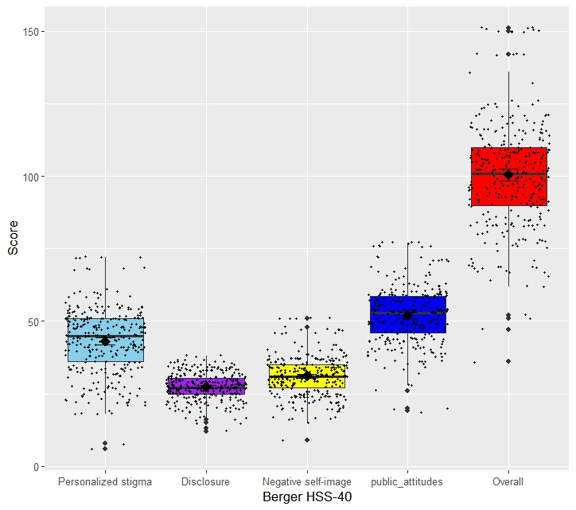

Figure 4.2 The boxplot showing the level of stigma among the participants

**4.3 The HRQOL of PLWH attending the HIV Clinic (WHOQOL HIV BREF)**

The WHOLQOL HIV BREF instrument was used in this study, the instrument gave a high level of internal reliability and validity (Cronbach alpha = 0.804) see Appendix III.

The instrument is divided into 6 domains: physical, psychological, level of independence, social relationship, environmental and spiritual, see Appendix IV for the scoring and interpretation of the instrument (WHO, 2012). The mean score of the domains were, physical (13.835), psychological (17.646), level of independence (13.796), social relationship (14.227), environmental (26.749) and spiritual (12.917). The findings from this study revealed the overall quality of life among PLWH attending the HIV clinic was above average, this was corroborated by the mean overall WHOQOL HIV BREF score of 67.912 ±8.973.

The boxplot in Figure 4.3 shows presents a graphical representation of the central of dispersion of the parameters in this study population.

**Table 4.3 The HRQOL of PLWH attending the HIV Clinic**

| Domains | n | min | max | median | IQR | mean | S.D |
| --- | --- | --- | --- | --- | --- | --- | --- |
| Physical | 319 | 5 | 20 | 14 | 4.00 | 13.835 | 2.763 |
| Psychological | 319 | 6 | 24 | 18 | 4.00 | 17.646 | 3.577 |
| Level of independence | 319 | 5 | 20 | 14 | 4.00 | 13.796 | 3.050 |
| Social relationship | 319 | 4 | 20 | 15 | 4.25 | 14.227 | 3.019 |
| Environmental | 319 | 8 | 40 | 26 | 9.00 | 26.749 | 5.393 |
| Spiritual | 319 | 5 | 20 | 13 | 6.00 | 12.917 | 3.703 |
| Overall | 302 | 39 | 91 | 69 | 26.00 | 67.912 | 8.973 |

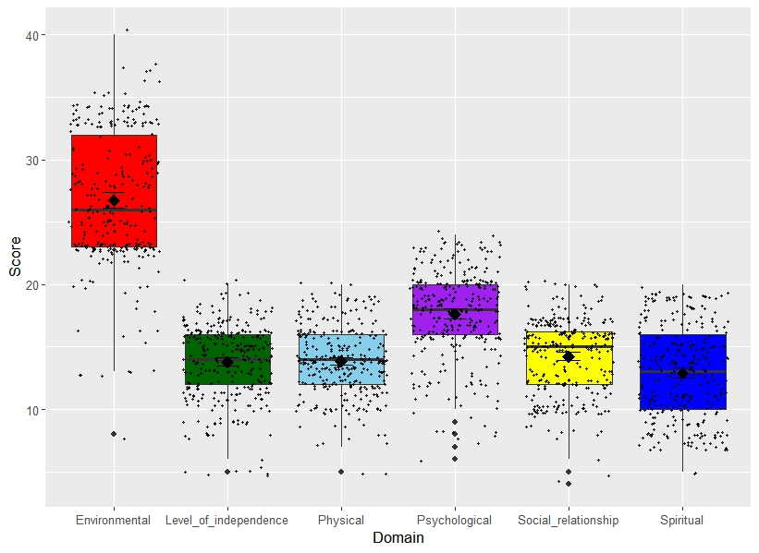

Figure 4.3 The boxplot showing the level of the WHOQOL among the participants

**4.4 The association between perceived stigma and HRQOL of PLWH attending the HIV Clinic**

The Spearman’s correlation was used to determine the association between the perceived stigma and the HRQOL of PLWH in this study, taking significance level at p <0.05. There was a weak correlation between personalised stigma and the following: WHOQOL-physical (r = 0.25), WHOQOL-social relationship (r = -0.14), WHOQOL-environment (r = 0.17) and WHOQOL-spiritual (r = 0.28). there was a weak correlation between disclosure and the following: WHOQOL-psychological (r = 0.16), WHOQOL-environmental (r = 0.18). There was a negative weak correlation between public attitudes and the following: WHOQOL-physical (r = -0.21), WHOQOL-level of independence (r = -0.18), WHOQOL-social relationship (r = -0.16), and WHOQOL-spiritual (r = -0.21)

Table **4.4 The association between perceived stigma and HRQOL of PLWH attending the HIV Clinic**

|  |  |  |  |  |  |  |  |  |  |  |  |
| --- | --- | --- | --- | --- | --- | --- | --- | --- | --- | --- | --- |
| term | O | PS | D | NSI | PA | Phy | Psy | LOI | SR | E | S |
| O | 1.00 |  |  |  |  |  |  |  |  |  |  |
| PS | 0.84** | 1.00 |  |  |  |  |  |  |  |  |  |
| D | 0.71** | 0.41** | 1.00 |  |  |  |  |  |  |  |  |
| NSI | 0.79** | 0.54** | 0.56** | 1.00 |  |  |  |  |  |  |  |
| PA | 0.91** | 0.76** | 0.63** | 0.69 | 1.00 |  |  |  |  |  |  |
| Phy | -0.23** | -0.25** | -0.06 | -0.24 | -0.21** | 1.00 |  |  |  |  |  |
| Psy | -0.01 | -0.05 | 0.16** | 0.03 | -0.01 | 0.38** | 1.00 |  |  |  |  |
| LOI | -0.19** | -0.10 | -0.08 | -0.19 | -0.18** | 0.48** | 0.33** | 1.00 |  |  |  |
| SR | -0.11 | -0.14* | 0.03 | -0.06 | -0.16** | 0.26** | 0.48** | 0.21** | 1.00 |  |  |
| E | 0.15** | 0.17** | 0.18** | 0.05 | 0.08 | 0.09 | 0.07 | 0.21** | 0.29** | 1.00 |  |
| S | -0.22** | -0.28** | -0.10 | -0.10 | -0.21** | 0.31** | 0.19** | 0.03 | 0.19** | -0.06 | 1.00 |

O= overall, PS=Personalised Stigma, D=Disclosure, NSI= Negative Self-Image, PA=Public attitude, Phy= WHOQOL-physical, Psy=WHOQOL-psychological, LOI= WHOQOL-level of independence, SR=WHOQOL-social relationship, E=WHOQOL-Environmental, S=WHOQOL-spiritual

**- significant at p-value < 0.01

*- significant at p-value <0.05

**4.5 The association between perceived stigma and viral load suppression (VLS) (clinical outcome) of PLWH attending the HIV clinic**

The Spearman’s correlation was used to determine the association between the perceived stigma and the viral load suppression in this study, taking significance level at p <0.05. There was no statistically significant correlation between personalised stigma and the viral load suppression.

**Table 4.5 The association between perceived stigma and viral load suppression (VLS) (clinical outcome) of PLWH attending the HIV clinic**

|  |  |  |  |  |  |  |  |
| --- | --- | --- | --- | --- | --- | --- | --- |
|  | Viral load | Present viral load | O | PS | D | NSI | PA |
| Viral load | 1.000 |  |  |  |  |  |  |
| Present viral load | 0.324** | 1.000 |  |  |  |  |  |
| O | 0.068 | 0.047 | 1.000 |  |  |  |  |
| PS | 0.087 | 0.058 | 0.843** | 1.000 |  |  |  |
| D | -0.020 | 0.041 | 0.706** | 0.411** | 1.000 |  |  |
| NSI | 0.041 | -0.025 | 0.787** | 0.549** | 0.562** | 1.000 |  |
| PA | 0.083 | 0.037 | 0.905** | 0.766** | 0.631** | 0.698** | 1.000 |

O= overall, PS=Personalised Stigma, D=Disclosure, NSI= Negative Self-Image, PA=Public attitude

**- significant at p-value < 0.01

*- significant at p-value <0.05

**4.6 Hypothesis Testing**

NULL HYPOTHESIS (H0)

1. There is no statistically significant association between perceived stigma and HRQOL of PLWH on cART attending HIV Clinic of General Hospital, Odan, Lagos.

2. There is no statistically significant association between perceived stigma and viral suppression (clinical outcome) of PLWH attending the HIV clinic of General Hospital, Odan, Lagos.

ALTERNATE HYPOTHESIS (H1)

1. There is a statistically significant association between perceived stigma and HRQOL of PLWH on cART attending HIV Clinic of General Hospital, Odan, Lagos.

2. There is a statistically significant association between perceived stigma and viral suppression (clinical outcome) of PLWH attending the HIV Clinic of General Hospital, Odan, Lagos.

1. The correlation analysis showed that there was a statistically significant association between perceived stigma and HRQOL of PLWH on cART attending HIV Clinic of General Hospital, Odan, Lagos. Hence we reject the null hypothesis and accept the alternate hypothesis.
2. The correlation analysis showed that there was no statistically significant association between perceived stigma and viral suppression (clinical outcome) of PLWH. Hence, we accept the null hypothesis and reject the alternate hypothesis.

APPENDIX I

|  |  |
| --- | --- |
| **Reliability Statistics BERGER HSS-40** | |
| Cronbach's Alpha | N of Items |
| .876 | 40 |

|  |  |  |  |  |
| --- | --- | --- | --- | --- |
| **Item-Total Statistics** | | | | |
|  | Scale Mean if Item Deleted | Scale Variance if Item Deleted | Corrected Item-Total Correlation | Cronbach's Alpha if Item Deleted |
| In many areas of my life, no one knows I have HIV | 99.86 | 319.073 | .289 | .874 |
| I feel guilty because I have HIV | 99.89 | 313.952 | .382 | .872 |
| People’s attitudes about HIV make me feel worse about myself | 100.02 | 313.797 | .386 | .872 |
| Telling someone I have HIV is risky | 99.35 | 318.158 | .284 | .874 |
| People with HIV lose jobs when employers find out | 99.35 | 317.372 | .379 | .873 |
| SDQ6 | 99.57 | 318.168 | .258 | .875 |
| SDQ7 | 100.31 | 313.762 | .360 | .873 |
| SDQ8 | 100.28 | 335.959 | -.178 | .882 |
| SDQ9 | 99.58 | 311.061 | .482 | .871 |
| SDQ10 | 99.69 | 310.595 | .443 | .871 |
| SDQ11 | 99.70 | 322.156 | .191 | .876 |
| SDQ12 | 99.88 | 302.931 | .524 | .869 |
| SDQ13 | 100.07 | 313.182 | .389 | .872 |
| SDQ14 | 99.81 | 312.009 | .465 | .871 |
| SDQ15 | 100.59 | 310.890 | .465 | .871 |
| SDQ16 | 99.42 | 314.984 | .443 | .872 |
| SDQ17 | 99.07 | 324.677 | .168 | .876 |
| SDQ18 | 100.19 | 312.990 | .400 | .872 |
| SDQ19 | 99.75 | 315.012 | .337 | .873 |
| SDQ20 | 99.49 | 319.978 | .230 | .875 |
| SDQ21 | 100.19 | 331.189 | -.056 | .881 |
| SDQ22 | 99.11 | 320.723 | .241 | .875 |
| SDQ23 | 99.71 | 308.394 | .470 | .870 |
| SDQ24 | 99.71 | 312.153 | .420 | .872 |
| SDQ25 | 99.66 | 313.807 | .347 | .873 |
| SDQ26 | 100.11 | 306.552 | .506 | .870 |
| SDQ27 | 99.81 | 314.479 | .343 | .873 |
| SDQ28 | 99.96 | 312.251 | .419 | .872 |
| SDQ29 | 99.98 | 310.646 | .492 | .870 |
| SDQ30 | 100.17 | 322.303 | .160 | .877 |
| SDQ31 | 99.86 | 312.637 | .434 | .871 |
| SDQ32 | 99.84 | 313.434 | .426 | .872 |
| SDQ33 | 99.97 | 312.687 | .463 | .871 |
| SDQ34 | 99.93 | 312.034 | .457 | .871 |
| SDQ35 | 100.00 | 310.852 | .489 | .870 |
| SDQ36 | 100.00 | 309.564 | .487 | .870 |
| SDQ37 | 99.79 | 315.129 | .377 | .872 |
| SDQ38 | 99.95 | 313.227 | .428 | .872 |
| SDQ39 | 99.81 | 311.526 | .458 | .871 |
| SDQ40 | 99.70 | 311.325 | .434 | .871 |

**APPENDIX II**

**BERGER HSS-40 SURVEY ITEMS:**

1. In many areas of my life, no one knows I have HIV 2

2. I feel guilty because I have HIV3

3. People’s attitudes about HIV make me feel worse about myself3

4. Telling someone I have HIV is risky2,4

5. People with HIV lose jobs when employers find out4

6. I work hard to keep my HIV a secret2,3

7. I feel I am not as good a person as others because I have HIV3

8. I never feel ashamed of having HIV3

9. People with HIV are treated like outcasts4

10. Most people believe a person who has HIV is dirty4

11. It is easier to avoid new friendships than worry about telling someone that I have HIV2,3,4

12. Having HIV makes me feel unclean3

13. Since learning I have HIV, I feel set apart and isolated from the rest of the world1,3,4

14. Most people think a person with HIV is disgusting4

15. Having HIV makes me feel I’m a bad person3

16. Most people with HIV are rejected when others find out1,4

17. I am very careful who I tell that I have HIV2

18. Some people who know I have HIV have grown more distant1

19. Since learning I have HIV, I worry about people discriminating against me2,4

20. Most people are uncomfortable around someone with HIV4

21. I never feel the need to hide the fact I have HIV2

22. I worry that people may judge me when they learn I have HIV2,4

23. Having HIV in my body is disgusting to me3

24. I have been hurt by how people reacted to learning I have HIV1

25. I worry people who know I have HIV will tell others2

26. I regret having told some people that I have HIV1

27. As a rule, telling others that I have HIV has been a mistake1,3,4

28. People avoid touching me once they know I have HIV1,4

29. People I care about stopped calling after learning I have HIV1

30. People have told me that getting HIV is what I deserve for how I lived my life1,4

31. Some people close to me are afraid others will reject them if it becomes known I have HIV1

32. People don’t want me around their children once they know I have HIV1,4

33. People have physically backed away from me when they learn I have HIV1,4

34. Some people act as though it is my fault I have HIV1,4

35. I have stopped socializing with some people because of to their reactions to my having HIV1

36. I have lost friends by telling them I have HIV1

37. I have told people close to me to keep the fact that I have HIV a secret2

38. People who know I have HIV tend to ignore my good points1,3,4

39. People seem afraid of me once they learn I have HIV1,3,4

40. When people learn you have HIV, they look for flaws in your character1,4

Where 1= Personalised stigma

2= Disclosure

3= Negative self-image

4= Public attitudes

**SCORING:**

1) Items are scored as follows:

strongly disagree = 1

disagree = 2

agree = 3

strongly agree = 4.

If a subject selects a response in between two options (e.g.: between SD and D), a

numerical value midway between the two options would be used (e.g.: 1.5).

2) Two items are reverse-scored: items 8 and 21.

3) After reversing these two items, each scale or subscale’s score is calculated by simply

The range of possible scores depends on the number of items in the scale. For the total

HIV Stigma Scale, scores can range from 40 to 160 [1 x 40 items to 4 x 40 items]. For

the personalized stigma subscale, scores can range from 18 to 72. For the disclosure

subscale, scores can range from 10 to 40. For the negative self-image subscale, scores

can range from 13 to 52. For the public attitudes subscale, scores can range from 20 to

80.

APPENDIX III

|  |  |
| --- | --- |
| **The WHOQOL HIV Bref Reliability Statistics** | |
| Cronbach's Alpha | N of Items |
| .804 | 31 |

|  |  |  |  |  |
| --- | --- | --- | --- | --- |
| **Item-Total Statistics** | | | | |
|  | Scale Mean if Item Deleted | Scale Variance if Item Deleted | Corrected Item-Total Correlation | Cronbach's Alpha if Item Deleted |
| SEQ1 | 100.03 | 198.307 | .381 | .796 |
| SEQ2 | 100.11 | 201.423 | .277 | .800 |
| SEQ3 | 100.90 | 204.491 | .211 | .802 |
| SEQ4 | 100.65 | 204.221 | .183 | .804 |
| SEQ5 | 100.17 | 200.412 | .321 | .798 |
| SEQ6 | 100.31 | 200.457 | .373 | .797 |
| SEQ7 | 100.15 | 198.689 | .373 | .796 |
| SEQ8 | 100.86 | 198.188 | .322 | .798 |
| SEQ9 | 100.57 | 201.008 | .245 | .802 |
| SEQ10 | 100.57 | 201.196 | .218 | .803 |
| SEQ11 | 99.99 | 197.241 | .399 | .795 |
| SEQ12 | 99.98 | 202.346 | .349 | .798 |
| SEQ13 | 99.77 | 195.066 | .606 | .790 |
| SEQ14 | 99.91 | 200.444 | .294 | .799 |
| SEQ15 | 100.01 | 196.673 | .378 | .796 |
| SEQ16 | 100.67 | 193.040 | .440 | .793 |
| SEQ17 | 100.23 | 196.101 | .391 | .795 |
| SEQ18 | 100.03 | 198.112 | .439 | .794 |
| SEQ19 | 100.60 | 199.876 | .316 | .799 |
| SEQ20 | 99.54 | 193.339 | .566 | .789 |
| SEQ21 | 99.67 | 198.603 | .340 | .798 |
| SEQ22 | 99.90 | 196.601 | .337 | .798 |
| SEQ23 | 100.05 | 201.410 | .250 | .801 |
| SEQ24 | 99.46 | 200.522 | .356 | .797 |
| SEQ25 | 99.74 | 208.763 | .088 | .806 |
| SEQ26 | 100.02 | 210.008 | .034 | .809 |
| SEQ27 | 99.81 | 201.028 | .324 | .798 |
| SEQ28 | 99.71 | 198.797 | .443 | .795 |
| SEQ29 | 99.83 | 200.222 | .354 | .797 |
| SEQ30 | 100.80 | 203.039 | .169 | .806 |
| SEQ31 | 100.85 | 211.140 | -.014 | .813 |

APPENDIX IV

|  |  |  |  |
| --- | --- | --- | --- |
| Domains | Items | Raw score | Transformed score |
| Physical | (6-Q3) + (6-Q4) +Q14 +Q21 |  |  |
| Psychological | Q6+ Q11+ Q15+ Q24+ (6-Q31) |  |  |
| Level of independence | (6-Q5) + Q20 +Q22 + Q23 |  |  |
| Social relationship | Q17 +Q25+ Q26+27 |  |  |
| Environmental | Q12+Q13+Q16+Q18+Q19+Q28+Q29+Q30 |  |  |
| Spiritual | Q7+ (6-Q8) + (6-Q9) + (6-Q10) |  |  |