4.1 The Sociodemographic Characteristics and Clinical History of the Participants

Table 4.1a The Sociodemographic Characteristics of the Participants

| **Characteristic** | **N = 319** |
| --- | --- |
| **Age, mean**±**SD (min, max)** | 50 ±10.9 (21, 77) |
| **Age group** |  |
| 20-29 years | 11 (3.7%) |
| 30-39 years | 40 (13%) |
| 40-49 years | 87 (29%) |
| 50-59 years | 90 (30%) |
| 60-69 years | 66 (23%) |
| 70-79 years | 4 (1.3%) |
| **Sex** |  |
| Female | 228 (71%) |
| Male | 91 (29%) |
| **Residence** |  |
| Lagos | 274 (87.5%) |
| Outside Lagos | 39 (12.5%) |
| **Marital status** |  |
| Divorced | 11 (3.1%) |
| Married | 187 (59%) |
| Separated | 9 (2.6%) |
| Single | 70 (22%) |
| Widowed | 41 (13%) |
| **Ethnicity** |  |
| Hausa | 10 (4%) |
| Igbo | 57 (18%) |
| Others | 61 (19%) |
| Yoruba | 186 (59%) |
| **Religion** |  |
| Atheist | 12 (3.8%) |
| Christianity | 224 (70%) |
| Islam | 82 (26%) |
| Traditional | 1 (0.2%) |
| **Educational** |  |
| Informal | 6 (2%) |
| Primary | 76 (24%) |
| Secondary | 137 (43%) |
| Tertiary | 100 (31%) |
| **Employment** |  |
| Employed | 154 (51%) |
| Unemployed | 147 (49%) |
| **Source of finance** |  |
| Family contributions | 31 (10%) |
| Others | 184 (60%) |
| pension | 25 (8.5%) |
| Profits from investment | 53 (17%) |
| Social welfare | 13 (4.5%) |
| **Average monthly income, mean**±SD **(Median, )** | 51,409±38,616 (10,000, 350,000) |
| **Income range** (Nigerian Bureau of Statistics) |  |
| Below Poverty Line | 18 (6.7%) |
| High income | 3 (1.2%) |
| low income | 87 (32%) |
| Middle income | 144 (53%) |
| Poverty Line | 19 (7.0%) |

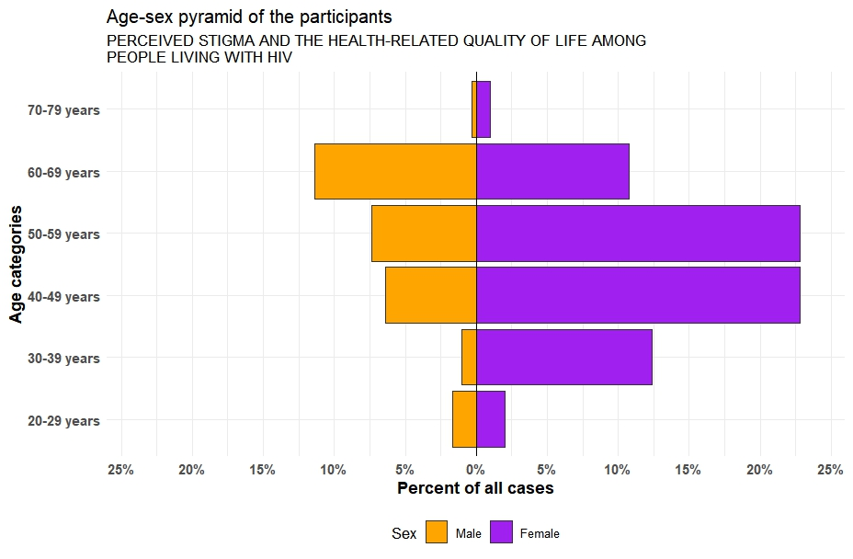

Figure 4.1 Age-sex pyramid of the participants

Table 4.1b The Clinical History of the Participants

| **Characteristic** | **N = 319** |
| --- | --- |
| **How long have you been aware of your HIV status** |  |
| 6months- 1 years | 19 (6%) |
| 1-5 years | 33 (11%) |
| 6-10 years | 89 (28%) |
| > 10 years | 172 (55%) |
|  |  |
|  |  |
| **How do you think you were infected with the virus** |  |
| Blood product | 107 (37%) |
| Injecting drugs | 38 (13%) |
| Sex with opposite sex partner | 73 (25%) |
| Sex with same sex partner | 74 (25%) |
| **How long have you been on ART** |  |
| 6months- 1 years | 19 (6%) |
| 1-5 years | 54 (18%) |
| 6-10 years | 65 (21%) |
| > 10 years | 169 (55%) |
| **Experiencing any adverse effects of the ARV drug you are on (Yes)** | 32 (10%) |
| **Presence of other chronic medical condition (Yes)** | 11 (3.4%) |
| **WHO HIV clinical staging** |  |
| 1 | 302 (95%) |
| 2 | 9 (2.8%) |
| 3 | 7 (2.2%) |
| **Viral load after 6months of cART mean±SD (min, max)** | 70.5 ± 718 (15, 12700) |
| **Present viral load mean±SD (min, max)** | 32.5 ± 156 (18, 2650) |

**4.2 Perceived Stigma among PLWH attending the HIV Clinic**

**Table 4.2 Perceived Stigma among PLWH attending the HIV Clinic using the Berger HSS-40 instrument**

| Domains | n | min | max | median | IQR | mean | S.D |
| --- | --- | --- | --- | --- | --- | --- | --- |
| Personalised Stigma | 319 | 6 | 72 | 45 | 15.0 | 43.129 | 11.368 |
| Disclosure | 319 | 12 | 38 | 27 | 5.5 | 27.455 | 4.706 |
| Negative self-image | 319 | 9 | 51 | 31 | 8.0 | 31.091 | 6.840 |
| Public attitudes | 319 | 19 | 77 | 53 | 12.5 | 52.116 | 9.977 |
| Overall | 319 | 36 | 151 | 101 | 20.0 | 100.489 | 18.685 |

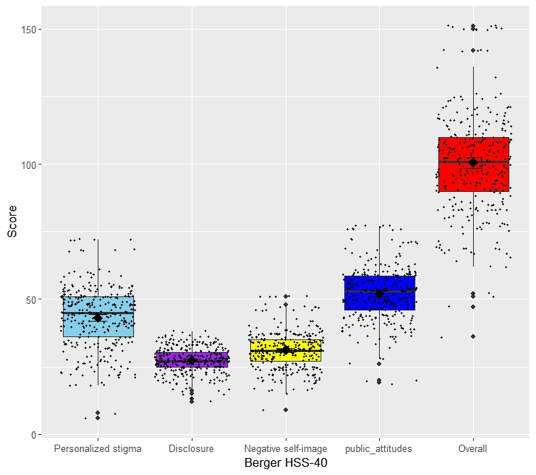

Figure 4.2 The boxplot showing the level of stigma among the participants

**4.3 The HRQOL of PLWH attending the HIV Clinic (WHOQOL HIV BREF)**

**Table 4.3 The HRQOL of PLWH attending the HIV Clinic**

| Domains | n | min | max | median | IQR | mean | S.D |
| --- | --- | --- | --- | --- | --- | --- | --- |
| Physical | 310 | 5 | 20 | 14 | 4.00 | 13.835 | 2.763 |
| Psychological | 305 | 6 | 24 | 18 | 4.00 | 17.646 | 3.577 |
| Level of independence | 304 | 5 | 20 | 14 | 4.00 | 13.796 | 3.050 |
| Social relationship | 304 | 4 | 20 | 15 | 4.25 | 14.227 | 3.019 |
| Environmental | 283 | 8 | 40 | 26 | 9.00 | 26.749 | 5.393 |
| Spiritual | 302 | 5 | 20 | 13 | 6.00 | 12.917 | 3.703 |

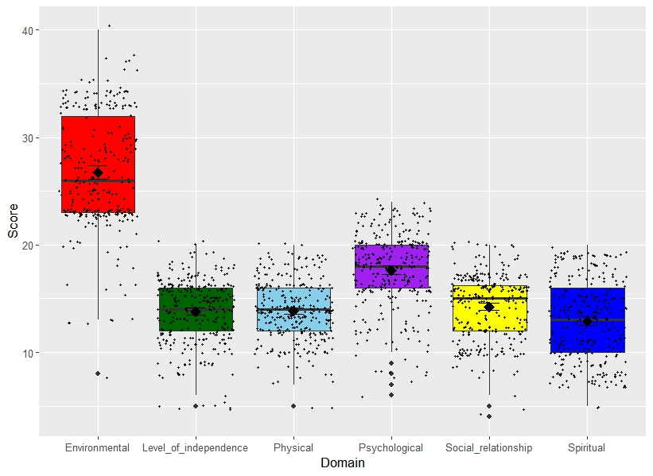

Figure 4.3 The boxplot showing the level of the WHOQOL among the participants

4.4 The association between perceived stigma and HRQOL of PLWH attending the HIV Clinic

|  |  |  |  |  |  |  |  |  |  |  |  |
| --- | --- | --- | --- | --- | --- | --- | --- | --- | --- | --- | --- |
| term | O | PS | D | NSI | PA | Phy | Psy | LOI | SR | E | S |
| O | 1.00 |  |  |  |  |  |  |  |  |  |  |
| PS | 0.84** | 1.00 |  |  |  |  |  |  |  |  |  |
| D | 0.71** | 0.41** | 1.00 |  |  |  |  |  |  |  |  |
| NSI | 0.79** | 0.54** | 0.56** | 1.00 |  |  |  |  |  |  |  |
| PA | 0.91** | 0.76** | 0.63** | 0.69 | 1.00 |  |  |  |  |  |  |
| Phy | -0.23** | -0.25** | -0.06 | -0.24 | -0.21** | 1.00 |  |  |  |  |  |
| Psy | -0.01 | -0.05 | 0.16** | 0.03 | -0.01 | 0.38** | 1.00 |  |  |  |  |
| LOI | -0.19** | -0.10 | -0.08 | -0.19 | -0.18** | 0.48** | 0.33** | 1.00 |  |  |  |
| SR | -0.11 | -0.14* | 0.03 | -0.06 | -0.16** | 0.26** | 0.48** | 0.21** | 1.00 |  |  |
| E | 0.15** | 0.17** | 0.18** | 0.05 | 0.08 | 0.09 | 0.07 | 0.21** | 0.29** | 1.00 |  |
| S | -0.22** | -0.28** | -0.10 | -0.10 | -0.21** | 0.31** | 0.19** | 0.03 | 0.19** | -0.06 | 1.00 |

O= overall, PS=Personalised Stigma, D=Disclosure, NSI= Negative Self-Image, PA=Public attitude, Phy= WHOQOL-physical, Psy=WHOQOL-psychological, LOI= WHOQOL-level of independence, SR=WHOQOL-social relationship, E=WHOQOL-Environmental, S=WHOQOL-spiritual

**- significant at p-value < 0.01

*- significant at p-value <0.05

4.5 The association between perceived stigma and viral load suppression (VLS) (clinical outcome) of PLWH attending the HIV clinic

|  |  |  |  |  |  |  |  |
| --- | --- | --- | --- | --- | --- | --- | --- |
|  | Viral load | Present viral load | O | PS | D | NSI | PA |
| Viral load | 1.000 |  |  |  |  |  |  |
| Present viral load | 0.324** | 1.000 |  |  |  |  |  |
| O | 0.068 | 0.047 | 1.000 |  |  |  |  |
| PS | 0.087 | 0.058 | 0.843** | 1.000 |  |  |  |
| D | -0.020 | 0.041 | 0.706** | 0.411** | 1.000 |  |  |
| NSI | 0.041 | -0.025 | 0.787** | 0.549** | 0.562** | 1.000 |  |
| PA | 0.083 | 0.037 | 0.905** | 0.766** | 0.631** | 0.698** | 1.000 |

O= overall, PS=Personalised Stigma, D=Disclosure, NSI= Negative Self-Image, PA=Public attitude

**- significant at p-value < 0.01

*- significant at p-value <0.05

4.6 Hypothesis Testing

1.5.1 NULL HYPOTHESIS (H0)

1. There is no statistically significant association between perceived stigma and HRQOL of PLWH on cART attending HIV Clinic of General Hospital, Odan, Lagos.

2. There is no statistically significant association between perceived stigma and viral suppression (clinical outcome) of PLWH attending the HIV clinic of General Hospital, Odan, Lagos.

1.5.1 ALTERNATE HYPOTHESIS (H1)

1. There is a statistically significant association between perceived stigma and HRQOL of PLWH on cART attending HIV Clinic of General Hospital, Odan, Lagos.

2. There is a statistically significant association between perceived stigma and viral suppression (clinical outcome) of PLWH attending the HIV Clinic of General Hospital, Odan, Lagos.