NFT GOLD ARTIST INVITATION USER JOURNEY

Scenario 1: new artist invited

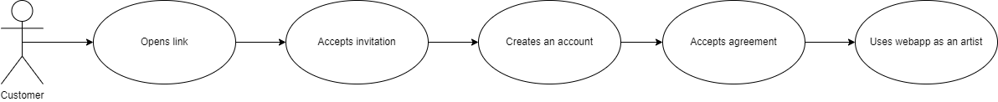

|  |
| --- |
| Step 1: Opens link |
| The artist opens the e-mail which was sent automatically by the web application (server-side) when a gallery invited him / her. |

|  |
| --- |
| Step 2: Accepts invitation |
| After opening the link in the e-mail, the artist will be redirected to a screen, where (s)he can decide whether (s)he wants to connect to the NFT GOLD web application as an artist or not. In this case, the user clicks ’Accept’ button and accepts the invitation. If the user clicks ’Reject’ the scenario ends. |

|  |
| --- |
| Step 3: Creates an account |
| After accepting the invitation, the user will be redirected to the *artist registration* page. In this page, after providing the required profile informations, the user can finally register as an artist. |

|  |
| --- |
| Step 4: Accepts agreement |
| If every required information about the artist provided successfully, after clicking ’Register’ button, an agreement offer will be displayed to the artist. In this agreement offer, those details will be shown which were provided by the gallery who invited the user before. The artist has 2 options: accepting the agreement offer, or rejecting it. If (s)he accepts the offer, the user – who just became an artist – and the gallery will connect, and they are ready to create artworks together. By rejecting the offer, the registration is successful, but the gallery and the artist will not be connected. |

|  |
| --- |
| Step 5: Uses webapp as an artist |
| Finally, after going through these steps, the user registered as an artist, and now (s)he can use the NFT GOLD web application with all the priviliges an artist has. |

Scenario 2: existing artist invited

Artists can connect to multiple galleries by accepting their invitation. If a gallery invites an artist, who is already registered, the user journey will be the same as in Scenario 1, but the step 3 (creates an account) will be skipped.