Conceptual Model, ERD, and Database Model

Team Echo

Business Rules

1. Every Customer has one Account
2. Every ATM can perform many transactions
3. Every Customer can perform many transactions
4. One bank is connected to multiple ATM’s

External views

1. 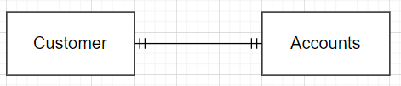
2. 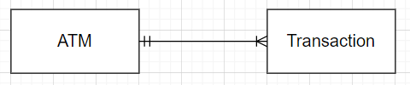
3. 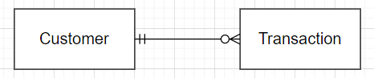

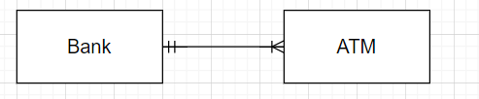

Conceptual Model

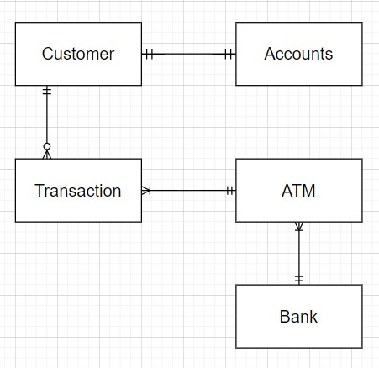

ERD

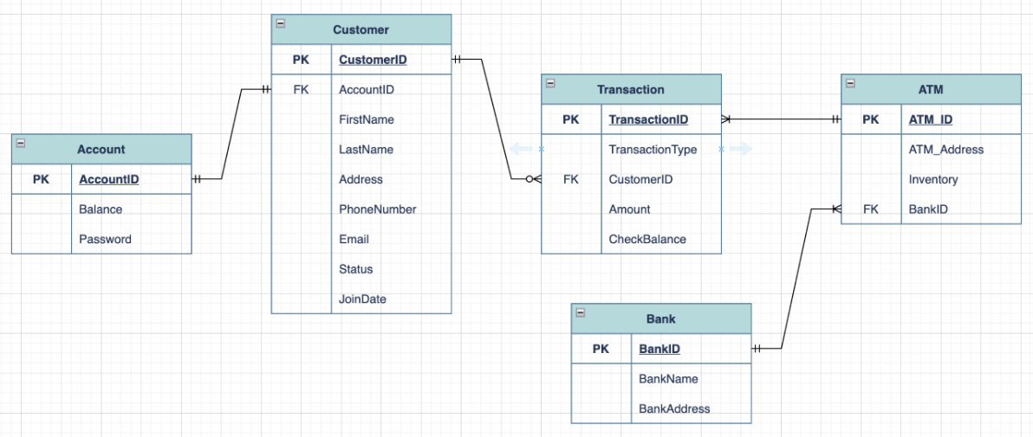

Database Diagram

