Each transaction starts with the login screen at the Piggy Bank ATM. In this screen, the user will enter their card number and pin into the respective places. Once the information is entered, the user will press login.

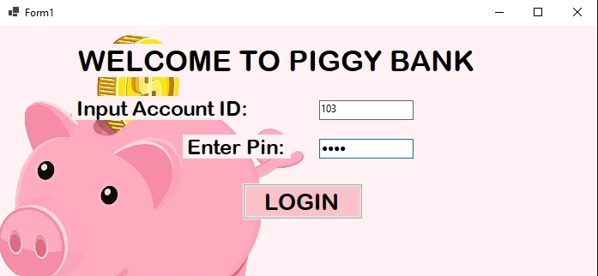

After this, the main menu screen will appear. On this screen the user’s current balance is displayed, and the user is prompted to choose between three transaction options. The buttons display the options to: 1 – deposit, 2 – withdraw, or 3 – view account.

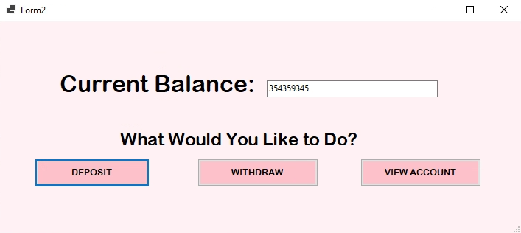

Once the user chooses their transaction option, the screen will change according to their choice.

1. If the user chose deposit, the screen would show the deposit menu. On this menu, the user is prompted to enter their desired deposit and press enter when they are finished.

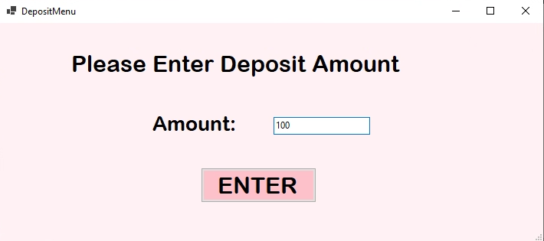

1. If the user chose to withdraw, the screen would show the withdraw menu. On this menu, the user is prompted to choose between 4 different withdrawal amounts: $10, $25, $50, and $100.

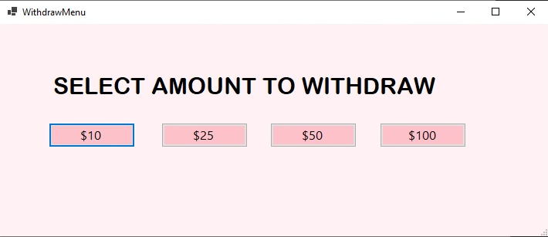

1. If the user chose to view account, the screen would show the account menu. On this menu, the screen displayed all of the user’s account information. This includes: customer ID, first name, last name, address, email, status, and join date. Once the user is finished viewing their account information, they will press the return button to return to the main menu and continue their transaction with either a deposit or withdrawal.

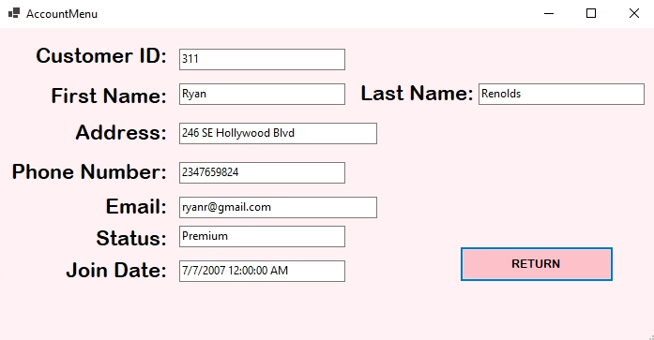

Finally, after the user has chosen their desired transaction and amount, they will either insert their deposit amount or the ATM will dispense the user’s withdrawal amount. The ATM will then show the final menu, where the screen thanks the user. This means the transaction is complete.

