# Measuring Purpose and Happiness: Psychometrics and Tests of Stability

Patrick E. McKnight1, Todd B. Kashdan1, Amie MacKay1, and Madeleine Gross2

1Department of Psychology, George Mason University

2Department of Psychology, University of California, Santa Barbara

# Author Note

Patrick E. McKnight  <https://orcid.org/0000-0002-9067-9066>

Todd B. Kashdan  <https://orcid.org/0000-0001-6438-0485>

# Abstract

In the social sciences, a case has been made for distinguishing between purpose in life and happiness. That said, a surprisingly small number of direct empirical comparisons exist that test both the stability of these measures and the stability of the relationship between them over time. The following study addresses these empirical omissions and provides a benchmark for evaluating the bivariate relationship between important constructs in positive psychology. We used the best tools available to assess every aspect of these two constructs. Our findings were clear and reproducible; both purpose and happiness measures produce stable estimates over time and the correlation between them suggests that they are correlated ($r>.43$; $p<.001$). Finally, the causal direction appears to favor happiness predicting subsequent ratings of purpose rather than the alternative ( $r≈0.15$ vs. $r≈−0.04$ ). We address the implications of all these findings and provide researchers with both some guidance on the use of these constructs as well as some future directions for research.

*Keywords*: purpose in life, happiness, stability, measurement

# Measuring Purpose and Happiness: Psychometrics and Tests of Stability

As a survivor of the holocaust, Viktor Frankl experienced more pain than most of us can imagine. Yet, he recognized that the absence of adversity did not make life worth living. For Frankl, a person must possess agency to pursue what matters most - irrespective of present thoughts and feelings. But, aside from handling adversity, what benefits does a person reap from committing effort and making progress towards a purpose? To better understand the potential benefits of purpose, there is value in contrasting it with the more widely studied experience of happiness.

There are multiple paths to a worthwhile existence. One entails hedonics, where positive emotional states are more common than negative emotional states. Another involves purpose, where life decisions and goals are centrally influenced by one’s ultimate concerns (not the mere attainment of pleasure and avoidance of suffering; Bronk, 2014; McKnight & Kashdan, 2009). Accumulating evidence supports how both purpose and happiness promote positive mental health (e.g., Reker et al.,1987; Schaefer et al., 2013). While the same can be said for many positively valenced constructs such as optimism (Peterson, 2000), kindness (Hui, Ng, Berzaghi, Cunningham-Amos, & Kogan, 2020), and mindfulness (Brown, Ryan & Creswell, 2007), purpose and happiness are grander than desirable personality traits. Purpose organizes the expenditure of finite resources such as time, energy, and money around a person’s important pursuits. Happiness reflects global evaluations that life is emotionally and mentally satisfying.

The study of purpose and happiness requires an understanding of the relevant well-being dimensions linked to each (e.g., Baumeister, Vohs, Aaker, & Garbinsky, 2013). The present study uses a theoretically informed measure of purpose (Hill, Edmonds, Peterson, Luyckx, & Andrews, 2016) and happiness (Lyubomirsky & Lepper, 1999) to examine how these two ways of living differ in their correlates and consequences.

## Defining Purpose in Life

Since Viktor Frankl referred to purpose as a psychological construct in 1959, several definitions have emerged, of which four are frequently cited. First, Ryff (1989) stated that a person with a sense of purpose “has goals in life and a sense of directedness; feels there is meaning to present and past life; holds beliefs that give life purpose; has aims and objectives for living” (p. 45). Second, Damon et al. (2003) described purpose as “a stable and generalized intention to accomplish something that is at once meaningful to the self and of consequence to the world beyond the self” (p. 121). Third, Kosine and colleagues (2008) defined purpose as “identification of highly valued, overarching goals, the attainment of which is anticipated to move people closer to achieving their true potential and bring them deep fulfillment’ (p. 133). Fourth, McKnight and Kashdan (2009) considered purpose to be a “central, self-organizing life aim that organizes and stimulates goals, manages behaviors, and provides a sense of meaning” (p. 242).

Efforts to synthesize definitions identify three overlapping elements: centrality, goal-directedness, and commitment. Centrality refers to how purpose-related values, beliefs, and behaviors define a person’s sense of self and who they are becoming. Goal-directedness refers to actions aimed at future desired outcomes. Commitment entails the regular expenditure of resources (time, energy, finances, social capital) and decision-making concerning these desired outcomes. Prosocial intentions are another element that is often viewed as core to purpose (e.g., Damon et al., 2003; Moran, 2009); however, it remains unclear if they are a necessary feature or a common descriptor of some people’s particular purposes (e.g., Hill, Burrow, O’Dell, & Thornton, 2010). A person possesses a strong purpose when they hold a worldview and dedicate behaviors towards ends that matter greatly, which may or may not include helping other people.

### Purpose Benefits

When considering whether and how purpose confers benefits, it is valuable to explore broad-ranging correlates and outcomes. A large body of research has linked a strong sense of purpose to better physical health, including a lower incidence of strokes, cardiovascular disease and other chronic illnesses, as well as longer life expectancy (e.g., Cohen, Bavishi, & Rozanski, 2016; Kim, Chen, Nakamura, Ryff, & VanderWeele, 2022). A complementary line of research connects purpose to enriched social life, from a greater openness toward racially diverse individuals to higher-quality friendships (e.g., Burrow, Stanley, Sumner, & Hill, 2014; Lund et al., 2022). In this research program, we extend these findings by exploring the relationship between purpose and psychological well-being.

At the broadest level, well-being is often described as “the experience of personally valued fulfillment within one’s life” (Disabato, Goodman, & Kashdan, in press). However, well-being is a multifaceted construct with no singular metric capturing its full scope. A comprehensive literature review identified 155 measures of positive mental health reflecting 410 dimensions (Iasiello et al., 2024), underscoring the complexity of the construct. Notably, purpose does not require the pursuit of happiness or satisfaction, yet it frequently correlates with both. The presence of a meaningful mission in life has been shown to explain 12-46% of the variance in happiness (Robak & Griffin, 2000; Aghababaei & Błachnio, 2014; Crego et al., 2021) and 11-44% of the variance in life satisfaction (Bronk et al., 2009; Kim et al., 2017). Additionally, purpose predicts longitudinal increases in life satisfaction over 18 months (Chen & Cheng, 2020).

To better understand the relationship between purpose and well-being, we examined how purpose might differ from the most widely used and studied dimension of well-being: happiness. Purpose is proposed to differ from happiness across four major categories: time orientation, need satisfaction, emotional experiences and tolerance, and self and identity. These categories allow us to test hypotheses regarding how purpose, while moderately to strongly correlated with happiness, differs in correlates and outcomes (e.g., Baumeister, Vohs, Aaker, & Garbinsky, 2013). These categories of proposed differences are detailed.

### Time Orientation

Purpose is hypothesized to be more strongly linked to constructs that emphasize long-term striving and goal pursuit, whereas happiness is more closely tied to present-moment experiences. Hope, as conceptualized by psychologists (Snyder et al., 1991), exists when a person believes goals are achievable - recognizing *pathways* to making progress and *agency* to use those pathways (Snyder et al., 2005). Purpose and hope share a bidirectional relationship, wherein purpose stimulates the identification of goals, which are likely informed and enhanced by hope for achieving them. Empirical findings support this connection with purpose explaining 4-18% of the variance in goal pathways and 19-45% of the variance in goal-directed agency among adolescent, emerging, and middle adult cohorts (Bronk et al., 2009). Moreover, in 4-year longitudinal research with older adults, purpose predicts increases in hope and hope predicts increases in purpose (Long et al., 2020).

Similarly, grit, encompasses perseverance of effort toward long-term goals that a person is passionate about (Duckworth et al., 2007). People with a strong sense of purpose are more likely to persist in the face of obstacles or setbacks and exhibit consistent long-term interests - that tend to serve as a source of meaning and purpose. Finally, there is self-control, reflecing the ability of the self to regulate impulses and other forms of short-term thinking to achieve valued goals (Inzlicht, Werner, Briskin, & Roberts, 2021). Purposeful individuals exhibit higher levels of self-control, as their long-term commitments provide a framework for prioritizing meaningful pursuits over immediate gratification (McKnight & Kashdan, 2009).

### Psychological Need Satisfaction

Self-determination theory (SDT) describes the fulfillment of three basic needs as critical to living well: autonomy, belonging, and competence (Deci & Ryan, 2000). Autonomy reflects a person’s belief they are in control over their actions. Competence reflects a sense of efficacy when interacting with the world, including the development of strengths, skills, and competencies to do so. Belonging is how much a person feels connected to people in their social environment and maintains satisfying relationships with them (Ryan & Deci, 2001, 2002). If meaningful goals are not self-chosen (autonomy), seem inaccessible (competence), or lack social support (belonging), they are unlikely to make a person “feel good” (McKnight & Kashdan, 2009). Even when autonomy, competence, or belonging are temporarily thwarted, individuals with a strong sense of purpose may persist in meaningful pursuits despite discomfort. Empirical research supports this distinction, with purpose accounting for only 7% of the variance in need satisfaction (Ferrand et al., 2014), suggesting that purpose operates more independently of psychological need fulfillment than happiness.

### Emotional Experiences and Tolerance

Purpose is also hypothesized to have a unique relationship with stressful events and resulting distress. Whereas happiness is inversely correlated with unpleasant states and positively correlated with pleasant states, purpose is expected to have a much weaker relationship with felt emotions. Individuals with a strong purpose allocate resources more efficiently, enabling them to view stressful events as more of a challenge and less of a threat, consequently lessening emotional strain (McKnight & Kashdan, 2009). These individuals, with a strong sense of purpose, are better able to continue pursuing their ultimate concerns regardless of transient emotional states, demonstrating a greater capacity for distress tolerance (McKnight & Kashdan, 2009). This is supported by research showing that individuals with higher purpose experience lower cortisol responses to stress (Fogelman & Canli, 2015), diminished negative emotional reactivity to daily stressors (Hill, Sin, Turiano, Burrow, & Almeida, 2018), and attenuated startle responses to negative stimuli (Schaefer et al., 2013).

Moreover, purpose facilitates adaptive emotion regulation. The concept of recentering, wherein individuals shift attention away from stressors and toward broader life goals, suggests that purpose provides a psychological buffer against distress (Burrow, Hill, Stanley, & Sumner, 2024). This recentering process allows for stress-related growth, wherein adversity fosters deeper self-insight, enhanced relationships, and greater appreciation for life (Park, 2010). Our study will comprehensively examine how purpose relates to the experience of emotional difficulties.

### Self and Identity

Unlike happiness, which is closely tied to hedonic well-being (e.g., pleasure and enjoyment), purpose is hypothesized to be more strongly associated with values that transcend momentary pleasure. Existing models of values categorize them into broad domains, including power, achievement, hedonism, stimulation, self-direction, universalism, benevolence, tradition, conformity, and security. Purpose is expected to align most closely with values that extend beyond immediate gratification and instead reflect a cohesive narrative about who the self is and what they do daily, including contributions to other people and broader society. To assess this proposed stronger connection between purpose compared with happiness to valued actions, we employed a novel methodological approach, asking participants to rate both the importance of particular values and behavioral consistency with those values. This distinction allows us to examine whether individuals with a strong sense of purpose are more likely to act in alignment with their espoused principles, thereby reinforcing a coherent identity

## The Present Research

Building on prior work differentiating meaning and happiness (Baumeister et al., 2013), we examined how purpose and happiness differ in their measurement stability over time (two years) and the correlates and consequences. For this initial exploration, we focused on differences in desirable trait-like qualities (e.g., hope, grit, self-control, need satisfaction, distress tolerance). These methods allowed for a fine-grained analysis of what people with strong purpose and/or happiness feel, think, and do on a typical day. With the inclusion of 6-month and 2-year follow-up surveys, our work allowed for exploratory tests of the shorter and longer-term patterns uniquely linked to purposeful and happy living.

# Methods

## Participants and Procedure

Community adults were recruited from the DC/Maryland/Virginia region through local advertisements. The baseline sample (Time one; T1 *n* = 303) completed trait measures and ideographic assessments in the laboratory and subsequently completed follow-up measures six months (Time two; T2 *n* = 205) and two years later (Time three; T3 *n* = 167) through an online survey platform. Demographics of samples at each time point are available in Table 1.

### Purpose

Brief Measure of Purpose in Life (BPIL; Hill, Edmonds, Peterson, Luyckx, & Andrews, 2015). The 4-item BPIL measures the degree to which one has a clear mission in life (e.g., *“My plans for the future match with my true interests and values’’*). Items are rated on a 5-point Likert scale (from 1 or *not at all* to 5 or *very much*). All scores were converted from the traditional 1-5 item scores and 4-20 total scores to POMP or percent of maximum possible scores (CITE); thus, the final scores range from 0 to 100. The BPIL demonstrates good construct validity through its positive relationships with another measure of purpose, the Life Engagement Test, and trait positive affect, and its inverse relationship with trait negative affect (Scheier et al., 2006). BPIL exhibited stability over 6 months (T1 to T2 *r* = .60) and 18 months (T2 to T3 *r* = .63). Additionally, the BPIL demonstrated acceptable internal consistency at all time points (T1: α = .84; T2: α = .90; T3: α = .88) and served as a point of comparison with our idiographic operationalization of purpose.

### Happiness

Subjective Happiness Scale (SHS; Lyubomirsky & Lepper, 1999). The 4-item SHS assesses global subjective happiness using a 7-point Likert scale with different anchors (1 or *not a very happy person* to 7 or *a very happy person*; 1 or *less happy* to 7 or *more happy*; 1 or *not at all* to 7 or *a great deal*) based on individual items (“*Some people are generally very happy. They enjoy life regardless of what is going on and get the most out of everything. To what extent does this characterization describe you?*”). The SHS exhibits satisfactory convergent validity through its strong relationships with other happiness-related scales (such as the Satisfaction With Life Scale; Diener, Emmons, Larsen, & Griffin, 1985). The SHS demonstrates acceptable internal consistency in the present study (T1: α = .87; T2: α = .89; T3: α = .89) and prior work suggests acceptable test-retest reliability scores of 0.55 to 0.90 spaced 3 weeks to one year apart (Lyubomirsky & Lepper, 1999).

## Data Analytic Approach

We conducted analyses to test the stability of the two measures and the relationship between them. Specifically, we analyzed the two measures in a systematic attempt to show that the two measures could be compared in a meaningful manner and the causal relationships may be interpreted. To accomplish this end, we conducted basic demographic and classical test theory analyses to determine the extent the two measures may be compared. If both purpose and happiness were measured with relatively equivalent psychometric properties, then we would be able to then estimate the stability of the measurement model over time. We used a multisample CFA to determine whether the values produced would be comparable between measures - a condition of scalar equivalence required for our next analyses. Once confirmed, we conducted several analyses to determine the potential causal direction between purpose and happiness with a cross-lagged panel analysis. The final analysis involved breaking up the two measures into quartiles to better understand the relationship between purpose and happiness. We detail those analyses below.

# Results

## Analysis 1: Descriptives and Psychometrics (Comparability of Measures)

## Analysis 2: Multi-Sample Analysis (Temporal Stability of Relationship)

## Analysis 3: Cross-lagged Panel Analysis (Causal Direction)

## Analysis 4: Quantile Regression (Deeper Look into the Relationship)

# Discussion

# Conclusions

Table 1

Psychometric Properties of Happiness and Purpose Measures Across Timepoints (POMP Scores)

| Measure | Timepoint | N | Mean | SD | Min | Max | Cronbach’s α |
| --- | --- | --- | --- | --- | --- | --- | --- |
| Happiness Measure |  |  |  |  |  |  |  |
| Happiness | Baseline | 328 | 53.09 | 19.23 | 0.00 | 85.71 | 0.874 |
| Happiness | Follow-up 1 | 200 | 53.73 | 20.08 | 0.00 | 85.71 | 0.887 |
| Happiness | Follow-up 2 | 119 | 51.56 | 20.18 | 0.00 | 82.14 | 0.889 |
| Purpose Measure |  |  |  |  |  |  |  |
| Purpose | Baseline | 314 | 54.17 | 17.86 | 0.00 | 80.00 | 0.844 |
| Purpose | Follow-up 1 | 197 | 55.23 | 16.96 | 0.00 | 80.00 | 0.904 |
| Purpose | Follow-up 2 | 119 | 54.58 | 18.13 | 0.00 | 80.00 | 0.884 |

Table 2

Standardized Correlations Between Purpose and Happiness (POMP Scores)

| Timepoint | Correlation (r) | p-value |
| --- | --- | --- |
| Baseline | 0.429 | 0.000 |
| Follow-up 1 | 0.528 | 0.000 |
| Follow-up 2 | 0.478 | 0.000 |
| Baseline | 0.440 | 0.000 |
| Follow-up 1 | 0.568 | 0.000 |
| Follow-up 2 | 0.495 | 0.000 |

Table 3

Cross-Lagged Panel Model Path Coefficients

|  | Path Type | Path | Coefficient | Standardized | p-value |  |
| --- | --- | --- | --- | --- | --- | --- |
| 1 | Auto-regressive Paths |  |  |  |  |  |
| 2 | Auto-regressive | Happiness (T1→T2) | 0.783 | 0.740 | < .001 | *** |
| 3 | Auto-regressive | Happiness (T2→T3) | 0.718 | 0.742 | < .001 | *** |
| 4 | Auto-regressive | Purpose (T1→T2) | 0.544 | 0.556 | < .001 | *** |
| 5 | Auto-regressive | Purpose (T2→T3) | 0.609 | 0.582 | < .001 | *** |
| 6 | Cross-lagged Paths |  |  |  |  |  |
| 51 | Cross-lagged | Happiness→Purpose (T1→T2) | 0.168 | 0.185 | 0.002 | ** |
| 61 | Cross-lagged | Happiness→Purpose (T2→T3) | 0.149 | 0.165 | 0.028 | * |
| 7 | Cross-lagged | Purpose→Happiness (T1→T2) | -0.039 | -0.035 | 0.527 |  |
| 8 | Cross-lagged | Purpose→Happiness (T2→T3) | -0.049 | -0.043 | 0.558 |  |
| 11 | Indirect Effects |  |  |  |  |  |
| 9 | Indirect Effect | Purpose→Happiness→Purpose | 0.064 | — | 0.199 |  |
| 10 | Indirect Effect | Happiness→Purpose→Happiness | -0.043 | — | 0.558 |  |

Table 4

Quantile Regression Slopes: Happiness Regressed on Purpose

|  | Timepoint | Quantile | Slope | t-value | p-value |  |
| --- | --- | --- | --- | --- | --- | --- |
| 1 | Baseline |  |  |  |  |  |
| b_purpose | Baseline | 15th | 0.40 | 3.91 | < .001 | *** |
| b_purpose1 | Baseline | 30th | 0.54 | 6.80 | < .001 | *** |
| b_purpose2 | Baseline | 50th | 0.48 | 7.39 | < .001 | *** |
| b_purpose3 | Baseline | 70th | 0.48 | 6.02 | < .001 | *** |
| b_purpose4 | Baseline | 85th | 0.40 | 6.25 | < .001 | *** |
| 11 | Follow-up 1 |  |  |  |  |  |
| fu1_purpose | Follow-up 1 | 15th | 0.50 | 3.56 | < .001 | *** |
| fu1_purpose1 | Follow-up 1 | 30th | 0.57 | 5.62 | < .001 | *** |
| fu1_purpose2 | Follow-up 1 | 50th | 0.71 | 8.09 | < .001 | *** |
| fu1_purpose3 | Follow-up 1 | 70th | 0.71 | 6.16 | < .001 | *** |
| fu1_purpose4 | Follow-up 1 | 85th | 0.49 | 4.02 | < .001 | *** |
| 12 | Follow-up 2 |  |  |  |  |  |
| fu2_purpose | Follow-up 2 | 15th | 0.41 | 2.18 | 0.032 | * |
| fu2_purpose1 | Follow-up 2 | 30th | 0.57 | 4.49 | < .001 | *** |
| fu2_purpose2 | Follow-up 2 | 50th | 0.55 | 4.15 | < .001 | *** |
| fu2_purpose3 | Follow-up 2 | 70th | 0.45 | 3.38 | < .001 | *** |
| fu2_purpose4 | Follow-up 2 | 85th | 0.29 | 2.17 | 0.032 | * |

Figure 1

Structural Relationship Between Purpose and Happiness Across Timepoints

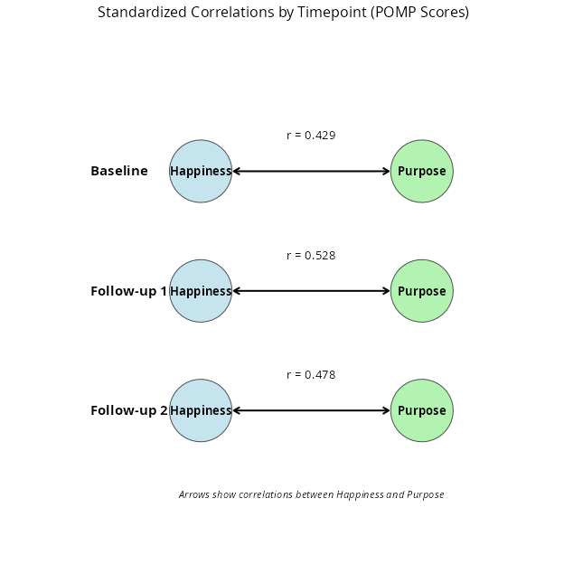

Figure 2

Cross-Lagged Panel Model of Purpose and Happiness with Standardized Path Coefficients

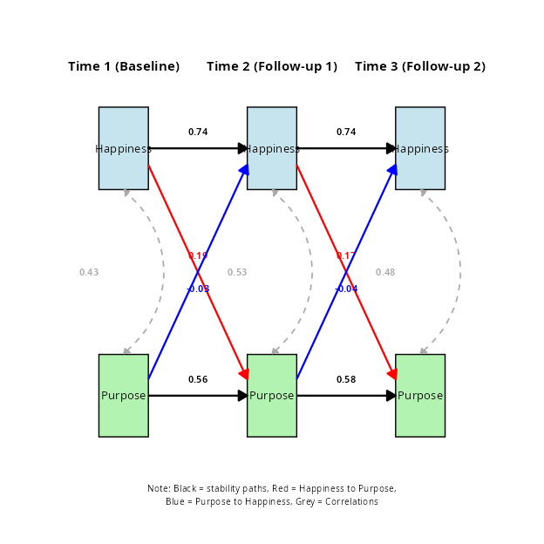

(a) Baseline: Happiness by Purpose in Life at Different Quantiles

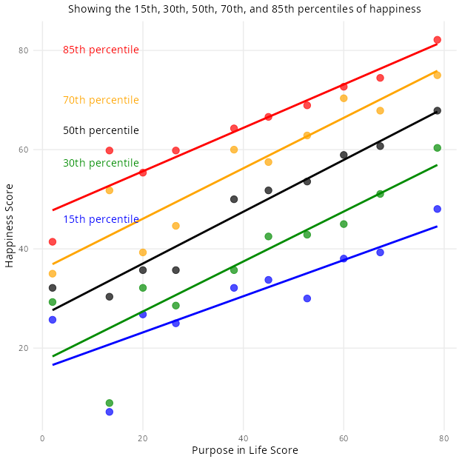

(b) Follow-up 1: Happiness by Purpose in Life at Different Quantiles

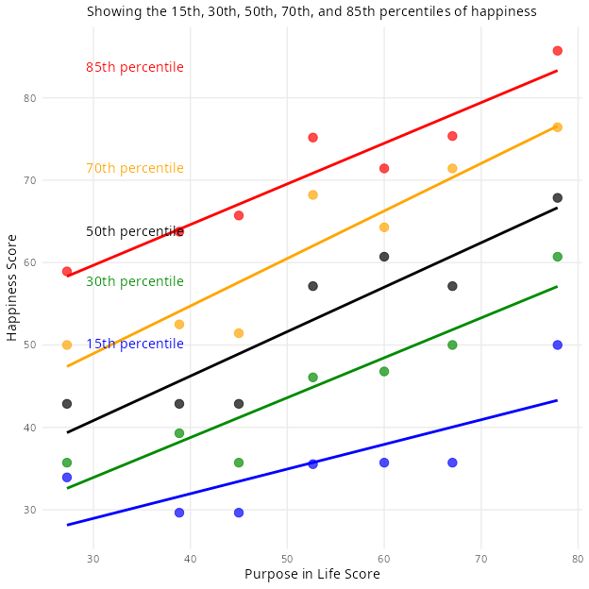

(c) Follow-up 2: Happiness by Purpose in Life at Different Quantiles

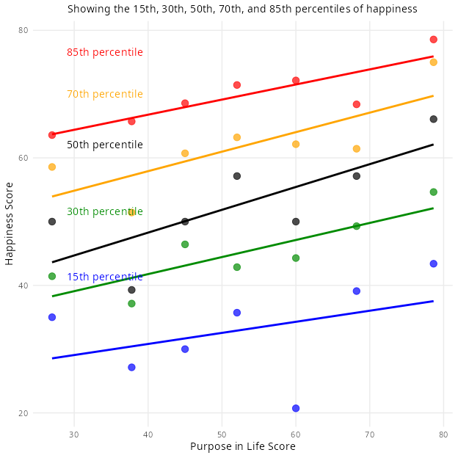

Figure 5

Quantile Regression Analysis of Purpose and Happiness

Figure 7

Comparative Analysis of Purpose-Happiness Relationship Across Timepoints

