Instructions for Downloading the MARCv2
and running a MARASM (Assembly Language) Program on the MARCv2

- Map a network drive to the EE375 file share, using explorer or from a command window

- Either, at the command prompt, use
Net Use S: \\usmasvddeecs\eecs\cadet\courses\ee\ee375\102
OR
SUBST s: “\\usmasvddeecs\eecs\cadet\courses\ee\ee375\102”
- OR, Using Explorer, map a network drive
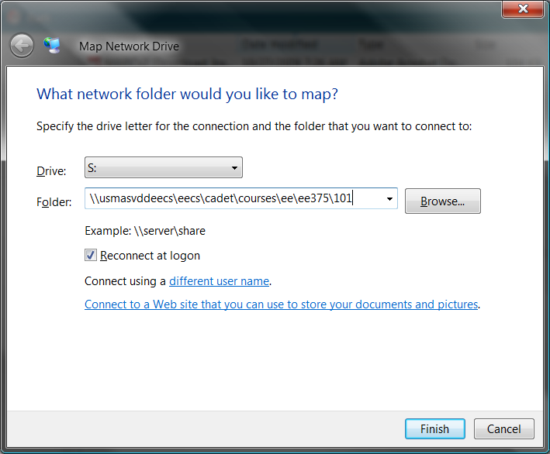

This mapping gives you access to the following files. Lab submissions will be in the S: directory structure. The following examples assume you have mapped S drive to the file share. If you use a different drive letter, modify the instructions appropriately.
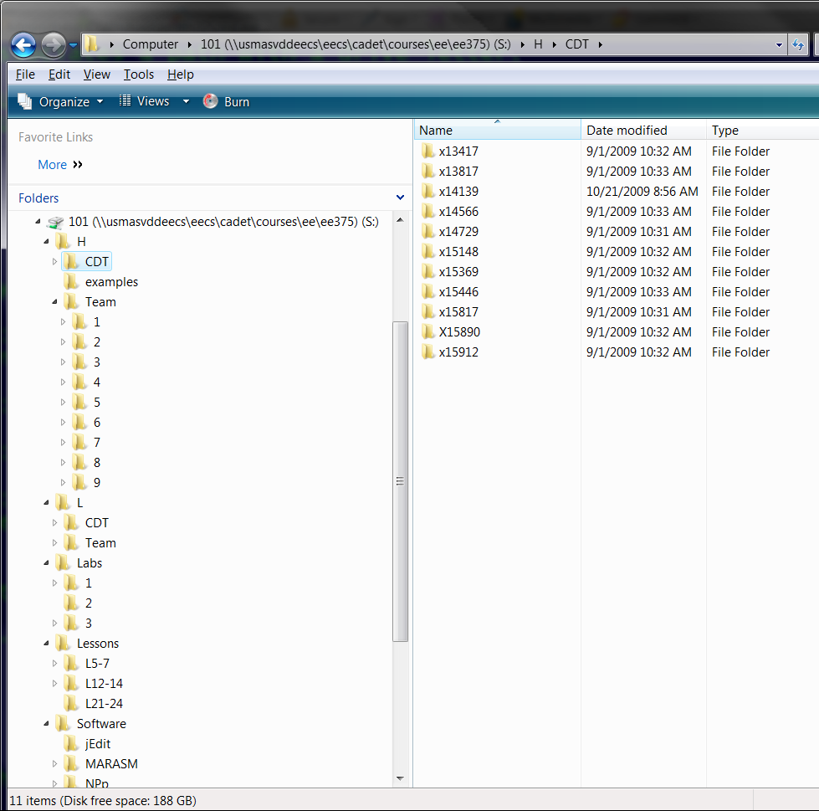
Notes:
Cdt folder
One x##### folder for
Each individual in class
For class file storage

Team Folder
One numbered folder 1-9 for each team for graded lab work submission

Lessons
Sample files and working examples used in class (VHDL, MSM, etc).

Software
MARASM – assembler
Jedit – a text editor
Notepad Plus – a text editor

- Start Active-HDL and create a new workspace and design
- VHDL Design Entry and next
- Create a New Workspace
- Default location will depend on your class hour, and whether you are using a team directory or personal directory
Team Example: S:\H\Team\1\lab5 (H hour team 1, lab 5 workspace)
Individual: S:\L\CDT\x16185\lab5 (L hour cadet with x number 16185, lab 5)
- Give it a name (CPU_102)
- Create an empty design→Next
- Use the default →Next
- give the design a name (can be same as workspace)—(CPU)
- Next, Finish

- The process above created a src folder along the following path:
Team Example: S:\H\Team\1\lab5\CPU_102\cpu\src
Individual: S:\L\CDT\x16185\lab5\CPU_102\cpu\src
Copy all of the files from the website into this directory using windows explorer.
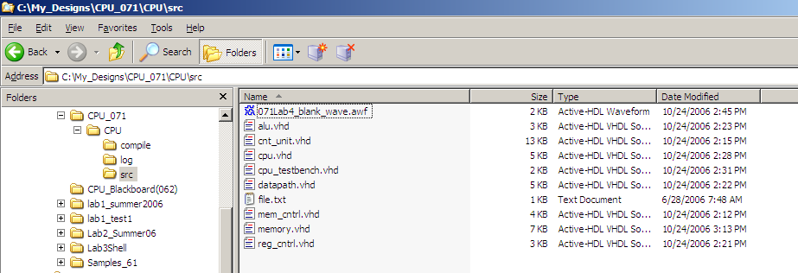

- In the Design Browser, double click “add a new file”
a. Select “Add Existing File”
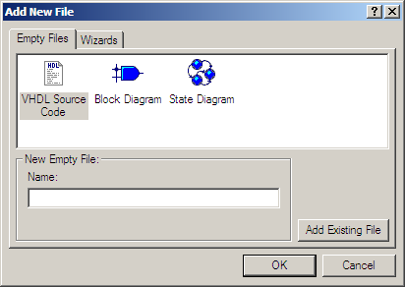

- Select all of the files (except for file.txt) (using the shift and control keys) and Select “Add”
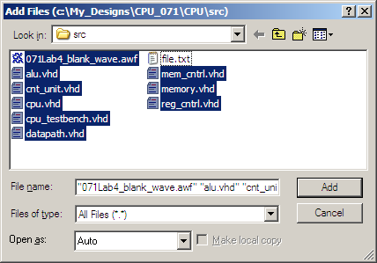

- Compile All
- You are now ready to run the program file.txt on the MARCv2
- Open the Waveform file.
- File..Save..As File_Waveform (creates a copy of the blank waveform for you to use)
- Use the Run For button (or F5) to start the simulation
  - If you do not get a waveform:
    - Go to the Structure Tab of the Design Browser
    - Select the dropdown box and click CPU_testbench (cpu_testbench)
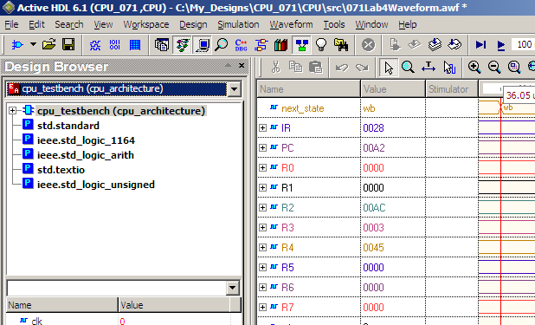
    - Restart the simulation and use the run for button again
- It takes 49 cycles for this program to run.
- When the MARCv2 gets the “hlt” command, it dumps the contents of memory to a file called Mem_dump.txt and then restarts executing the program. (In this file we didn’t write any memory contents, so the Mem-dump.txt file is an exact copy of file.txt.)

- To identify the end of the file, Search backwards to find 4000 (“hlt”) in the IR:
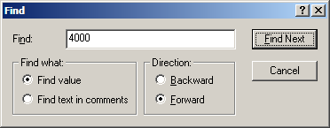

Note: This step doesn’t work for Active-HDL version 7.2. For this version, you need to search backwards to find a ‘1’ on the dump signal. (You can use the ‘find’ option in the cnt_unit.vhd file to understand why this will help you find the end of the program.)

