LISTING PBM PART 2

MEMBUAT FORM DI Android Studio

Form yang dibuat

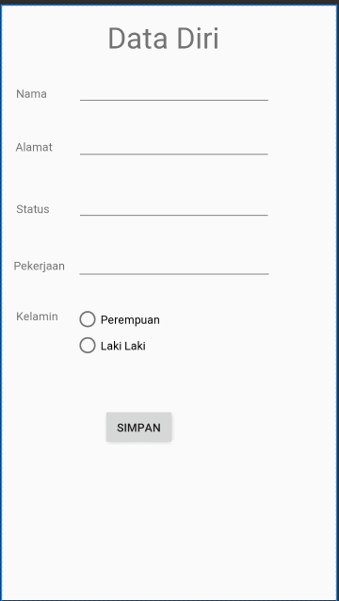

Menu menu yang digunakan

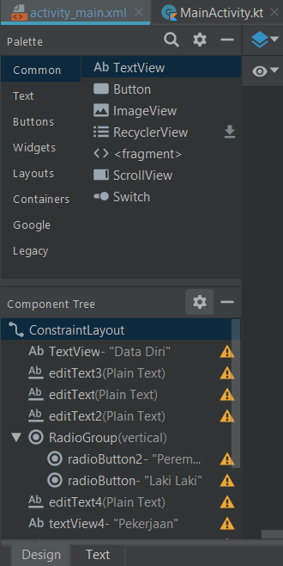

Kode program

|  |
| --- |
| <?xml version="1.0" encoding="utf-8"?> <androidx.constraintlayout.widget.ConstraintLayout xmlns:android="http://schemas.android.com/apk/res/android"  xmlns:app="http://schemas.android.com/apk/res-auto"  xmlns:tools="http://schemas.android.com/tools"  android:layout_width="match_parent"  android:layout_height="match_parent"  android:orientation="horizontal"  tools:context=".MainActivity">   <TextView  android:layout_width="wrap_content"  android:layout_height="wrap_content"  android:text="Data Diri"  android:textSize="36sp"  app:layout_constraintBottom_toBottomOf="parent"  app:layout_constraintHorizontal_bias="0.477"  app:layout_constraintLeft_toLeftOf="parent"  app:layout_constraintRight_toRightOf="parent"  app:layout_constraintTop_toTopOf="parent"  app:layout_constraintVertical_bias="0.022" />   <EditText  android:id="@+id/editText3"  android:layout_width="238dp"  android:layout_height="53dp"  android:ems="10"  android:inputType="textPersonName"  android:text=""  app:layout_constraintBottom_toBottomOf="parent"  app:layout_constraintEnd_toEndOf="parent"  app:layout_constraintHorizontal_bias="0.539"  app:layout_constraintStart_toStartOf="parent"  app:layout_constraintTop_toTopOf="parent"  app:layout_constraintVertical_bias="0.316"  tools:ignore="MissingConstraints" />   <EditText  android:id="@+id/editText"  android:layout_width="239dp"  android:layout_height="46dp"  android:ems="10"  android:inputType="textPersonName"  android:text=""  app:layout_constraintBottom_toBottomOf="parent"  app:layout_constraintEnd_toEndOf="parent"  app:layout_constraintHorizontal_bias="0.54"  app:layout_constraintStart_toStartOf="parent"  app:layout_constraintTop_toTopOf="parent"  app:layout_constraintVertical_bias="0.116"  tools:ignore="MissingConstraints" />   <EditText  android:id="@+id/editText2"  android:layout_width="238dp"  android:layout_height="48dp"  android:ems="10"  android:inputType="textPersonName"  android:text=""  app:layout_constraintBottom_toBottomOf="parent"  app:layout_constraintEnd_toEndOf="parent"  app:layout_constraintHorizontal_bias="0.539"  app:layout_constraintStart_toStartOf="parent"  app:layout_constraintTop_toTopOf="parent"  app:layout_constraintVertical_bias="0.211"  tools:ignore="MissingConstraints" />   <RadioGroup  android:layout_width="245dp"  android:layout_height="77dp"  app:layout_constraintBottom_toBottomOf="parent"  app:layout_constraintEnd_toEndOf="parent"  app:layout_constraintHorizontal_bias="0.543"  app:layout_constraintStart_toStartOf="parent"  app:layout_constraintTop_toTopOf="parent"  app:layout_constraintVertical_bias="0.566">   <RadioButton  android:id="@+id/radioButton2"  android:layout_width="246dp"  android:layout_height="wrap_content"  android:text="Perempuan" />   <RadioButton  android:id="@+id/radioButton"  android:layout_width="match_parent"  android:layout_height="wrap_content"  android:text="Laki Laki" />  </RadioGroup>   <EditText  android:id="@+id/editText4"  android:layout_width="240dp"  android:layout_height="50dp"  android:ems="10"  android:inputType="textPersonName"  android:text=""  app:layout_constraintBottom_toBottomOf="parent"  app:layout_constraintEnd_toEndOf="parent"  app:layout_constraintHorizontal_bias="0.539"  app:layout_constraintStart_toStartOf="parent"  app:layout_constraintTop_toTopOf="parent"  app:layout_constraintVertical_bias="0.425"  tools:ignore="MissingConstraints" />   <TextView  android:id="@+id/textView4"  android:layout_width="wrap_content"  android:layout_height="wrap_content"  android:text="Pekerjaan"  app:layout_constraintBottom_toBottomOf="parent"  app:layout_constraintEnd_toEndOf="parent"  app:layout_constraintHorizontal_bias="0.045"  app:layout_constraintStart_toStartOf="parent"  app:layout_constraintTop_toTopOf="parent"  app:layout_constraintVertical_bias="0.436" />   <TextView  android:id="@+id/textView2"  android:layout_width="wrap_content"  android:layout_height="wrap_content"  android:text="Alamat"  app:layout_constraintBottom_toBottomOf="parent"  app:layout_constraintEnd_toEndOf="parent"  app:layout_constraintHorizontal_bias="0.049"  app:layout_constraintStart_toStartOf="parent"  app:layout_constraintTop_toTopOf="parent"  app:layout_constraintVertical_bias="0.231" />   <TextView  android:id="@+id/textView"  android:layout_width="wrap_content"  android:layout_height="wrap_content"  android:text="Nama"  app:layout_constraintBottom_toBottomOf="parent"  app:layout_constraintEnd_toEndOf="parent"  app:layout_constraintHorizontal_bias="0.05"  app:layout_constraintStart_toStartOf="parent"  app:layout_constraintTop_toTopOf="parent"  app:layout_constraintVertical_bias="0.139"  tools:ignore="MissingConstraints" />   <TextView  android:id="@+id/textView3"  android:layout_width="wrap_content"  android:layout_height="wrap_content"  android:text="Status"  app:layout_constraintBottom_toBottomOf="parent"  app:layout_constraintEnd_toEndOf="parent"  app:layout_constraintHorizontal_bias="0.051"  app:layout_constraintStart_toStartOf="parent"  app:layout_constraintTop_toTopOf="parent"  app:layout_constraintVertical_bias="0.338" />   <TextView  android:id="@+id/textView5"  android:layout_width="wrap_content"  android:layout_height="wrap_content"  android:text="Kelamin"  app:layout_constraintBottom_toBottomOf="parent"  app:layout_constraintEnd_toEndOf="parent"  app:layout_constraintHorizontal_bias="0.052"  app:layout_constraintStart_toStartOf="parent"  app:layout_constraintTop_toTopOf="parent"  app:layout_constraintVertical_bias="0.523" />   <Button  android:id="@+id/button"  android:layout_width="wrap_content"  android:layout_height="wrap_content"  android:text="Simpan"  app:layout_constraintBottom_toBottomOf="parent"  app:layout_constraintEnd_toEndOf="parent"  app:layout_constraintHorizontal_bias="0.387"  app:layout_constraintStart_toStartOf="parent"  app:layout_constraintTop_toTopOf="parent"  app:layout_constraintVertical_bias="0.724" />  </androidx.constraintlayout.widget.ConstraintLayout> |

Hasil di emulator

