# Task – 2 [ Information Gathering using maltego ]

**Step 1)** Open maltego , setup an account and login

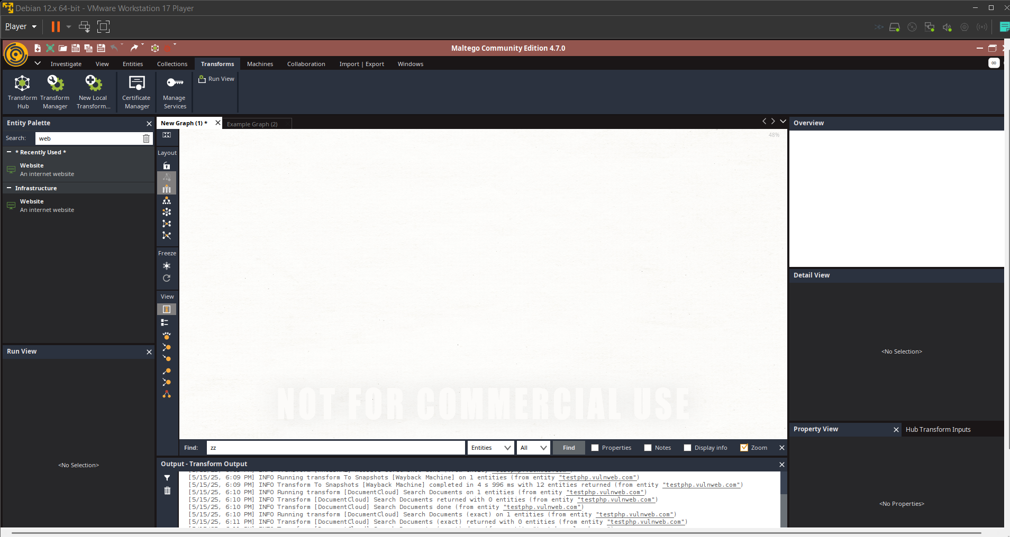

**Step 2)** Search for website and drag the website to the graph.

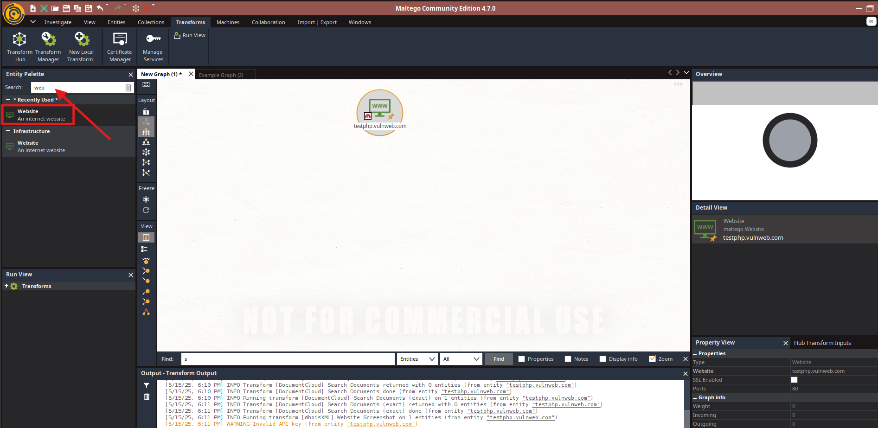

**Step 3) D**ouble click on the entity and enter the url of your target. Now it is testphp.vulnweb.com

**Step 4)**  Right click on the entity and select transform.

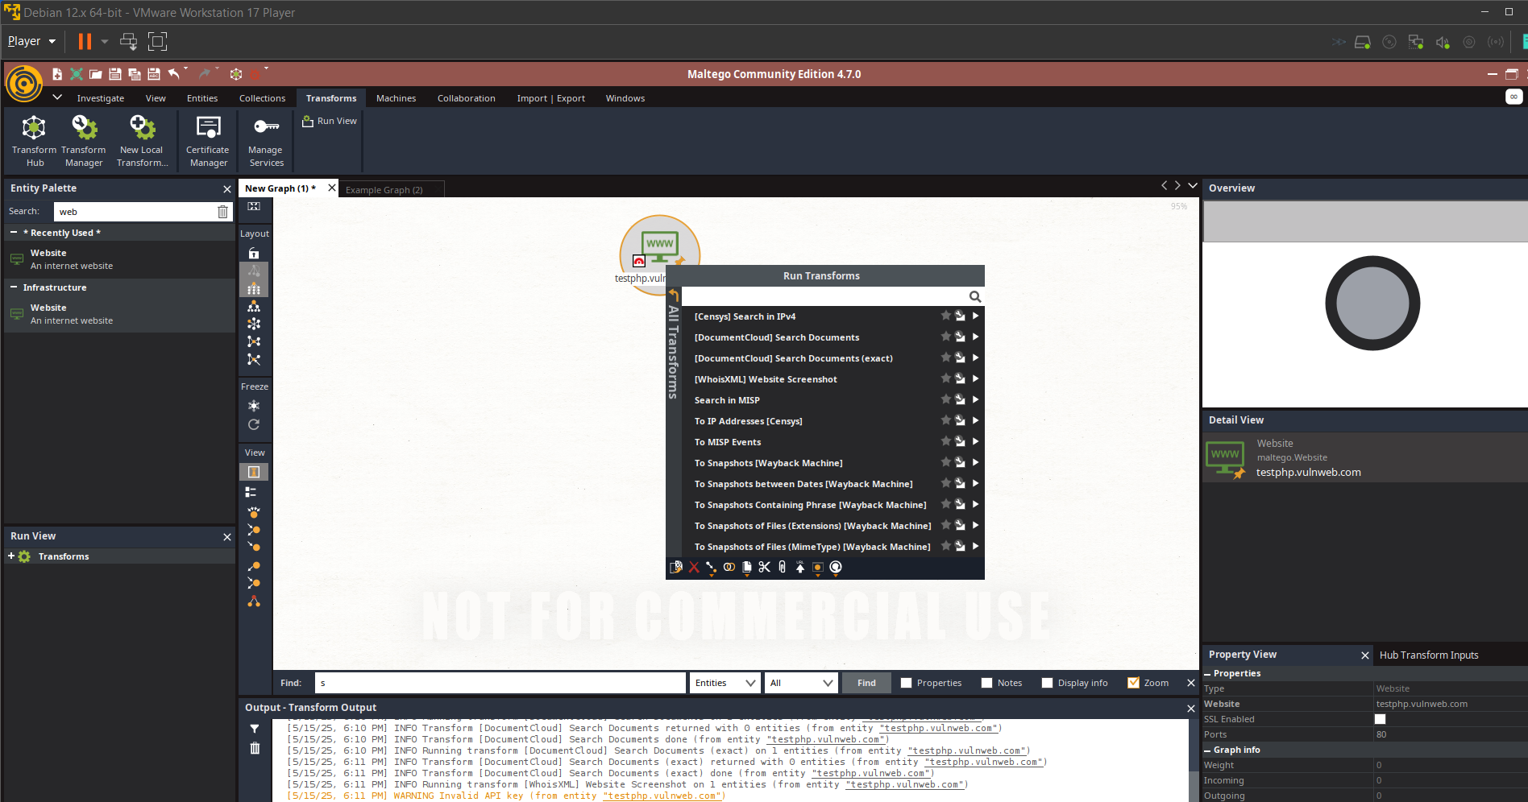

**Step 5)** Click on the transform to run it and it will find all info about the web (as per its ability if in case your downloaded transforms are not giving you info try to download and install other) and repeat the same steps.

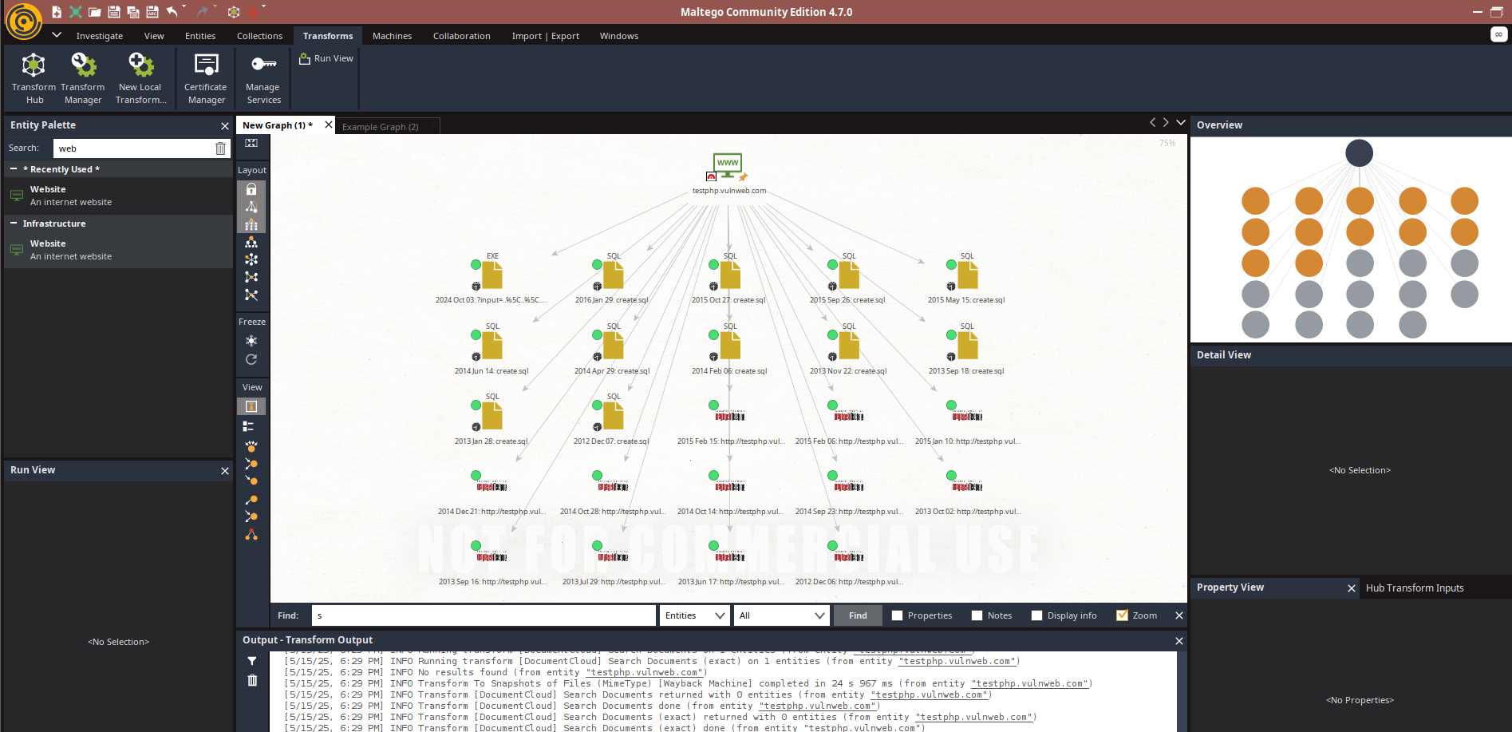

Here I found some wayback urls and filenames with extension by running transforms now we can further run transforms on all of them by clicking on them one by one