**Smart Room System**

**Admin Web Guide**

|  |  |  |  |  |
| --- | --- | --- | --- | --- |
| Service Name | Smart Room System | | | |
| Writer | MyungHoon Jung | | Created | 2018.5.02 |
| Confirm | | | | |
| **CSI** | | **Jackie Lee** | | |
| **HandySoft** | | **MyungHoon Jung** | | |

# Login

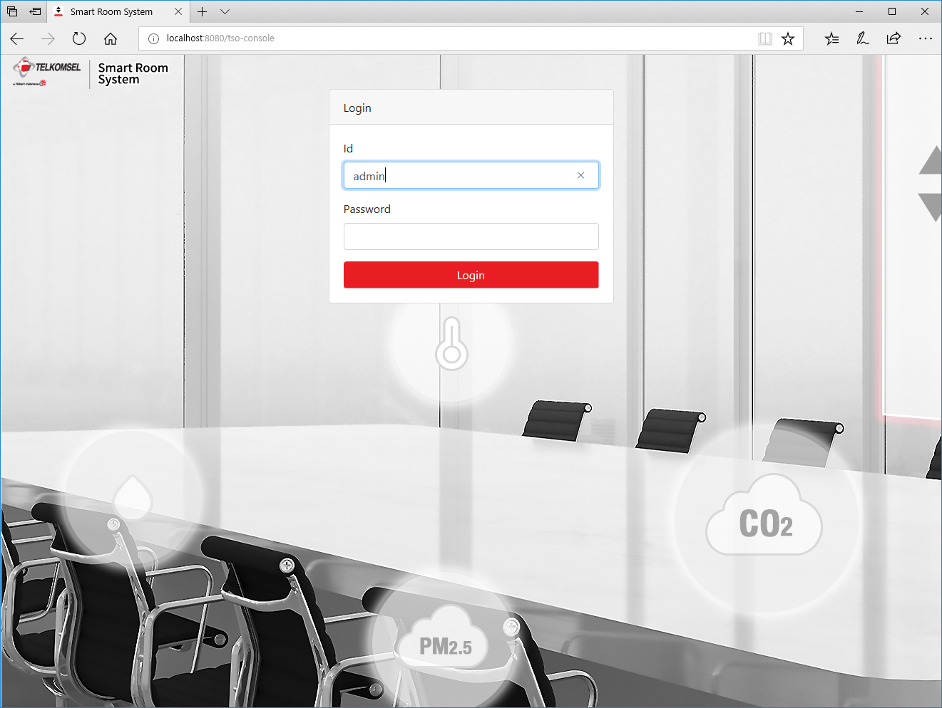

Log in to the Admin Web Page with your ID and Password.

# Dashboard

On this menu, you can check the room’s environmental status values and control the lamp, temperature and blinds.

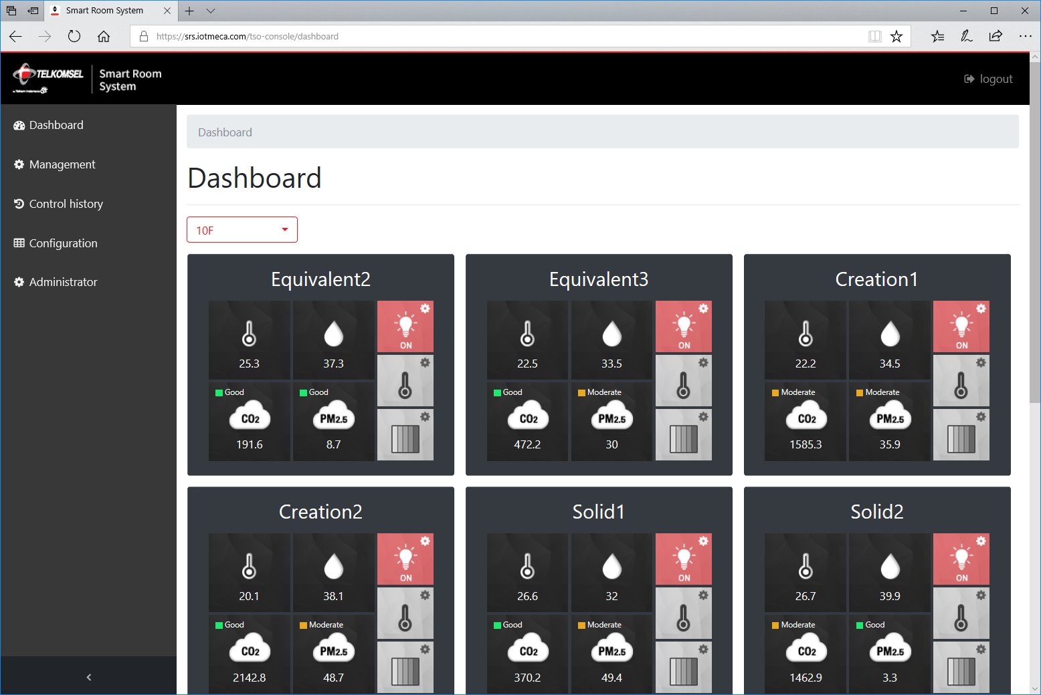

Select a floor by the floor selection  and check meeting rooms.

To control the lamp of the room, press a button 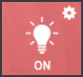 on the room information card.

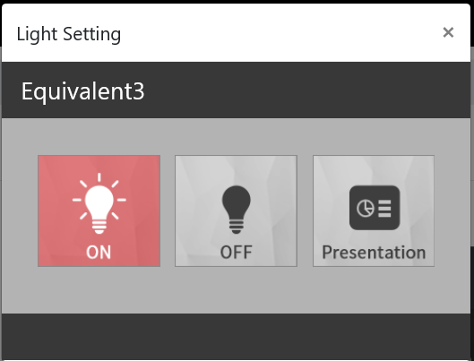 Press the lamp status button you want to change.

To control the temperature of the room, press a button 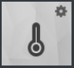 on the room information card.

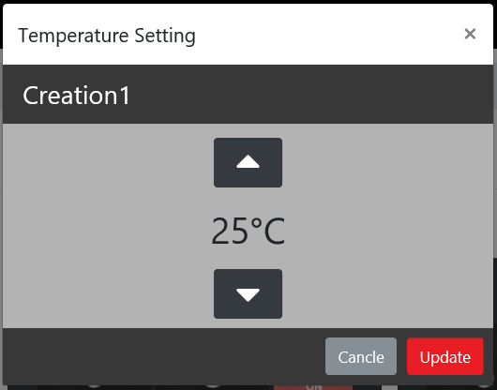 Set the temperature you want to change and press the Update button.

To control blinds of the room, press a button 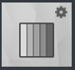 on the room information card.

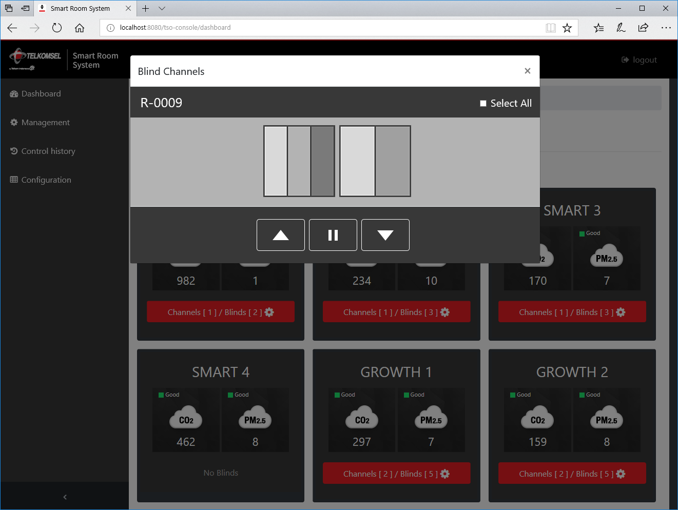 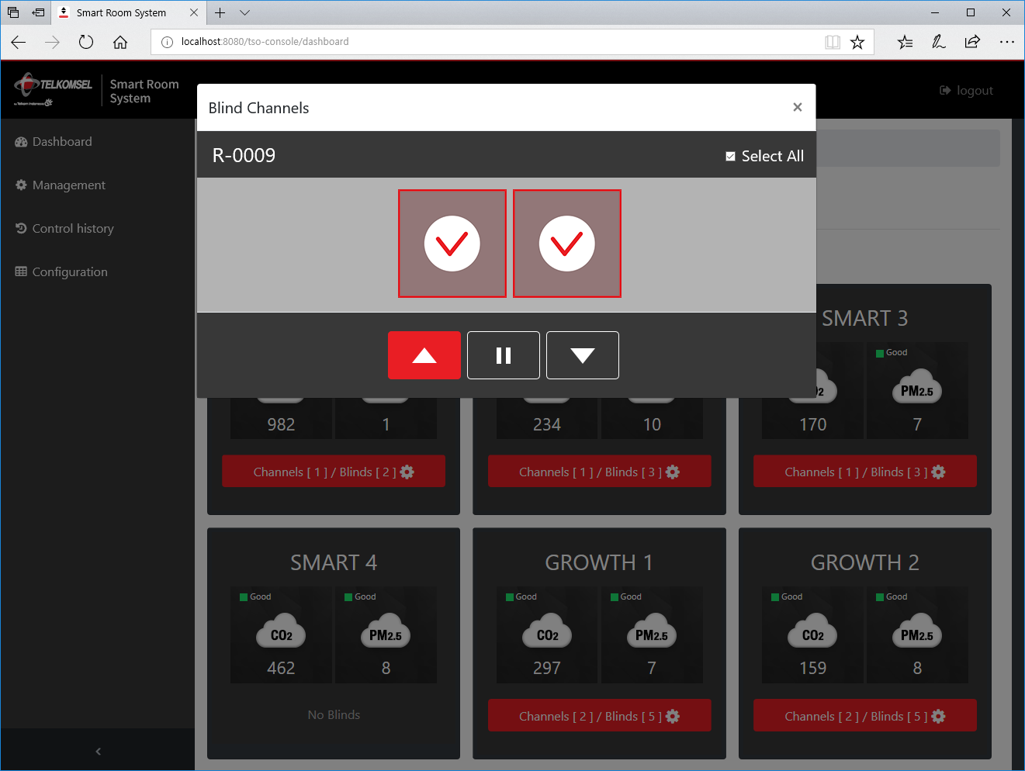

Click blind channels you want to control and press the directional button you wish to move.

# Management

On this menu, you can update room details and add a new room.

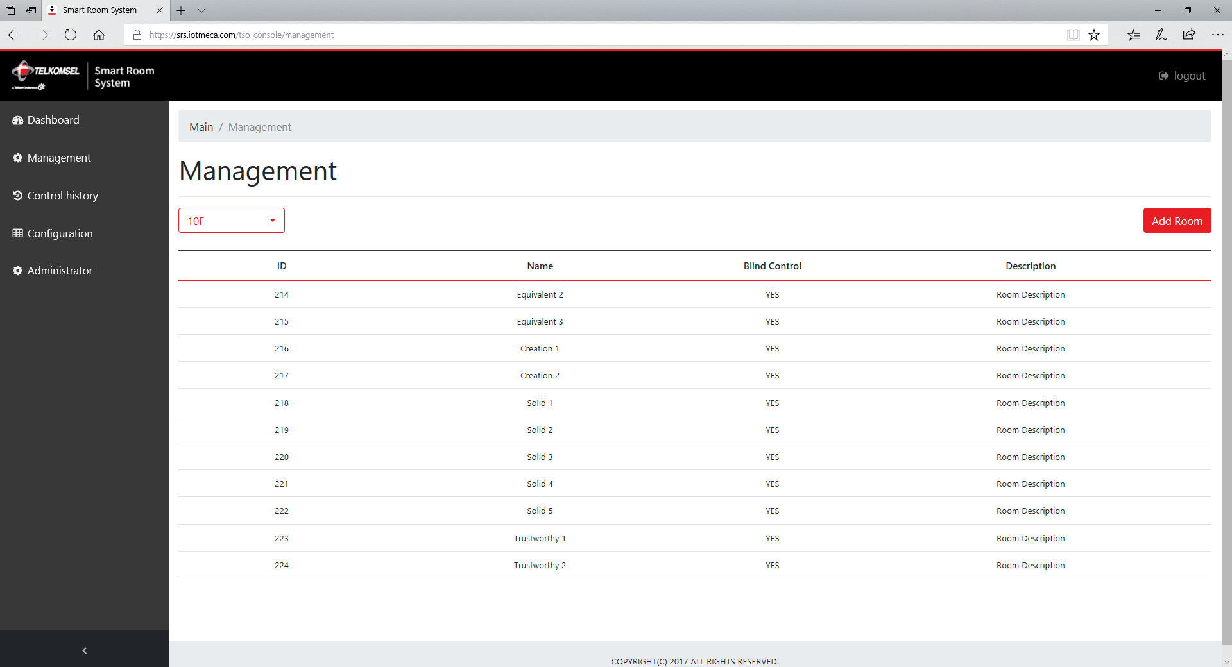

Select a floor by the floor selection and check meeting rooms.

To add a new room, press the button in the upper right corner of the screen.

To view room details, click on a Room name on the list.

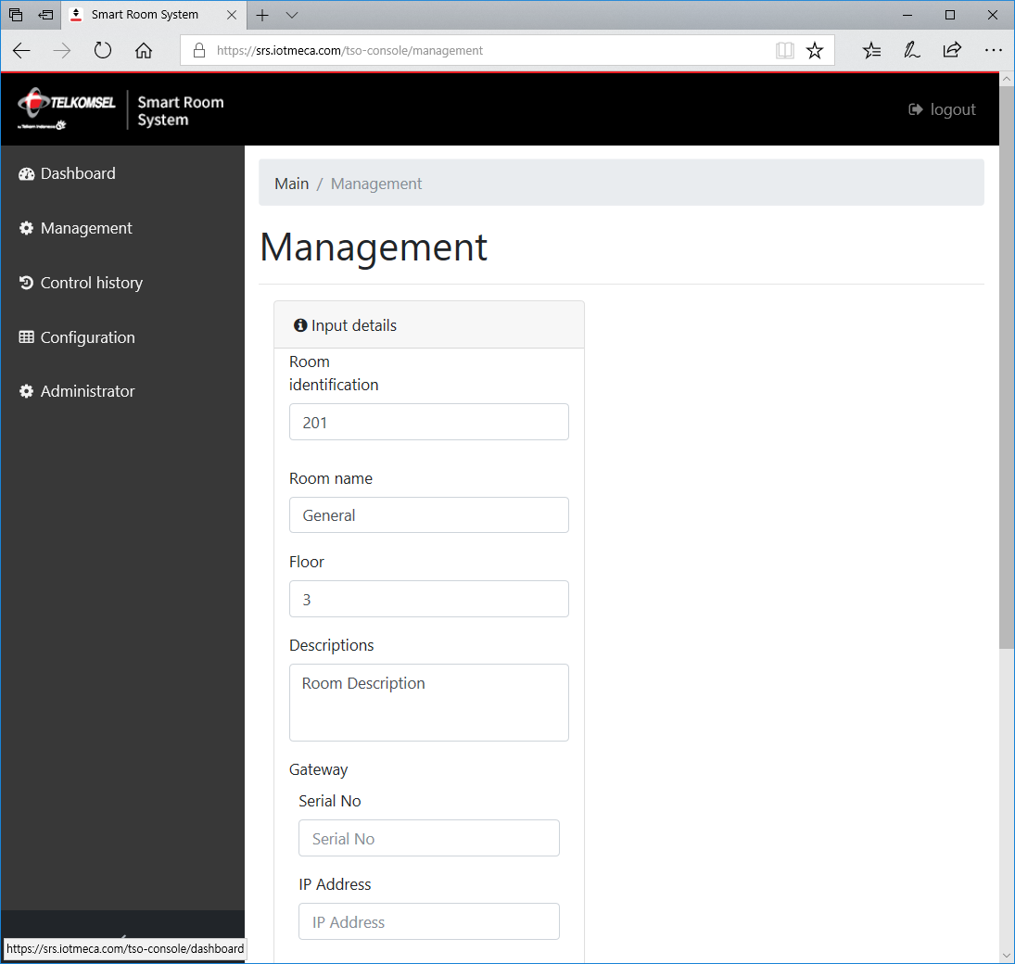 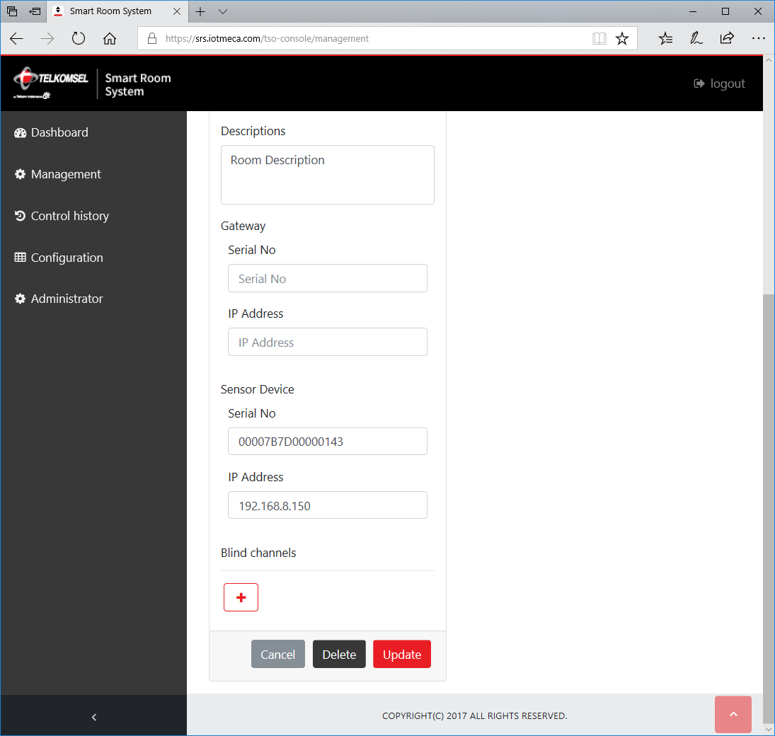

You can update any attirbute of the room.

# Control History

On this menu, you can see who has controlled the blinds of the rooms.

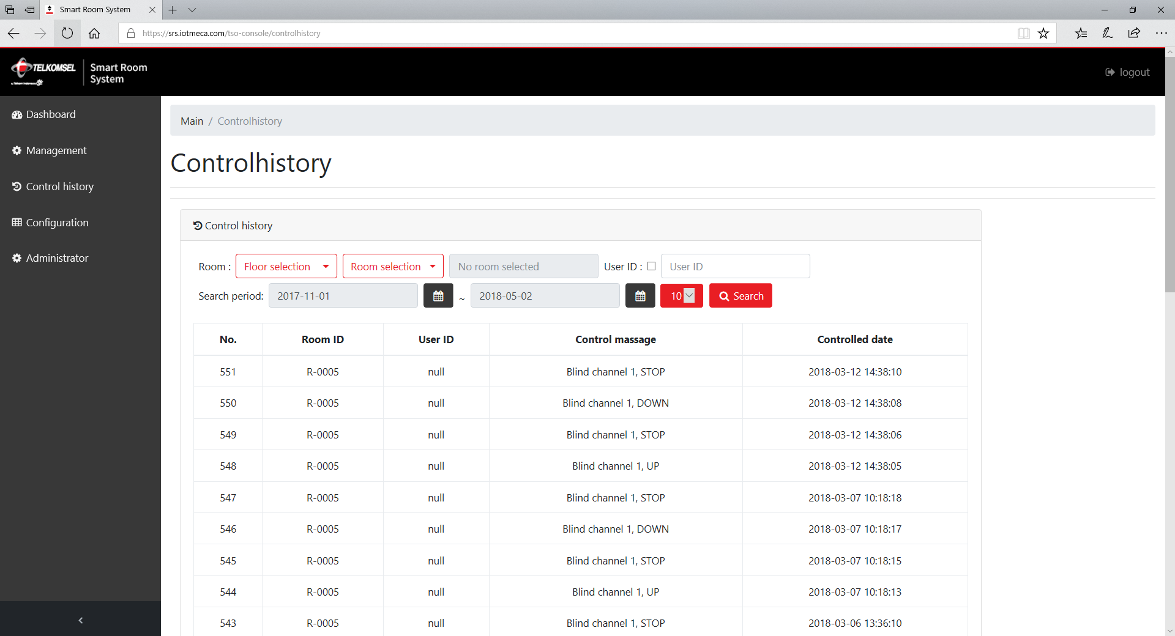

To view a specific room’s control histories, select the room using the selections.

To view a specific user’s control histoies, enter the user-id into the User ID input box.

# Configuration

On this menu, you can update whole room information by uploading configuration Excel file to the Smart Room System server.

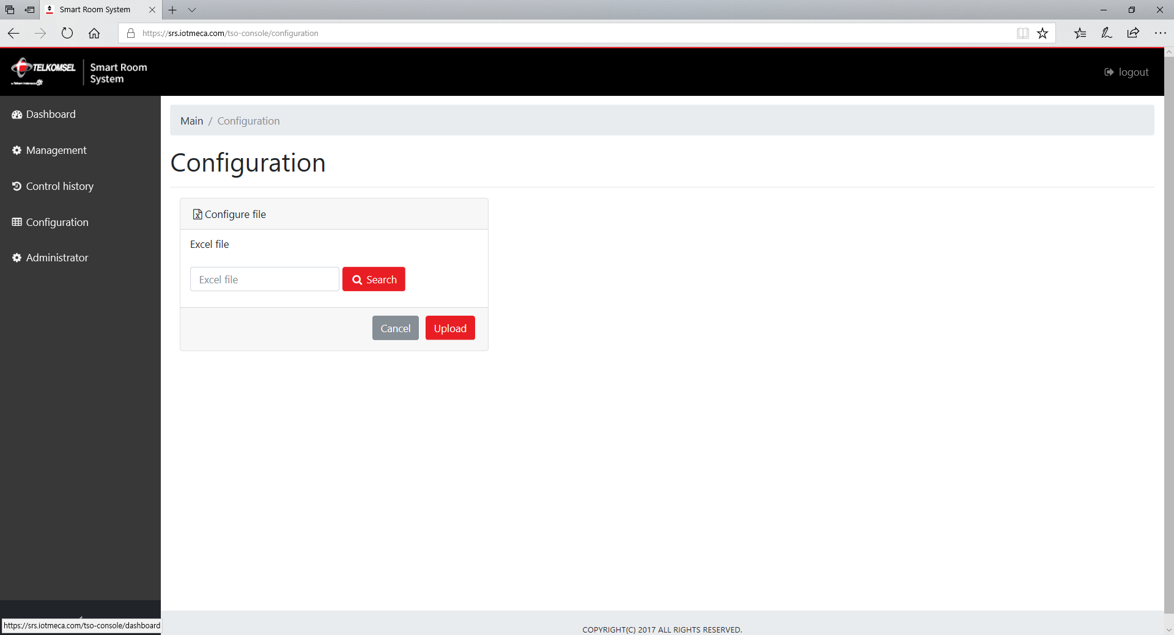

Search the configuration Excel file and press the ‘Upload’ button.

* Notice: The format of the configuration excel file is strict, so you must refer the preshared configuration excel file.

# Administrator

On this menu, you can manage administrator members.

Only administrator members can access Smart Room System Admin Web pages.

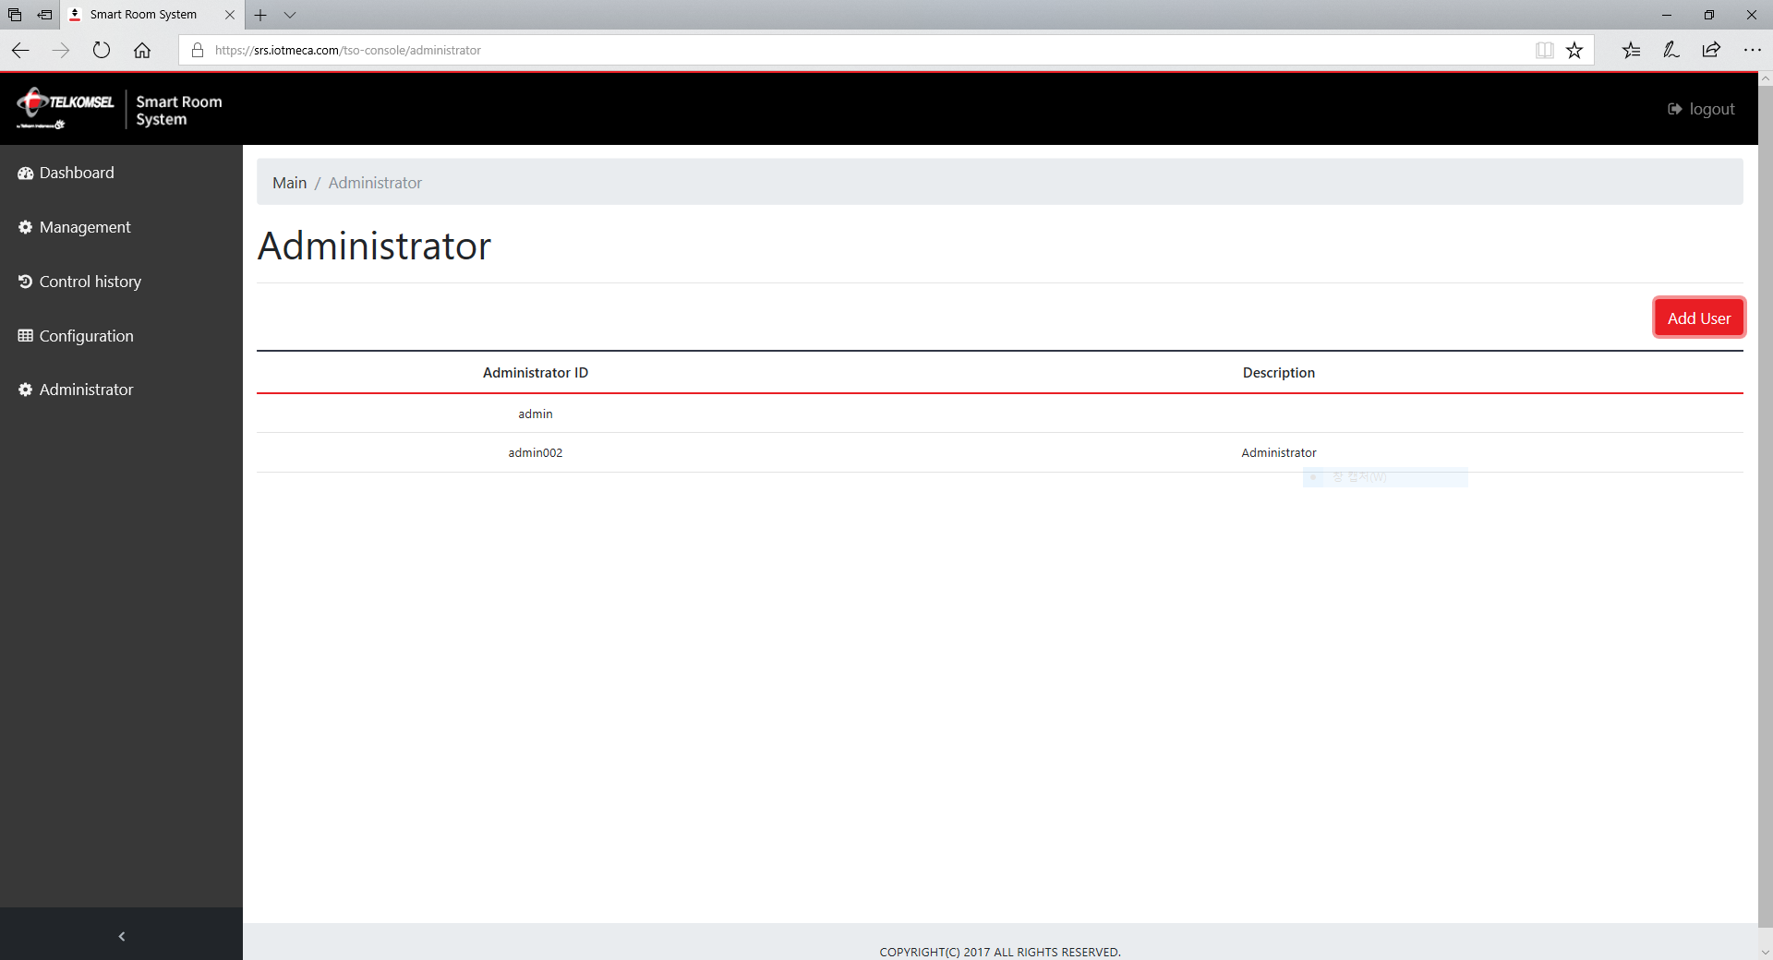

To add a new member, press the ‘Add User’ button.

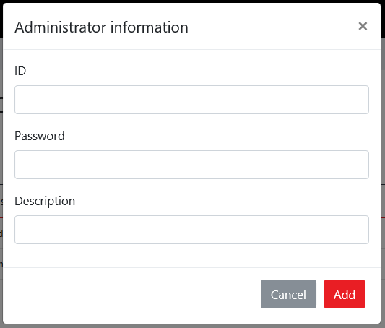

<End>