**Smart Room System**

**Mobile APP User Guide**

|  |  |  |  |  |
| --- | --- | --- | --- | --- |
| Service Name | Smart Room System | | | |
| Writer | MyungHoon Jung | | Created | 2018.5.04 |
| Confirm | | | | |
| **CSI** | | **Jackie Lee** | | |
| **HandySoft** | | **MyungHoon Jung** | | |

# Login

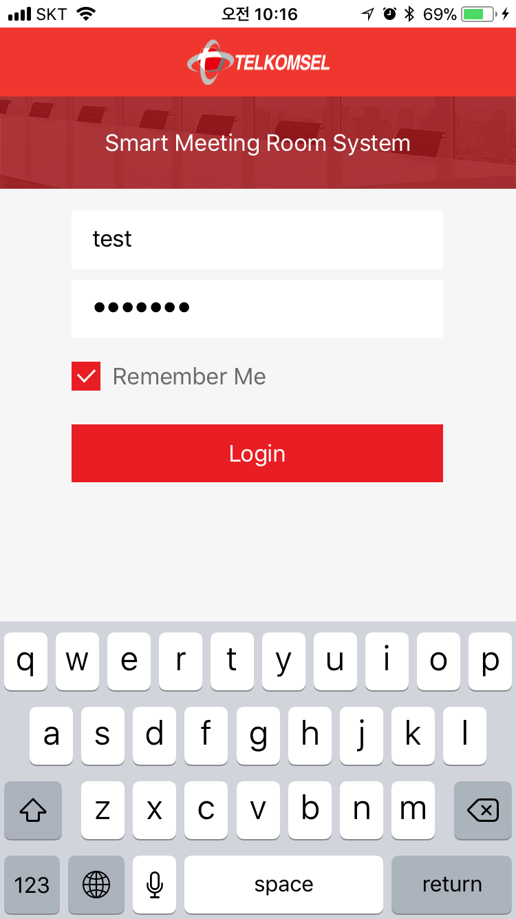

Log in to the Smart-Room-System App with your ID and password.

# Select Floor

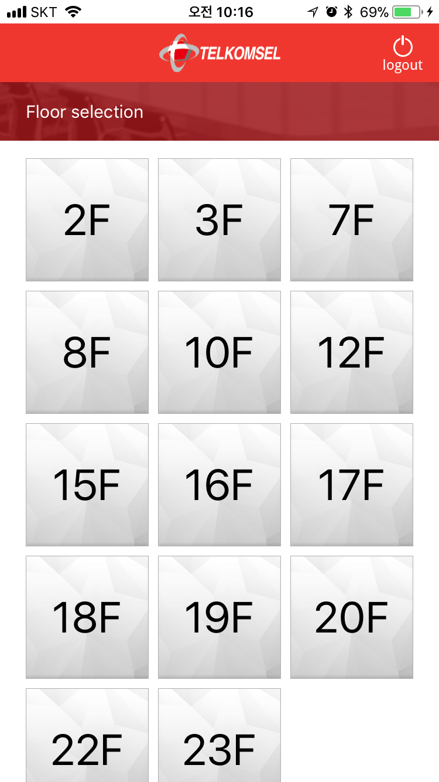

Touch a floor number button on the list.

# Select Room

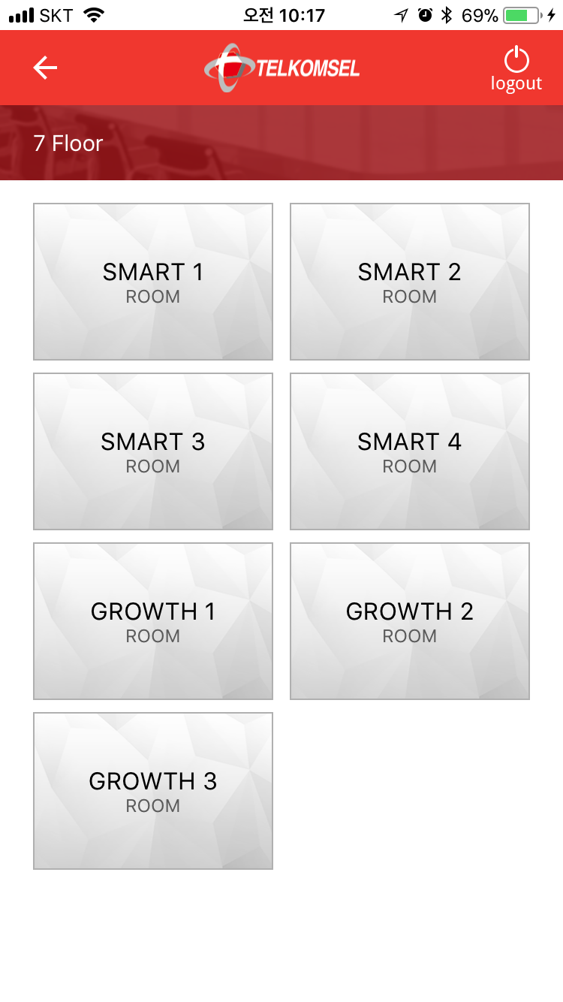

Touch a room name button on the list.

# View Room Status

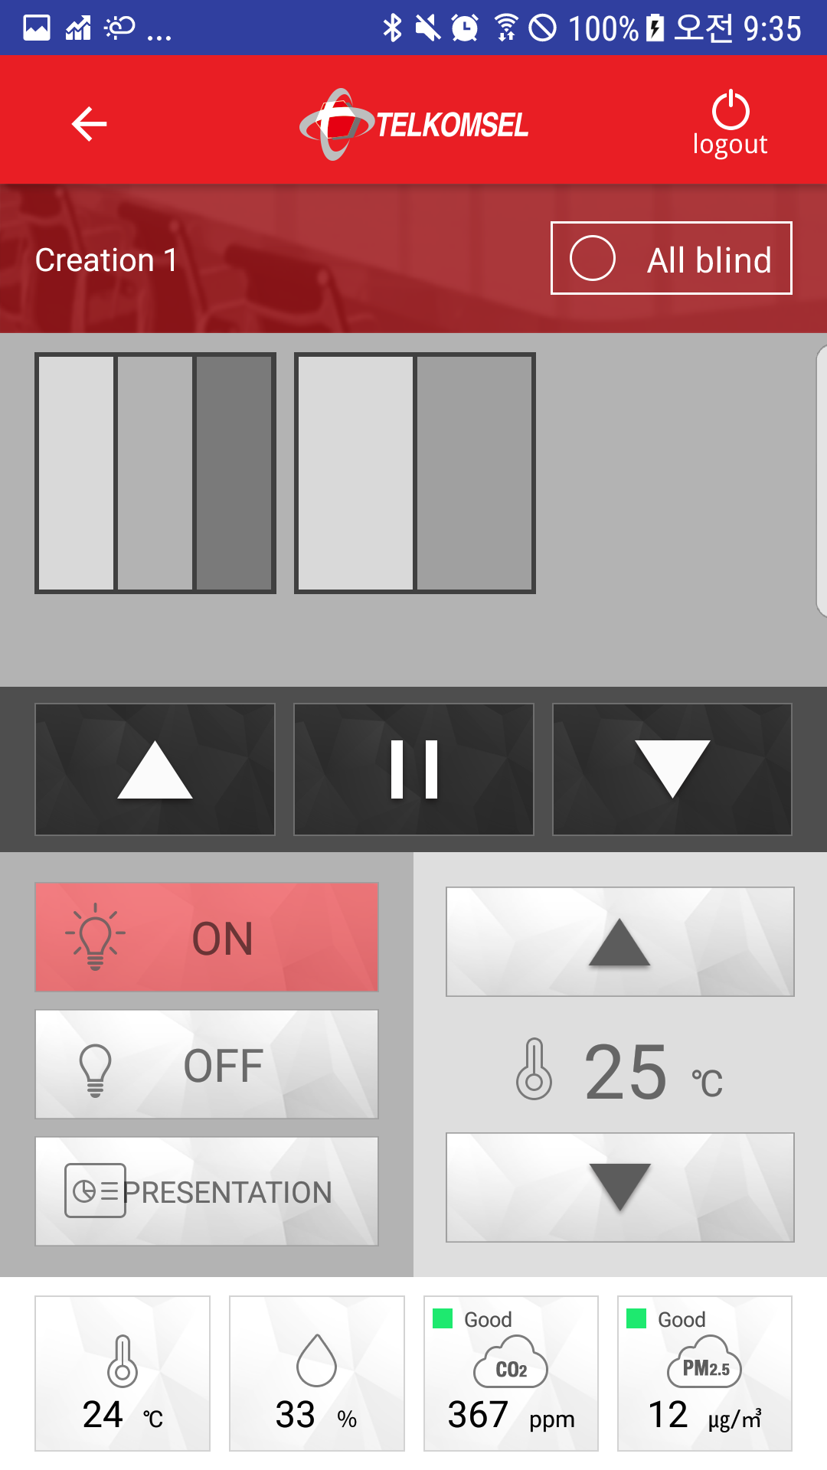

You can see the control panels and the environmental status values.

Note: The room ‘Creation 1’ has two channels and each channel has three blinds and two blinds.

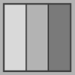 The first channel has three blinds.

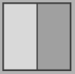 The second channel has two blinds.

# Use Control Panels

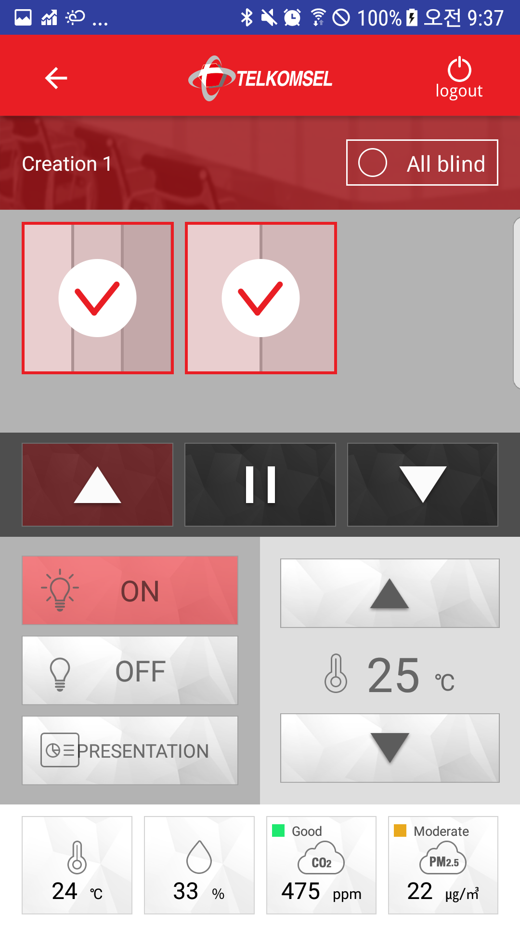

1) To control blinds, touch the blind channels you want to control and touch the directional button you wish to move.

2) To control the lamp status, touch the lamp status button you want to change.

3) To adjust temperature, touch the ‘Up arrow’ or ‘Down arrow’ button.