**Smart Room System**

**Android Pad User Guide**

|  |  |  |  |  |
| --- | --- | --- | --- | --- |
| Service Name | Smart Room System | | | |
| Writer | MyungHoon Jung | | Created | 2018.5.02 |
| Confirm | | | | |
| **CSI** | | **Jackie Lee** | | |
| **HandySoft** | | **MyungHoon Jung** | | |

# Login

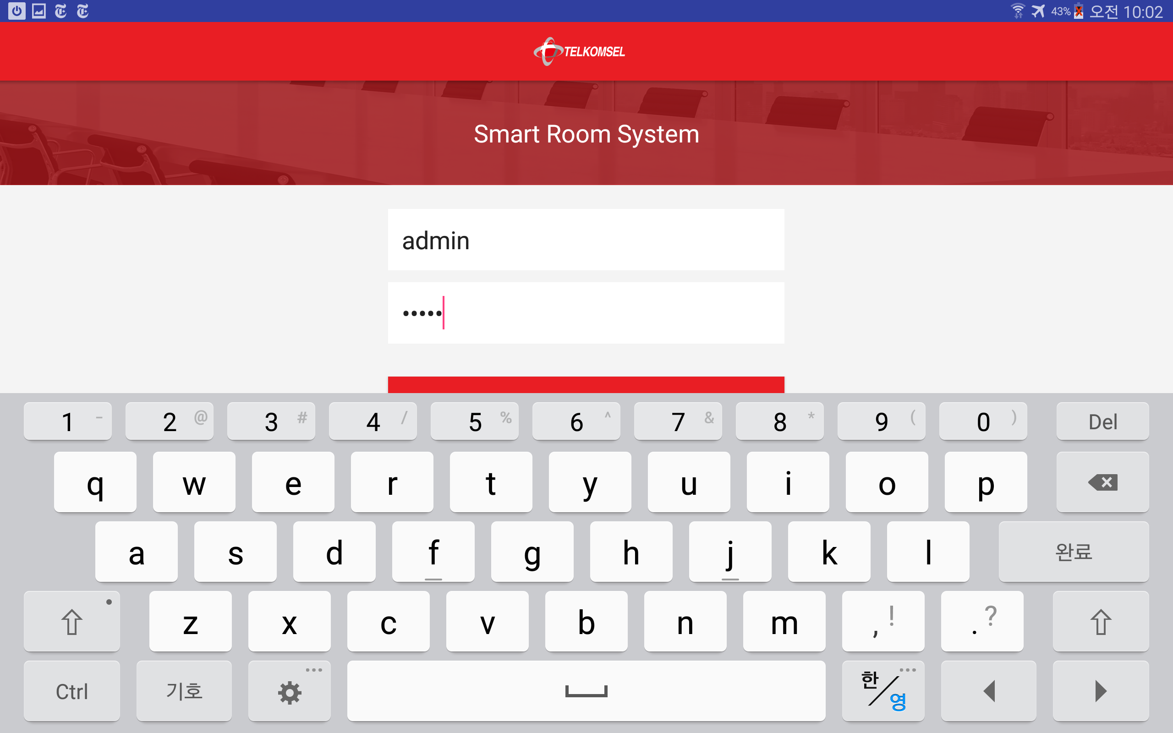

Log in to the Smart-Room-System App with your ID and password.

# Set Room

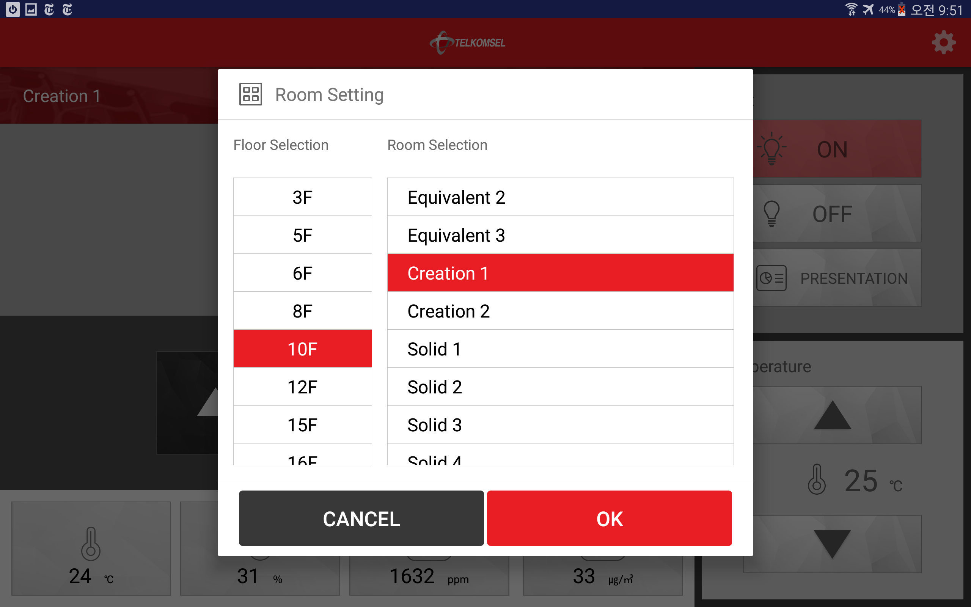

To set a specific room for your Android Pad App, touch the button  in the upper right corner of the screen and select ‘Room Setting’ on the menu list.

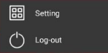 * Only users with administrator privilege can see the menu ‘Room Setting’.

After ‘Room Setting’ screen pops up, select a floor number, select the room and press the ‘OK’ button.

# View Room Status

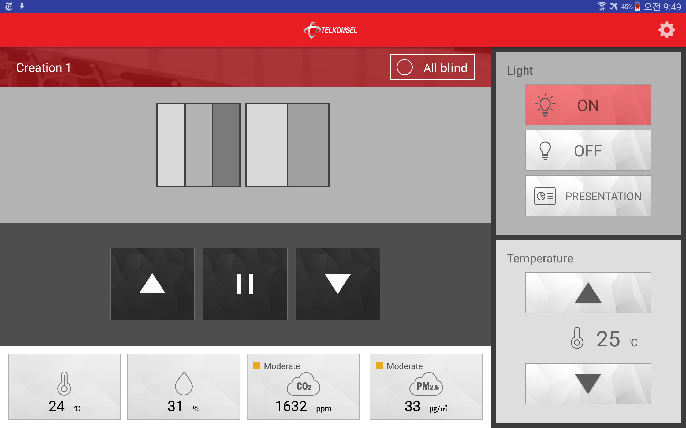

You can see the control panel and the environmental status values.

The room ‘Creation 1’ has two channels and each channel has three blinds and two blinds.

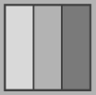 The first channel has three blinds.

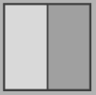 The second channel has two blinds.

# Use Control Panels

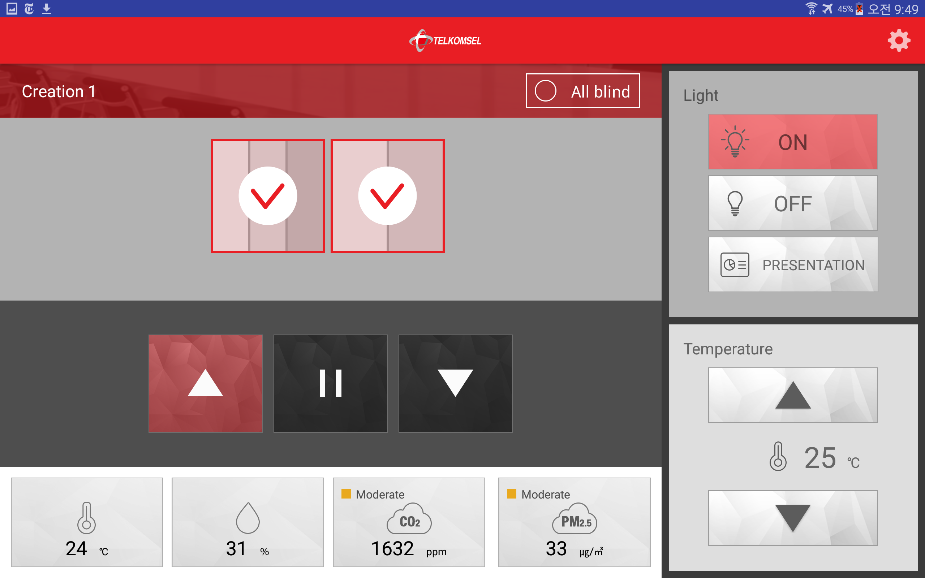

1) To control blinds, touch the blind channels you want to control and touch the directional button you wish to move.

2) To control the lamp status, touch the lamp status button you want to change.

3) To adjust temperature, touch the ‘Up arrow’ or ‘Down arrow’ button.