**Smart Room System**

**System Administrator Guide**

|  |  |  |  |  |
| --- | --- | --- | --- | --- |
| Service Name | Smart Room System | | | |
| Writer | MyungHoon Jung | | Created | 2018.5.28 |
| Confirm | | | | |
| **CSI** | | **Jackie Lee** | | |
| **HandySoft** | | **MyungHoon Jung** | | |

# Overview

This document is the operating manual for the server administrator of the Smart Room system.

# Service System Diagram

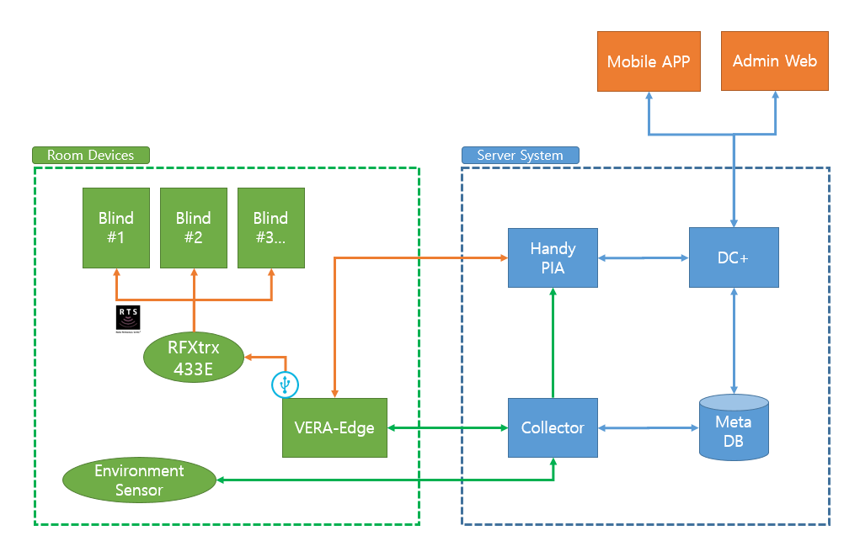

# S/W Diagram

1. DC+: Web server for interfacing with mobile apps and the administration web.
2. Collector: Module for environmental data collection.
3. HandyPIA: OneM2M platform server for the IoT service.
4. MetaDB: Database for managing room information.

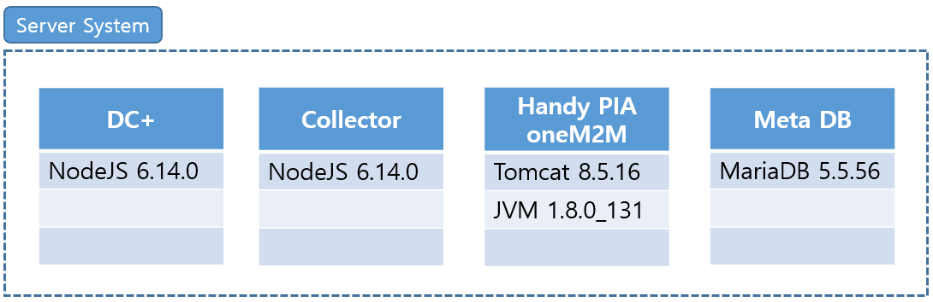

# Server Manage

1. Server Info.

* IP Address: 192.168.0.18
* Used ports:
  + DC-Plus: 8080
  + Collector: 3000
  + HandyPIA-oneM2M: 8081
  + MariaDB: 3306
  + SNMP: 161

1. Installation path & Source location

* Service (DC+, Collector, HandyPIA-oneM2M)
  + Account: sary
  + Path: HOME=/home/sary/server/*
* DB (mariadb)
  + Installed using the ‘yum’ package manager with root privilege.
  + Default location: /var/lib/mysql

1. Procedure of service start and stop
   * Service (Manage script: /home/sary/srs-manager.sh)
     + Start: $. /srs-manager.sh start
     + Stop: $. /srs-manager.sh stop
     + Restart: $. /srs-manager.sh restart
     + Status: $. /srs-manager.sh status
   * DB (Mariadb has been installed as a service, so it started automatically after server rebooting)
     + Start: systemctl start mysqld
     + Stop systemctl stop mysqld
2. Service check

* Access using a web browser: <http://127.0.0.1:8080>
* Default administrator account: admin / admin

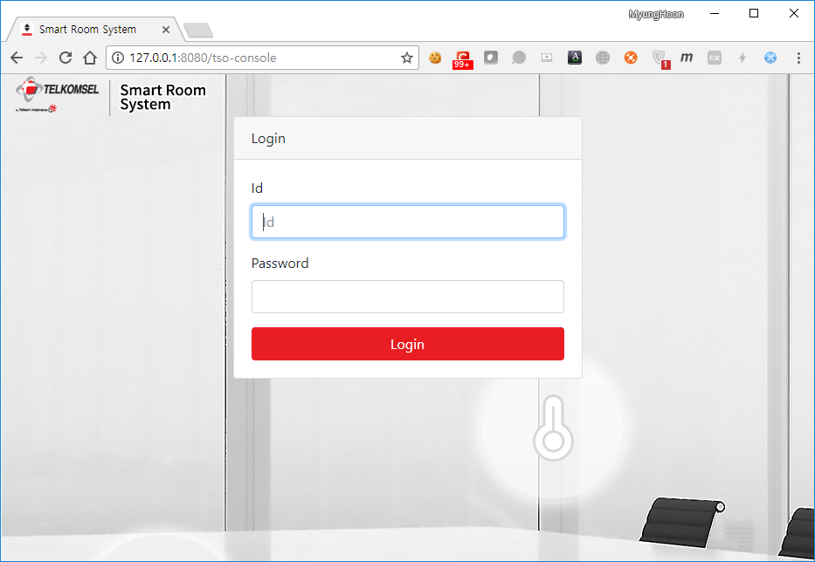 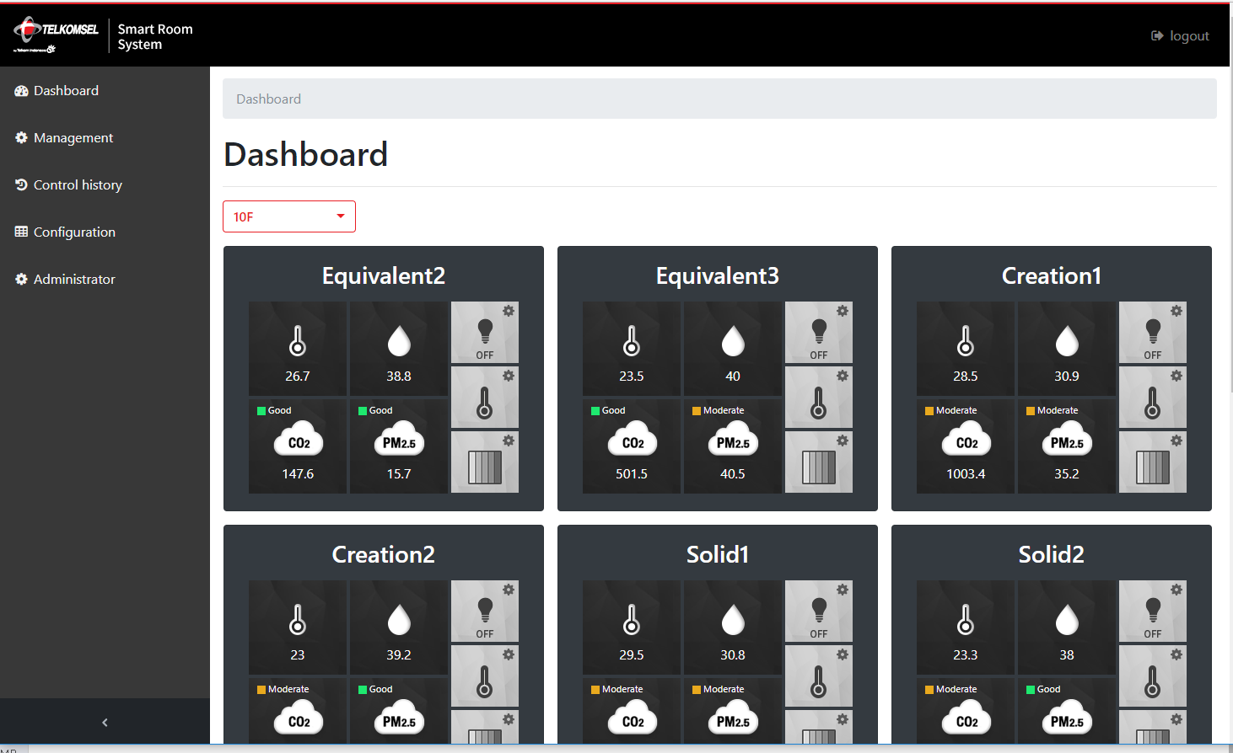

# Device Interface

1. VeraEdge Gateway – Control Blind
   * Protocol: Http Request
   * Request Format
     + URL: http://{VeraEdgeGatewayStaticIP}/port_3480/data_request
     + Parameters
       - id=lu_action
       - action={ActionName}
         * ActionName=Up, Down, Stop
       - serviceId=urn:upnp-org-serviceId:WindowCovering
       - DeviceNum={BlindControllerDeviceID}
         * BlindControllerDeviceID = Get From VeraEdge (Refer to the blind setting guide)
     + Example
       - http://10.30.1.100/port_3480/data_request?id=lu_action&action=Up&serviceId=urn:upnp-org-serviceId:WindowCovering&DeviceNum=10
   * API Reference
     + <http://wiki.micasaverde.com/index.php/Luup_Requests>
2. iAeris Env. Sensor – Get Sensor Values
   * Protocol: Http Request
   * Request Format
     + URL: http://{iAerisEnvSensorStaticIP}/read
     + Example: http://10.30.1.200/read
   * Response
     + Data Type: JSONP
     + Example
       - ?({"HCHO":0.000,"CO2":1099,"CO":0,"RH":49.6,"Temperature":25.9,"PM10":0.0,"PM2_5":18.7,"EPAPM10":0.0,"EPAPM2_5":0.0,"PID":"iAeris2","BLESNO":"001C9717C554","SNO":"000062F9C5540265","date":"2018-5-28 14:15:21","TVOC":0.000});