Blind Setting

* Steps
  1. Register VeraEdge Gateway into the Vera user account.
  2. Create RFXtrx controller device in the VeraEdge
  3. Create Blind controller device in the VeraEdge
  4. Pairing the Blind controller with the Blind motor
  5. Update Room Metadata of the SRS

1. Register VeraEdge Gateway into the Vera user account.
   1. Vera User Account: telkomsel / telkomsel@2018
   2. Connect VeraEdge to an internet enabled LAN cable
   3. Access <http://home.getvera.com> and log in

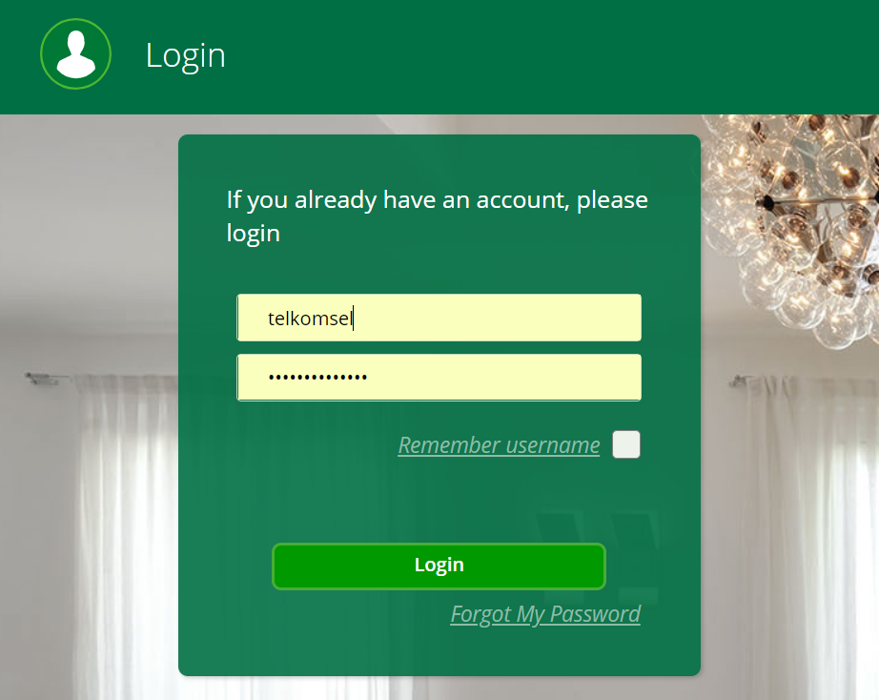

* 1. Find VeraEdge and register into the account
     1. Your Laptop (or Desktop) and the VeraEdge must be in the same network.
        + Add Another Controller

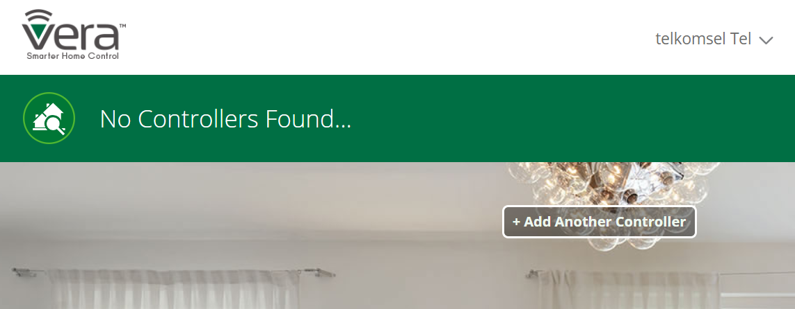

* Select ‘VeraEdge’

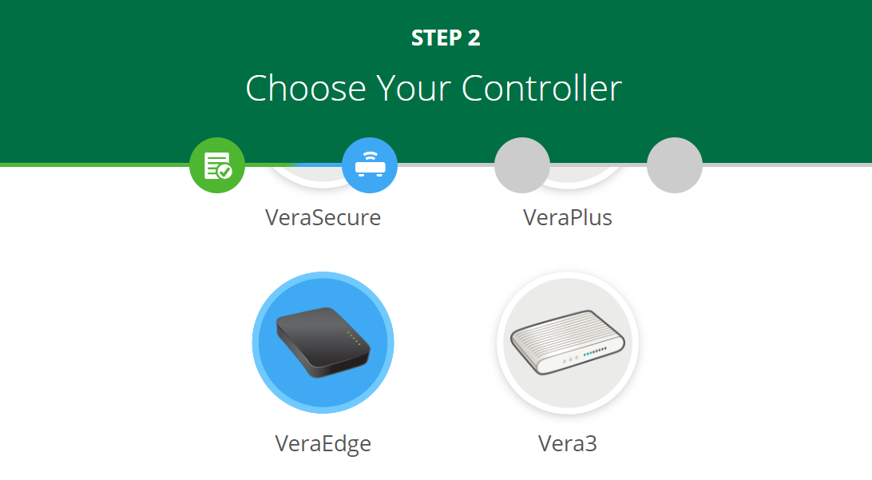

* Find Vera Controller by S/N

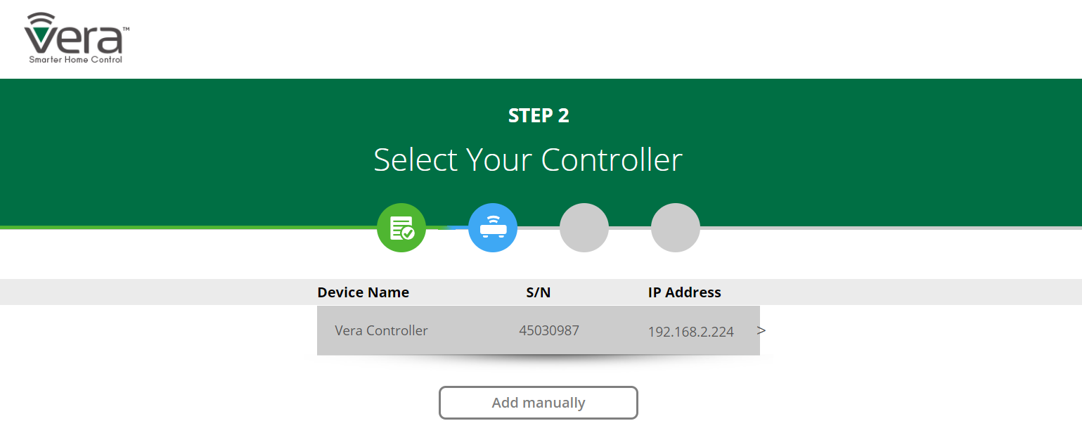

* Click ‘Next Step’

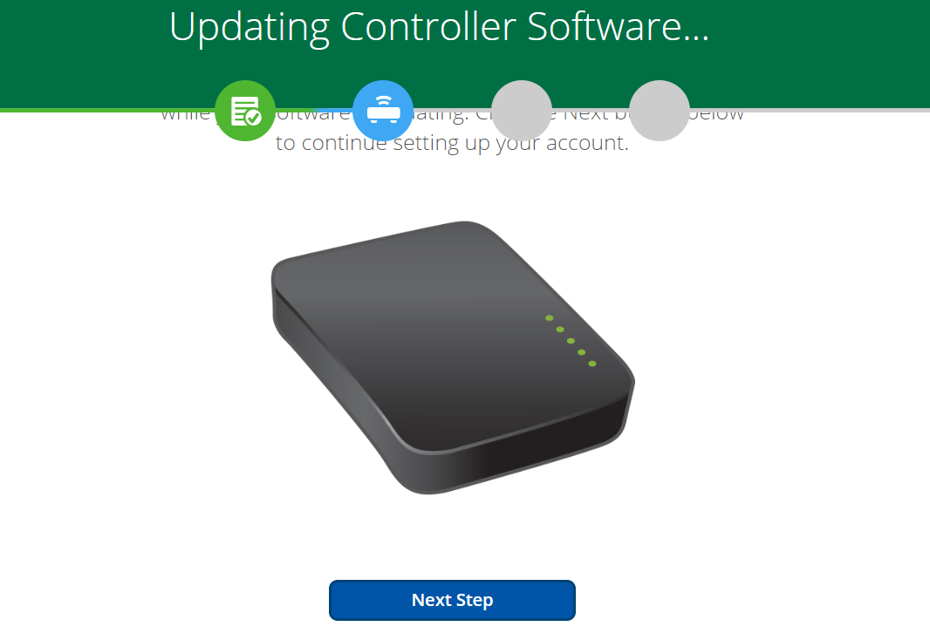

* Wait for VeraEdge to update

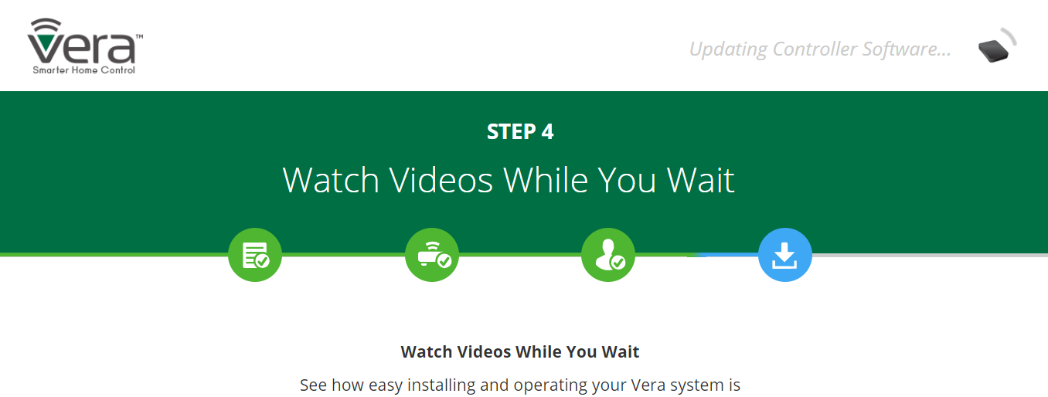

* Go to dashboard when update is complete



* Click ‘Complete Setup’

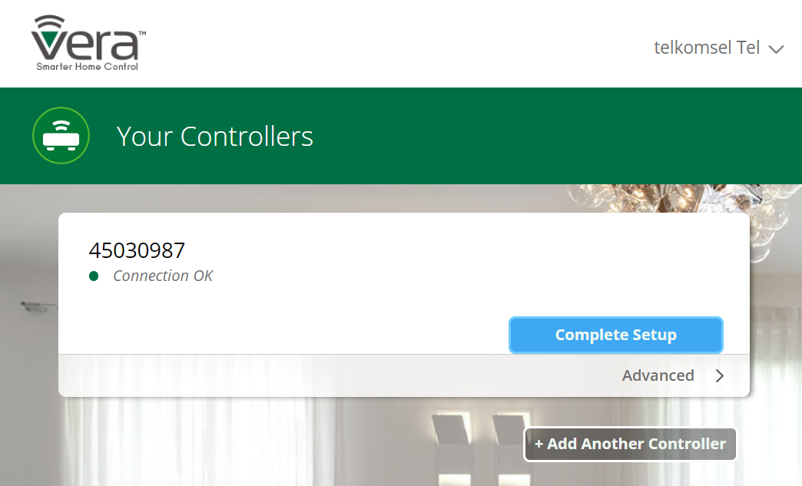

* Registration is complete.
* Do not upgrade VeraEdge firmware

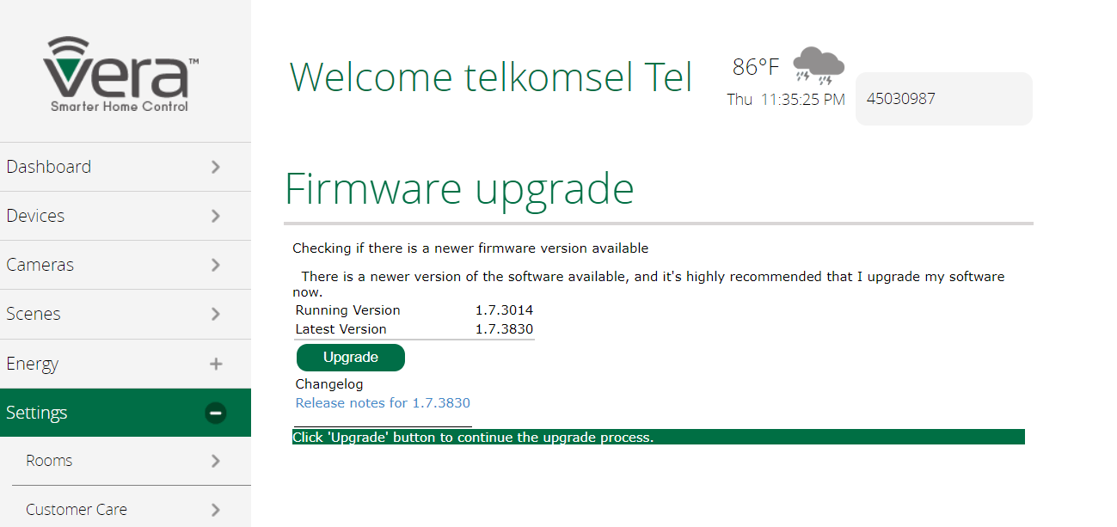

* Click ‘OK’ when you see below

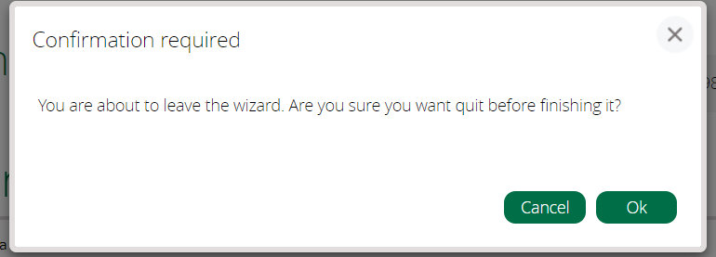

1. Create RFXtrx controller device in the VeraEdge
   1. Download REXtrx device definition files from <http://code.mios.com/trac/mios_rfxtrx/changeset/153/trunk?old_path=%2F&format=zip>

And extract the zip file. It contains 38 files.

* 1. Connect into the VeraEdge from the <http://home.getvera.com>
  2. On VeraEdge WEB UI: Goto ‘Apps > Develop apps > Luup files’ and upload all files.

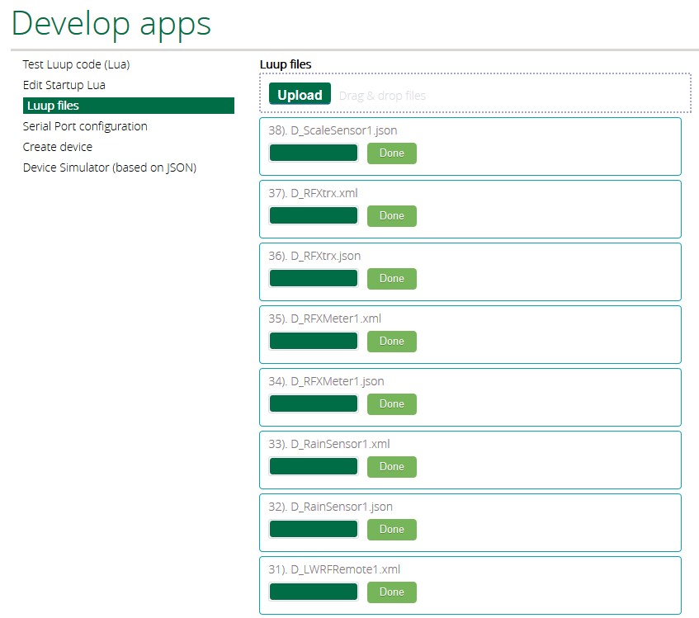

* 1. To create virtual RFXtrx device in VeraEdge, goto ‘Apps > Develop apps > Create device’ and enter ‘D\_RFXtrx.xml’ into ‘Upnp Device Filename’ filed and click ‘Create device’ button on the bottom. (Wait about 2 minutes for VeraEdge to reboot)

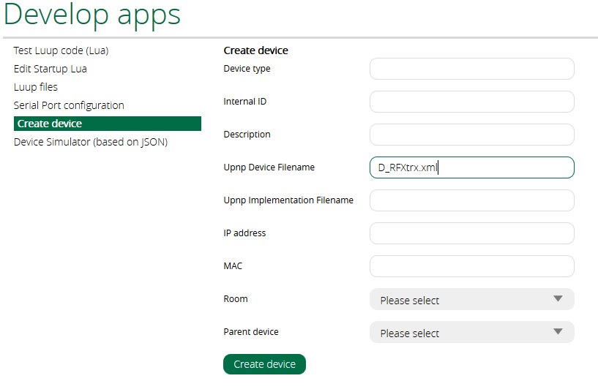

* 1. Refresh the WEB page and go to the menu ‘Device’. ‘RFXtrx controller device’ should appear. But if you don’t see it, please restart VeraEdge(power off, on) and repeat creation virtual RFXtrx device

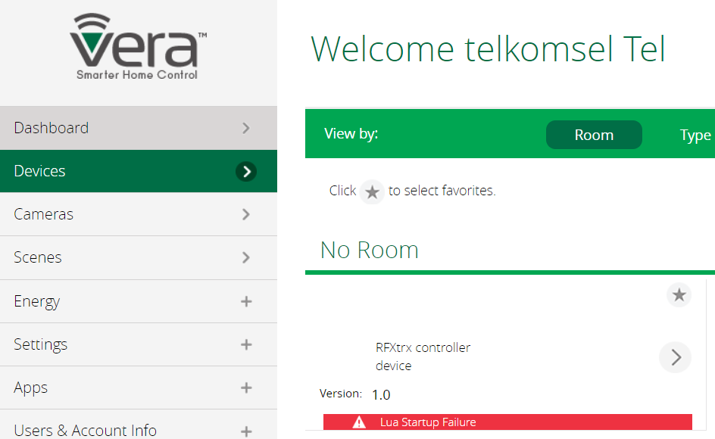

* 1. Connect RFXtrx device with VeraEdge using serial cable
  2. Go to the menu ‘Apps > Develop apps >Serial port configuration’ and set properties like below
     + Path = /dev/ttyUSB0
     + Baud = 38400
     + Used by device = RFXtrx controller device

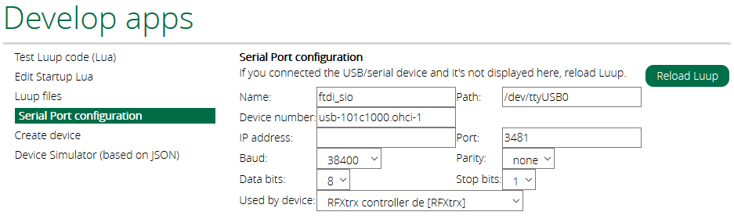

* 1. Click ‘Save’ button to apply the settings.

1. Create Blind controller device in the VeraEdge
   1. To create virtual blind motor controller, go to the menu ‘Device’ and go in to the settings of ‘RFXtrx controller device’
   2. On the settings menu list, click the menu ‘New device’ and set the properties like below
      * Category = RFY
      * Device Type = Window covering
      * Device name = {FloorNo}-{RoomName}-ch:{BlindChannelNumber}

ex) 8F-WarRoom-ch:1

* + - Id = Enter the room ID. (Refer to Excel File provided)

ex) Room ID, 'War Room' = 213

* + - Unit code = Blind channel number (Range = 1~4)

ex) Channel 1 = 1

Back 
Category: 
Device type. 
Window covering 
Device name: 8F-VVoorRoom-ch:1 
Id: 
unic cade. 
Create 
213 
2 
Decimal value in range 1 
- 1048575 

* + - On the menu ‘Device’, you should see the virtual blind controller, like below.

Open Close 
up 
OYO 
Stop 
Down 

1. Paring the Blind Motor with the Blind Controller
   1. Prepare the blind remote controller of the room.
   2. Make sure the blind is well controlled by the remote control
   3. Change the blind motor to the PROGRAM mode.
      1. To change the mode, press the PROGRAM button for 2 seconds using a spiky pin. The button is on the back side of the remote controller (At that time the blind motor should jog, briefly up&down).
   4. Go to the settings of ‘RFXtrx controller device’, and go in to the ‘Manage device’
   5. Select the blind control device to pair with the blind motor in the PROGRAM mode and click ‘Run’ button. (At that time the blind motor should jog, briefly up&down). If jogs, they are paired.

G-EXCELLENCE I-ch. 
Refresh table 
1 device(s) selected 
Device ID 
Battery level: 
Device type: 
New 
New device 
type 
Command. 
1046 
Window covering 
G-EXCELLENCE I-ch. 
Change 
Program 
indcw coverin O 
Select All 
Unselect All 
Run 
Delete selected devices 
Auzcrnatic 
@ONOOFF 
creation 
Delete selected devices & prevent automatic creation 

* 1. Test the blind control by default web UI on the menu ‘Device’

Open Close 
up 
OYO 
Stop 
Down 

1. Update Room Metadata of the SRS
   1. Prepare the VeraEdge IP address and virtual blind controller ID
      1. Check the virtual blind controller ID from VeraEdge WEB UI

Ex) Go in ‘Devices > 8F-WarRoom-ch:1 > Advanced > Params’ and check the value of the field ‘id’

restricted 
device file 
id 
room 
impl file 
D WindowCovering1 _xml 
1001 

* 1. Update the Room information
     1. Access <http://sary.sofila.eduframe.co.kr:8080> with user ‘admin / admin’
     2. Go to the menu ‘Management’ and find the target room.
     3. Update date ‘Gateway Static IP’ and ‘Blind controller ID’ of each blind.

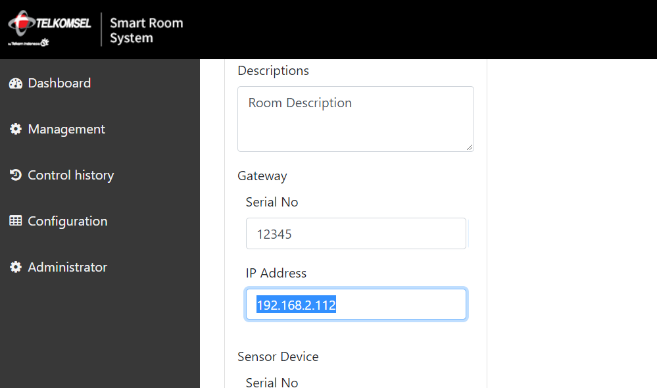

Smart Room 
System 
Dashboard 
Management 
Control history 
Configuration 
Blind Channels 
Channel No 
Blind Count 
Blind Controller ID 
Cancel 
Delete 
logout 
Modify 
1001 
Blind 
channel 
CHI (3) 
CH2 (3) 

1. Update VeraEdge Static IP Address (Do this instruction when Static IP address is confirmed)
   1. Go to the VeraEdge WEB UI
      1. Access <http://home.getvera.com>
      2. Connect the target VeraEdge
      3. Go to Settings > Net&Wi-Fi
      4. Choice ‘Manually configure’

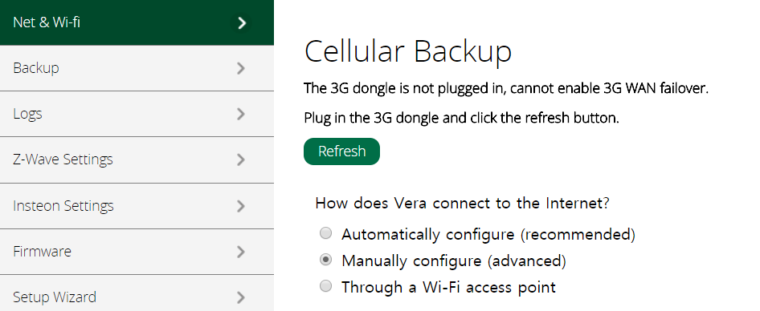

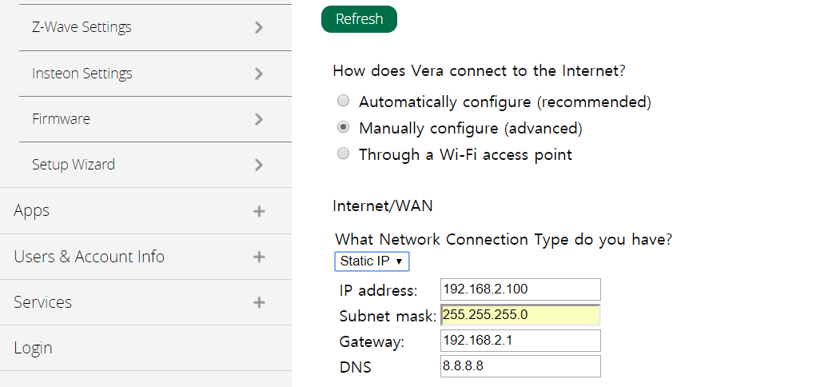

* + 1. Change the selection ‘DHCP’ to ‘Static IP’ and fill out the fields with correct values.
    2. Disable the option ‘Firewall’

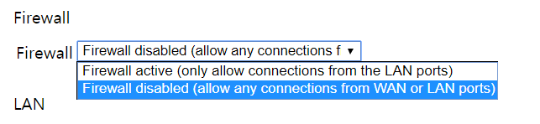

* + 1. Click ‘Save and apply’ button at the bottom. (It will take about 2 minutes)