iAeris – Air quality sensor setup guide.

1. Arrange the static IP for iAeris of each room and record the IP and the serial number of the iAeris in the excel sheet.
   1. Check serial-no on the back side of the iAeris device.

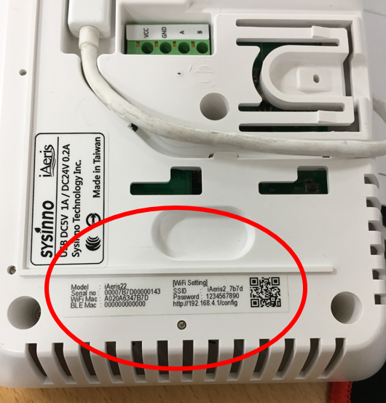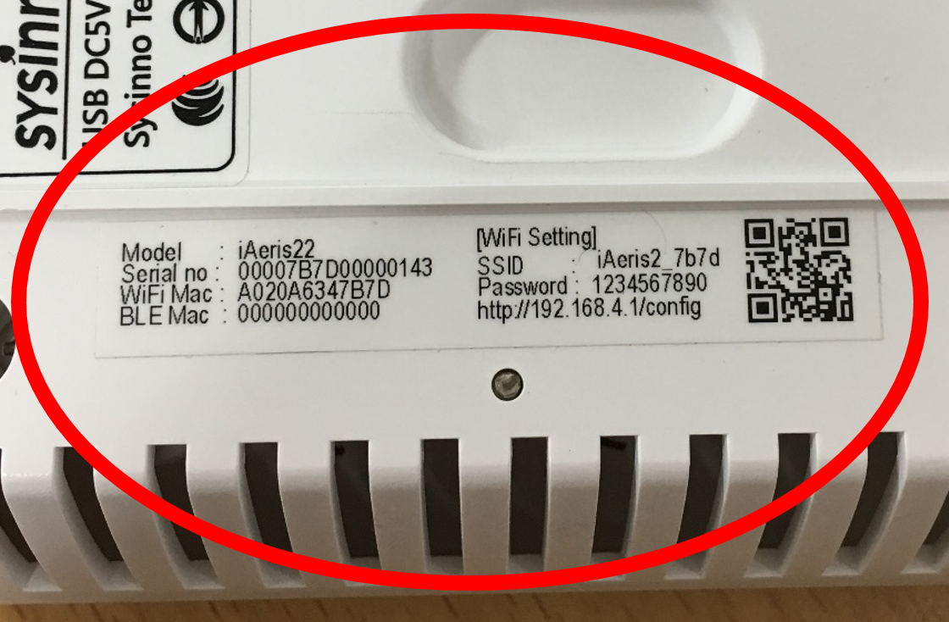

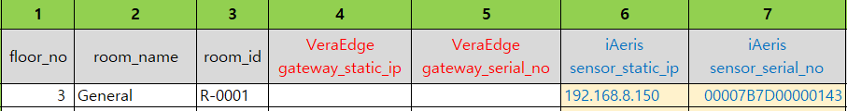

1. WiFi connectiong.
   1. Check WiFI-SSID and password on the back side of the iAeris device.

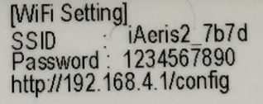

* 1. Connect to the iAeris in the conference room with WiFi on the notebook.

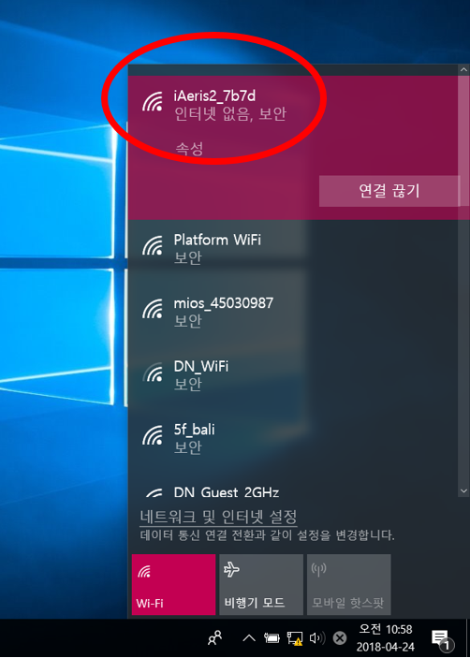

1. Network setting.
   1. After connecting to the device with WiFi, access the URL below.
   2. <http://192.168.4.1/config>

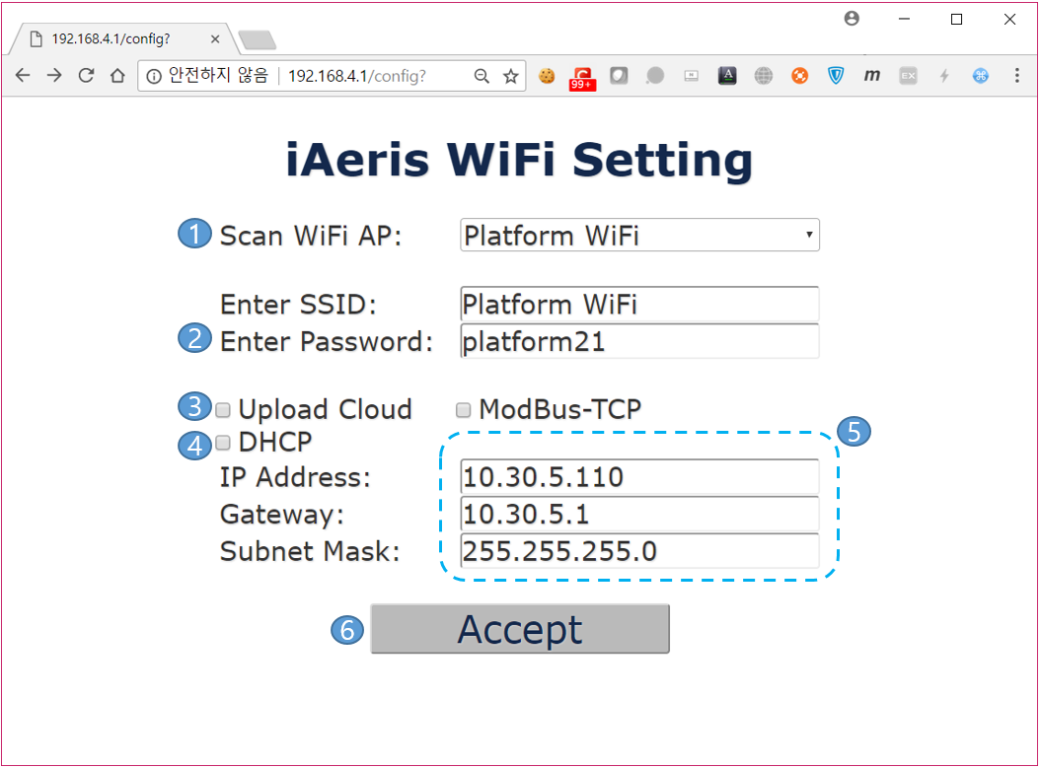

1. Select the WiFi AP to which the device will connect.
2. Enter the password of the AP selected above.
3. Uncheck the option ‘Upload Cloud’
4. Uncheck the option ‘DHCP’
5. Enter the static IP, Gateway and Subnet Mask for the device.
6. Press the ‘Accept’ button.
7. Wait while setting.

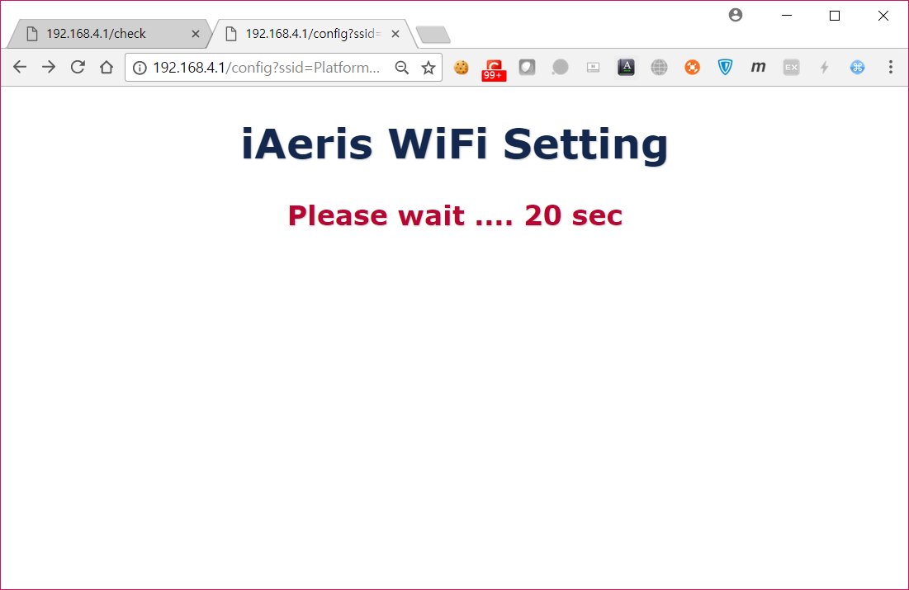

1. Successful case.

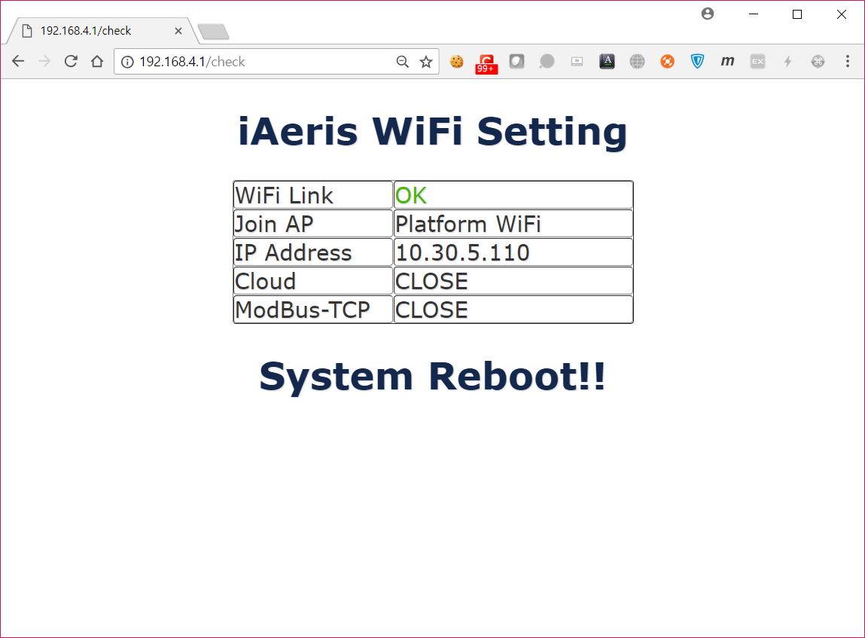

1. Failed case.
   1. Go to the step 3 and try again.

