APPTITUDE
1.
Answer the following questions based on the information given in the graph below:
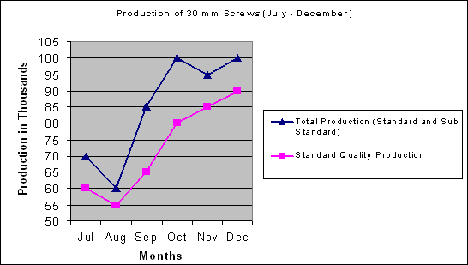
Sales Price:
Standard Quality Screws | Rs. 5.70 | Per 100
Sub Standard Quality Screws | Rs. 2.85 | Per 100

By how much did the total sales value of November's Screw production vary from October's?
 | Rs. 285.00 (Increase)
 | No change
 | Rs. 142.50 (Decrease)
 | Rs. 28.50 (Decrease)

2.) Five friends Lokesh, Manoj, Neeraj, Raveesh and Rohit have agreed to work together on a part-time job offered by a local restaurant. The restaurant works five days a week and this group has the following schedule when they can work:
- Neeraj and Raveesh can work on Monday, Tuesday and Wednesday
- Raveesh and Rohit can work on Monday, Wednesday and Thursday
- Rohit and Lokesh can work on Monday, Friday and Thursday
- Lokesh and Manoj can work on Friday, Tuesday and Thursday
- Neeraj and Manoj can work on Friday, Tuesday and Wednesday
Which one of the five friends cannot work on Thursdays?

3.)

The cost, in dollars, of manufacturing x refrigerators is 9,000 + 400x. The amount received when selling these x refrigerators is 500x dollars. What is the least number of refrigerators that must be manufactured and sold so that the amount received is at least equal to the manufacturing cost?

10
18
90
50

4.)
Select A - If you think the statement is patently true or follows logically given the information or opinions contained in the passage
Select B - If the statement is patently untrue or the opposite follows logically, given the information or opinions contained in the passage
Select C - If you cannot say whether the statement is true or untrue or follows logically without further information
The big economic difference between nuclear and fossil-fueled power stations is that the nuclear reactors are more expensive to build and decommission, but cheaper to run. So dispute over the relative efficiency of the two systems revolve not just around the prices of coal and uranium today and tomorrow, but also around the way in which the future income should be compared with current income.

If nuclear reactors were cheaper to build and decommission than fossil fuelled power stations, they would definitely have the economic advantage.
5.) In this test, you are given two words outside the brackets. You have to fill in the brackets with a word which has a similar meaning (maybe in a different context) as that of the words on the right and left hand side of the brackets.
FINAL ( ) ULTIMATE
end
Last
Finish
Dead
- A takes 4 days to finish a job and B takes 5 days. If both of them work together on the same job, what proportion of the work is done by A?
5/9
4/9
6/9
7/9
7.)
In the right angled triangle below, if tan Ө + sin Ө = 32 / 15 and all sides are whole numbers, find cos Ө .
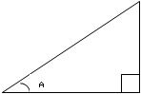
12/13
4/5
5/13
3/5

Bottom of Form
8.)

A and B can separately do a piece of work in 10 and 15 days respectively. They work together for some time and then B stops. If A completes the rest of the work in 5 days, then B has worked for

5 days
4 days
2 Days
3 days

9.)
Which of the following circles contains letters in a different order?

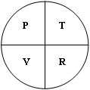 | 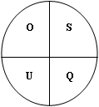 | 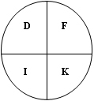 | 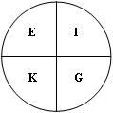 | 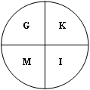

10.) Five friends Lokesh, Manoj, Neeraj, Raveesh and Rohit have agreed to work together on a part-time job offered by a local restaurant. The restaurant works five days a week and this group has the following schedule when they can work:
- Neeraj and Raveesh can work on Monday, Tuesday and Wednesday
- Raveesh and Rohit can work on Monday, Wednesday and Thursday
- Rohit and Lokesh can work on Monday, Friday and Thursday
- Lokesh and Manoj can work on Friday, Tuesday and Thursday
- Neeraj and Manoj can work on Friday, Tuesday and Wednesday
Which is the one who cannot work on Tuesdays?

11.) There are 200 employees in a company. An external vendor is chosen to Serve coffee twice a day. 100 coffee cups were offered by the company but as an incentive to have the cups in tact at the end of the day, the company offered 30 paise for every cup remained safely and charged 90 paise for every broken cup. At an end of a day, the vendor received Rs. 24. How many cups did the vendor break?
10
20
8
5

12.)
Each problem in this test consists of a series of diagrams, which follow a logical sequence. You are to choose the next diagram in the series from the four options on the right. Then indicate your answer by choosing the correct one (A B C D) .


 |  |  | 

13.) 1.a cube object 3" * 3" * 3" is painted with green in all the outer surfaces. If the cube is cut into cubes of 1"*1"*1", how many 1" cubes will have at least one surface painted.
a. 8 b.26 c.27 d. none ans.b

14.) 14.a & b can separately do a piece of work in 10 & 15 days respectively. They work together for sometimes and b stops. If a completes the rest of work in 5 days ,then b has worked for
a.5 b.4 c.3 d.2 (days). Ans.c

C-QUESTIONS

1. Struct x
{
int i;
char c;
}
union y{
struct x a;
double d;
};
printf("%d",sizeof(union y));

a)8
b)5
c)4
d)1
ans:8

2. struct x{
char c1;
char c2;
int i;
short int j;
};

struct y{
short int j;
char c1;
char c2;
int i;
};

printf("%d %d",size of (struct x),size of (struct y));

a)12 12
b)8 8
c)12 8
d)8 12

3. enum x {a=1,b,c,d,f=60,y}
printf("%d",y);
a)5
b)61
c)6
d)60
ans:b

4. #include<stdio.h>
void main()
{
int k=2,j=3,p=0;
p=(k,j,k);
printf("%d\n",p);

}
a)2
b)error
c)0
d)3

ans:a
10.
#include<stdio.h>
void main()
{
unsigned int i= -1;
printf("%d\n",i);
printf("%u\n",i*-1);
}

a)runtime error
b)compilation error
c)prints -1 to 1
d)prints 1 and 1

6. How to typedef a function pointer which takes int as a parameter
and return an int
a)Is not possible
b)typedef int *funcptr int;
c)typedef int * funcptr( int);
d)typedef int (*funcptr)(int);
ans:d

7. #include<stdio.h>
void main()
{
int k=10;
k<<=1;
printf("%d\n",k);
}
a)10
b)0
c)20
d)compilation error
ans:c

8.) #include<stdio.h>
void main()
{
int a[2][2]={{2},{3}};
printf("%d",a[0][0]);
printf("%d",a[0][1]);
printf("%d",a[1][0]);
printf("%d",a[1][1]);
}
a) 2300
b)2000
c)0030
d)2030
ans:d

14) #include<stdio.h>
void main(int x)

{
printf("%d",x) ;

}
if the name of the executable file is abc and the command line is
given as
abc xyz
what is the output
a)compilation error
b)1
c)2
d)undefined
ans:2

18. #include<stdio.h>
void main(int argc)
{
int d=1234.5678;
printf("%d",d);
}

a) error, b) 1234.5678, c) 1234, d) 1235
ANS:c

19. #include<stdio.h>
void main(int argc)
{
int a[]={5,6};
printf("%d",a[1.6]);
}

a) 5, b) runtime error, c) compilation error, d) 6
ANS:d

21. #include<stdio.h>
void main(int arg c)
{
int x=1111;
printf("%d",!x);
}
a.prints 1111
b.compilation error
c.prints 0
d.is not a valid option
ans:c
23. int i=10;
a.declaration
b.definition
c.both
d.none
ans:c
25. #include<stdio.h>
void main(int arg c)
{
char a[]=abcdefghijklmnopqrstuvwxyz;
char *p=a;
printf(%d,strlen(p));
p+=10;
printf(%d,strlen(a));
}
a.26 26
b.26 16
c.compilation error
d.16 26
ans:a
27. if the following program (myprog)is run from the command line as
myprog 1 2 3
what would be the output?
Main(int argc , char *argv[])
{
int I ,j=0;
for (I=0;I<argc;I++)
j=j+atoi(argv[i]);
printf(%d.j);
}

a. 123 b.6 c.error d.123
ans:6

29. what is the output of the following code?
#include<stdio.h>
void main()
{
printf("%d",printf(" hello world "));
}

a) 13, b) hello world 13, c) hello world, d) error
ANS:b

