what is blockchain

stuart haber and w.scott stornetta published a paper called "how to timestamp a digital document" in 1991.

But officially it is papered by satoshi nakamoto.

the blockchain ideas are actually are presented in the paper by those.

generally blockchain is a growing list is records called as blocks which are linked and secured ny cryptography.

basically block contains of data and previous hash and its hash, hash means it's like a fingerprint.

the first block in the blockchain is called GENESIS block, always it will be the number one.No other block can't be 1. Genisis block remains no 1 forever after blockchain intiliazed.

genesis block don't have the previous hash it is one and only block dn't have previous hash.

the second block will have the previous hash as same as the before block hash. that's y it is know as blockchain because there are cryptographically linked each other with there hashes.

ex: block 1 hash: 000000000

block 2 previous hash :000000000

hash :123456789

if the data is changed in the block 1 and it hash(finerprint) will be changed and block 2 link will be changed as block 1 hash(fingerprint) changed due to data change.

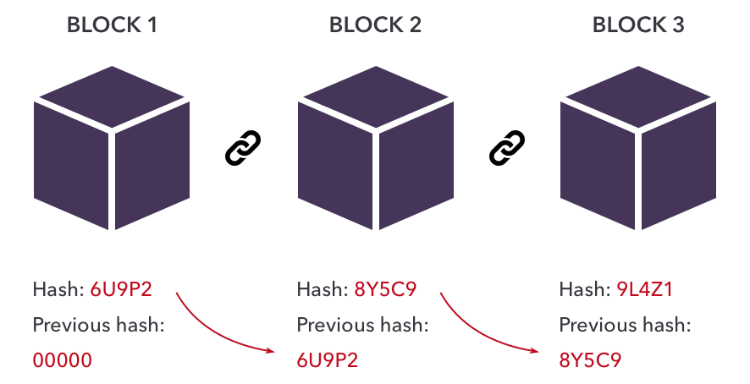

Blocks are cryptographically linked together.

Original paper: how to time-stamp a digital document

<https://www.anf.es/pdf/Haber_Stornetta.pdf>