Error Handling on Forms
Updated: 6/6/2007 7:50PM

This includes forms on Wizards and Action Dialogs. Although this does not include tables, they are kept in consideration.

Method A – Visible Under Input
Description: Error message displays under the field


Figure 2: Example of Method A

Table 2: Pros and Cons of Method A
Pros | Cons
Info is always visible | Message length
Could work in a table on the edit div (but only visible in edit div) | Might be an overwhelming amount of red text with the label, the error message, and the invalid data.
 | Creates more vertical scrolling

Method B – Dynamic on focus
Description: Error message displays when focus is in the field.
Alternates:
– Error message always displays
– Error message displays above or below the field

Figure 1: Example of Method B

Table 1: Pros and Cons of Method B
Pros | Cons
Displays info when it’s needed | May not have space available on the right. Might need to have “smart” positioning.
Could work in a table | Potential accessibility issues, may need to display at all times

Method C – Combo tooltip and JS alert
Description: Error message displays as a tooltip when the user hovers over the label or error icon and it displays in a JavaScript alert when the user clicks on the label or error icon.

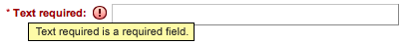
Figure 3: Example of tooltip on Method C

Table 3: Pros and Cons of Method C
Pros | Cons
No extra coding, already works this way. | The message is hidden. The user needs to figure out to click or hover.
 | JS alert adds clicks to dismiss the alert

Method D – Wufoo
Description: Display background color plus message on focus

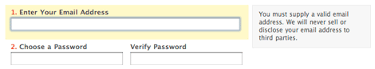
Figure 4: Example of Method D

Method E – Snaptax
Description: Display background color and matching tip area on focus

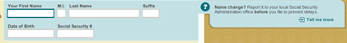
Figure 5: Example of Method E

General Questions:
Do we need parity for JS errors invalid list value or date (red text, not msg or icon)? I think it’s okay without a tip or icon, then the user gets a “different” error on Save. On Save Errors, Invalid values (characters not in the allowable charset) would should red text plus whatever else (icon and msg).
Tables – Might need to color the cell and show an icon?

