Multi-Select Cascade List Behavior Notes
Updated 7/19/2007 11:15AM

MULTI-SELECT CASCADE LIST

Used for multilist type attributes where “Is Cascading?” is Yes. Only applicable to non-object lists.

Fig 1: Multi-select cascade in read mode (??? To be determined after consulting CDP, leaning toward leaf only, although there were several requests for a setting.)

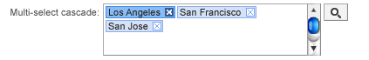
Fig 2: Multi-select cascade in edit mode

The Multi-Select Cascade List is made up of a Target Element and a Launch Button that launches the Tree Palette. Values can only be added from the Tree Palette (unless we also allow for paste).

Target Element

- Can contain 0 to many pills
- No type-in or auto-complete
- No paste from clipboard (??? Need to consider including the ability to paste)
- On load, no pills are highlighted (may need to change based on MSL behavior, see CQ#253701)
- On focus with pills, the first pill is highlighted (may need to change based on MSL behavior, see CQ#253701)
- On focus without pills, the focus shifts to the Launch Button
- Lose focus with pills, the pill highlights are removed (may need to change based on MSL behavior, see CQ#253701)
- Tab moves focus to the Launch button (except in Safari, which moves to the next element)
- SHIFT-Tab moves focus to the previous editable element
- ALT+L Launches the Tree Palette

Pills

- Selected values display in pills.
- Upon initial focus, the first value in the list of pills becomes active. (may need to change based on MSL behavior, see CQ#253701)
- Pills only display the leaf-node of the cascade list as the value.
- User hovers over the pill to see the full path in a tool tip. For example, hovering over “Los Angeles” might display “North America | United States | California | Los Angeles” in a tooltip.
- NOTE: In the table, the tooltip for the cell would need to be all the selected values fully piped. ??? keep in mind FireFox tooltip “bug”
- Pill Truncation
  - Pills size is determined by the width of the value and limited by element width.
  - If the pill is wider than the width of the target element, truncate the pill, and add an ellipse.
  - Because pills are truncated, a horizontal scrollbar will never appear
- Pill highlighting
  - Click highlights pill and removes highlight from all others
  - SHIFT + Click highlights a range of pills from the first click to the SHIFT-Clicked pill
  - CTRL + Click (CMD + Click on Mac) toggles highlight for the pill and retains other highlights
  - Right arrow highlights next pill, removes highlight from all others, moves across and down the rows (does not wrap back to the beginning on the list)
  - Left arrow highlights previous pill, removes highlight from all others, moves back and up the rows (does not wrap to the end of the list)
  - SHIFT + Right Arrow or SHIFT + Down Arrow highlights next pill, and retains other highlights, moves across and down the rows (does not wrap)
  - SHIFT + Left Arrow or SHIFT + Up Arrow highlights previous pill, and retains other highlights, moves back and up the rows (does not wrap)
  - SHIFT + HOME or SHIFT + ALT + Up Arrow highlights the range of pills between the last clicked and the first pill
  - SHIFT + END or SHIFT + ALT + Down Arrow highlights the range of pills between the last clicked and the last pill
  - CTRL + A (CMD + A on Mac) highlights all pills
  - Up Arrow – none (or possibly return focus to type-in area) (or possibly same as Left Arrow)
  - Down Arrow – none (or possibly same as Right Arrow)
  - Home – none
  - End - none
- Deleting pills
  - Click X (remove button on the pill) deletes the that pill (and retains highlights of other pills)
  - Delete Key or Backspace Key deletes all highlighted pills
- Removing the last selected pill moves the focus to the Launch button.
- Pill Truncation
  - Pill size is determined by the width of the value and limited by element width.
  - If a pill is wider than the width of the target element, truncate the pill, add an ellipse, and display the full value in a tooltip.
  - Because pills are truncated, a horizontal scrollbar will never appear

Launch Palette Button

- ALT+L launches the palette when the focus is either in the target element or the button.
- Enter Key launches the palette when the focus is on the button.
- Click the button to launch the palette.
- If the palette is already open, it moves the focus into the palette.

Cascade List Tree Palette

The Tree palette consists of the following:
- Drag handle (to move palette)
- Close button
- Title = the field label
- Results tree
- Resize handle

Palette

Default position: Directly above the button with right edge aligned with the right edge of the button leaving the first row of pills visible in the target element,

Palette is moveable and resizable. Position and size is remembered for that entire edit session for all instances of the palette on the page.

Upon initial launch of the tree palette, the results tree displays. The initial focus is on the root or first/top-most node of the tree.

The user can tab through the palette in a loop in the following order:
- Root node of tree
- Close button

When the user closes the palette the expansions are not retained.

Tree Results

- When launched, the root/first folder is selected
- Multiple nodes are selectable at a time
- Node Selection
  - Highlighting a folder will NOT automatically highlight all its children
  - Click to select a node or folder (deselects all others)
  - SHIFT-Click to select a range of values. Acts only on the visible nodes. If a parent node is within the range, but not all its children are selected, because the parent node is highlighted, it’s as if all the children were selected.
  - CTRL+Click (or CMD + Click on Mac) to toggle the selection of a node or folder and retain all other selections
  - Right Arrow while on a folder will expand the folder (no action on a leaf node)
  - Left Arrow while on a folder will collapse the folder (no action on a leaf node)
  - Up Arrow - select the visible node/folder above the current selection (deselects all others)
  - Down Arrow – select the visible node/folder below the current selection (deselects all others)
  - Home - none
  - End - none
  - SHIFT + Left Arrow – none
  - SHIFT + Right Arrow - none
  - SHIFT + Up arrow highlights the visible node/folder above the current selection and retains all other selections
  - SHIFT + Down arrow highlights the visible node/folder below the current selection and retains all other selections
  - SHIFT + ALT + Up Arrow or SHIFT + HOME highlights all visible nodes/folders between the current selection and the first folder
  - SHIFT + ALT + Down Arrow or SHIFT + END highlights all visible nodes/folders between the current selection and the last folder
  - Double -click folder will expand/collapse the folder (no action on a leaf node)
  - CTRL + A (CMD + A on Mac) highlights all visible nodes

Adding Pills from the Palette

- Adding pills appends to the beginning of the already selected pills
- Methods to Add
  - Drag value or multiple highlighted values to the target element
  - Enter key creates pill(s) for each highlighted value
  - Double-click a folder or leaf node
- Adding a folder creates a pill for each leaf node in the folder through all levels of that folder
- Double-clicking a leaf node will add pills for all the leaf nodes within the folder (and its subfolders)
- Each time values are added (regardless of if they have previously been added and already exist as pills), the “Added” confirmation cue displays.
  - When dragging from palette, the cue displays over the target element
  - When pressing Enter on the palette, the cue displays on the palette (below the Close and to the right of the title)
- Values that already exist and are added again do not move to the front of the pill list. For example, using Figure 3 below, if the user adds London again, the “Added” confirmation cue would display but the pill would not change position.
- When dragging folders and/or leaf nodes from the palette the drag number that displays will be the total number of leaf nodes.

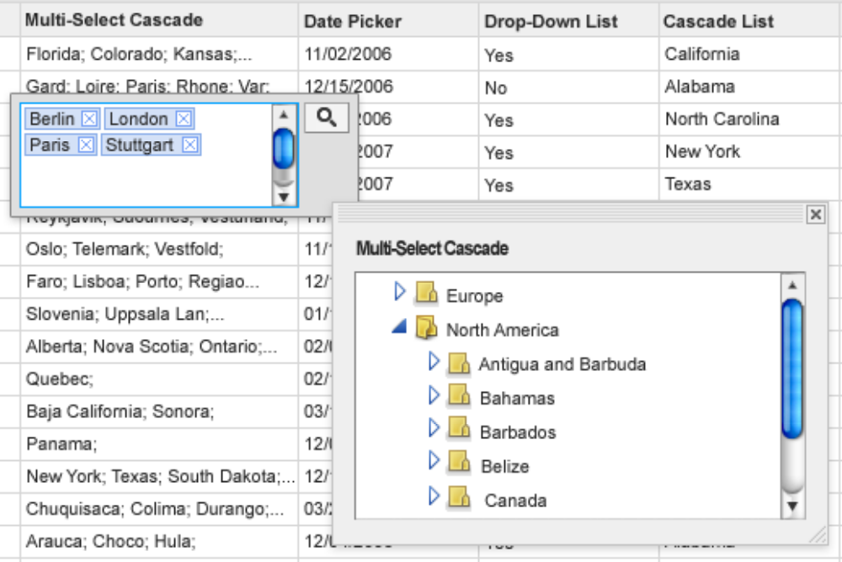
Figure 3: Example of edit element in a table and the tree palette

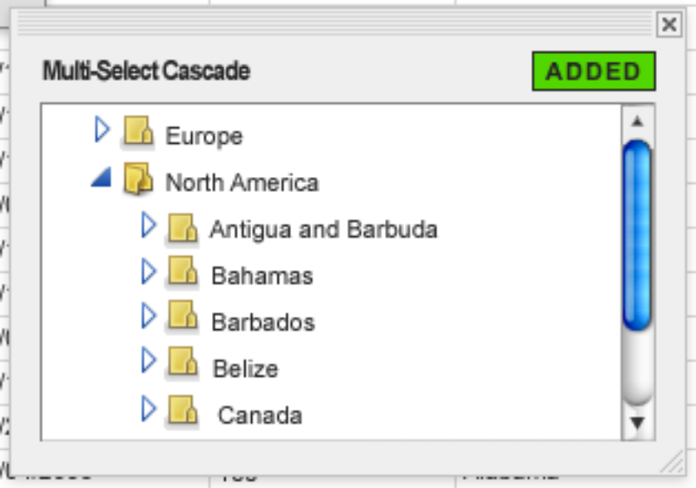
Figure 4: Example of palette with the “Added” cue on

