Multi-Select List Behavior Notes
Updated 5/16/2007 2:20 PM – Superseded 5/24/2007 12:30 PM

As of 5/24/07, this document is superseded by the UI Specifications
multi-select_list.doc
filter.doc
palettes.doc
The contents of this document will be replicated in multi-select_list.doc until full compliance is verified.

MULTI-SELECT LIST

Used for multi-list type attributes where display type is List. Applicable to both non-object lists and object lists (excluding users, user groups and special user lists). Examples may include Product Lines, Countries, Sites, and Specifications.

Because Lists that are administratively set as a List (or not search) are relatively small, all the values are loaded into cache at the time that the edit control is displayed on the page. The auto-complete is all done quickly on the client.

Fig 1: Multi-select list in read mode

If the list is a list of objects (like Sites or Specifications), then the values would display as links to each object. Links are not displayed for non-objects. Links are not displayed when the form is in edit mode, but the field is not editable.

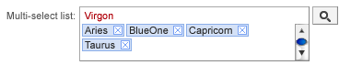
Fig 2: Multi-select list in edit mode

The Multi-Select List element is made up of a Target Element and a Launch Button that launches the Filter Palette. The Target Element has a Type-in Area that supports Auto-Complete and a Selected Values List that contains pills. Values can be added to the Selected Values List from the Filter Palette or the Type-in Area.

Target Element

- On load, any pills (previously saved values) are displayed in alphabetic order
- On focus, element gets focus ring, the type-in cursor displays in the Type-in Area, and any pills (previously saved data) are not highlighted
- Lose focus, remove focus ring, no pills highlighted
- Tab key validates the text in the type-in area and moves focus to Launch button (except in Safari, which moves to the next element)
- SHIFT-Tab validates the text in the type-in area and moves focus to the previous editable element
- ALT + L – launches the palette

Type-in Area and Auto-Complete

- Supports type-in
- Supports auto-complete
  - As the user types in a value, the text is validated on the fly to help the user find a valid match.
- Supports paste (to paste in semi-colon separated valued from the clipboard)
- Supports drag/drop from Bookmarks, Recently Visited, and Search Results (regardless of if the object type matches)
  - The dropped ID will display in the type-in line and then be validated on Enter or lose focus? I think this is cleaner than dropping and automatically creating pills for the values of the proper object type. Then, we’d need some messaging for values not added. This way the bad values would remain on the type-in line.
- User can type the full value or choose from an auto-complete list
- As the user types, a list of matching options (maximum 20 values) displays
- When the auto-complete list displays the first value in the list is highlighted
- Up/down Arrow keys highlight options
- ENTER: validates text in the type-in area and keeps the focus on the target element
- Clicking an option selects the option and creates a pill
- Right Arrow key selects the option and creates a pill
- ESC key dismisses the auto-complete list
- Auto-complete will not support wildcard characters. It auto-completes on a starts with search.
- Down Arrow key (when the auto-complete list is not activated), highlights the first pill in the Selected Values List (so the pills are ready to accept keyboard controls)

Validation

- If an invalid value is typed or pasted in, when the target element loses focus (or the user presses the Enter key), the text is displayed in red
- When the user puts his cursor back into the type-in area and starts to type in corrections, the auto-complete kicks in again
- If valid values are typed or pasted in, when the target element loses focus (or the user presses the Enter key), the values are displayed in pills
- Multiple values separated by semi-colons are each evaluated. Valid values are removed from the type-in area and added as pills. Invalid values remain in the type-in area in red text

Selected Values List and Pills

- A pill represents one distinct value. It can not be modified, only removed.
- Can contain multiple pills
- If there are selected values, those values are displayed in pills, beginning in the second row of the input. The pills for previously saved data are listed in alphabetical order. Newly added pills are always added at the beginning of the pill list (unordered).
- Because multi-select lists do not accept multiples of the same values, only one instance of a pill for a specific value will display in the target element. For example, if I’ve selected “United States” and then I select “United States” again (either by type-in or from the palette), only one “United States” pill will display in the target element. There will not be a warning.
- Values that are already represented as pills, are still visible and available in the palette table and auto-complete menu with no visual indicator that the value is already selected.
- Pills will float across the element and wrap to the next row
- When more pills than are visible in the Selected Values List, a vertical scrollbar will appear
- Deleting Pills
  - Click the X (remove button on the pill) retains other selections
  - Press Delete or Backspace key (removes all highlighted pills) returns focus to type-in area
- Pill Truncation
  - Pills size is determined by the width of the value and limited by element width.
  - If the pill is wider than the width of the target element, truncate the pill, add an ellipse and display the full value in a tooltip.
  - The tooltip is present ONLY if the pill is truncated
  - Because pills are truncated, a horizontal scrollbar will never appear
- Pill highlighting
  - Click highlights pill and removes highlight from all others
  - SHIFT + Click highlights a range of pills from the first click to the SHIFT-Clicked pill
  - CTRL + Click toggles highlight for the pill and retains other highlights
  - Right arrow highlights next pill, removes highlight from all others, moves across and down the rows (does not wrap back to the beginning on the list)
  - Left arrow highlights previous pill, removes highlight from all others, moves back and up the rows (does not wrap to the end of the list)
  - SHIFT + Right arrow highlights next pill, and retains other highlights, moves across and down the rows (does not wrap)
  - SHIFT + Left arrow highlights previous pill, and retains other highlights, moves back and up the rows (does not wrap)
  - SHIFT + HOME or SHIFT + Up Arrow highlights the range of pills between the last clicked and the first pill
  - SHIFT + END or SHIFT + Down Arrow highlights the range of pills between the last clicked and the last pill
  - CTRL + A or CMD + A highlights all pills

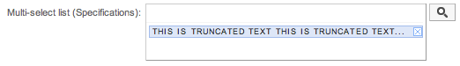
Fig 3: Truncated pill example

Launch Palette Button

- ALT+L launches the palette when the focus is either in the target element or the button
- Enter Key launches the palette when the focus is on the button
- Click the button to launch the palette
- If the palette is already open, it moves the focus into the palette

Adding Pills

- Once a valid value is entered or selected from the auto-complete list, it is added as a pill. The user can begin typing in the next value.
- Adding Pills
  - Type-in values (if invalid, display in red text) and press Enter key (or lose focus)
  - Type-in and select a value from auto-complete list (with mouse click, Enter key, or right arrow key)
  - Drag values from the palette (adds pills to beginning of list)
  - Double-click a value in the palette
  - Enter key from the palette adds pills for the highlighted rows
- Each time a pill is added an “Added” confirmation cue will display. The cue is a div with a black border, green background, and #333 text that says, “ADDED”. It displays for a quarter of a second and then fades out in .4 seconds.
  - For type-in or drag from palette, the cue displays over the Selected Values List (pill area)
  - For double-click and enter on the palette, the cue displays on the palette (below the Close and to the right of the title)

Filter Palette

The filter palette consists of the following:
- Drag handle (to move palette)
- Close button
- Title = the field label
- Filter field
- Table of Values
- For non-object lists, list of values (and value descriptions)
- For object lists, table results (columns will be based on quick search results)
- “New” button for object lists
- Resize handle

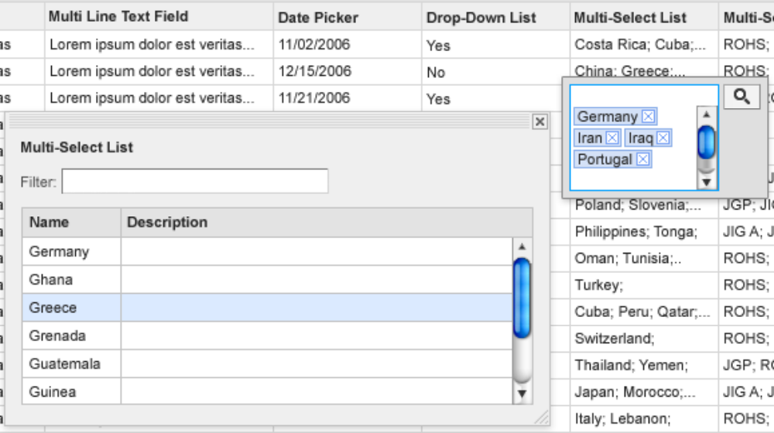
Fig 4: Example Palette

Palette

Default position: Directly below button with right edge aligned with the right edge of the button

Palette is moveable and resizable. Position and size is remembered for that entire edit session for all instances of the palette on the page.

Upon initial launch of the search palette, no results display. The user must type-in search criteria and click the Search button, in order to view results.

Upon initial launch, the focus is in the Search field.

The user can tab through the palette in the following order:
- Search field
- Search button
- First row of results (if no results exist, auto go to next)
- “New” button (if it exists)
- Close button

After the Close button, the tab order would continue in a loop to the Search field.

When the user closes the palette the selections and filter are NOT retained.

If the user leaves the palette open (regardless of moving or resizing) and clicks the View button for another field, AND both the palette and the new field are visible on the page, then the palette remains in the same place and size, but the content refreshes to match the element.

If the user leaves the palette open and scrolls down to click another View button (not on the same page/screen as the open palette, then the palette would move to the default location (under the button and right-aligned with the right edge of the button).

There is no relationship between invalid values typed-in the target element and the palette. Making selections from the palette creates pills in the target (because all possible values are valid) and does not change anything typed-in the target.

The title is the label for the target element and it displays below the drag bar and above the Filter.
Title (label name)
color: #333;
font-weight: bold;

Filter

Typing text into the Filter will remove rows from the table that do not match the typed-in filter criteria. The filtering occurs dynamically as the user types.

Filter will not support wildcard characters. The filter performs a contains search.

Upon initial display of the palette, focus is in the filter field, so the filter field has the focus ring.

When the user does any actions in the table, the focus ring returns to the target element.

Table

Multiple rows can be highlighted.

Highlighting table rows:
* Click row to highlight
* Up/down arrows in table will highlight one row at a time.
* Highlight multiple rows by holding the SHIFT key and pressing Arrow Down/Up, or SHIFT or CTRL clicking multiple pills.
Making selections:
* Double-click a row to create a pill for that value in the target element.
* Press enter to create pill for each highlighted row (one or multiple).
* Dragging highlighted rows to the target element, creates pills.

When you drag, you will see a semi-transparent box with the number of values you are dragging. Because it is semi-transparent, you can faintly see the text and elements underneath the box as you drag over them.
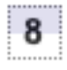
Fig 5: Drag style (as if it is partially over a purple box)

When you drag over the target element, the box will turn green.
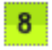
Fig 6: Drag style over the target element (as if it is partially over a purple box)

The table columns are sortable and resizable.

“View Port” or “Mask” (likely, will not happen. Likely, will have a horizontal scrollbar)
Ideally, if the table is wider than the palette, a visual indicator (arrow or ellipse) displays in the column header to signal the user that there are more columns out of view.
The user can drag the palette wider to view additional columns.
Alternately, the user can resize the columns narrower to reveal more columns.
No horizontal scrollbar displays.
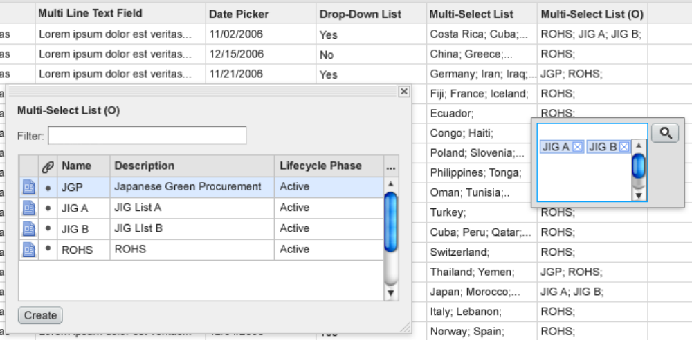
Fig 7: Example Multi-select List in Table where the list is an Object list

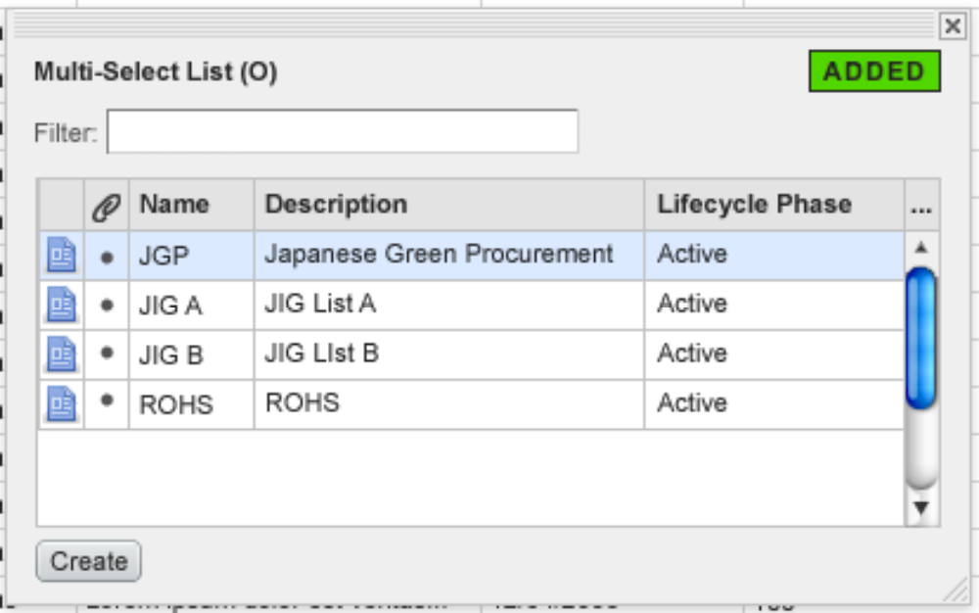
Fig 8: Example palette with Added cue on

