Oracle Applications
User Experience
Card Sort
Customer Needs Management

Evaluation Dates
September 29th – October 17th

Report Author
kurt.x.peterson@oracle.com
Usability Engineer

Report Status: Draft
November 10, 2008


Executive Summary
Between September 29th and October 17th a series of card sorting activities were used to facilitate the development of the User’s Mental Model (UMM) for the Customer Needs Management (CNM) application. The sessions were used to assist the User Experience group in learning how the user understands the concepts and how to best structure the application based on the appropriate model. The participants had the following characteristics:
- Work in an Engineering-to-Order company
- Responsible for or highly involved in the Request for Proposal (RFP) requirements breakout and assignment
- Responsible for and/or work with Request for Quotations (RFQs) and bid submissions
The card sorting data was analyzed using a cluster analysis program to derive the overall sort shown in Figure 4. The figure shows the composite sort of all 32 cards for all 5 participants. The closer the concepts are to each other on the sorting diagram, the more conceptually related they are. EZ Calc generates groups based on relationship strength between items. The diagram represents how the users understand the 32 concepts identified for the study or in other words their Mental Model of the concepts. Since the application only applies the groupings the labels to the left and the right were applied during the data analysis phase based on observations during the card sort and interview sessions. Due to the granularity of the terms this data cannot be used to structure menus, but instead is useful in determining objects that can be grouped in the application.

Card Sort Groupings
The end result of the card sort was two primary groupings project information and resources. The project information represented the core information used in the Engineering-to-Order process. The sub groups were consistent with the different phases of the ETO process discovered in the structured interview sessions. One relationship of interest was the separation of the proposal information and the quoting information. This may indicate a need for official proposal information that is sent to the customer versus internal costing information shared between team members.

Another grouping in the resources section showed that ideas are not as applicable to everyday work in an ETO company. Users may likely utilize ideas when forming product improvements as opposed to being part of a project. Additionally, there was a close relationship between attachments and relationships in the resources grouping. This is expected given the fact that attachments would likely be relationships.
Card sorting diagram:
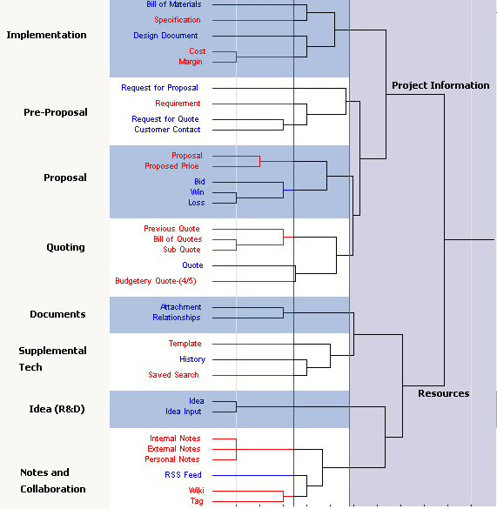

Table of Contents

Executive Summary 2
Card Sort Groupings 2
Table of Contents 3
Report Contributors 4
Background 5
Card Sort 5
Customer Needs Management 5
Participants 5
Materials 6
Procedure 7
Results 8
Sorting Data 8
Conclusion 10

Report Contributors
Study Contributors
Name | Position
Kurt Peterson | Usability Engineer
Joel Nave | Manager, User Experience
Anurag Batra | Principal Product Manager
Steve Chalgren | Director, Product Strategy
Report Reviewers
Name | Position
Joel Nave | Manager, User Experience
Anurag Batra | Principal Product Manager
Steve Chalgren | Director, Product Strategy
Michael Ma | Director, Development
Usability History
Activity | Author(s) | Date
CNM Structured Interviews | Kurt Peterson | November 10, 2008

Background

Card Sort
A card sort was used to facilitate the development of the User’s Mental Model (UMM) for the Customer Needs Management (CNM) application. The sessions were used to assist the User Experience group in learning how the user understands the concepts and how to best structure the application based on the appropriate model.
The focal group for this exercise was companies that build products using an Engineering-to-Order (ETO) methodology. The users were not required to be Agile users, but customer companies comprised the majority of the participants. Each person participated in a 30 minute to 1-hour session between September 29th – October 17th. The participants were asked to validate a set of terms and then sort those concepts into logical groupings.
The goals of the study included:
- Develop a better understanding of the UMM
- Discover user preferences for application terminology

Customer Needs Management
Customer Needs Management is a solution that will help customers manage their product development process from the idea stage to the creation of a quote and the collection of requirements. The target market for this product is currently companies who create custom solutions for their customers based on their product needs.

Participants
Six users participated in this activity. Users were recruited through either the Applications User Experience Participant Database (PDB) or through internal recommendations from customer contacts. None of the customer companies recruited had a signed Customer Participation Confidentiality Agreement (CPCA) and therefore will not have their personal or company names included in this document.
The targeted participants normally engaged in the following activities:
- Work in an Engineering-to-Order company
- Responsible for or highly involved in the Request for Proposal (RFP) requirements breakout and assignment
- Responsible for or work with Request for Quotations (RFQs) and bid submissions
Table 1: User Profiles
Participant # | Title | Industry | Company Size
1 | Business System Analyst | Semi Conductor Tool and Automation Solutions | 1000 – 5000
2 | Senior Project Engineer | Government Contractor, Aerospace | 1000 - 5000
3 | Engineering Systems Coordinator | Oil and Gas Valves, Heavy Industrial | 100 – 500
4 | Product Manager | Semi Conductor Tool and Automation Solutions | 1000 – 5000
5 | Director of Business Development | Heavy Industrial Construction, Design-Build | <100
6 | Program Manager | Government, Intelligence Systems | < 5000

.

Materials
Since all of the participants were remote the card sorting was done through a web conference utilizing a Word document and a Visio file. In order to maximize the screen real estate most effectively the definitions were presented in a numbered list. The cards were created as Visio objects so that the participants could sort them use the mouse. The cards contained only at single concept or term, but users were encouraged to review the previous document if they did not understand the meaning or definition of the term. Below is an example of the starting screen for the study.
Figure 1: Visio Starting Screen
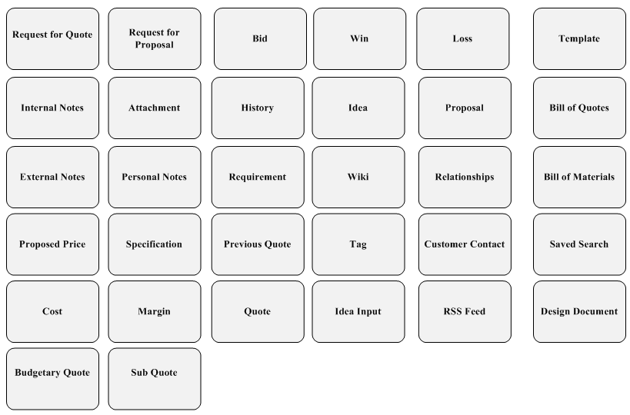

Procedure
Each session was held individually with the participants during a 30 minute to 1-hour period. The sessions were done remotely using Meeting Place phone conferencing and iMeeting web conference software (sessions were facilitated from Oracle’s Great America Parkway location).
The sessions began with each participant being greeted by the usability engineer and being introduced to the nature of the activity. Participants were informed about the use of audio and video equipment to record their actions and comments. The participants were given a brief description of the study activity and goals.
The Card Sort activity involved three subtasks: Card Sort Read/Re-name, Card Sort Initial Grouping, and Card Sort Secondary Grouping. Card sort subtasks were presented to the participants as separate and discrete steps. Instructions specific to each subtask were given separately. Participants were not told what they would be doing in the later steps because this might have biased their decisions. Details of each subtask are summarized below.
Part 1. Card Sorting Read/Rename
- Participants read through each card to make sure they understood the meaning of the function. Test facilitator instructed participants not to order the cards.
- Participants renamed and redefined any cards they found unfamiliar or inappropriate by explaining which cards were not applicable to the moderator and giving alternative(s).
Part 2. Card Sorting Initial Grouping
- Participants sorted the cards into logical groups. When they had finished reading the cards, participants were instructed to,
“Arrange the cards into groups in a way that makes sense to you. There is no right or wrong arrangement. We are interested in what you perceive to be the most logical or intuitive arrangement of the cards.”
- After finishing the groupings, participants named each group with second level card provided to them by the moderator.
Part 3. Card Sorting Secondary Grouping
- Participants sorted the grouped cards into higher-level groups if any were apparent.
- Participants named each of the higher-level groups with a third level card provided to them by the moderator.

Results

Sorting Data
The card sorting data was analyzed using a cluster analysis program to derive the overall sort shown in Figure 2. The figure shows the composite sort of all 32 cards for all 5 participants. The closer the concepts are to each other on the sorting diagram, the more conceptually related they are. EZ Calc generates groups based on relationship strength between items. The diagram below represents how the users understand the 32 concepts identified for the study or in other words their Mental Model of the concepts. Since the application only applies the groupings the labels to the left and the right were applied during the data analysis phase based on observations during the card sort and interview sessions. Due to the granularity of the terms this data cannot be used to structure menus, but instead is useful in determining objects that can be grouped in the application.
Figure 2: Card Sorting Results

The diagram indicates that users separated the terms in to two primary groups project information and resources.
The project information section is the core concepts that the users feel apply to their process. The resources section is tools and aids used to assist during the process. In the project information section there are three sub groups, pre-proposal, proposal and quoting, and project implementation. The three sub sections seem to follow the primary process steps outlined during the interview sessions with the participants.
During the pre-proposal steps they contact the customer, receive the requests from the customer, and gather requirements. Outlined in the previous report the pre-proposal phase is a very important time for an Engineering-to-Order company because it is when the most ambiguity exists.

Proposal and quoting is the next step that follows the pre-proposal phase. Once the team has all of the pre-proposal information and the user is fairly certain they know what they are building they will enter the proposal creation phase. The users seem to have broken this section into two more sections, quoting and proposal. The separation may be due to the difference between the internal information about the cost of the project and individual components versus the external proposal which may be delivered as a package to the customer containing technical, project management, and pricing information. To the user the proposal is what is accepted and rejected the quote is part of the proposal that is delivered.
An interesting similarity is the closeness of the bill of quotes and sub-quotes with the previous quote. Obviously none of the users currently used anything like a bill of quotes or a sub quote. The concept was rather new to the users. One potential reason they may have associated these elements closest was that they all contained the word quote. Another possibility is that the users believed any kind of quote relating to the object should be associated with the bill of quotes either past quotes or sub-quotes. From a user perspective it may make more sense see all quotes in a single section as opposed to quotes and sub-quotes in one section and past quotes in the relationships section.
The final group in the project information is the implementation. The user has grouped all of the information actually required to accept and carry out the project. The actual design documents, bill of materials, specifications, and the costs and margins of carrying out the project. The cost and margin may be utilized when negotiating the project after wining the bid. The teams need to make sure the margins are good enough and the cost of supplying the materials is not higher then originally quoted.
In the resources grouping, one interesting relationship is the closeness of the attachments and the relationships. Obviously an attachment would be a relationship, though not every relationship would be an attachment. This may indicate that these system concepts need to have a close grouping or a strong relationship in the application.
Another interesting relationship is the difference between notes and the other collaboration tools. The users did not utilize any of the tools like a wiki or a tag or even an rss feed. The notes are grouped separately possibly because of the familiarity with notes over other forms of collaboration. Additionally, notes may be a more important form of collaboration to the users, which indicates a need for further separation. Finally, they may just be more closely linked due to the naming similarity or the representation of the technologies in popular terminology.
Ideas seemed to be part of a separate group or a tool used by product engineers in research and development. The users did not utilize any concepts like an idea object in their current processes. Ideas were not an important concept because typically the users involved were more interested in finding the most efficient solution to a design problem as opposed to the most innovative.

Conclusion
The information found during the card sort is not surprising given the results of the structured interview sessions with the users where they described the key steps in carrying out a project. The results were similar to their earlier comments and matched the users thoughts about their expected process. There were a few notable issues that can be utilized in the design of the application. Foremost, the user will likely expect a key difference represented between internal information and any kind of external information. The proposal package delivered to the customer could have very different information included in it versus the information found in the information shared among team members.
The users seemed to utilize the concept of proposal over a quote when describing what they were creating. The proposal consisted of multiple entities including technical information, project management information, and a quote or costing information. Different teams who dealt either with the project management, finance, or engineering often managed these different sections of the proposal. The quote was more of an internal tool used by the group doing the costing for the project and would be delivered as part of the proposal in either a price breakdown or as a single number. The proposal was the external document and did not include internal information like the margins, actual cost, or any kind of notes or decisions made by the teams.
Overall the card sort revealed that the users mental model was highly dependent on their process. They saw the different steps of the project as they related to an overall project.

Appendix A
Terms
User Experience, Product Management, and Strategy identified thirty-two card-sorting terms that were used during the study. The terms were selected based primarily on information found in the requirements definition document (RDD) for CNM.
- Request for Quote
A standard business process a prospect or customer uses to solicit a bid for our products and/or services with a rigid set of requirements.

- Request for Proposal
A standard business process a prospect or customer uses to solicit a bid for our products and/or services with a flexible set of requirements.

- Bid
A proposal submitted to carry out a project for a customer for a specific price.

- Win
Receiving a project based on a bid proposal.

- Loss
No receiving a project based on a bid proposal

- Template
A predefined way of structuring any document such as a quote, requirement, proposal etc.

- Proposal
A formal written document that spells out what will be delivered, the costs, terms, conditions, and so forth, which is submitted as part of the bidding process.
- Idea
An initial concept, a starting point that will usually be aggregated with other ideas to form a business argument for a particular feature, product, or strategic decision.
- History
A listing of previous actions taken on an object.

- Attachment
A document or link that is associated with a system object that gives additional information.

- Internal Notes
Notes used internally between team members to give additional information.
- External Notes
Notes used to communicate with groups outside of the company (e.g. customer, vendors)
- Personal Notes
Notes that give information but are only viewable by the person who created the note.
- Requirement
An essential attribute or characteristic of a project/product.
- Wiki
A collaborative space for displaying content that is editable by any member in the group.
- Relationships
The relationship between a requirement or input and a formulated idea, item, issue, program, or quote.

- Bill of Quotes
All quotes in a hierarchy with related requirements, ideas, related to a major proposal.

- Sub Quote
A sub level quote created for a larger quote. For example a Power Plant would have a quote for facilities, the reactor, turbines, mechanicals etc…

- Quote
A full complex proposal delivered to the customer.
- Previous Quote
A quote for a past proposal

- Bill of Materials
A comprehensive listing of all components and subassemblies that go into a specific product, showing the quantity of each required for the assembly.
- Customer Contact
The contact information of a customer (e.g. email, phone number, address)
- Tag
A descriptive marker that can be applied to an object in the system, which can be used to locate the object in a search or browsing activity.
- Saved Search
Saved search criteria that can be accessed to find parts related to the saved criteria.
- RSS Feed
An external information source that updates automatically including information on a specified topic.
- Specification
A document that specifies, in a complete, precise, verifiable manner, the requirements, design, behavior, or other characteristics of a system, component, product, or project.
- Proposed Price
The proposed price that is given to the customer in the bid.
- Cost
The actual cost of executing the project, component, or product
- Margin
The different between the cost and the selling price
- Design Document
A preliminary design document or blueprint, based on requirements information, which is used for estimating feasibility and price information.
- Idea Source
An email, note, or any other source of input that should be associated with an idea.

