
KONABLUE • Sandbox

Introduction to KonaBlue ..................................... 1
Exploring the KonaBlue Directory ........................ 3
Working with the KonaBlue Prototype .................. 4

I. Introduction to KonaBlue

Like all prototypes, KonaBlue is a representation of the final application. It is written using several different standards namely HTML, CSS, JavaScript, JSON, the dojo library (written in JavaScript) and PHP.

Through SVN, you can find the main prototype folder using this path: agile > prototype > html > beta

Viewing KonaBlue and breaking it down to a framework, you will begin to see that there are some distinct sections to KonaBlue. The files within the KonaBlue Directory are classified using these distinctions, as well as others.

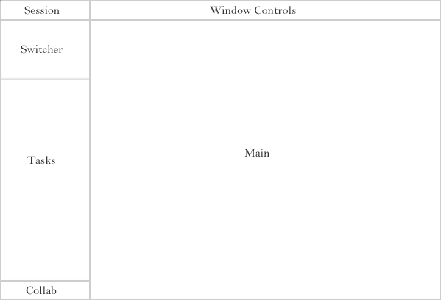
Figure 1-1: The KonaBlue Framework

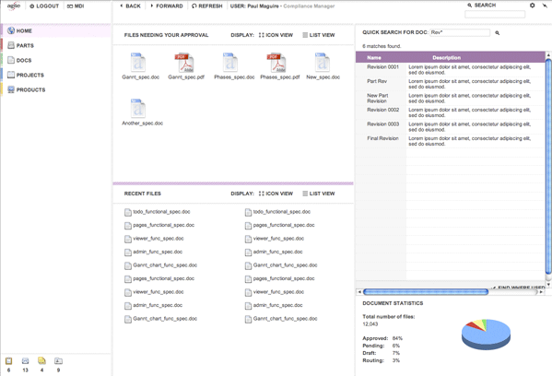

Figure 1-2: The finished site

The framework is made up of sections – Session, Switcher, Tasks, Collab, Window Controls and Main.

The switcher controls the flow of the prototype. It also has categories – Home, Parts, Docs, Projects and Products. Dependent sections such as tasks and main are further broken down by these categories. The categories in the switcher are also broken down into subcategories. These can be seen if the task pane for the category is accessed.

I.I Dojo

The switcher’s framework is controlled by dojo and is optimized for 1025 x 768 or bigger. This structuring in dojo helps provide the nifty sliding feature present in the prototype. For a short reference, the three most important tags to remember for dojo are ContentPane, LayoutContainer and SplitContainer.

Because dojo makes calculations before it renders the prototype, expect that there will be a delay in going from one screen to the next.

II. Exploring the KonaBlue Directory

In the actual prototype directory there are several folders you see immediately - content, css, images and js.

The content folder holds major files while css, images and js provide styles, images and functions.

CSS
There are several stylesheets housed in this directory. They represent both some of the ordering of our prototype (ex. main_docs.css) and also some of the general types of objects we have created (ex. tables.css).

JS
JS files have several classifications. Dojo is also housed in this directory.

JS files named "agile" have functions in them that usually pertain to the overall workings of a certain section. With those that start with "data" and "class," it is necessary to take the next word into account, namely either "switcher" or "tasks". Files prefaced with "invo" are general styles to be used throughout and after the designation of “invo” these files are denoted with the type of general things the functions inside can control. Example, invo.metrics.js deals with functions to manipulate an object.

Images
This folder contains all the images for the prototype. Like everything else, there are several types of images in here.

By far the most common types are those prefaced with "icn", which means they are icons. The images with “color” at the front of their names are used for the "switcher". Images using "bgd" create the subtle gray shading seen at the edges of the prototype. Those using "back" simply create the colored diagonal lines sometimes used to shade areas of the prototype.

Those with other names are used for very specific purpose and are not likely to be used more than once, as the other images are.

Content
The section holds the meat of the prototype, divided into several directories - collab, main, session, shared, switcher, tasks, and win_ctrls. These usually correspond to a section of finished site. (See Figure 1-1)

The section we will be most concerned with is main, as most of the action will occur there.

III. Working with the KonaBlue Prototype

There are several files needed to work with the prototype. This is dependent on several things related to classification. Below, the major sections are listed along with the files you will probably need to work in to change things in that particular section.

Switcher
The switcher is drawn using JS to dynamically write the HTML. Almost all functions that are used to generate the switcher can be found in class.switcher.js. In addition there is a js function called initSwitcher in index.php. Any data that the switcher is fed can be found in data.switcher.js. It is formatted as JSON. Data that might be found here includes what a certain section of the switcher is named and where it links to.

Tasks
The tasks in the task pane are also drawn using JS to dynamically write the HTML. The switcher data js (data.switcher.js) file determines with task appears in the task pane. Almost all functions that are used the generate tasks can be found in class.tasks.js. In addition there is a js function called initTasks in index.php. Any data that a task is fed can be found in data.tasks.js. It is formatted as JSON.

Main
Anything that appears in the main window can be changed via the appropriate files and folders, labelled for their section. These sections are reflected in the switcher. They are – home, docs, parts, projects and products. All sections in main are subdivided further into subdirectories which I call “flows” Within these subdirectories the files are further subdivided by a naming scheme, beginning with usually either screen or mod and at times popup.

These prefixes serve to make important distinctions between the type of files you are working with. Remember that the prototype is made up of modules that are arranged in screens. Thus files prefixed with “mod” are modules, pieces that make up a screen. Files prefixed with “screen” the screen that these modules make up. Files prefixed with “popup” are the popups seen when the options icon is pressed.

Many screens of the same nature make up a flow. So the create bom flow in the parts section is made up of the files prefixed with “screen_part_create_bom”. The screens of the create_bom flow are in turn made up of the files prefixed with “mod_part_create_bom” and so on.

All screens are named in sequence, documenting each change as a step. They may also have a version name after the numerical sequence is declared. These indicate there is more than one state a screen can be in during that step.
Modules are named according to their function, ex. some end in “table”, others in “tabs” etc. Some modules are considered general, for example the empty action bar (gray bar at the bottom of any given screen in a flow). These general mod files are located in beta > content > main .

When looking at a file with the prefix “screen”, you’ll see that they all share a distinct structure. At the very top, php variables are declared. Screen files then lay out the modules using php includes. Any scripts that need to run are declared at the end of the file.

Note: You’ll find that most files in main have their own CSS files dedicated to them, but some characteristics are shared by all files in main and thus have their own categorized CSS files such as buttons.css and tables.css.

Main: docs
All flows that appear in the docs category can be found in main > docs. The docs directory has subdirectories beneath it, “find documents” (find_docs), “view changes for approval” (appr_chng), “view documents for approval” (appr_doc), “view checked out documents” (check_in). Most associated styles can be found in main_docs.css.

Main: home
All flows that appear in the docs category can be found in main > home. Currently home contains only one subdirectory named startpage. This unlikely to change. Styles for the “startpage” flow can be found in main.css under the heading “home startpage”.

Main: parts
All flows that appear in the docs category can be found in main > parts. The parts directory has sub-directories beneath it, but not all correspond to an option on the parts task pane, “Find parts” (find_parts), “Create a Part” (create_bom), “Remove a part” (remove_part), “Replace a part” (replace_part). The save_bom_as flow can be accessed through the flow “find_parts”. Most associated styles can be found in main_parts.css.

Main: projects
All flows that appear in the projects category can be found in main > projects. Currently the projects directory has only one subdirectory, find_projs. This is the beginning page for projects. Most associated styles can be found in main_projects.css.

Main: products
All flows that appear in the projects category can be found in main > products. Currently the projects directory has only one subdirectory, find_prods. This is the beginning page for products. Most associated styles can be found in main_products.css.

III.I Going through flows

KonaBlue is a complex prototype. Each flow relies on a number of steps, some flows having a greater number of steps than others. To get to each screen you can each follow each step in sequence or have the option of using the hidden screen shortcuts in MDI.

III.II Changing headers

A filed named strings.php was created as a common repository for header names. To change or add a new header string, consult the strings.php file located in beta > content > main

