INDEX PAGE

**Chapter Title****Page No.**

ABSTRACT V

1. INTRODUCTION
2. PROBLEM STATEMENT
   1. Existing System Challenges
   2. Specific Problems Identified
   3. Need For A New Solution
3. LITERATURE REVIEW
4. EXISTING SYSTEM
5. PROPOSED SYSTEM
   1. Core Modules and Features

FIGURES INDEX

**Figure No. Page No.**

Fig: 1.1 About Figure 10

Fig: 1.2 About Figure 23

Fig: 2.1 About Figure 26

Fig: 2.2 About Figure 31

**1.INTRODUCTION**

“**Hire Smart**” is a next-generation web-based placement and career guidance portal designed to transform the traditional campus recruitment process by connecting students, academic placement cells, and recruiting companies through a unified digital platform. Addressing the inefficiencies of conventional systems like paper-based resumes, email chains, and manual coordination, “Hire Smart” streamlines the entire recruitment lifecycle into a fully digital, real-time, and user-friendly experience.

The portal provides students with a personalized dashboard where they can upload and manage their resumes, explore curated job listings based on eligibility and skill sets, and track application statuses. Students can directly apply to jobs through the platform and receive real-time notifications about their application updates, interview schedules, or shortlisting results. Additionally, the platform offers career development resources such as interview preparation materials, aptitude test links, and company-specific insights to enhance students' job readiness.

For placement officers and administrators, “Hire Smart” offers a robust management console that enables the creation, editing, and publishing of job postings, managing eligibility criteria, scheduling interviews, and accessing a centralized, searchable resume database. Admins can also analyze placement statistics through built-in reporting tools, helping them track performance and improve placement strategies.

Recruiters are provided with a dedicated, role-based access portal where they can browse filtered lists of student profiles, download resumes, post job opportunities with detailed eligibility requirements, and shortlist candidates directly from the system. Automated notifications ensure that selected candidates and administrators are immediately informed of any recruitment updates.

Built using the **MERN (MongoDB, Express.js, React.js, Node.js)** stack and secured with **JWT (JSON Web Token)** authentication, the platform ensures seamless performance, strong security, and a mobile-responsive experience. Real-time updates are powered through WebSocket technologies, minimizing delays and eliminating the need for page reloads. Through role-based access control, “Hire Smart” ensures that students, administrators, and companies have access only to the information they are authorized to view, maintaining confidentiality and data integrity.

By integrating powerful features into a single cohesive system, “Hire Smart” not only simplifies campus placements but also enhances collaboration between academia and industry, resulting in higher placement rates, improved candidate-job matching, and greater satisfaction among all stakeholders.

**2. PROBLEM STATEMENT**

Campus placement is a crucial phase in a student’s academic journey, marking the transition from education to employment. Traditionally, the placement process in many colleges and universities has been conducted manually through emails, printed resumes, offline notifications, and physical coordination between students, placement officers, and recruiters. This manual system often leads to inefficiencies, miscommunication, missed opportunities, and increased administrative burden. In the modern era where digital transformation is a norm across industries, the placement ecosystem remains in urgent need of a structured, digital-first solution.

**2.1. Existing System Challenges**

* **Manual Resume Management**

Students are often required to submit hard copies or email their resumes to placement cells. Tracking, organizing, and retrieving these resumes becomes tedious, error-prone, and time-consuming for administrators and recruiters.

* **Inefficient Communication**

Job openings, shortlisting results, and interview schedules are often communicated through fragmented channels such as notice boards, emails, or WhatsApp groups, leading to delays, missed information, and confusion among students.

* **Lack of Real-Time Updates**

In traditional systems, students often remain unaware of their application status, leading to uncertainty and disengagement. Placement cells struggle to maintain updated communication with hundreds or thousands of students at a time.

* **Administrative Overload**

Placement officers face overwhelming workloads when managing candidate databases, eligibility checks, shortlisting processes, and company requirements manually. This manual effort reduces their ability to focus on improving industry relationships and student preparation.

* **Fragmented Recruiter Access**

Companies participating in campus drives often receive resumes in bulk through emails or offline channels, making it difficult to search, filter, and select candidates efficiently. Lack of structured access discourages companies from actively engaging in college recruitment programs.

* **Security and Privacy Issues**

Sharing resumes and candidate information through unsecured channels (emails, printouts, external drives) leads to a lack of data privacy, risking misuse of sensitive personal information.

**2.2** **Specific Problems Identified**

* **Absence of a Centralized Portal**

There is no unified platform where students, administrators, and recruiters can collaborate seamlessly. Different stakeholders operate in isolated environments, leading to inefficiencies.

* **Poor Candidate-Job Matching**

Without eligibility filters, skill-based searches, or automated recommendations, students apply for irrelevant positions, and recruiters spend more time manually sifting through unsuitable profiles.

* **Difficulty in Managing Multiple Roles**

The existing systems do not properly distinguish between different user roles (students, admins, companies) leading to unnecessary access permissions and data confusion.

* **Lack of Structured Job Postings**

Companies struggle to clearly define job eligibility criteria, deadlines, and required skills due to the unstructured format of communications, leading to misunderstandings and misaligned applications.

* **No Performance Insights or Analytics**

Placement officers have no way to measure metrics such as application rates, selection ratios, department-wise placement statistics, or overall recruitment success rates without manual efforts.

* **Limited Career Guidance Resources**

Students often lack access to organized career development materials like interview FAQs, aptitude preparation, and company-specific insights, which are essential for their placement success.

**2.3.Need for a New Solution**

Given the increasing competition in the job market and the need for faster, more reliable placement processes, there is an urgent need for a comprehensive, digital platform that:

* Automates resume management and candidate shortlisting
* Facilitates real-time communication and notifications
* Provides role-based secure access to students, admins, and recruiters
* Allows recruiters to post jobs with specific eligibility criteria
* Enables students to apply for jobs and track their application status
* Centralizes career resources to boost student readiness
* Generates placement analytics for continuous improvement

**3.LITERATURE REVIEW**

The hiring process has undergone significant transformation in recent years, driven by advancements in technology, the growth of data analytics, and the evolving needs of employers and job seekers. A number of studies and existing systems provide valuable insight into the current landscape and the necessity for smarter, tech-enabled recruitment solutions like "Hire Smart".

* **Traditional Recruitment Methods**

Traditional hiring practices rely heavily on manual resume screening, interviews, and subjective decision-making. According to a study published in the *Journal of Human Resource Management* (2019), up to 60% of recruiters' time is spent on repetitive tasks such as filtering resumes and scheduling interviews. These outdated systems often result in inefficiencies, communication gaps, and delayed hiring decisions.

* **Communication Tools in Campus Recruitment**

Many institutions and recruiters still depend on emails, WhatsApp messages, and notice boards to communicate with students. While these methods are easily accessible, they lack automation, centralized tracking, and reliable delivery confirmation. Research by *IEEE Xplore (2021)* suggests that decentralized communication methods can lead to missed opportunities and confusion among candidates.

* **AI in Recruitment**

The integration of Artificial Intelligence (AI) in recruitment is gaining momentum, with AI-powered tools now being used to screen resumes, analyze candidate data, and even conduct preliminary interviews through chatbots. According to *Deloitte's 2020 Global Human Capital Trends Report*, over 33% of companies are now using AI to enhance recruitment efficiency and reduce hiring bias.

* **Automated Interview Scheduling**

Tools like Calendly, Google Calendar integrations, and applicant tracking systems (ATS) have introduced automated scheduling, but their use is not widespread in campus hiring. A study by *McKinsey & Company (2020)* shows that companies that implemented automated scheduling reported a 40% faster interview process compared to those using manual methods.

* **Smart Hiring Platforms**

Modern hiring platforms such as LinkedIn Talent Solutions, HireVue, and Zoho Recruit offer automation, video interviewing, and candidate analytics. However, many are tailored to corporate settings and not optimized for student hiring or campus drives. This creates a gap where customized, student-focused platforms like "Hire Smart" can play a crucial role.

* **Challenges in Student Recruitment**

In educational institutions, students often struggle to balance academic schedules with recruitment activities. A research article from *SpringerLink (2021)* highlighted that lack of timely updates and scheduling conflicts are two major reasons for low student participation in campus interviews.

**4.EXISTING SYSTEM**

Currently, the recruitment process especially in campus placements and student hiring is managed manually and lacks centralized automation. Most communication and coordination between recruiters, placement cells, and students happen through emails, WhatsApp messages, or phone calls.

* **Communication Channels:**
* Recruiters share interview details like date, time, and venue through emails or WhatsApp group messages.
* Students have to regularly check their inboxes or chat groups to stay updated.
* There is no confirmation system to ensure every student receives or views the notification.
* **Interview Scheduling:**
* Schedules are manually managed by HR teams or placement officers.
* Time slots are assigned through shared documents or spreadsheets.
* There is no system for conflict checking or flexible rescheduling, which creates issues for students with tight academic schedules.
* **Candidate Shortlisting:**
* Recruiters manually go through all submitted resumes.
* There is no automated pre-screening, so even underqualified candidates may be called for interviews.
* This wastes time and effort for both interviewers and candidates.
* **Data Management:**
* Student data, resumes, and application status are often stored in Excel sheets or email threads.
* There is no unified platform for tracking applications, interview feedback, or status updates.
* **Follow-ups & Notifications:**
* Follow-ups and result announcements are also shared through informal channels like messages or emails.

1. **Disadvantages**

* **Lack of Real-Time Notifications:**

Students may miss important interview updates due to delayed or unnoticed emails or messages.

* **Manual and Time-Consuming:**

Recruiters and placement coordinators spend a lot of time on tasks like shortlisting, scheduling, and follow-ups.

* **Poor Candidate Management:**

No centralized system to track each student’s application status, interview progress, or results.

* **Scheduling Conflicts:**

Interviews often clash with students’ classes or exams due to manual, non-flexible scheduling.

* **Unfiltered Applicant Pool:**

Recruiters may waste time interviewing students who do not meet the basic eligibility or skill requirements.

* **Communication Gaps:**

Relying on WhatsApp and emails can lead to miscommunication, missed messages, or inconsistent information sharing.

* **No Feedback Mechanism:**

Students often don’t receive updates or results from interviews, affecting transparency and learning.

* **Data Insecurity:**

Storing resumes and personal data in shared emails or spreadsheets may lead to data loss or privacy issues.

* **Lack of Automation:**

Repetitive tasks such as sending invites, sorting resumes, or scheduling interviews are done manually, increasing the risk of human error.

**5.PROPOSED SYSTEM**

The proposed system, "Hire Smart", is a modern, role-based campus placement and career guidance web application, specifically designed to address the limitations of existing systems. It provides a unified digital ecosystem where students, placement administrators, and recruiting companies can collaborate seamlessly to facilitate efficient, transparent, and scalable recruitment processes.

**5.1.Core Modules and Features**

* **Student Portal**
* Secure Login & Registration: Students authenticate securely using email/password with JWT tokens.
* Resume Management: Upload, update, and manage multiple resume versions (PDF/DOCX).
* Job Listings Dashboard: View real-time job postings with eligibility filters, skill requirements, deadlines, and application status.
* Direct Application: Apply to jobs within the platform, eliminating manual email-based submissions.
* Push Notifications: Receive instant alerts for shortlisting, interview scheduling, and application status updates via WebSockets or secure push services.
* Career Resources: Access a curated library of interview FAQs, aptitude test links, coding practice sites, and company-specific preparation guides.
* **Administrator Portal**
* Job Posting Management: Create, update, and delete job postings with detailed eligibility criteria and application timelines.
* Resume Bank: Centralized repository of all uploaded student resumes, searchable by department, graduation year, skills, and more.
* Candidate Shortlisting: Filter candidates based on custom criteria (e.g., CGPA, skills) and mark them as shortlisted directly within the system.
* Batch Notifications: Send personalized bulk notifications to students regarding new job openings, deadlines, and placement drives.
* **Company Portal (Recruiters)**
* Role-Based Secure Access: Recruiters register and authenticate to access a dedicated interface.
* Browse & Filter Resumes: Search student profiles based on skills, CGPA, department, etc., and download resumes.
* Job Announcement Publishing: Post openings with detailed job descriptions, eligibility conditions, and application deadlines.
* Shortlisting and Scheduling:
  + Mark candidates as shortlisted.
  + Trigger automated notifications to students and admins.
  + Set interview dates and send invites.

**a. Advantages**

* **Time Savings:** Automation reduces manual tasks, saving time for both recruiters and candidates.
* **Increased Efficiency:** AI-powered screening ensures that only the most qualified candidates are shortlisted.
* **Improved Candidate Experience:** Real-time notifications and clear communication create a smoother, more transparent process for candidates.
* **Reduced Errors:** Automated scheduling and notifications minimize the risk of human error and miscommunication.
* **Data-Driven Decisions:** Advanced analytics help recruiters make better hiring decisions based on objective data rather than intuition.
* **Scalability:** **Hire Smart** can handle large volumes of applications, making it ideal for both small companies and large-scale campus recruitment events.

**6.SYSTEM REQUIREMENTS**

**6.1. FUNCTIONAL REQUIREMENTS**

Functional requirements define the core services, features, and behavior that the **"Hire Smart"** system must support:

**a. Student Features**

* User authentication via email and password (secured with JWT).
* Upload, update, and delete resumes (in PDF/DOCX formats).
* View available job postings with role details, eligibility, and deadlines.
* Apply to jobs directly from the dashboard.
* Receive push notifications regarding:
  + Application status.
  + Shortlisting updates.
  + Interview schedules.
* Access a centralized resource library (FAQs, aptitude tests, company-specific prep).

**b. Administrator Features**

* Admin login authentication.
* Post, edit, and delete job openings.
* Define eligibility criteria for job postings (e.g., minimum CGPA, department filters).
* View and manage uploaded student resumes.
* Search and filter student profiles by various attributes.
* Shortlist candidates for companies.
* Send batch notifications to selected students.

**c. Company (Recruiter) Features**

* Secure company login and authentication.
* Post job openings with specific eligibility filters.
* Browse and search resumes.
* Shortlist students directly within the platform

**d. General Features**

* Role-based access control (Student/Admin/Company).
* Secure file upload handling for resumes.

**6.2. NON-FUNCTIONAL REQUIREMENTS**

These define system qualities like performance, usability, reliability, etc.:

| **Attribute** | **Requirement** |
| --- | --- |
| **Performance** | Fast loading times (<2 seconds for major pages). Real-time updates without full reload. |
| **Security** | JWT authentication, password hashing (bcrypt), secured API endpoints, and access control based on user roles. |
| **Scalability** | The system should support hundreds of concurrent users (students, admins, companies). |
| **Usability** | Intuitive UI/UX for easy navigation across different user roles. |
| **Availability** | 99.9% uptime for hosted applications. |
| **Maintainability** | Modular code structure (MERN stack separation: frontend, backend, database). |
| **Portability** | Responsive across desktops, tablets, and smartphones. |
| **Backup & Recovery** | Regular database backups and file storage redundancies. |

**6.3. HARDWARE REQUIREMENTS**

| **Component** | **Minimum Requirement** |
| --- | --- |
| Processor | Intel Core i3 (or equivalent) and above |
| RAM | 8 GB RAM |
| Storage | 50 GB free hard disk space |
| Network | Reliable internet connection for hosting and access |
| Devices Supported | Desktop, Laptop, Tablet, Mobile Phones |

**6.4. SOFTWARE REQUIREMENTS**

| **Component** | **Software/Version** |
| --- | --- |
| Operating System (Server) | Linux (Ubuntu 20.04) / Windows 10+ |
| Database | MongoDB Atlas or Local MongoDB Server |
| Backend | Node.js v18+, Express.js Framework |
| Frontend | React.js v18+, Tailwind CSS |
| Authentication | JWT (JSON Web Token) |
| APIs | RESTful APIs with secure endpoints |
| Notification Service | WebSockets (Socket.IO) / FCM (Firebase Cloud Messaging) |
| Code Repository | GitHub / GitLab |
| Hosting Platforms | Vercel (Frontend), Render/Railway.app (Backend) |
| Development Tools | Visual Studio Code, Postman, Git |
| File Upload Handling | Multer middleware (Node.js) |
| Version Control | Git |

**7.METHODOLOGY**

The development of "Hire Smart" follows a structured, modular approach based on the Agile Software Development Methodology. This allows for iterative progress, continuous feedback, and flexibility to accommodate feature enhancements or user-driven changes. The overall methodology adopted can be divided into the following major phases:

**Requirement Analysis**

* **Stakeholder Meetings**: Conducted discussions with students, placement officers, and recruiters to gather real-world needs and challenges faced during traditional campus recruitment.
* **Requirement Documentation**: Clearly defined functional and non-functional requirements for the three primary user groups — Students, Administrators, and Companies.
* **Technology Stack Decision**: Selected MERN (MongoDB, Express.js, React.js, Node.js) stack for building a scalable, modern web application, along with JWT for secure authentication.

**System Design**

* **Architecture Planning**: Designed a three-role based system (Student, Admin, Company) using role-based access control (RBAC) principles.
* **Database Design**: Created entity-relationship (ER) diagrams to model collections like Users, Resumes, Jobs, Applications, and Notifications in MongoDB.
* **Frontend Design**:
  + Designed wireframes for major screens (Dashboard, Job Listings, Resume Upload, Admin Console, Recruiter View).
  + Ensured a responsive and mobile-first design using Tailwind CSS.
* **Backend Design**:
  + Designed secure RESTful APIs with protected routes based on JWT authentication.
  + Architected backend services for resume uploads (using Multer), notification management, and job application processing.

**Implementation**

**Frontend Development (React.js + Tailwind CSS)**

* Developed reusable, component-based UI modules for each user type.
* Integrated secure login and registration flows.
* Created dynamic dashboards for real-time job updates and notification handling.
* Implemented resume upload, job application forms, resource library, and notification pop-ups.

**Backend Development (Node.js + Express.js)**

* Built RESTful APIs to handle:
  + User authentication and role management.
  + Resume upload, update, and retrieval.
  + Job posting creation, editing, and deletion.
  + Application submissions and status updates.
  + Sending real-time push notifications via WebSocket (Socket.IO) or FCM (Firebase Cloud Messaging).
* Integrated Multer middleware for handling resume file uploads securely.

**Database Management (MongoDB)**

* Implemented collections and schema validations for:
  + Students (profile + resume details)
  + Companies (recruiter profiles)
  + Job Postings
  + Applications
  + Notifications
* Applied indexing for fast resume and job search capabilities.

**Testing**

* **Unit Testing**: Tested individual components and APIs for correct functionality using tools like Jest and Postman.
* **Integration Testing**: Verified end-to-end workflows, e.g., student applying to a job, admin shortlisting, recruiter viewing resumes.
* **User Acceptance Testing (UAT)**: Collected feedback from a test group of students, admins, and recruiters to ensure the platform met expectations.
* **Security Testing**: Ensured secured APIs, encrypted passwords (with bcrypt), and protected file storage for resumes.

**8.MODULES DESCRIPTION**

“**Hire Smart**” is divided into multiple interlinked modules, each addressing the specific needs of its users — Students, Administrators, and Recruiters — while ensuring security, efficiency, and a seamless user experience.

**Student Module**

* **User Registration & Login:**
  + Students can create an account and log in securely using JWT-based authentication.
* **Resume Management:**
  + Upload, update, or delete multiple versions of resumes (PDF, DOCX format).
* **Job Browsing:**
  + View real-time job listings posted by companies
* **Notification System:**
  + Receive real-time push notifications for:
    - Shortlisting notifications.
    - Interview schedules.
* **Resource Access:**
  + Access curated interview FAQs, aptitude questions, company-specific preparation materials.

**Administrator (Placement Cell) Module**

* **Admin Authentication:**
  + Secure admin login with elevated privileges.
* **Job Post Management:**
  + Create, edit, or delete job postings with detailed criteria (skills, branch eligibility, minimum CGPA, deadlines).
* **Resume Bank:**
  + Access a centralized repository of all uploaded student resumes.
* **Shortlisting Management:**
  + Shortlist candidates for specific jobs and send automatic notifications.
* **Placement Drive Management:**
  + Schedule and announce campus recruitment drives with dates and criteria.
* **Resource Management:**
  + Upload and manage aptitude tests, interview FAQs, and preparation materials in the resource library.

**Company/Recruiter Module**

* **Recruiter Authentication:**
  + Role-specific login for recruiters with limited, secure access.
* **Job Posting:**
  + Create job openings, set eligibility criteria (skills, CGPA, year of study)
* **Resume Browsing:**
  + View student resumes
* **Shortlisting Candidates:**
  + Mark students as shortlisted for interviews

**Authentication and Authorization Module**

* **User Role Management:**
  + Differentiate access and functionality for Students, Admins, and Recruiters.
* **JWT-Based Secure Sessions:**
  + Every user action is authenticated using JSON Web Tokens.
* **Password Encryption:**
  + Passwords are encrypted using bcrypt.js before storing them in the database.

**Notification and Alert Module**

* **Real-Time Notifications:**
  + Notifications for application updates, interview calls, shortlisting results.
* **Push Notification Integration:**
  + Integration with WebSockets or Firebase Cloud Messaging (FCM) for real-time delivery.

**Resume Management Module**

* **Resume Upload & Storage:**
  + Upload resumes through the frontend.
  + Store securely on the server or cloud storage (local uploads/ folder ).
* **Resume Preview & Download:**
  + Students, admins, and recruiters can view or download resumes.
* **Version Control:**
  + Students can manage and update different versions of resumes for different roles.

**Job Management Module**

* **Job Creation by Admins and Companies:**
  + Dynamic forms for job details, requirements, eligibility criteria.
* **Job Listing for Students:**
  + Students see filtered jobs based on their profiles.
* **Application Management:**
  + Students apply through the portal, and application status is tracked by both admins and recruiters.

**Resource Library Module**

* **Central Repository:**
  + Admins upload learning materials, interview guides, aptitude practice resources.
* **Student Access:**
  + Students can easily access preparation resources to boost their placement success.

**9.DESIGNING**

1. **Data Flow Diagrams**

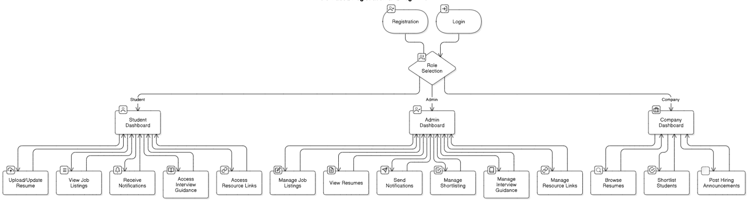

1. **Entity-Relationship (ER) Diagram**

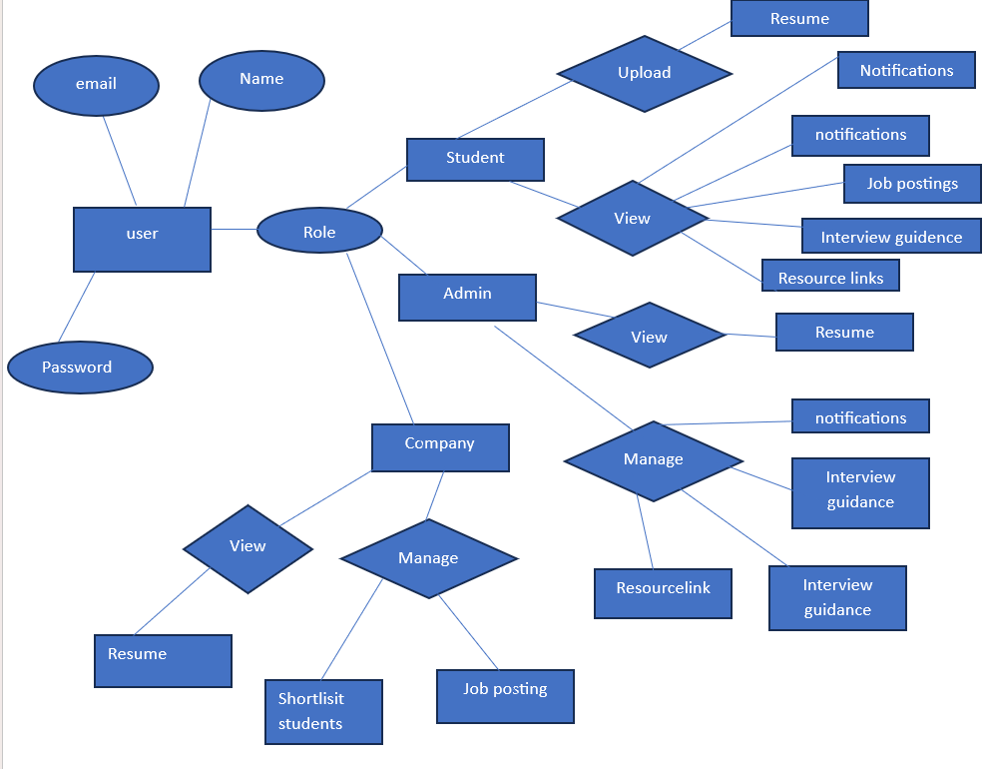

1. **UML Diagrams:**

* **Class Diagram**

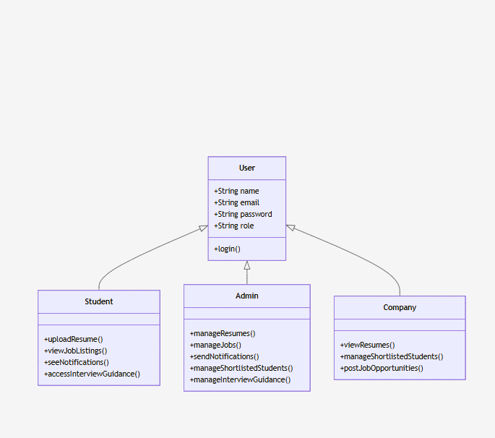

* Object Diagram

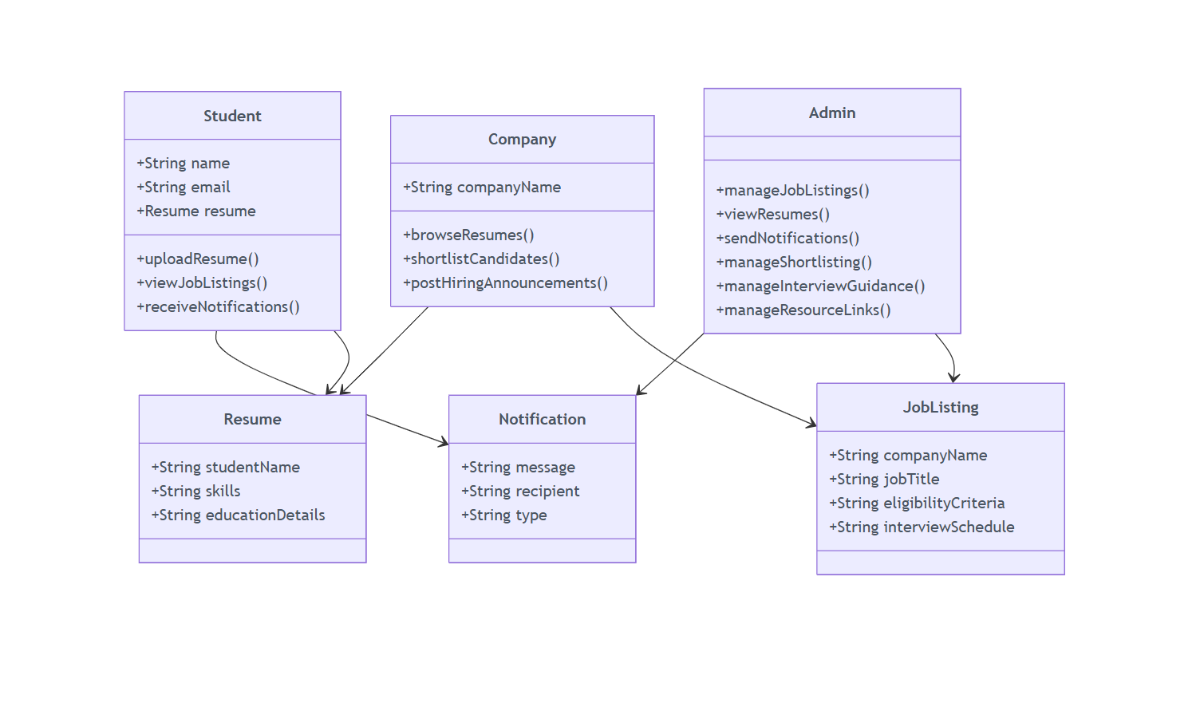

* Sequence Diagram

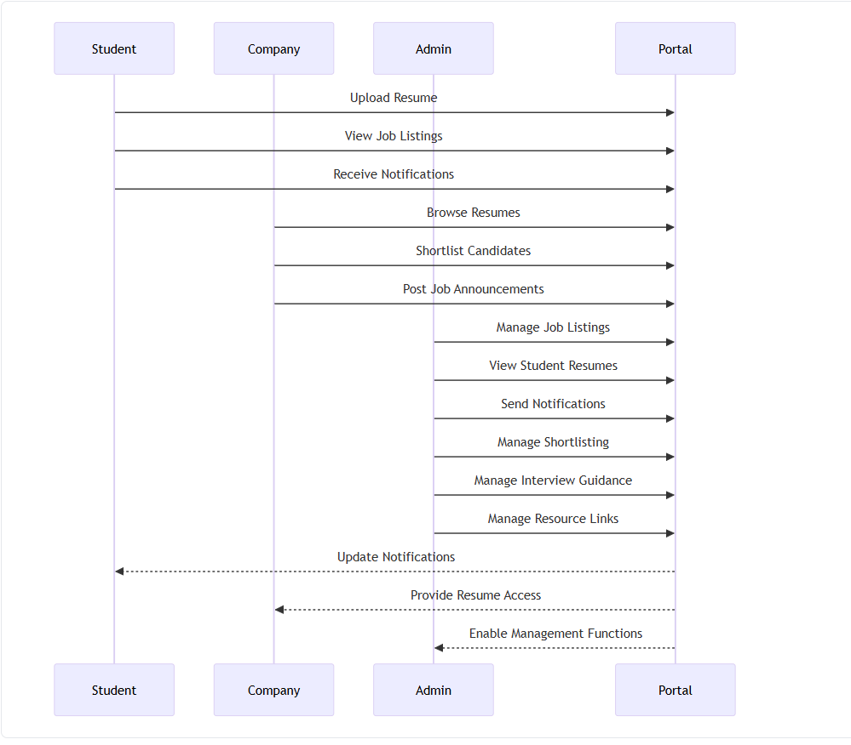

* **Use Case Diagram**

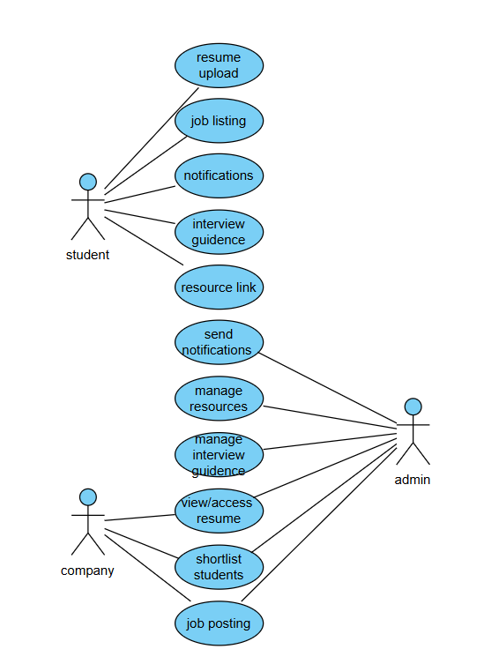

* **State Chart Diagram**

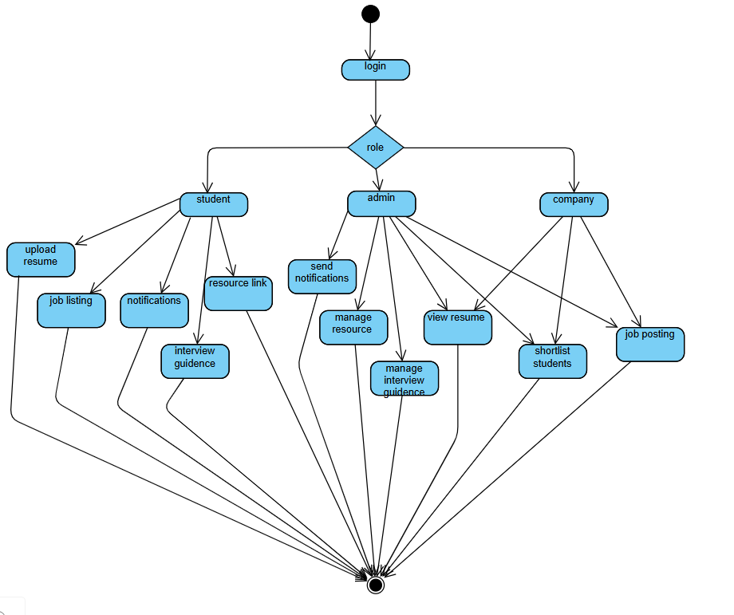

**10. IMPLEMENTATION**

**11. RESULTS**

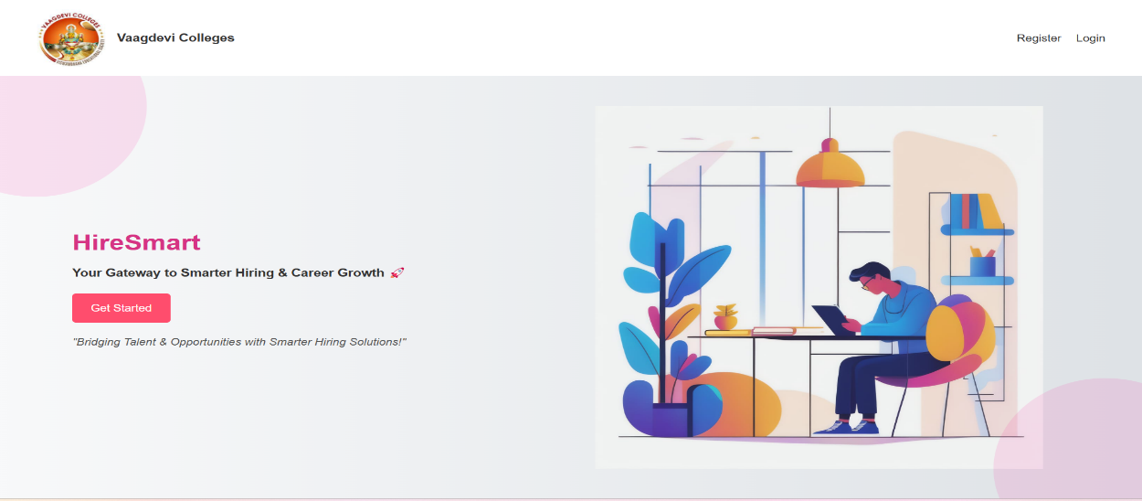



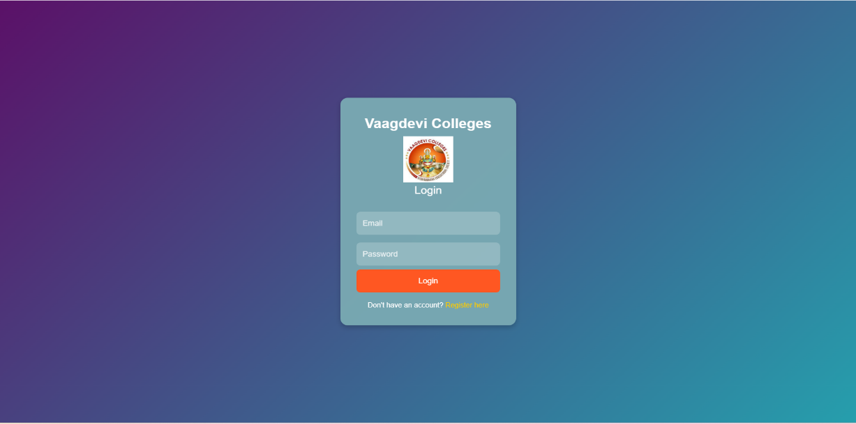

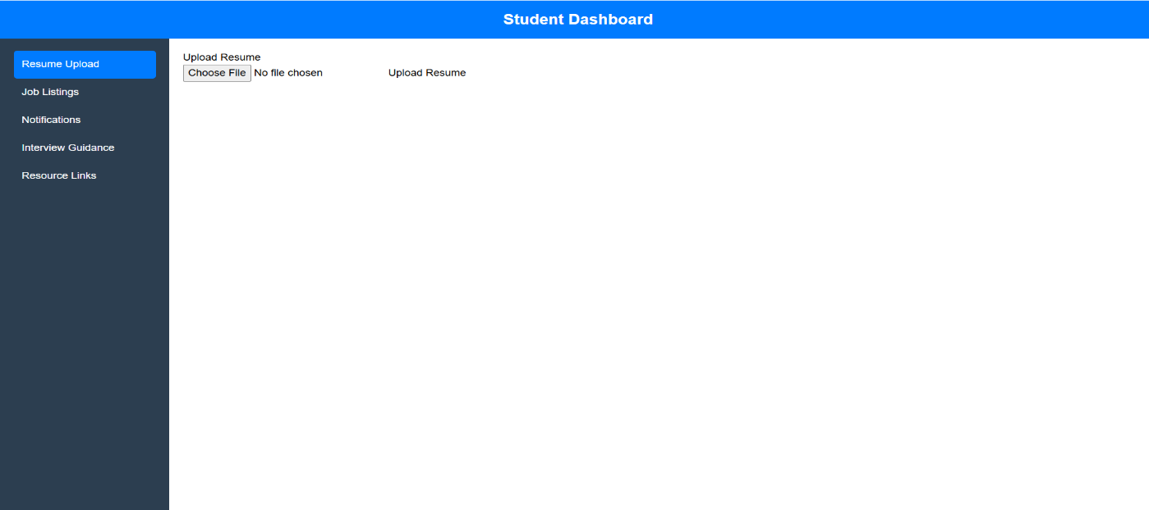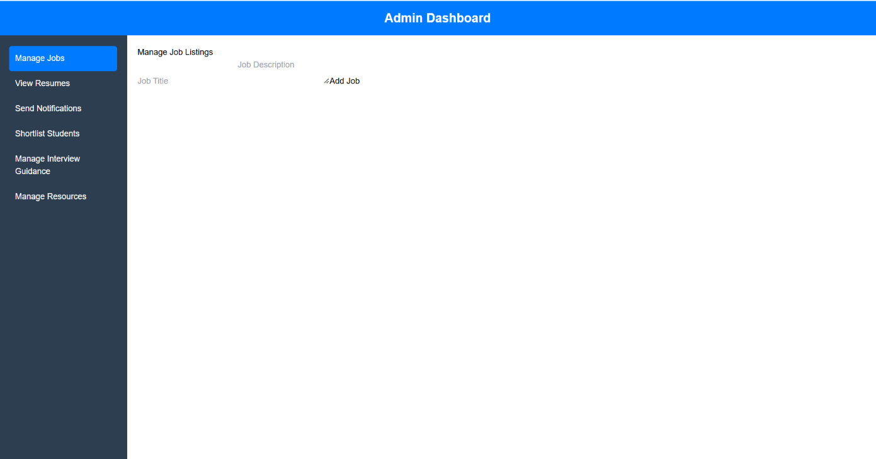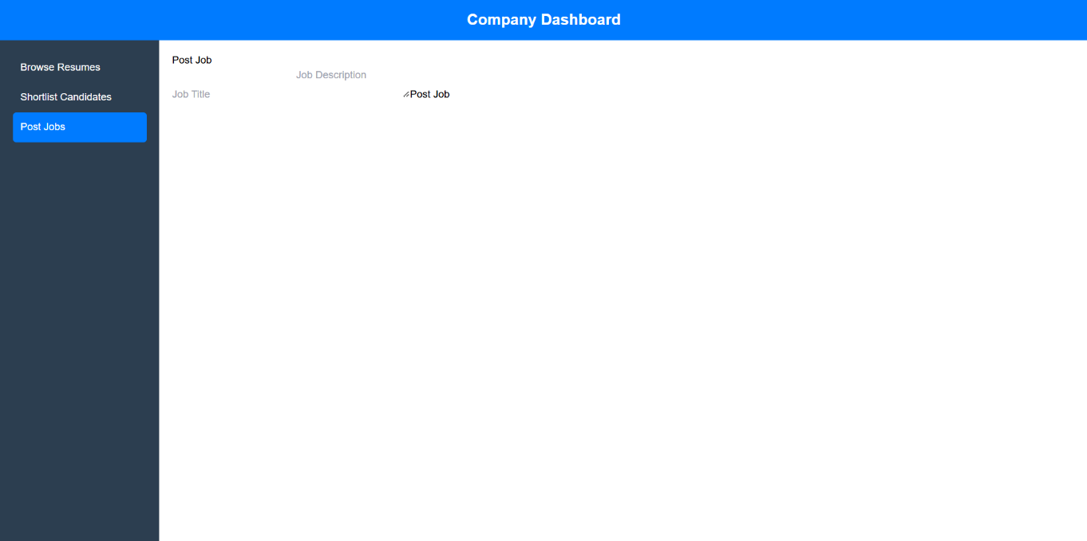

**12.TESTING**

**13. CONCLUSION AND FUTURE SCOPE**

**14. REFERENCES**