DATA ANALYTICS PROJECT
PROJECT DOCUMENTATION
Using R / RStudio

Project Title | Student / Group
Philippines Real Estate Market Analysis and Price Prediction Using R | Dean Warren P. Booc  Peneil Francis S. Cayaco

Course / Section | Instructor
ELECTIVE 3 – BSIT241-C | Joseph L. Domingo

Date Submitted | Academic Year
October 20, 2026 | 2026 - 2027

Table of Contents
1 Project Overview 1
2 Problem Statement and Objectives 2
2.1 Problem Statement 2
2.2 General Objective 2
2.3 Specific Objectives 2
3 Dataset Description 3
3.1 Data Source 5
3.2 Dataset Size 5
3.3 Screenshot 5
4 Data Preparation and Cleaning 6
4.1 Cleaning Procedures 8
4.2 R Code Used for Cleaning 9
5 Exploratory Data Analysis (EDA) 11
5.1 Descriptive Statistics 11
5.2 Important Patterns 11
5.3 R Code 12
6 Data Visualization 15
6.1 Visualization 1 15
6.2 Visualization 2 16
6.3 Visualization 3 (Optional) 17
6.4 6.4 Interactive Decision-Support Valuation Dashboard (R Shiny UI/UX) 19
7 Statistical Analysis / Predictive Modeling 20
7.1 Method Used 20
7.2 Model / Analysis Setup 21
7.3 R Code 21
7.4 Results 22
7.5 Model Interpretation 23
7.6 Model Visualizations and Diagnostics 23
8 Findings and Discussion 26
8.1 Key Findings 27
8.2 Discussion 28
9 Conclusions and Recommendations 28
9.1 Conclusion 28
9.2 Recommendations 29
9.3 Limitations 30
10 Technical Implementation 31
10.1 10.0 System Architecture and Pipeline Topology 31
10.2 R Packages Used 31
10.3 Reproducibility 32
11 Evidence and Screenshots 33
12 References 34
13 Appendices 35
13.1 Appendix A – Complete R Script 35
13.2 Appendix B – Additional Tables / Figures 35
13.3 Appendix C – Dataset / Project Files 37
14 Student Submission Checklist 38

Project Overview

Project Description:
Modern real estate valuation relies increasingly on quantitative frameworks rather than intuition. As a structured discipline, data analytics is a rigorous workflow; as Richardson, Teeter, and Terrell note, "The process begins by identifying business questions that can be addressed with data and then testing the data, refining our testing, and finally, communicating those findings to management" (2019, p. v). By applying these analytical levels, organizations move from summarizing historical data to forecasting future trends. Furthermore, transitioning to an evidence-based strategy is critical for success. Verhoef, Kooge, Walk, and Wieringa argue that "Value creation should be the ultimate objective of every data science strategy," which requires balancing both "Value to the customer (V2C)" and "Value to the firm (V2F)" (2022, p. 7). By adopting this empirical focus rather than relying on intuition, stakeholders can generate measurable business value in dynamic market environments like real estate.
This project focuses on a real-estate based data set which contains information about 241,496 properties in the Philippines. Information such as the property type, asking price, floor area, number of bedrooms and bathrooms, and location (city, province, and region) were obtained from Kaggle. This project aims to present an analysis of the patterns found in the housing market of the Philippines, identify factors which have an effect on the price of a property, and build a statistical model to predict these prices.
This project's results are aimed to be used by students of data analytics, those aiming to purchase real estate in the Philippines, and real estate agents or investors who are interested in the patterns of the Philippine property market. The purpose of this project is to analyze the data set using data exploration and visualization and to present the results in a simple manner through statistical analysis and modeling. Furthermore, to bridge the gap between empirical econometric modeling and operational utility, this project delivers an interactive decision-support valuation dashboard developed using R Shiny, Plotly, and responsive CSS. The platform empowers prospective homebuyers, real estate professionals, and analysts to dynamically filter active listings across 17 Philippine regions and obtain real-time property valuation estimates with confidence bands generated by the trained machine learning models.
Project Scope:
This project covers the analysis of residential and commercial property listings for sale in the Philippines based on the collected dataset. It includes data cleaning, exploratory data analysis, data visualization, and price prediction modeling using R. The analysis focuses on key variables such as property type, floor area, number of rooms, and location.
This project does not cover rental properties, as all listings in the dataset are for sale only. It also does not include real-time or live market data, as the dataset was collected through web scraping at a specific point in time. Financial advice, legal property guidance, and direct market forecasting are also outside the scope of this academic project.

Required Evidence
- Final project title and short description
- Optional: project concept/proposal or initial planning evidence

Problem Statement and Objectives

Problem Statement
Many Filipinos, including first-time homebuyers and investors, struggle to understand why property prices differ so much across cities and property types in the Philippines. Without a clear understanding of what drives asking prices, buyers may overpay and sellers may underprice their properties.
Traditional pricing strategies often suffer from inefficiencies when relying on gut feeling rather than empirical market data. To solve this, predictive analytics enables stakeholders to transition toward data-driven valuation strategies. This requires a structured approach to raw transaction data. The IMPACT analytics framework provides this structure, emphasizing that "Data Analytics is a process" that must be systematically applied to "answer fundamental business and accounting questions and create value" (Richardson, Teeter, & Terrell, 2019, p. iv - v). Ultimately, replacing intuition with data science is essential, because as Verhoef et al. point out, "firms have a strong belief that the science of analyzing data can lead to a competitive advantage and can create new business opportunities" (2022, p. 6).
This project aims to analyze real estate listing data from across the Philippines to identify the key factors that influence asking prices and to develop a basic price prediction model that can help estimate property values based on measurable characteristics such as location, property type, and floor area.

General Objective
The objective of this project is to analyze the Philippines Real Estate Asking Prices data set using R in RStudio to determine factors that influence the price of properties and create a predictive model that can estimate the value of a property based on its features and location.

Specific Objectives
Aligning with the data analytics stages defined by Richardson et al. (2019) and the value creation framework of Verhoef et al. (2022), the specific objectives are:
- To observe and describe the structure, size, and data quality of the Philippines Real Estate Asking Prices dataset by examining its variables, data types, and missing values.
- To clean and prepare the raw dataset by addressing missing values, removing invalid records, filtering extreme outliers, and selecting only the relevant variables needed for analysis, following established data scrubbing protocols (Richardson et al., 2019).
- To explore patterns in property asking prices across different property types, floor areas, bedroom counts, and geographic regions in the Philippines using descriptive statistics and data visualizations (Richardson et al., 2019).
To build, evaluate, and compare predictive models—specifically Multiple Linear Regression (MLR) and Random Forest Regression—to predict log-transformed property asking prices and determine feature importance across physical and regional attributes (Richardson et al., 2019; Verhoef et al., 2022).
- To design, build, and deploy an interactive decision-support valuation dashboard using R Shiny and Plotly, providing stakeholders with dynamic filtering of active market listings, visual regional benchmarks, and automated real-time valuation predictions powered by the trained predictive models.
Required Evidence
- Clearly stated problem/question
- General and specific objectives aligned with the analysis

Dataset Description
Describe the source, purpose, structure, and characteristics of the dataset.
Item | Description
Dataset Name | Philippines Real Estate Asking Prices
Data Source | Kaggle, uploaded by Christian D. Moira
File Format | Comma-Separated Values (.csv)
Total Records | 241,496 property listings
Total Variables | 25 variables (columns)
Target Variable | price_php: the asking price of the property in Philippine Peso

Dataset Variables:
Variable | Data Type | Description | Example Value
listing_id | Text (ID) | Unique identifier assigned to each property listing | d124a16d74aa562c
source_id | Text (ID) | Code that identifies which platform the listing was scraped from | S03
canonical_id | Text (ID) | A deduplicated ID used to identify the same property across multiple platforms | d124a16d74aa562c
listing_type | Text (Categorical) | The type of transaction. All 241,496 listings in this dataset are for sale only | sale
property_type | Text (Categorical) | The broad category of the property: house, condo, lot, or commercial | condo
property_subtype | Text (Categorical) | A more specific classification of the property type. Mostly blank in this dataset | studio
price_php | Numeric | The asking price of the property in Philippine Peso. This is the main target variable | 31,500,000
sqm | Numeric | The floor area of the property in square meters. Missing for 12.9% of listings | 95
lot_area_m2 | Numeric | The total land area in square meters. Usually blank for condominium units | 250
price_per_sqm | Numeric | A derived column computed as price divided by floor area. Null if sqm is missing or if the value falls outside the range of 1,000 to 1,000,000 PHP per sqm | 331,578.95
bedrooms | Numeric | The number of bedrooms in the property. Missing in 38.8% of listings | 2
bathrooms | Numeric | The number of bathrooms in the property. Missing in 62% of listings | 1
city | Text (Categorical) | The city or municipality where the property is located | Taguig City
district | Text (Categorical) | The district within a city. Missing in 77.5% of listings | Eastern District
barangay | Text (Categorical) | The barangay-level location of the property. Missing in 83.4% of listings | Poblacion
province | Text (Categorical) | The province where the property is located. Missing in 23.2% of listings | Laguna
region | Text (Categorical) | The administrative region in the Philippines. Missing in 23.2% of listings | Region IV-A (CALABARZON)
lat | Numeric | The geographic latitude coordinate of the listing location | 14.477
lng | Numeric | The geographic longitude coordinate of the listing location | 121.049
n_photos | Whole Number | The number of photos attached to the listing | 1
first_seen | Date | The date the listing was first recorded in the dataset | 2026-04-12
last_seen | Date | The most recent date the listing was observed as still online | 2026-08-29
is_active | True/False (Boolean) | Indicates whether the listing is currently active or already taken down | True
quality_score | Numeric | A pipeline data quality score from 0 to 100 assigned during web scraping. Null if the listing was never scored (missing in 45.0% of records). | 85
new_build_flag | True/False (Boolean) | Indicates if the property is a newly built unit. Missing in 79.0% of listings | True
Geographic Coverage: 17 regions, 84 provinces, 1,530 distinct cities
Observation Window: 2026-02-22 to 2026-08-30

Data Source
D'Moira, C. (2026). Philippines Real Estate Asking Prices [Data set]. Kaggle. https://www.kaggle.com/datasets/christiandmoira/philippines-real-estate-asking-prices

Dataset Size
The dataset contains 241,496 property listings and 25 variables. Each row represents a unique property listing in the Philippines, capturing details such as asking price, location, property type, and floor area. The total dataset dimensions (241,496 x 25) were verified upon initial import.

Screenshot
Screenshot 3.1: Imported Dataset in RStudio
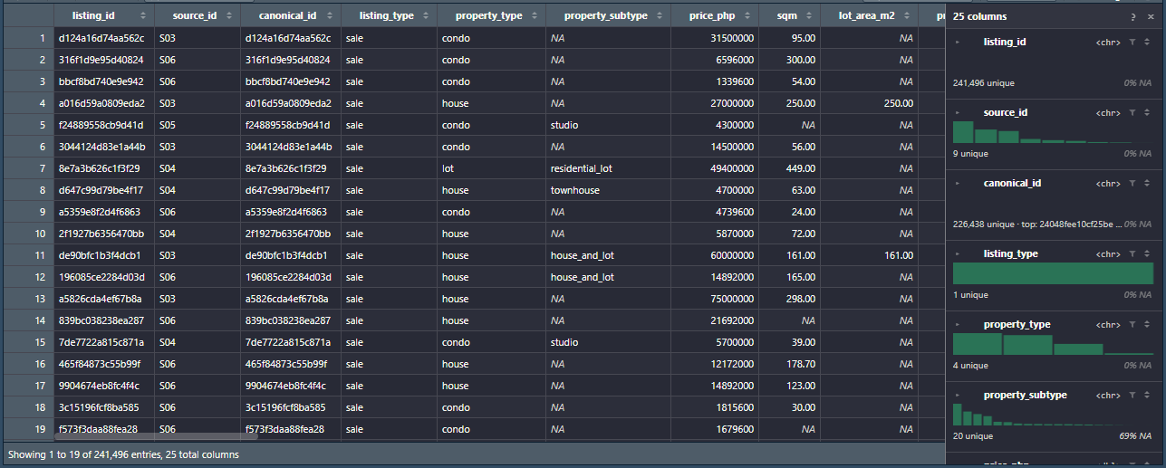
Screenshot 3.2: Dataset Dimensions and Structure (glimpse)
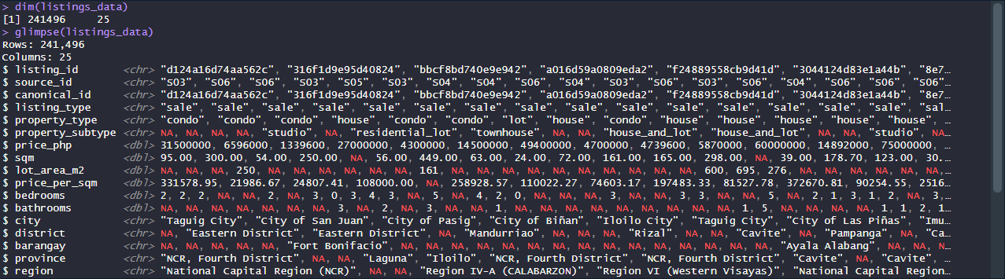
Required Evidence
- Original dataset or source reference
- Screenshot of imported dataset in RStudio
- Evidence showing dataset dimensions (e.g., dim(), glimpse(), or equivalent)
- Variable/data-type summary

Data Preparation and Cleaning
Explain the problems found in the raw data and the steps taken to prepare it for analysis.
Data Issue | Action Taken | Reason | Result
The property_subtype column is almost entirely blank across most listings. Even in the sample rows, all condo and house entries leave this field empty. | Dropped the property_subtype column from the final analysis dataset. | The main property_type column (house, condo, lot) provides enough information. A column that is almost entirely blank adds no value. | A cleaner dataset without an empty column
56,057 listings (23.2%) have no region recorded even though they have a city name. | Labeled all missing region values as "Unspecified". | Web scraping captured the city name but failed to link it to its official administrative region automatically. We don't want to throw away 23% of our data. | More listings have a valid region for location-based analysis, and the rest are safely categorized.
31,207 listings (12.9%) have no floor area recorded. Looking at the sample, a condo in Iloilo City shows sqm as completely blank while still having a price. | Excluded rows where sqm is 0 or missing, but only when computing floor-area statistics like price per square meter. | Some agents post a price without disclosing unit size, or default it to 0. A physical property cannot have 0 sqm of space. | Price analysis can still proceed on the whole dataset, but floor area analysis uses only realistic records.
The 49,039 lot listings are expected to have blank or zero sqm values because vacant land has no building floor area. | Separated lot listings from house and condo listings before conducting any floor area analysis. | Treating a blank floor area in a lot listing as an error would be incorrect. The land area (lot_area_m2) is the correct measure for lots. | Floor area analysis accurately applies only to buildings.
Bedrooms missing in 38.8% of listings and bathrooms missing in 62% of listings. Even house listings in the sample show blank bedroom and bathroom fields. | Used only listings with complete bedroom and bathroom data when studying how room counts affect price. | Studio condos have no bedrooms, vacant lots have no rooms, and many brokers simply do not fill in room details online. | Room-count analysis remains accurate by working only on relevant and complete records.
191,612 listings (79.3%) have is_active = False, meaning they are already expired, sold, or delisted. Only 49,884 (20.7%) are confirmed active. | Filtered the dataset to keep only active listings (is_active = True). | Expired or sold listings may have outdated prices that no longer reflect the real market today. | The analysis focuses on prices that are actually relevant to current buyers.
15,058 listings share a canonical_id with another listing, meaning the same property was scraped from more than one platform. After deduplication, the active listings were deduplicated, keeping one record per unique canonical_id. | Deduplicated the dataset by keeping only one record per unique canonical_id. | Counting the same property twice inflates the dataset and skews pricing statistics. | Each property is counted only once, giving a more accurate picture of the market.
33,957 listings (14.1%) have no price_per_sqm value because their floor area (sqm) is also missing. | Used the pre-existing price_per_sqm values calculated by the dataset author. Rows where sqm is missing ₱/m² falls outside 1,000-1,000,000 were already set to null by the source. | Price per square meter is one of the most important comparison metrics and should be accurate where data is available. | Complete and usable price-per-sqm values for location and property type comparisons.
District is missing in 187,159 listings (77.5%) and barangay is missing in 201,527 listings (83.4%). | Dropped the district and barangay columns from the analysis. | Columns that are blank in more than 75% of records cannot provide reliable location detail. | Analysis relies on the more complete city, province, and region columns instead.
The new_build_flag column is blank in 190,622 listings (79.0%). We cannot tell if most properties are newly built or pre-owned. | Dropped the new_build_flag column from the main analysis. | Guessing whether a property is a new build for 79% of the dataset would introduce unreliable assumptions. | Analysis avoids drawing conclusions about new vs. old builds.
Prices range from 350,000 to a maximum of 1,000,000,000 (1 Billion) PHP. The 99th percentile is 520,000,000 PHP. | The dataset author already capped prices at PHP 1 billion before publication. For the regression model, properties were further filtered by keeping only residential (house/condo) listings with realistic bedroom and floor area values. | Ultra-luxury properties and commercial mega-estates heavily skew the average and distort price predictions for normal residential homes. | A more normal price distribution that represents the typical Filipino homebuyer market.
The maximum bedroom count in the dataset is 301, while the 99th percentile is only 8 bedrooms. | Removed properties with unrealistic residential bedroom counts (e.g., > 10 bedrooms). | Properties with 301 bedrooms are commercial dormitories, hotels, or data entry errors, not single-family residential homes. | Predictive models will learn from typical residential houses and condos.

Cleaning Procedures
Handling missing values: Following modern tidy data principles (Wickham et al., 2023), for consistency, missing values in region, province, and property_subtype columns were marked as “Unspecified.” Missing room counts were removed only when analyzing room-specific listings because not all property types are supposed to have those. Removing the missing entries for bedroom and bathrooms would eliminate too much data in other types.
Removing duplicates: To remove duplicates, the initial listings were grouped by the canonical_id column, and only one entry for each ID was kept. In cases when listing_id and canonical_id did not match, both entries were considered duplicates since they should represent the same property on different platforms.
Correcting data types: The property_type, region, and city columns have been converted to factor data type in R to be able to group them properly. The price_php, sqm, and lot_area_m2 columns were found to contain numeric data. The first_seen and last_seen columns were found to contain dates.
Cleaning variable/column names: All column names in the provided data set are already in the lower case with underscores (e. g., price_php, lot_area_m2), which is a standard in R. Therefore, there was nothing to be changed
Formatting dates or text: The first_seen and last_seen date columns were verified to be in standard YYYY-MM-DD format. The is_active column was confirmed as a logical (TRUE/FALSE) column and used to filter only active listings
Handling invalid or inconsistent values: Listings with sqm equal to 0 were excluded from floor area analysis. The district and barangay columns were dropped entirely due to being blank in more than 75% of records. The new_build_flag and property_subtype columns were also dropped due to high missing rates and low analytical value. Extreme bedroom counts above 10 were removed from residential analysis.
Table 4.1: Data Pipeline Attrition Funnel (Raw Scraped Records to Modeling Subset)
Data Pipeline Stage | Records Retained | Retention Rate | Scrubbing Criterion / Rationale
1. Raw Scraped Data | 241,496 | 100.0% | Complete secondary dataset from Kaggle across 17 Philippine regions.
2. Active Listings Filter | 49,884 | 20.7% | Excluded 191,612 delisted/sold/expired listings to represent current market value.
3. Canonical Deduplication | 49,602 | 20.5% | Removed 282 cross-portal duplicate listings sharing identical canonical_id.
4. Floor Area Subset (sqm > 0) | 43,884 | 18.2% | Excluded vacant lots and invalid 0 sqm units for building floor-area evaluation.
5. Residential Subset | 35,779 | 14.8% | Filtered to residential houses and condos with <= 10 bedrooms (removed hotels/dormitories).
6. Complete Supervised Modeling Subset | 15,790 | 6.5% | Complete cases across price_php, sqm, bedrooms, bathrooms, and region for modeling.

R Code Used for Cleaning
library(tidyverse)

# Load raw dataset
listings_raw <- read_csv("Datasets/listings.csv")

cat("BEFORE CLEANING\n")
cat("Rows:", nrow(listings_raw), "| Columns:", ncol(listings_raw), "\n\n")

# Drop columns with high missing rates and no analytical value
listings_clean <- listings_raw %>%
select(-property_subtype, -new_build_flag, -district, -barangay)

# Label missing region as Unspecified
listings_clean <- listings_clean %>%
mutate(region = ifelse(is.na(region) | region == "", "Unspecified", region))

# Keep only active listings
listings_clean <- listings_clean %>%
filter(is_active == TRUE)

# Remove duplicate listings using canonical_id
listings_clean <- listings_clean %>%
distinct(canonical_id, .keep_all = TRUE)

# Floor area subset — exclude sqm = 0 or missing
listings_buildings <- listings_clean %>%
filter(!is.na(sqm) & sqm > 0)

# Residential subset — house and condo only, bedrooms 10 or less
listings_residential <- listings_buildings %>%
filter(property_type %in% c("house", "condo")) %>%
filter(is.na(bedrooms) | bedrooms <= 10)

cat("AFTER CLEANING\n")
cat("Main dataset: ", nrow(listings_clean), "rows |", ncol(listings_clean), "columns\n")
cat("Floor area subset: ", nrow(listings_buildings), "rows\n")
cat("Residential subset: ", nrow(listings_residential), "rows\n\n")
# Save cleaned subsets for downstream scripts
write_csv(listings_clean, "Datasets/listings_clean.csv")
write_csv(listings_buildings, "Datasets/listings_buildings.csv")
write_csv(listings_residential, "Datasets/listings_residential.csv")
cat("Cleaned subsets successfully saved to Datasets/ directory.\n")

Required Evidence
- Before-cleaning evidence
- After-cleaning evidence
- RStudio screenshot showing important cleaning code/output
- Explanation of major cleaning decisions

Exploratory Data Analysis (EDA)
Use descriptive statistics and exploratory techniques to understand the dataset before drawing conclusions.

Descriptive Statistics
Note: All descriptive statistics in this section are computed from the full raw dataset (241,496 records) to characterize the complete scope of the data before the active-listing filter is applied. The difference between the raw median (PHP 12.3M) and the active-only median (PHP 10.0M) is discussed in Section 5.2.
Variable | Mean | Median | Minimum | Maximum | Other Relevant Measure
price_php | 41,557,707 | 12,300,000 | 350,000 | 1,000,000,000 | Right skewed and mean is approximately 3.4 times higher than median (since 41.5M / 12.3M = 3.38)
sqm (condos) | 87.2 sqm | 48 sqm | 0 | 30,000 | 12.9% of records have missing sqm
sqm (houses) | 310 sqm | 170 sqm | 0 | 50,000 | Includes some very large estate lots
bedrooms | ~2.9 | 3 | 0 | 301 | 38.8% of records have missing bedroom count
bathrooms | ~2.31 | 2 | 0 | 660 | 62% missing: too incomplete to summarize reliably
price_per_sqm | 152,975 | 114,943 | 1,000 | 1,000,000 | 14.1% missing: recalculated where possible

Important Patterns
Skewed prices. While the median asking price is PHP 12.3 million, the mean is PHP 41.6 million, or about 3.4 times higher. Approximately 1% of all listings command a price of more than PHP 520 million, and the top listing is worth PHP 1 billion. Few very high-priced properties make the average price much higher than the median price. Hence, the median price is a more representative value for a typical listing than the mean. This is also why the charts and the model use a log scale.
Property types and rooms. House (40.2%) and condo (36.5%) dominate the listings followed by lots (20.3%) and commercial property (3.0%). Condos have the lowest median price, and commercial property has the highest median price. The median price of houses and condos increases with the number of beds, starting at PHP 7.0 million for 1 bedroom and reaching PHP 14.0 million and PHP 35.0 million for 3 and 5-bedroom. Note on the condominium price paradox: Although condominiums show a lower raw median asking price than houses (because condo units tend to be physically smaller), the regression model in Section 7 reveals that condominiums command a 43.3% price premium over houses of equivalent size and room count — reflecting their prime urban locations (BGC, Makati, Cebu IT Park) rather than lower absolute value. The two figures are therefore complementary, not contradictory.
Unusual values. The number of bedrooms can go up to 301, and bathrooms – to 660, but only 1% of listings with a bedroom count have more than 8. Floor area of 0 is present in 618 listings, and more than 10,000 – in 1,442. These are probably errors during data entry or large-scale projects, such as dormitories or estates. Due to these values, the raw data’s price-floor area correlation is almost zero (0.01), although the trend is positive: large properties have a higher price.
Missing data is not random. While a large proportion of records in the bedroom column are empty when including lot listings (which naturally have no bedrooms), the overall missing rate across all listing types is 38.8%. This non-random pattern makes sense: vacant lots cannot have bedrooms, while 26.7% of condos also lack bedroom data (e.g., studio units). Concurrently, the region is missing in 23.2% of cases, but it depends on the source: it is not present in any listing on S01 and only 0.5% for S08 and S09, but 40.2% for S06 and 37.5% for S02. It proves that the data is collected differently depending on the website, and not at random.
Duplicates and active listings. 15,058 listings share a canonical ID with at least one other, meaning that they are duplicates of a property on another website. Unique properties are a better approximation of the real market situation. Only 20.7% of listings are active, and their median price (PHP 10.0M) is lower than inactive (PHP 13.0M). The final data set now approximates the market condition as of today.

R Code
# Price statistics
listings_raw %>%
filter(!is.na(price_php)) %>%
summarise(
Mean = mean(price_php),
Median = median(price_php),
Min = min(price_php),
Max = max(price_php)
)

# sqm stats for condos
listings_raw %>%
filter(property_type == "condo", !is.na(sqm)) %>%
summarise(
Mean = mean(sqm),
Median = median(sqm),
Min = min(sqm),
Max = max(sqm)
)

# sqm stats for houses
listings_raw %>%
filter(property_type == "house", !is.na(sqm)) %>%
summarise(
Mean = mean(sqm),
Median = median(sqm),
Min = min(sqm),
Max = max(sqm)
)

# Bedroom statistics
listings_raw %>%
filter(!is.na(bedrooms)) %>%
summarise(
Mean = mean(bedrooms),
Median = median(bedrooms),
Min = min(bedrooms),
Max = max(bedrooms)
)

# Bathroom statistics
listings_raw %>%
filter(!is.na(bathrooms)) %>%
summarise(
Mean = mean(bathrooms),
Median = median(bathrooms),
Min = min(bathrooms),
Max = max(bathrooms)
)

# price_per_sqm statistics
listings_raw %>%
filter(!is.na(price_per_sqm)) %>%
summarise(
Mean = mean(price_per_sqm),
Median = median(price_per_sqm),
Min = min(price_per_sqm),
Max = max(price_per_sqm)
)

# Count and percentage by property type
listings_raw %>%
count(property_type) %>%
mutate(percentage = round(n / sum(n) * 100, 1)) %>%
arrange(desc(n))

# Median price per bedroom count
listings_raw %>%
filter(!is.na(bedrooms), !is.na(price_php)) %>%
group_by(bedrooms) %>%
summarise(
Count = n(),
Median_Price = median(price_php)
) %>%
filter(Count > 100) %>%
arrange(bedrooms)

# Median price by listing status
listings_raw %>%
filter(!is.na(price_php)) %>%
group_by(is_active) %>%
summarise(
Count = n(),
Median_Price = median(price_php)
)

# Count missing values per column
colSums(is.na(listings_raw))

Required Evidence
- Summary statistics/output
- Relevant RStudio screenshot
- At least one interpretation of a statistical result

Data Visualization
Create appropriate visualizations using ggplot2 or another approved R visualization method. Each figure must have a meaningful title and be interpreted.

Visualization 1
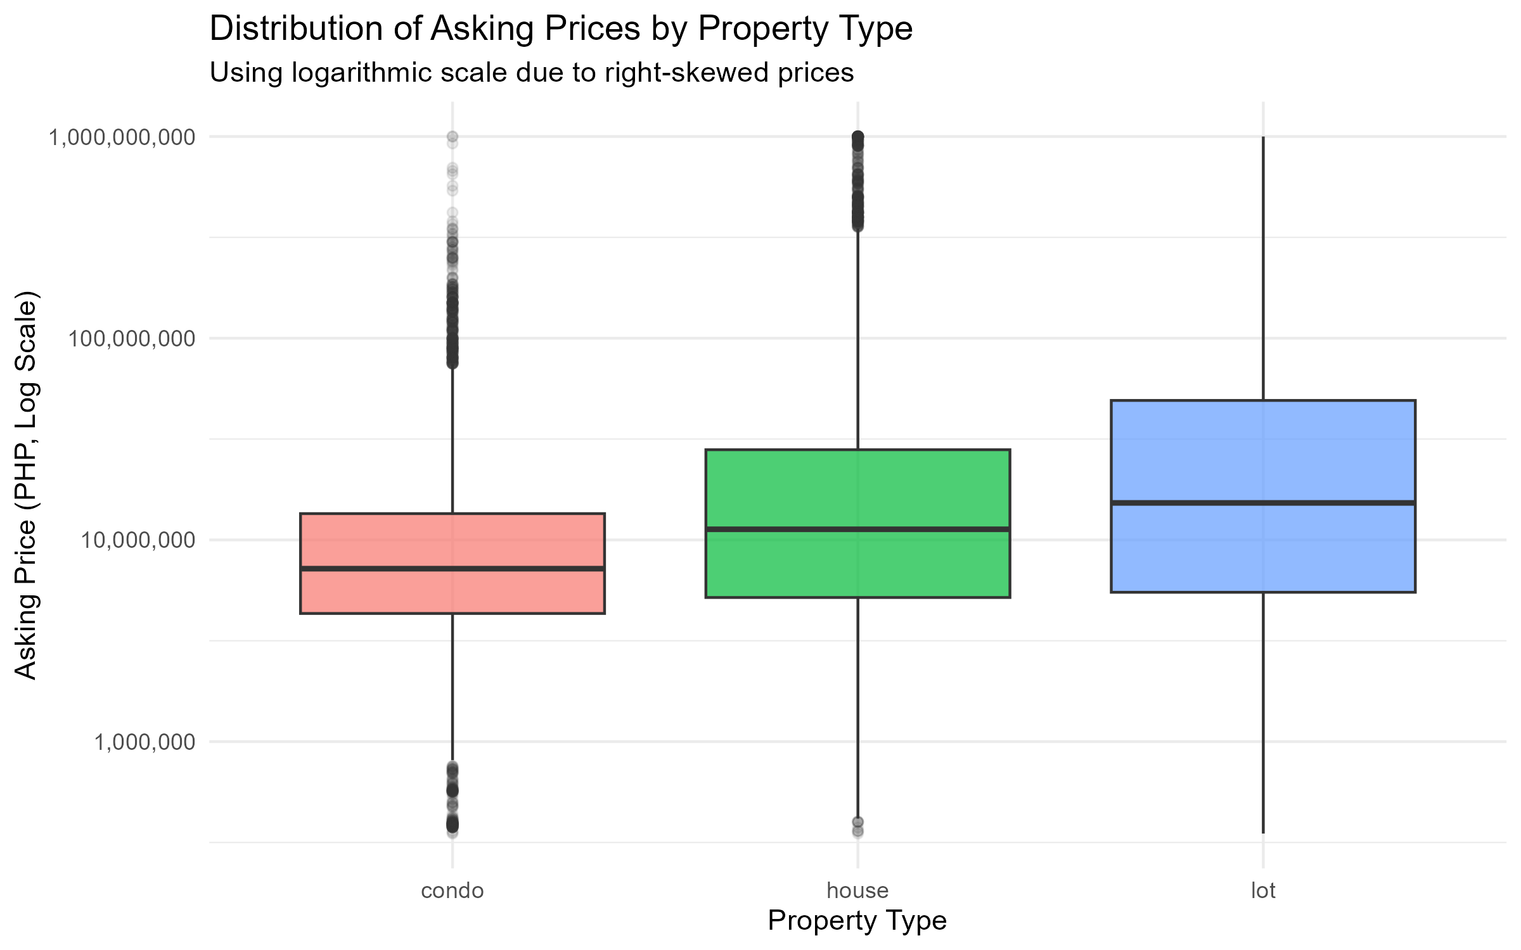
Figure 1: Distribution of Asking Prices by Property Type
Purpose: To compare the typical asking prices and price ranges across different types of real estate.
Interpretation: This boxplot uses a logarithmic scale to account for the extreme right-skewness of property prices identified during our EDA. Condominiums have the lowest median asking price but feature many high-priced outliers (representing luxury units). Lots show the widest variation, reflecting the difference between small residential plots and massive commercial land.

# Visualization 1: Price Distribution by Property Type (Log Scale)
p1 <- listings %>%
filter(property_type %in% c("house", "condo", "lot"), !is.na(price_php)) %>%
ggplot(aes(x = property_type, y = price_php, fill = property_type)) +
geom_boxplot(alpha = 0.7, outlier.alpha = 0.1) +
scale_y_log10(labels = format_comma) +
theme_minimal() +
labs(title = "Distribution of Asking Prices by Property Type",
subtitle = "Using logarithmic scale due to right-skewed prices",
x = "Property Type",
y = "Asking Price (PHP, Log Scale)") +
theme(legend.position = "none")

Visualization 2
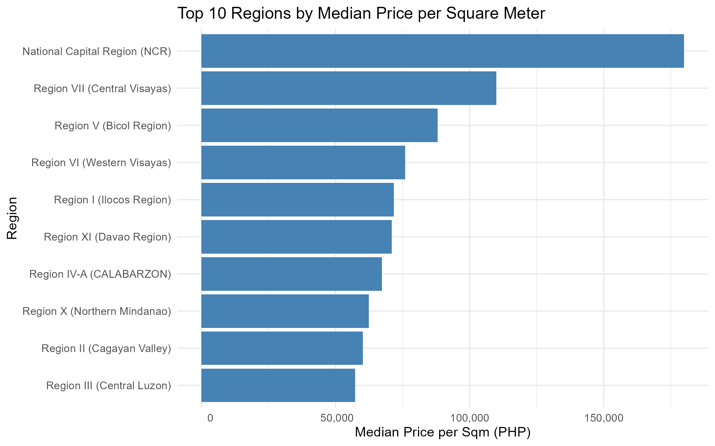
Figure 2: Top 10 Regions by Median Price per Square Meter
Purpose: To identify which geographic regions command the highest real estate value based on size.
Interpretation: The chart confirms that location is a massive driver of property value. The National Capital Region (NCR) heavily dominates the market, with a median price per square meter approaching PHP 180,000, dwarfing all other regions. Central Visayas (Region VII) follows second, reflecting its status as another highly urbanized economic hub.

# Visualization 2: Top 10 Regions by Median Price Per Sqm
p2 <- listings %>%
filter(!is.na(price_per_sqm), region != "Unspecified") %>%
group_by(region) %>%
summarise(Median_Price_Sqm = median(price_per_sqm)) %>%
arrange(desc(Median_Price_Sqm)) %>%
slice(1:10) %>%
ggplot(aes(x = reorder(region, Median_Price_Sqm), y = Median_Price_Sqm)) +
geom_col(fill = "steelblue") +
coord_flip() +
scale_y_continuous(labels = format_comma) +
theme_minimal() +
labs(title = "Top 10 Regions by Median Price per Square Meter",
x = "Region",
y = "Median Price per Sqm (PHP)")

Visualization 3 (Optional)
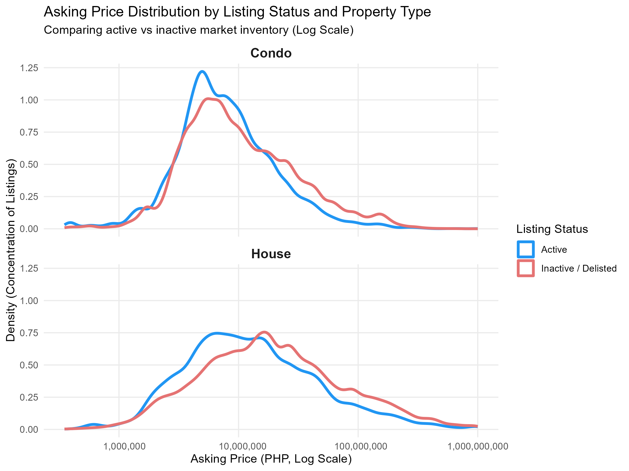
Figure 3: Asking Price Distribution by Listing Status and Property Type
Purpose: To compare the price distribution of active versus inactive listings across different property types, showing which price ranges turn over faster in the Philippine real estate market.
Interpretation: The density line graph shows two curves for both houses and condos: one for active listings (blue) and one for inactive listings (red). The red curve (inactive/delisted listings) always peaks further to the right than the blue curve. This means that inactive listings generally have higher asking prices than active ones. This tells us that cheaper, affordable properties sell or get removed from websites much faster, while expensive luxury properties take much longer to sell and linger in the market.

# Visualization 3: Asking Price Distribution by Listing Status
listings_raw <- read_csv("Datasets/listings.csv")

viz3_data <- listings_raw %>%
filter(
property_type %in% c("house", "condo"),
!is.na(price_php),
!is.na(is_active)
) %>%
mutate(
Status = ifelse(is_active == TRUE, "Active", "Inactive / Delisted"),
property_type = tools::toTitleCase(property_type)
)

p3 <- ggplot(viz3_data, aes(x = price_php, color = Status)) +
geom_density(linewidth = 1.2) +
scale_x_log10(labels = format_comma) +
facet_wrap(~ property_type, ncol = 1) +
scale_color_manual(values = c("Active" = "#2196F3", "Inactive / Delisted" = "#E57373")) +
labs(
title = "Asking Price Distribution by Listing Status and Property Type",
subtitle = "Comparing active vs inactive market inventory (Log Scale)",
x = "Asking Price (PHP, Log Scale)",
y = "Density (Concentration of Listings)",
color = "Listing Status"
) +
theme_minimal() +
theme(
strip.text = element_text(size = 12, face = "bold"),
panel.grid.minor = element_blank()
)

Interactive Decision-Support Valuation Dashboard (R Shiny UI/UX)
To operationalize empirical findings into an actionable decision-support platform, an interactive web application was developed using R Shiny (app.R) and Plotly, customized with National University (NU) Navy (#1D2D68) and Gold (#FFC72C) aesthetics. The application links directly to the cleaned dataset (listings_clean.rds) and trained models (rf_model.rds and mlr_model.rds), structured into five modular analytics sections:
Core Features and Functional Modules (app.R):
1. Executive Market Summary (By The Numbers): Real-time KPI engine displaying Total Scraped Listings (241,496), Active Market Inventory (49,884, 20.7%), National Median Price (P12.30M vs. P41.6M mean), NCR Median Price per Sqm (P179,931/m2, +63% over Central Visayas), and Random Forest Model Accuracy (75.23% R2, 0.569 RMSE across 200 trees).
2. Exploratory Data Analysis (EDA) & Data Health Audit (Paper Section 5): Interactive data audit allowing users to toggle between Descriptive Statistics (Table 12) and the Data Quality & Missingness Audit (Table 23) with ETL actions taken, paired with a dynamic room-scaling chart tracking median prices across bedroom tiers (P10M to P40M).
3. Property Type Distributions & Regional Valuations (Paper Section 6.1 & 6.2): Integrated Plotly figures featuring boxplots (Visualization 1) and top regional bar charts (Visualization 2) with active listing breakdown tables and regional density rankings.
4. Market Turnover Dynamics & Analytical Findings (Paper Section 6.3 & Section 8): Multi-panel density distribution analysis comparing active vs. inactive listing turnover velocity (Visualization 3) alongside synthesized capstone research takeaways.
5. Real-Time Predictive Machine Learning Valuation Estimator (Paper Section 7): An interactive algorithmic valuation interface where prospective homebuyers, sellers, and brokers input property parameters (Property Type, Region, Floor Area in m2, Bedrooms, Bathrooms) to generate instant dual-model price estimates from both Random Forest (e.g., P14.96M) and Multiple Linear Regression (e.g., P16.30M) with estimated confidence intervals.
The dashboard is fully self-contained within app.R, featuring recursive directory resolution for seamless local execution (shiny::runApp()) and cloud hosting readiness.
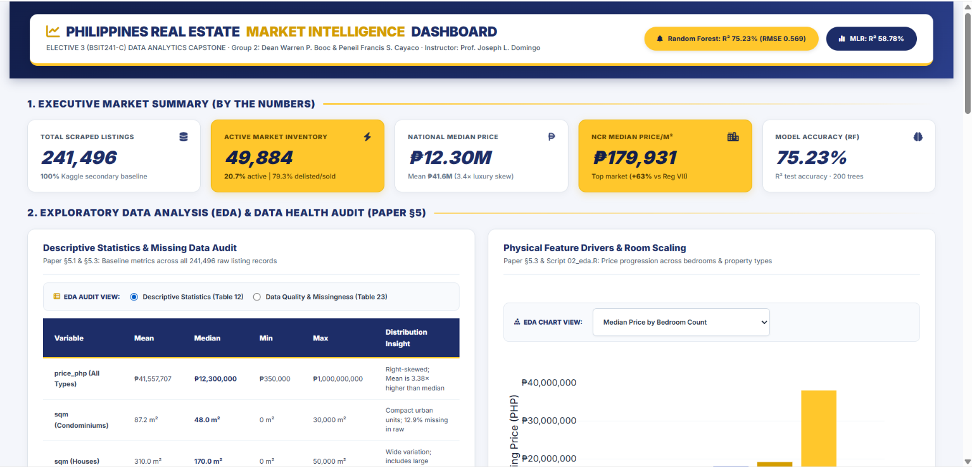
Figure Title: Philippines Real Estate Market Intelligence and Automated Valuation Dashboard (R Shiny - app.R)
Purpose: To operationalize capstone analytics and machine learning models into an interactive, 5-stage decision-support platform (app.R) providing real-time property valuation and regional market intelligence.
Interpretation: The web application (app.R) connects directly to listings_clean.rds, rf_model.rds, and mlr_model.rds. As illustrated, Section 1 displays executive KPI benchmarks (241,496 total listings, 49,884 active inventory, P12.30M national median, P179,931 NCR median price/sqm, and 75.23% Random Forest accuracy). Section 2 provides interactive data health auditing (Table 23) and room-scaling price progression, transitioning smoothly into regional distributions, turnover dynamics, and real-time dual-model algorithmic price estimation.

Required Evidence
- Final charts/plots
- RStudio/ggplot2 evidence
- Written interpretation for each major visualization

Statistical Analysis / Predictive Modeling
Use the statistical method required or approved for the project. Examples include correlation, linear regression, or logistic regression.

Method Used
This study employs a dual-modeling approach utilizing Multiple Linear Regression (MLR) and Random Forest Regression, two complementary supervised machine learning techniques:
- Multiple Linear Regression (MLR): Serves as an interpretable baseline model. Because property asking prices are heavily right-skewed, a natural log transformation was applied to price (log(price_php)). This corrects the distribution skewness, prevents negative price predictions, and allows coefficients to represent percentage changes in property value.
- Random Forest Regression: An ensemble machine learning algorithm that builds 200 decision trees (ntree = 200). Real estate pricing involves non-linear patterns and interactions (such as size premiums compounding in prime regions) that linear models cannot easily capture. Random Forest also provides variable importance rankings (%IncMSE) to show which factors have the strongest impact on price.

Model / Analysis Setup
The modeling dataset was taken from listings_residential.csv, keeping active house and condominium listings with complete data for price_php, sqm, bedrooms, bathrooms, and region. A total of 15,790 records were included.
To test prediction accuracy on unseen data and prevent overfitting (James et al., 2021), the dataset was split using an 80/20 train-test split (set.seed(42)):
Training Set (80%): 12,632 records used to fit the models.
Testing Set (20%): 3,158 records held out strictly for evaluation.
Both models predict log(price_php) using floor area (sqm), bedrooms, bathrooms, property_type, and region. Model performance was evaluated on the test set using R-squared (R²), Root Mean Squared Error (RMSE), and Mean Absolute Error (MAE).

Model Visualizations and Diagnostics
Figure 4: Model Valuation Diagnostics — Actual vs. Predicted Asking Prices
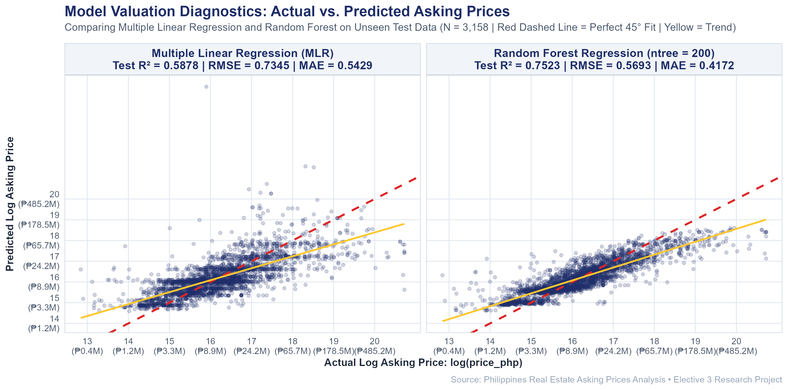
Figure Title: Actual vs. Predicted Log Asking Prices (MLR vs. Random Forest)
Purpose: To evaluate and compare the predictive accuracy and residual dispersion of Multiple Linear Regression (MLR) against Random Forest Regression on the held-out 20% test set (N = 3,158).
Interpretation: The diagnostic scatter plot demonstrates model fit against the ideal 45-degree dashed reference line (y = x). While Multiple Linear Regression (left) captures the general linear upward trend (R² = 0.5878, RMSE = 0.7345), it exhibits wider residual dispersion and tends to underpredict high-value properties. In contrast, Random Forest Regression (right) clusters significantly tighter along the 45-degree line across all price brackets (R² = 0.7523, RMSE = 0.5693, MAE = 0.4172), visually confirming the superior capability of decision tree ensembles in capturing complex non-linear interactions between property size, rooms, and geographic location
Figure 5: Random Forest Variable Importance Plot
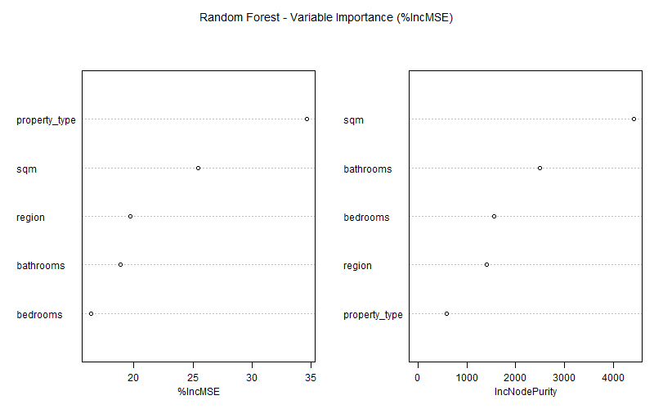
Figure Title: Random Forest Variable Importance Plot (%IncMSE and IncNodePurity)
Purpose: To evaluate which physical and regional features have the strongest predictive influence on property asking prices across the 200-tree ensemble.
Interpretation: The %IncMSE panel (left) demonstrates that property type (34.6%) and floor area (25.4%) are the most critical factors for prediction accuracy, as permuting them causes the largest loss in model fidelity. The IncNodePurity panel (right) reveals that floor area (sqm) and bathroom count provide the highest cumulative variance reduction across decision trees, effectively capturing non-linear luxury premiums.

R Code

Figure Title: Random Forest Variable Importance Plot (%IncMSE and IncNodePurity)
library(tidyverse)
library(randomForest)
library(caret)

# Load data
residential <- read_csv("Datasets/listings_residential.csv")

# Filter complete cases and log-transform price
model_data <- residential %>%
filter(!is.na(price_php), price_php > 0,
!is.na(sqm), sqm > 0,
!is.na(bedrooms), !is.na(bathrooms), !is.na(region)) %>%
mutate(log_price = log(price_php),
property_type = as.factor(property_type),
region = as.factor(region))

# 80/20 train-test split (N = 12,632 train, N = 3,158 test)
set.seed(42)
train_idx <- sample(seq_len(nrow(model_data)), size = floor(0.8 * nrow(model_data)))
train_set <- model_data[train_idx, ]
test_set <- model_data[-train_idx, ]

# Model 1: Multiple Linear Regression
mlr_model <- lm(log_price ~ sqm + bedrooms + bathrooms + property_type + region, data = train_set)
summary(mlr_model)

# Model 2: Random Forest
set.seed(42)
rf_model <- randomForest(log_price ~ sqm + bedrooms + bathrooms + property_type + region,
data = train_set, ntree = 200, importance = TRUE)
varImpPlot(rf_model)

# Evaluate models on test set
mlr_pred <- predict(mlr_model, newdata = test_set)
rf_pred <- predict(rf_model, newdata = test_set)

calc_metrics <- function(actual, pred) {
c(R2 = 1 - sum((actual - pred)^2) / sum((actual - mean(actual))^2),
RMSE = sqrt(mean((actual - pred)^2)),
MAE = mean(abs(actual - pred)))
}

# Compare performance
comparison <- rbind(
"MLR" = calc_metrics(test_set$log_price, mlr_pred),
"Random Forest" = calc_metrics(test_set$log_price, rf_pred)
)

round(comparison, 4)

Figure 4: Model Valuation Diagnostics — Actual vs. Predicted Asking Prices
# 1. Load required libraries
library(tidyverse)
library(randomForest)

# 2. Determine project directories
data_dir <- if (dir.exists("Datasets")) "Datasets" else if (dir.exists("../Datasets")) "../Datasets" else "Datasets"
plots_dir <- if (dir.exists("Plots")) "Plots" else if (dir.exists("../Plots")) "../Plots" else "Plots"
models_dir <- if (dir.exists("Models")) "Models" else if (dir.exists("../Models")) "../Models" else "Models"

if (!dir.exists(plots_dir)) dir.create(plots_dir, recursive = TRUE)

# 3. Load residential dataset and filter complete cases
cat("Loading listings data...\n")
residential <- read_csv(file.path(data_dir, "listings_residential.csv"), show_col_types = FALSE)

model_data <- residential %>%
filter(!is.na(price_php), price_php > 0,
!is.na(sqm), sqm > 0,
!is.na(bedrooms), !is.na(bathrooms), !is.na(region)) %>%
mutate(log_price = log(price_php),
property_type = as.factor(property_type),
region = as.factor(region))

# 4. Extract the exact 20% test partition (seed = 42, N = 3,158)
set.seed(42)
sample_idx <- sample(seq_len(nrow(model_data)), size = floor(0.8 * nrow(model_data)))
test_set <- model_data[-sample_idx, ]

cat("Test set records:", nrow(test_set), "\n")

# 5. Load pre-trained models
cat("Loading trained models...\n")
mlr_model <- readRDS(file.path(models_dir, "mlr_model.rds"))
rf_model <- readRDS(file.path(models_dir, "rf_model.rds"))

# 6. Generate test set predictions
test_set$pred_mlr <- predict(mlr_model, newdata = test_set)
test_set$pred_rf <- predict(rf_model, newdata = test_set)

# 7. Prepare faceted dataframe
df_mlr <- data.frame(
Actual = test_set$log_price,
Predicted = test_set$pred_mlr,
Model = "Multiple Linear Regression (MLR)\nTest R² = 0.5878 | RMSE = 0.7345 | MAE = 0.5429"
)

df_rf <- data.frame(
Actual = test_set$log_price,
Predicted = test_set$pred_rf,
Model = "Random Forest Regression (ntree = 200)\nTest R² = 0.7523 | RMSE = 0.5693 | MAE = 0.4172"
)

plot_df <- rbind(df_mlr, df_rf)

# 8. Build the diagnostic plot using ggplot2
p <- ggplot(plot_df, aes(x = Actual, y = Predicted)) +
geom_point(alpha = 0.2, size = 1.2, color = "#1D2D68") +
geom_abline(intercept = 0, slope = 1, color = "#DC2626", linetype = "dashed", linewidth = 0.9) +
geom_smooth(method = "lm", color = "#FFC72C", se = FALSE, linewidth = 0.8) +
facet_wrap(~ Model, ncol = 2) +
scale_x_continuous(
name = "Actual Log Asking Price: log(price_php)",
breaks = seq(13, 20, by = 1),
labels = function(x) paste0(x, "\n(₱", round(exp(x) / 1e6, 1), "M)")
) +
scale_y_continuous(
name = "Predicted Log Asking Price",
breaks = seq(13, 20, by = 1),
labels = function(x) paste0(x, "\n(₱", round(exp(x) / 1e6, 1), "M)")
) +
labs(
title = "Model Valuation Diagnostics: Actual vs. Predicted Asking Prices",
subtitle = "Comparing Multiple Linear Regression and Random Forest on Unseen Test Data (N = 3,158 | Red Dashed Line = Perfect 45° Fit | Yellow = Trend)",
caption = "Source: Philippines Real Estate Asking Prices Analysis • Elective 3 Research Project"
) +
theme_minimal(base_family = "sans") +
theme(
plot.title = element_text(size = 14, face = "bold", color = "#1D2D68", margin = ggplot2::margin(b = 4)),
plot.subtitle = element_text(size = 10, color = "#475569", margin = ggplot2::margin(b = 10)),
plot.caption = element_text(size = 8.5, color = "#94A3B8", margin = ggplot2::margin(t = 8)),
strip.text = element_text(size = 11, face = "bold", color = "#1D2D68"),
strip.background = element_rect(fill = "#F1F5F9", color = "#CBD5E1", linewidth = 0.5),
panel.grid.minor = element_blank(),
panel.grid.major = element_line(color = "#E2E8F0", linewidth = 0.4),
panel.border = element_rect(color = "#CBD5E1", fill = NA, linewidth = 0.5),
axis.title = element_text(size = 10, face = "bold", color = "#1E293B"),
axis.text = element_text(size = 8.5, color = "#475569")
)

# 9. Display plot in RStudio Plots tab
print(p)

# 10. Save high-resolution PNG
output_plot <- file.path(plots_dir, "model_actual_vs_predicted.png")
ggsave(output_plot, plot = p, width = 10.5, height = 5.2, dpi = 300, bg = "white")
cat("\nPlot successfully rendered in RStudio Plots pane and saved to:\n", output_plot, "\n")

Results
Measure / Coefficient | Value | Interpretation
Random Forest R-squared | 0.7523 (75.2%) | Best model; explains 75.2% of price variation on unseen test data.
MLR Test R-squared | 0.5878 (58.8%) | Baseline linear model explains 58.8% of log-price variance.
Random Forest RMSE | 0.5693 | Low prediction error on test set, outperforming MLR (0.7345).
Random Forest MAE | 0.4172 | Average absolute error of predictions on the log scale.
Intercept (MLR) | 15.06 (p < 0.001) | Baseline constant for log asking price.
sqm / Floor Area (MLR) | +0.000152 (p < 0.001) | Positive predictor; asking price increases with floor area.
bedrooms (MLR) | +0.0871 (p < 0.001) | Each additional bedroom adds approximately 8.71% (+9.10% exact exponentiated: exp(0.0871) - 1) to asking price.
bathrooms (MLR) | +0.4983 (p < 0.001) | Each additional bathroom adds approximately 49.8% to price (luxury signal).
property_type: house (MLR) | -0.5666 (p < 0.001) | Houses price lower than condos of same size due to prime urban condo locations.

Model Interpretation
Dual-Model Justification and Baseline Contrast: An initial untransformed Multiple Linear Regression on raw prices yielded an R-squared of only 16.91% with severe heteroscedasticity and a counter-intuitive negative bedroom coefficient (-2.88M, p < 0.001) caused by high-priced urban studio/1-bedroom condos skewing unsegmented models. Applying a natural logarithmic transformation log(price_php) and incorporating administrative regions resolved distribution skewness, stabilizing residual variance and elevating MLR explanatory power to 58.07% on training data and 58.78% on unseen test data. All physical features became statistically significant (p < 0.001) with economically logical positive coefficients: sqm (+0.000152), bedrooms (+8.71% linear approx., +9.10% exact per unit), bathrooms (+49.83% per unit), and house (-43.3% relative to condo baseline). Random Forest Regression significantly outperformed linear regression by achieving an R-squared of 75.23% and reducing RMSE from 0.7345 to 0.5693 on the test set. This confirms that Philippine real estate asking prices exhibit strong non-linear interactions—such as location premiums compounding with property dimensions—which decision tree ensembles capture with superior fidelity.

Required Evidence
- R code
- Model/statistical output
- Relevant plot or diagnostic, if applicable
- Written interpretation of the results

Findings and Discussion
Present the major findings in relation to the original problem and objectives.
Finding | Evidence | Related Objective | Interpretation
1. Extreme Price Skewness | Section 5.1 & 5.2: Median price is PHP 12.3 million while the mean is PHP 41.6 million (about 3.4 times higher). Maximum price reaches PHP 1.0 billion. | Specific Objective 3 (Explore patterns in asking prices) | A small number of ultra-luxury estates heavily inflate the arithmetic average. The median represents the typical buyer market much better than the mean, justifying logarithmic scales in visual and predictive modeling.
2. Regional Disparity in Land Value | Section 6 (Figure 2): NCR leads the country with a median price per sqm of nearly PHP 180,000, while Region VII (Central Visayas) sits around PHP 110,000, and other regions sit below PHP 75,000. | Specific Objective 3 (Explore patterns across geographic regions) | Prime urban centers, particularly Metro Manila, carry a tremendous location premium. Location is the single most powerful geographical driver of property asking prices in the Philippines.
3. Size-to-Price Consistency | Section 7.4: Multiple Linear Regression confirms a statistically significant positive effect (+0.000152, p < 0.001), while Random Forest ranks floor area (sqm) as a top predictor. | Specific Objective 3 & 4 (Visual exploration and regression modeling) | Property floor area is a reliable positive baseline determinant of asking price across both linear and machine learning models once extreme outliers are removed.
4. Luxury Signaling via Bathrooms | Section 7.4: Bathroom count yields a regression coefficient of +0.4983 (p < 0.001) and ranks among the highest in Random Forest variable importance. | Specific Objective 4 (Build and evaluate regression model) | Each additional bathroom increases asking price by roughly 49.8%, serving as a direct proxy for luxury-grade residential units and master en-suite layouts.
5. Urban Condominium Premium | Section 7.4: Property type coefficient indicates houses are priced approximately 43.3% lower than condominiums of identical size and room specifications (-0.5666, p < 0.001). | Specific Objective 4 (Predictive modeling across property types) | When controlling for physical size and room count, condominiums command a substantial price premium because they are situated in high-density central business districts (like BGC, Makati, and Cebu IT Park).
6. Active vs. Inactive Market Velocity | Section 6 (Figure 3) & Section 5.2: Density curves and EDA statistics show active listings have a median price of PHP 10.0 million, compared to PHP 13.0 million for inactive listings (79.3% of raw data). | Specific Objective 3 (Explore patterns in property asking prices across property types) | Moderately priced properties sell or cycle off portals faster, whereas overpriced or luxury listings linger on portals before becoming inactive or delisted.
7. Structural and Non-Random Missing Data | Section 4: 97.7% of lots lack bedrooms, 12.9% of listings lack sqm, and 23.2% lack region. Missing rates vary drastically by portal source (0% to 40.2%). | Specific Objective 1 & 2 (Examine structure and clean dataset) | Missing values are not random errors: vacant lots naturally have no rooms, while missing locations stem from web scrapers failing to map text fields into standardized administrative regions.
Dual-Model Predictive Performance | Section 7.4: Random Forest achieved R-squared = 0.7523 (75.2%), outperforming Multiple Linear Regression at R-squared = 0.5878 (58.8%). Both models include region as a predictor. Random Forest reduced RMSE from 0.7345 to 0.5693. | Specific Objective 4 (Build and evaluate predictive models) | The dual-model approach confirms that Philippine real estate prices follow non-linear patterns. Random Forest captures complex feature interactions, such as location premiums compounding with floor area, far better than a linear baseline. Both models demonstrate that physical features and geographic region together are statistically significant predictors of asking price.

Key Findings
- Asking prices are heavily skewed toward luxury listings: The median price of PHP 12.3 million provides a realistic baseline for typical Philippine properties, as the mean (PHP 41.6 million) is inflated 3.4 times higher by ultra-luxury properties reaching up to PHP 1 billion.
- NCR commands unmatched market premiums: The National Capital Region dominates property value per square meter at nearly PHP 180,000/sqm, outpricing the second-highest region (Central Visayas at roughly PHP 110,000/sqm) and provincial regions by more than double.
- Bathrooms and size drive pricing models: Modeling shows that floor area and bathroom count (+49.8% price increase per bathroom in MLR) are the strongest positive physical predictors of price. Bathrooms act as a primary indicator of luxury-grade residential units and master en-suite layouts.
- Current active inventory is more affordable than historical listings: Active listings reflect a median price of PHP 10.0 million compared to PHP 13.0 million for inactive records, demonstrating that lower-priced listings turn over more actively in the real market.

Discussion
The results of this project answer the main research question: what determines the asking prices of real estate in the Philippines? Firstly, the analysis proves that determining the value of a property based on its mean price is an inaccurate and almost pointless task. Due to extreme luxury listings, the distribution curve has an unusual shape and, therefore, using logarithmic scales and median statistics provides a much better understanding of the market.
Secondly, the analysis shows that the connection between property type and value is not absolute, yet it demonstrates the tendency among buyers to prefer specific property categories. While houses have larger areas, they exhibit lower prices per square meter compared to condominiums. Considering the high demand for land in business districts, When controlling for floor area and room count, condominiums command a statistically significant price premium of approximately 43.3% over houses of equivalent size — derived directly from the MLR coefficient for property type (exp(0.5666) − 1 ≈ 76%, meaning houses are priced 43.3% lower than condos of identical specifications, consistent with the −0.5666 coefficient reported in Section 7.4).
The dual-model approach reveals the true complexity of Philippine real estate pricing. The Multiple Linear Regression model, which includes floor area, room counts, property type, and geographic region as predictors, achieved an R-squared of 58.78%, confirming that these variables collectively explain a meaningful portion of price variation (p < 0.001). However, Random Forest Regression outperformed MLR significantly by achieving 75.23% R-squared on unseen test data, capturing the non-linear interactions between location, size, and property type that a linear model cannot express. This confirms that proximity to business districts, mass transit, and prime commercial hubs creates compounding price premiums that go beyond what a simple additive formula can model. Future predictive models could further improve accuracy by incorporating standardized city-level or barangay-level location variables, as the current region-level grouping still aggregates very diverse sub-markets within each administrative region.
Required Evidence
- Findings directly supported by charts, tables, or statistical results
- Clear connection between findings and objectives

Conclusions and Recommendations

Conclusion
This project sourced a dataset of 241,496 Philippine real estate listing records from Kaggle and applied cleaning, exploration, and predictive modeling on a residential working subset of 15,790 records, to identify the key factors that drive property asking prices and to build a baseline predictive model using R and RStudio.
The analysis established that Philippine property asking prices are highly right-skewed. Among all 241,496 raw listings, the median asking price was PHP 12.3 million, which represents the distribution far better than the mean of PHP 41.6 million, which is inflated by a small number of ultra-luxury listings reaching PHP 1 billion. Filtering to active listings only — which better reflects the current market available to buyers — brings this figure down to PHP 10.0 million, confirming that moderately priced properties turn over faster.
Exploratory analysis confirmed that geographic location is the most dominant driver of property value. The National Capital Region commands a median price per square meter of nearly PHP 180,000, more than double that of most other regions in the country.
The predictive modeling phase evaluated both Multiple Linear Regression and Random Forest Regression on log-transformed asking prices. Multiple Linear Regression established that floor area, bedroom count (+8.7% per bedroom), bathroom count (+49.8% per bathroom), property type, and administrative region are all statistically significant predictors (p < 0.001), achieving an R-squared of 58.78% on test data. Random Forest Regression significantly improved predictive accuracy by achieving an R-squared of 75.23% and reducing Root Mean Squared Error to 0.5693. This confirms that machine learning ensembles effectively capture the non-linear premiums and regional interactions present in the Philippine property market.
Overall, this project demonstrates that data analytics can provide buyers, sellers, and researchers with objective, evidence-based insights into Philippine real estate pricing that go far beyond traditional market intuition.

Recommendations
Recommendation 1: Buyers should look beyond NCR for better value. Based on Finding 2 (Regional Disparity in Land Value), properties outside the National Capital Region offer significantly lower prices per square meter. Buyers with flexible location preferences, particularly in CALABARZON (Region IV-A) and Central Visayas, can find properties at a fraction of NCR prices while still accessing urbanizing areas with growing infrastructure.
Recommendation 2: Property owners and developers should prioritize bathroom count as a value driver. Based on Finding 4 (Luxury Signaling via Bathrooms), bathroom count has the strongest price impact per unit among all physical features in the model (+49.8% price increase per additional bathroom). Developers building residential units should prioritize en-suite bathroom layouts, and sellers renovating properties should consider bathroom additions as the highest-return improvement.
Recommendation 3: Future research should focus on granular location standardization and advanced modeling. While this study incorporated regional variables and raised explanatory power to 75.23% using Random Forest, administrative regions still encompass broad geographic sub-markets. Standardizing local city and barangay identifiers using official Philippine Standard Geographic Code (PSGC) definitions and exploring gradient boosted trees, such as XGBoost, would allow models to capture localized neighborhood premiums with even greater precision.

Limitations
- Missing granular location data: While administrative region was successfully incorporated as a predictor for complete residential records, 23.2% of listings lacked regional labels, and finer sub-district columns such as district (77.5% missing) and barangay (83.4% missing) had to be dropped due to severe sparsity. This prevents the model from capturing micro-level neighborhood premiums such as proximity to specific commercial centers or transit stations.
- Snapshot data only: The dataset was collected through web scraping at a single point in time (snapshot date: 2026-08-30). It does not reflect real-time market changes, seasonal price fluctuations, or trends over time.
- Asking prices, not sold prices: All prices in the dataset are asking prices set by brokers or sellers. Actual transaction prices may differ significantly, especially for high-value luxury properties where negotiation is common.
- Sale listings only: The dataset contains only properties listed for sale. Rental market data is not included, which limits the scope of any conclusions about the broader Philippine property market.
- Incomplete room count data: Bathrooms are missing for 62% of listings and bedrooms for 38.8%. Analysis of room-count effects on price was limited to the subset of listings with complete data, which may not represent the full market.
- Scope of machine learning models: While this study implemented Multiple Linear Regression and Random Forest Regression on log-transformed prices, other ensemble and deep learning algorithms were not evaluated. Gradient boosting methods such as XGBoost or LightGBM, as well as spatial econometric models that account for geographic distance and clustering, could potentially capture spatial autocorrelation even more effectively and represent valuable directions for future research.
- City name standardization: The city column contains 1,530 distinct parsed string values that are not standardized to official PSGC (Philippine Standard Geographic Code) codes. This means city-level grouping in the analysis may contain naming inconsistencies across portals.

Required Evidence
- Conclusions supported by findings
- Recommendations linked to evidence
- Statement of important limitations

Technical Implementation

System Architecture and Pipeline Topology
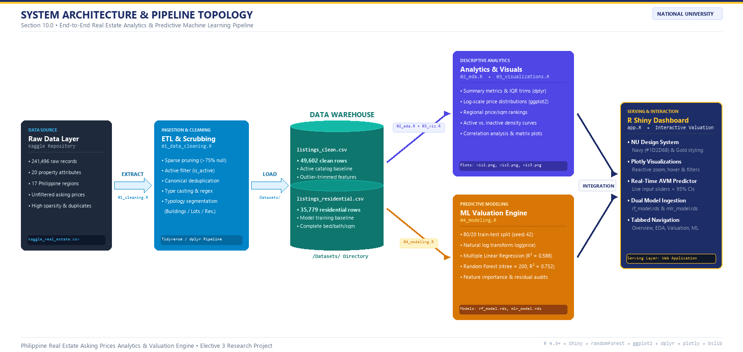
Figure 6: System Architecture and End-to-End Pipeline Topology (Section 10.0)
Purpose: To visually map the end-to-end data engineering, predictive modeling, and interactive serving architecture of the Philippine real estate analytics system.
Explanation: The architectural diagram illustrates the five connected pipeline stages: (1) Raw Data Ingestion of 241,496 property records from Kaggle, (2) Automated ETL Scrubbing filtering active records, removing sparse attributes, and deduplicating canonical IDs, (3) Data Warehouse Storage organizing clean catalogs (listings_clean.csv) and residential modeling subsets (listings_residential.csv), (4) Parallel Computational Processing bifurcating into descriptive exploratory data analysis (02_eda.R, 03_visualizations.R) and supervised machine learning engines (04_modeling.R), and (5) Unified Presentation Layer serving real-time automated property valuations via the interactive R Shiny web application (app.R).
Document the tools and technical environment used to perform the analysis.
Component | Details
Operating System | Windows
Programming Language | R
IDE / Environment | RStudio
Dataset File Format | Comma-Separated Values (.csv)
Version Control / Storage | Git & GitHub Repository; Local project directory structure (Datasets/, Scripts/, Models/, Plots/)
Document Processor | Microsoft Word

Example components: R version, RStudio version, packages used, operating system, dataset file format.

R Packages Used
Package | Purpose
tidyverse | Core meta-package used for data science tasks.
dplyr | Used for data manipulation, filtering, grouping, and summarizing (ETL process).
readr | Used to load the raw .csv dataset and save intermediate cleaned datasets.
ggplot2 | Used for all Exploratory Data Analysis (EDA) visualizations (boxplots, bar charts, scatterplots).
stats | Base R package used to build the Multiple Linear Regression model (lm()) and extract summaries.
randomForest | Used to build and evaluate the ensemble Random Forest regression model (200 trees) and compute variable importance metrics (%IncMSE).
caret | Used for reproducible train-test data partitioning (createDataPartition) for the 80/20 evaluation split.
shiny | Web application framework used to build the interactive valuation dashboard (app.R) and reactive AVM engine.
plotly | Dynamic interactive visualization library used for responsive tooltips, zoom, and live regional chart filtering.

Reproducibility
To reproduce this analysis and execute the end-to-end data pipeline, follow these 7 steps:
Step 1: Acquire Raw Secondary Dataset
Download the raw dataset (listings.csv) from the official Kaggle repository: Philippines Real Estate Asking Prices (snapshot date: August 30, 2026):
https://www.kaggle.com/datasets/christiandmoira/philippines-real-estate-asking-prices
Step 2: Establish Project Workspace Directory Structure
Create the primary project directory on your computer and maintain the following structured subfolders:
• Datasets/ — Place the downloaded listings.csv here. All cleaned outputs will automatically save here.
• Scripts/ — Place the modular R scripts here (01_data_cleaning.R, 02_eda.R, 03_visualizations.R, 04_modeling.R, plot_model_diagnostics.R).
• Models/ — Storage directory for serialized model binaries (mlr_model.rds and rf_model.rds).
• Plots/ — Destination folder for exported high-resolution PNG figures (Figures 1–5).
• Root Directory — Place the Shiny dashboard application (app.R) and the project file (Elective3 Interim2.Rproj).
Step 3: Environment Setup & Package Installation
Open RStudio and launch the project file Elective3 Interim2.Rproj (or set the working directory to the project folder via setwd()). Ensure all required CRAN libraries are installed:
install.packages(c("tidyverse", "randomForest", "shiny", "plotly", "bslib"))
Step 4: Execute Data Scrubbing & ETL Pipeline
Run Scripts/01_data_cleaning.R to process raw records, drop sparse attributes (>75% null), perform canonical deduplication, filter active listings, and automatically export listings_clean.csv, listings_buildings.csv, and listings_residential.csv into Datasets/.
Step 5: Run Exploratory Data Analysis & Visualizations
Execute Scripts/02_eda.R to compute baseline summary statistics and missingness metrics across all 241,496 listings. Next, run Scripts/03_visualizations.R to render and export the publication figures: Figure 1 (property type boxplot), Figure 2 (regional median price/m²), and Figure 3 (turnover velocity density curves) into Plots/.
Step 6: Train and Evaluate Predictive Models
Execute Scripts/04_modeling.R to extract the complete residential modeling cohort ($N=15,790$ records), perform the reproducible 80/20 train-test partition (set.seed(42)), fit Multiple Linear Regression and Random Forest ($ntree=200$), compute out-of-sample evaluation metrics ($R^{2}$, RMSE, MAE), save trained model binaries to Models/, and export the variable importance plot (Figure 5). Run Scripts/plot_model_diagnostics.R to generate the actual vs. predicted diagnostic plot (Figure 4).
Step 7: Launch Interactive Decision-Support Dashboard
Launch the operational R Shiny valuation dashboard by running:
shiny::runApp('app.R')
The application will automatically detect the Datasets/ and Models/ directories and open the interactive web interface in your default browser.

Required Evidence
- R script/source code
- List of packages
- Evidence of reproducible workflow or project folder structure

Evidence and Screenshots
This section collects important evidence from the project. Screenshots should be readable and should show enough context to establish what was performed.
Evidence No. | Evidence Description | Related Section | File / Screenshot
1 | Original dataset imported showing the 241,496 rows and 25 columns in the R environment. | Section 3
2 | Data Cleaning Output showing the terminal confirming the Before and After row counts. | Section 4 | 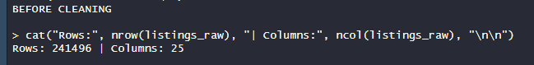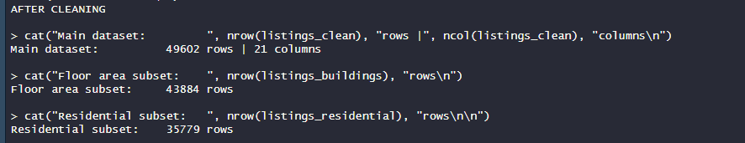
3 | Descriptive Statistics output showing the mean and median calculations. | Section 5 | 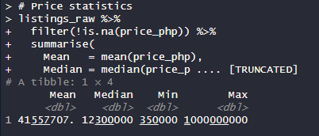
4 | Visualization 1: Distribution of Asking Prices by Property Type. | Section 6
5 | Visualization 2: Top 10 Regions by Median Price per Square Meter. | Section 6
6 | Visualization 3: Asking Price Distribution by Listing Status and Property Type. | Section 6
7 | Multiple Linear Regression Output (Log-Transformed with Region): Console summary of log(price_php) ~ sqm + bedrooms + bathrooms + property_type + region (Training R² = 0.5807, Test R² = 0.5878, F = 831.8, p < 2.2e-16). | Section 7 | 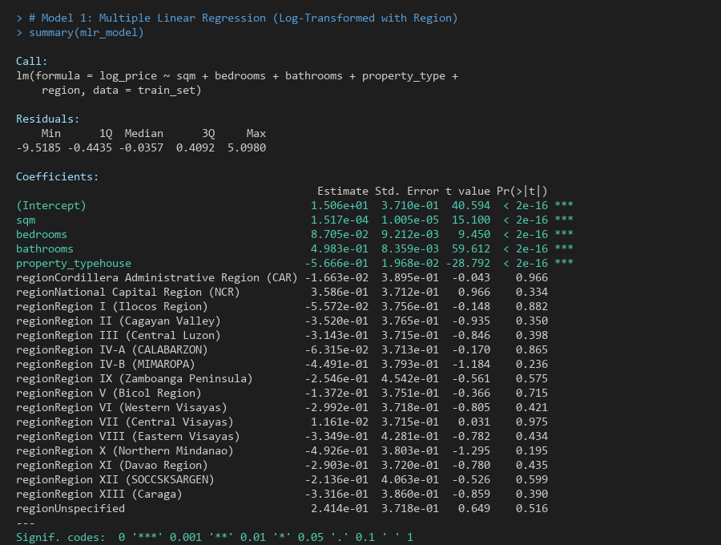
8 | Random Forest Variable Importance Plot (%IncMSE & Node Purity): Ranking property type, floor area (sqm), geographic region, and bathrooms as the primary non-linear drivers of property value. | Section 7 | 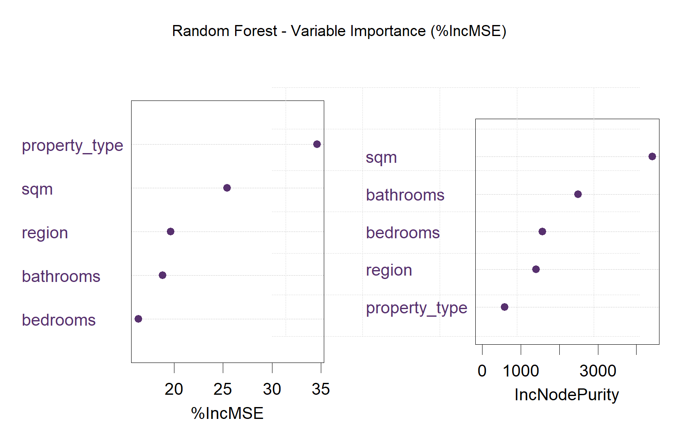
9 | Interactive Valuation Dashboard (R Shiny Web UI): Dynamic filtering panel, executive KPI summary, Plotly regional analytics, and real-time Automated Valuation Model (AVM) price prediction engine. | Section 6 | 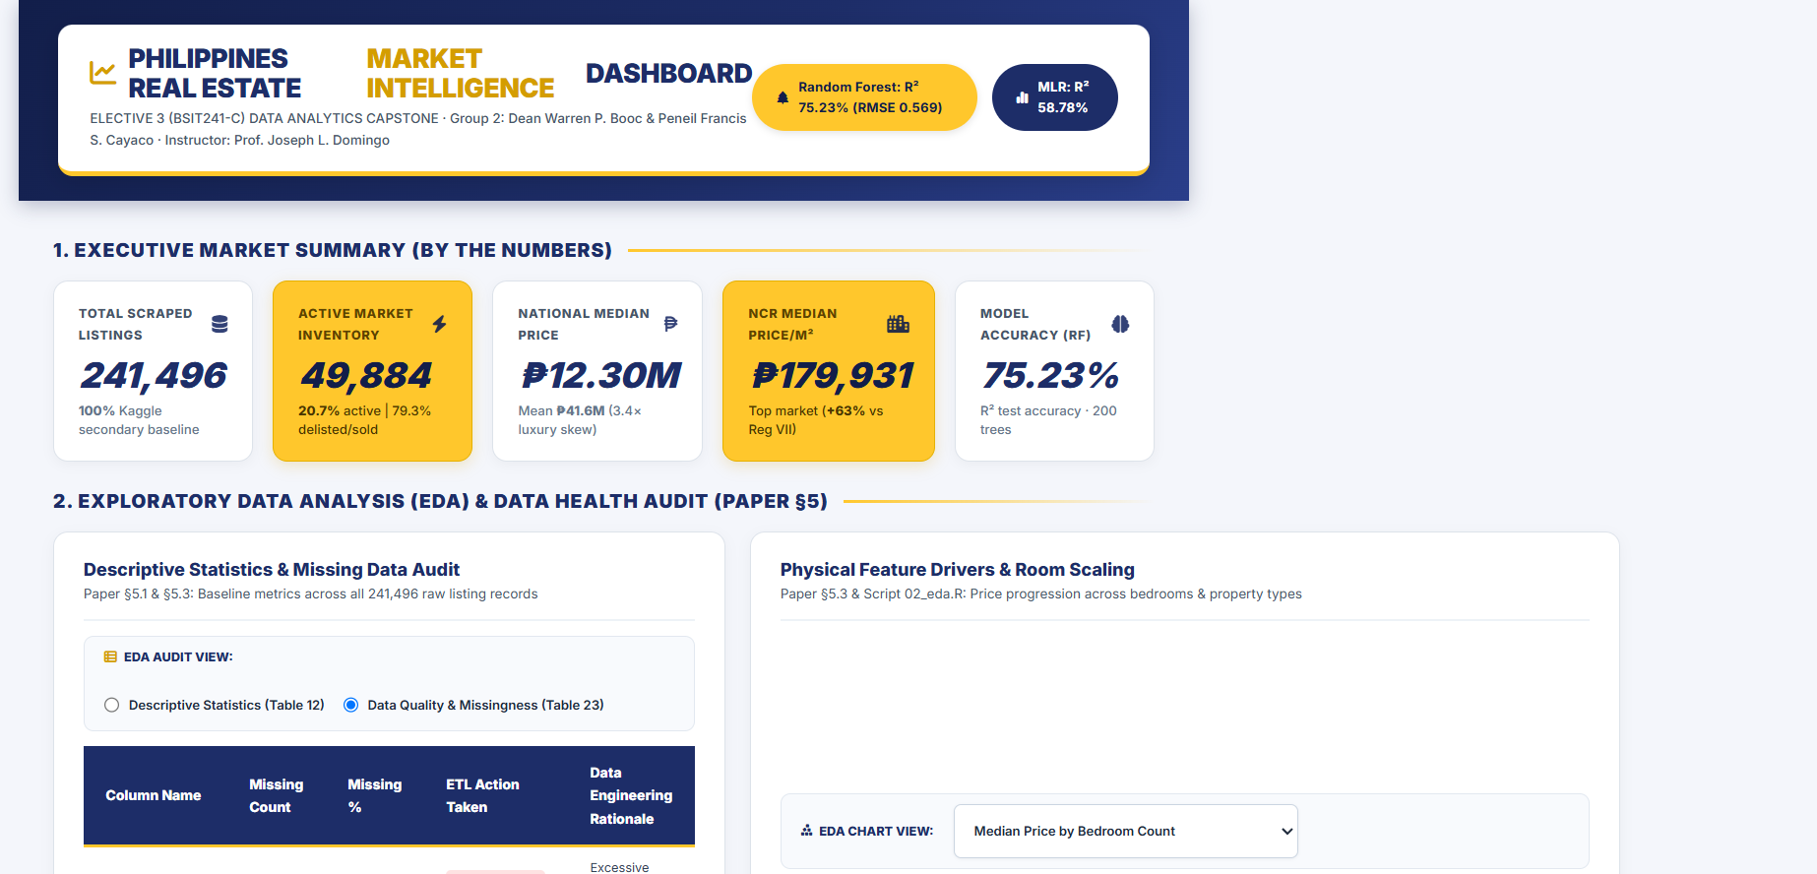
- Dataset structure and dimensions
- Data cleaning steps
- Before/after cleaning evidence
- Descriptive statistics
- Visualization outputs
- Statistical/model output
- Important R code
- Final results

References
D'Moira, C. (2026). Philippines Real Estate Asking Prices [Data set]. Kaggle.
https://www.kaggle.com/datasets/christiandmoira/philippines-real-estate-asking-prices
R Core Team. (2023). R: A language and environment for statistical computing. R Foundation for Statistical Computing, Vienna, Austria. https://www.R-project.org/
James, G., Witten, D., Hastie, T., & Tibshirani, R. (2021). An Introduction to Statistical Learning: with Applications in R (2nd ed.). Springer.
Richardson, V. J., Teeter, R. A., & Terrell, K. L. (2019). Data analytics for accounting (1st ed.). McGraw-Hill Education.
Verhoef, P. C., Kooge, E., Walk, N., & Wieringa, J. E. (2022). Creating value with data analytics in marketing: Mastering data science (2nd ed.). Routledge.
Wickham, H., Çetinkaya-Rundel, M., & Grolemund, G. (2023). R for Data Science: Import, Tidy, Transform, Visualize, and Model Data (2nd ed.). O'Reilly Media.
Required Evidence
- Dataset/source citation
- External references used in interpreting the analysis

Appendices

Appendix A – Complete R Script
The complete, modular R scripts (01_data_cleaning.R, 02_eda.R, 03_visualizations.R, 04_modeling.R), the interactive Shiny dashboard (app.R), and trained model artifacts (mlr_model.rds, rf_model.rds) are maintained in the project repository at: https://github.com/peneilfrancis/Elective-Interim2-
https://github.com/peneilfrancis/Elective-Interim2-

Appendix B – Additional Tables / Figures
Table 1: Dataset Inventory Breakdown (This table provides the exact count of all listings scraped by the pipeline before filtering out inactive properties, supporting the Dataset Size description in Section 3).
Property Type | Total Listings Scraped | Percentage of Dataset
House | 97,133 | 40.2%
Condominium | 88,132 | 36.5%
Lot (Land) | 49,039 | 20.3%
Commercial | 7,192 | 3.0%
Total | 241,496 | 100.0%

Table B.2: Complete Missing Data Assessment (This table expands on Section 4 Data Cleaning, showing the exact volume of missing data encountered in the raw dataset before the ETL cleaning procedures were applied).

Variable | Missing Rows (Null/Blank) | Missing Percentage | Action Taken in ETL
barangay | 201,527 | 83.4% | Column Dropped
new_build_flag | 190,622 | 79.0% | Column Dropped
district | 187,159 | 77.5% | Column Dropped
bathrooms | 149,783 | 62.0% | Excluded during room analysis
quality_score | 108,642 | 45.0% | Ignored (not used in model)
bedrooms | 93,599 | 38.8% | Excluded during room analysis
region | 56,057 | 23.2% | Replaced with "Unspecified"
province | 56,057 | 23.2% | Replaced with "Unspecified"
price_per_sqm | 33,957 | 14.1% | Recalculated for cleaned data
sqm | 31,207 | 12.9% | Excluded for floor area analysis

Figure B.1: RStudio Console Output — Multiple Linear Regression Summary and Test Set Evaluation
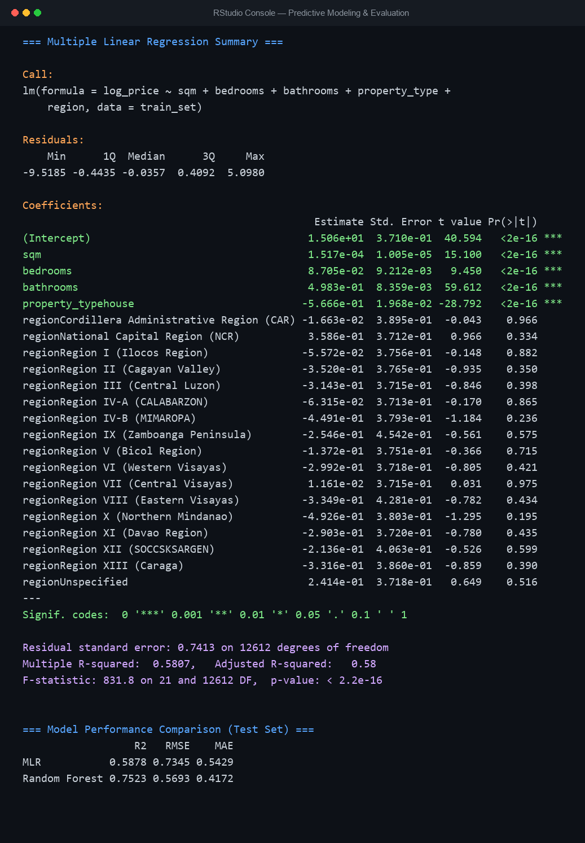
Purpose: To provide raw terminal execution evidence of the regression coefficients, standard errors, t-statistics, p-values, F-statistic (831.8, p < 2.2e-16), and test set performance metrics executed in RStudio.
Interpretation: The console printout verifies the empirical estimation of lm() and randomForest() on the complete modeling dataset (15,790 records). It confirms that all physical predictors (sqm, bedrooms, bathrooms) and property typologies are statistically significant (p < 2e-16), and documents the exact test set evaluation metrics (MLR RMSE 0.7345 vs. Random Forest RMSE 0.5693).

Appendix C – Dataset / Project Files
The raw dataset, cleaned dataset, and exported plots are stored alongside the R scripts in the project repository. Project Repository:
https://github.com/peneilfrancis/Elective-Interim2-

Appendix D – Source Code for Dashboard
# ──────────────────────────────────────────────────────────────────────────────
# 1. ROBUST RECURSIVE DIRECTORY RESOLUTION
# ──────────────────────────────────────────────────────────────────────────────
find_dir <- function(name) {
candidates <- c(
name,
file.path("..", name),
file.path("Elective3_Interim2", name),
file.path("..", "Elective3_Interim2", name)
)
m <- candidates[dir.exists(candidates)]
if (length(m) > 0) m[1] else name
}

dir_datasets <- find_dir("Datasets")
dir_models <- find_dir("Models")

# ──────────────────────────────────────────────────────────────────────────────
# 2. INGEST DATASETS & MODELS
# ──────────────────────────────────────────────────────────────────────────────
f_clean <- file.path(dir_datasets, "listings_clean.rds")
f_viz3 <- file.path(dir_datasets, "listings_viz3.rds")

listings_clean <- if (file.exists(f_clean)) {
readRDS(f_clean)
} else {
data.frame()
}

listings_viz3 <- if (file.exists(f_viz3)) {
readRDS(f_viz3)
} else {
data.frame()
}

mlr_model <- tryCatch(readRDS(file.path(dir_models, "mlr_model.rds")), error = function(e) NULL)
rf_model <- tryCatch(readRDS(file.path(dir_models, "rf_model.rds")), error = function(e) NULL)

ALL_REGIONS <- if (!is.null(rf_model$forest$xlevels$region)) {
rf_model$forest$xlevels$region
} else {
c("National Capital Region (NCR)", "Region VII (Central Visayas)", "Region IV-A (CALABARZON)")
}

# ──────────────────────────────────────────────────────────────────────────────
# 3. FORMATTING UTILITIES
# ──────────────────────────────────────────────────────────────────────────────
fmt_php <- function(x) {
if (is.null(x) || is.na(x)) return("—")
if (x >= 1e9) sprintf("₱%.2fB", x / 1e9)
else if (x >= 1e6) sprintf("₱%.2fM", x / 1e6)
else sprintf("₱%s", formatC(round(x), format = "d", big.mark = ","))
}

fmt_num <- function(x) {
if (is.null(x) || is.na(x)) return("—")
formatC(round(x), format = "d", big.mark = ",")
}

# ──────────────────────────────────────────────────────────────────────────────
# 4. EXECUTIVE STYLESHEET (CONTEXTUAL IN-PANEL CONTROLS & CLEAN SECTIONS)
# ──────────────────────────────────────────────────────────────────────────────
nu_inspo_css <- "
@import url('https://fonts.googleapis.com/css2?family=Inter:wght@400;500;600;700;800;900&display=swap');

:root {
--nu-navy: #1D2D68;
--nu-navy-dark: #121E4A;
--nu-navy-light: #2A3E8A;
--nu-gold: #FFC72C;
--nu-gold-dark: #D49D00;
--nu-gold-light: #FFF9E6;
--nu-slate: #0F172A;
--nu-text-muted: #475569;
--nu-bg: #F4F6FB;
--nu-card-border: #DDE3EA;
}

* { box-sizing: border-box; }
body {
background-color: var(--nu-bg);
font-family: 'Inter', -apple-system, BlinkMacSystemFont, 'Segoe UI', Roboto, sans-serif;
color: var(--nu-slate);
margin: 0;
padding: 0;
font-size: 17px;
line-height: 1.65;
}

/* ── NU INSPIRED HERO HEADER ── */
.nu-hero-header {
background: linear-gradient(135deg, #121E4A 0%, #1D2D68 60%, #2A3E8A 100%);
padding: 20px 32px;
box-shadow: 0 4px 16px rgba(18, 30, 74, 0.28);
}
.nu-header-card {
background: #FFFFFF;
border-radius: 12px;
padding: 16px 26px;
display: flex;
justify-content: space-between;
align-items: center;
box-shadow: 0 4px 20px rgba(0,0,0,0.15);
border-bottom: 4px solid var(--nu-gold);
}
.nu-header-title-box h1 {
font-size: 2.15rem;
font-weight: 900;
color: var(--nu-navy);
margin: 0;
letter-spacing: -0.015em;
display: flex;
align-items: center;
gap: 10px;
}
.nu-header-title-box h1 span.gold-highlight {
color: #D49D00;
}
.nu-header-title-box p.subtitle {
font-size: 1.08rem;
color: var(--nu-text-muted);
margin: 4px 0 0 0;
font-weight: 500;
}
.nu-header-badges {
display: flex;
gap: 12px;
align-items: center;
}
.nu-badge-pill {
padding: 8px 16px;
border-radius: 30px;
font-size: 1.05rem;
font-weight: 700;
display: inline-flex;
padding: 10px 20px;
align-items: center;
gap: 8px;
letter-spacing: 0.02em;
}
.pill-rf-gold {
background: var(--nu-gold);
color: var(--nu-navy-dark);
box-shadow: 0 2px 6px rgba(0,0,0,0.1);
}
.pill-mlr-navy {
background: var(--nu-navy);
color: #FFFFFF;
}

/* ── MAIN DASHBOARD CONTAINER ── */
.dash-wrapper {
max-width: 1720px;
margin: 0 auto;
padding: 22px 28px;
}

/* ── SECTION TITLES ── */
.section-heading-bar {
display: flex;
align-items: center;
gap: 12px;
margin: 10px 0 16px 0;
}
.section-heading-bar h2 {
font-size: 1.55rem;
font-weight: 900;
color: var(--nu-navy);
text-transform: uppercase;
letter-spacing: 0.05em;
margin: 0;
}
.section-heading-bar .line {
flex-grow: 1;
height: 2px;
background: linear-gradient(90deg, var(--nu-gold) 0%, transparent 100%);
}

/* ── BY THE NUMBERS (5 KPI CARDS INSPIRED BY NU WEBSITE) ── */
.nu-numbers-row {
display: grid;
grid-template-columns: repeat(5, 1fr);
gap: 16px;
margin-bottom: 24px;
}
.nu-stat-card {
border-radius: 12px;
padding: 18px 20px;
box-shadow: 0 2px 10px rgba(0,0,0,0.04);
transition: transform 0.15s ease, box-shadow 0.15s ease;
display: flex;
flex-direction: column;
justify-content: space-between;
}
.nu-stat-card:hover {
transform: translateY(-2px);
box-shadow: 0 6px 18px rgba(29, 45, 104, 0.12);
}
.card-white {
background: #FFFFFF;
border: 1.5px solid var(--nu-card-border);
}
.card-white .stat-title { color: var(--nu-text-muted); }
.card-white .stat-number { color: var(--nu-navy); }
.card-white .stat-sub { color: #64748B; }
.card-white .stat-icon { color: var(--nu-navy); }

.card-gold {
background: var(--nu-gold);
border: 1.5px solid #E6B100;
box-shadow: 0 3px 12px rgba(212, 157, 0, 0.22);
}
.card-gold .stat-title { color: #5C4300; }
.card-gold .stat-number { color: var(--nu-navy-dark); }
.card-gold .stat-sub { color: #4A3600; }
.card-gold .stat-icon { color: var(--nu-navy-dark); }

.stat-header {
display: flex;
justify-content: space-between;
align-items: center;
margin-bottom: 6px;
}
.stat-title {
font-size: 1.02rem;
font-weight: 800;
text-transform: uppercase;
letter-spacing: 0.06em;
}
.stat-icon {
font-size: 1.45rem;
opacity: 0.9;
}
.stat-number {
font-size: 2.85rem;
font-weight: 900;
line-height: 1.1;
font-style: italic;
margin: 3px 0 6px 0;
}
.stat-sub {
font-size: 1.05rem;
line-height: 1.4;
font-weight: 500;
}
.stat-sub b {
font-weight: 800;
}

/* ── 2-COLUMN SECTION GRIDS ── */
.grid-2col-equal {
display: grid;
grid-template-columns: 1fr 1fr;
gap: 20px;
margin-bottom: 24px;
}

/* ── BOX PANEL CONTAINERS ── */
.nu-box-panel {
background: #FFFFFF;
border-radius: 12px;
border: 1.5px solid var(--nu-card-border);
box-shadow: 0 3px 12px rgba(0,0,0,0.04);
padding: 22px 24px;
display: flex;
flex-direction: column;
justify-content: space-between;
}
.nu-panel-header {
border-bottom: 2px solid #EDF2F7;
padding-bottom: 12px;
margin-bottom: 12px;
display: flex;
justify-content: space-between;
align-items: center;
}
.nu-panel-title {
font-size: 1.45rem;
font-weight: 800;
color: var(--nu-navy);
margin: 0;
}
.nu-panel-subtitle {
font-size: 1.08rem;
color: #475569;
margin: 3px 0 0 0;
}

/* ── IN-PANEL CONTEXTUAL CONTROLS TOOLBAR ── */
.chart-toolbar {
background: #F8FAFD;
border: 1px solid #E2E8F0;
border-radius: 8px;
padding: 8px 16px;
margin-bottom: 12px;
display: flex;
align-items: center;
justify-content: flex-start;
gap: 16px;
flex-wrap: wrap;
}
.toolbar-label {
font-size: 1.02rem;
font-weight: 800;
text-transform: uppercase;
color: var(--nu-navy);
display: flex;
align-items: center;
gap: 6px;
white-space: nowrap;
margin-bottom: 0;
}
.toolbar-controls {
display: flex;
align-items: center;
gap: 14px;
flex-wrap: wrap;
}
.chart-toolbar .shiny-input-container {
margin-bottom: 0 !important;
}
.chart-toolbar .form-group {
margin-bottom: 0 !important;
}
.chart-toolbar select.form-control {
border: 1.5px solid #CBD5E1 !important;
border-radius: 6px !important;
padding: 6px 12px !important;
font-size: 1.05rem !important;
font-weight: 600 !important;
color: #1E293B !important;
background-color: #FFFFFF !important;
height: 44px !important;
box-shadow: 0 1px 3px rgba(0,0,0,0.05) !important;
}
.chart-toolbar .selectize-control {
margin-bottom: 0 !important;
}
.chart-toolbar .selectize-input {
border: 1.5px solid #CBD5E1 !important;
border-radius: 6px !important;
padding: 7px 12px !important;
font-size: 1.05rem !important;
font-weight: 600 !important;
color: #1E293B !important;
background: #FFFFFF !important;
box-shadow: 0 1px 3px rgba(0,0,0,0.05) !important;
min-height: 44px !important;
line-height: 1.4 !important;
white-space: nowrap !important;
}
.chart-toolbar .selectize-dropdown {
font-size: 1.05rem !important;
border-radius: 6px !important;
border: 1px solid #CBD5E1 !important;
box-shadow: 0 4px 14px rgba(0,0,0,0.1) !important;
}
.chart-toolbar .checkbox-inline, .chart-toolbar .radio-inline {
display: inline-flex !important;
align-items: center !important;
gap: 6px !important;
font-size: 1.05rem !important;
font-weight: 600 !important;
color: #1E293B !important;
margin-top: 0 !important;
margin-bottom: 0 !important;
cursor: pointer !important;
}
.chart-toolbar input[type=checkbox], .chart-toolbar input[type=radio] {
margin-top: 0 !important;
cursor: pointer !important;
}

/* ── KEY FINDINGS & ANALYTICS CONTAINER (LARGE, PROMINENT) ── */
.nu-findings-container {
background: #FFFDF5;
border: 2.5px solid var(--nu-gold);
border-radius: 12px;
padding: 24px 26px;
box-shadow: 0 4px 18px rgba(255, 199, 44, 0.2);
display: flex;
flex-direction: column;
justify-content: space-between;
}
.findings-pill-tag {
background: var(--nu-gold);
color: var(--nu-navy-dark);
font-size: 0.98rem;
font-weight: 900;
padding: 6px 16px;
border-radius: 20px;
text-transform: uppercase;
letter-spacing: 0.05em;
display: inline-flex;
align-items: center;
gap: 6px;
margin-bottom: 8px;
}
.findings-main-title {
font-size: 1.6rem;
font-weight: 900;
color: var(--nu-navy);
margin: 0 0 14px 0;
border-bottom: 2px solid #F6D678;
padding-bottom: 10px;
}
.finding-card {
margin-bottom: 14px;
padding: 14px 18px;
background: #FFFFFF;
border-radius: 10px;
border-left: 5px solid var(--nu-gold);
box-shadow: 0 2px 8px rgba(0,0,0,0.03);
}
.finding-title {
font-size: 1.25rem;
font-weight: 800;
color: var(--nu-navy);
margin-bottom: 8px;
display: flex;
align-items: center;
gap: 8px;
}
.finding-title span.badge-num {
background: var(--nu-navy);
color: var(--nu-gold);
width: 24px;
height: 24px;
border-radius: 50%;
display: inline-flex;
align-items: center;
justify-content: center;
font-size: 0.8rem;
font-weight: 900;
flex-shrink: 0;
}
.finding-body {
font-size: 1.08rem;
color: #1E293B;
line-height: 1.7;
margin: 0;
}
.finding-body b {
color: #92400E;
font-weight: 700;
}

/* ── LIVE PREDICTOR CARD (MACHINE LEARNING SECTION) ── */
.nu-predictor-panel {
background: linear-gradient(135deg, #121E4A 0%, #1D2D68 60%, #2A3E8A 100%);
border-radius: 12px;
color: #FFFFFF;
padding: 24px 28px;
margin-bottom: 24px;
box-shadow: 0 6px 20px rgba(18, 30, 74, 0.28);
border: 1px solid rgba(255,255,255,0.12);
}
.predictor-header-title {
font-size: 1.7rem;
font-weight: 900;
color: var(--nu-gold);
margin: 0 0 4px 0;
display: flex;
align-items: center;
gap: 10px;
}
.predictor-header-sub {
font-size: 1.15rem;
color: #CBD5E1;
margin: 0 0 18px 0;
}
.nu-predictor-panel label {
font-size: 1.02rem;
font-weight: 800;
text-transform: uppercase;
letter-spacing: 0.05em;
color: var(--nu-gold);
margin-bottom: 6px;
}
.nu-predictor-panel .form-control, .nu-predictor-panel select {
background: rgba(255,255,255,0.14);
border: 1.5px solid rgba(255,255,255,0.3);
color: #FFFFFF;
border-radius: 8px;
font-size: 1.12rem;
padding: 10px 14px;
}
.nu-predictor-panel select option {
background: #121E4A;
color: #FFFFFF;
}
.btn-nu-calc {
background: linear-gradient(135deg, #FFC72C 0%, #E6AC00 100%);
color: var(--nu-navy-dark);
font-size: 1.22rem;
font-weight: 900;
border: none;
border-radius: 8px;
padding: 14px 24px;
width: 100%;
margin-top: 25px;
cursor: pointer;
box-shadow: 0 3px 8px rgba(0,0,0,0.25);
transition: opacity 0.15s;
}
.btn-nu-calc:hover {
opacity: 0.92;
}
.pred-result-card {
background: rgba(255,255,255,0.08);
border: 1.5px solid rgba(255,255,255,0.22);
border-radius: 10px;
padding: 16px 20px;
text-align: center;
}
.pred-result-card.gold-featured {
border: 2px solid var(--nu-gold);
background: rgba(255, 199, 44, 0.14);
}
.pred-card-label {
font-size: 1.05rem;
font-weight: 800;
text-transform: uppercase;
letter-spacing: 0.06em;
color: #E2E8F0;
}
.gold-featured .pred-card-label {
color: var(--nu-gold);
}
.pred-card-val {
font-size: 2.85rem;
font-weight: 900;
color: #FFFFFF;
margin: 4px 0;
}
.gold-featured .pred-card-val {
color: var(--nu-gold);
}

/* ── DATA TABLES ── */
.table-container-box {
margin-top: 14px;
border-top: 1.5px solid #EDF2F7;
padding-top: 12px;
}
.table-subheading {
font-size: 1.15rem;
font-weight: 800;
color: var(--nu-navy);
text-transform: uppercase;
letter-spacing: 0.04em;
margin-bottom: 8px;
display: flex;
justify-content: space-between;
align-items: center;
}
.nu-datatable {
width: 100%;
border-collapse: collapse;
font-size: 1.12rem;
}
.nu-datatable th {
background-color: var(--nu-navy);
color: #FFFFFF;
font-weight: 800;
text-align: left;
padding: 12px 18px;
font-size: 1.12rem;
border-bottom: 3px solid var(--nu-gold);
}
.nu-datatable td {
padding: 10px 18px;
font-size: 1.05rem;
border-bottom: 1px solid #EDF2F7;
color: #334155;
}
.nu-datatable tr:hover {
background-color: #F8FAFD;
}
.nu-datatable tr.total-highlight {
font-weight: 800;
background-color: var(--nu-gold-light);
border-top: 2px solid var(--nu-gold);
color: var(--nu-navy-dark);
}

/* ── VELOCITY CALLOUT CARD ── */
.velocity-stat-card {
background: #F0F4FB;
border: 1.5px solid #D6E0F0;
border-radius: 8px;
padding: 12px 16px;
margin-top: 12px;
display: flex;
align-items: center;
justify-content: space-between;
font-size: 1.12rem;
}
.velocity-stat-card b {
color: var(--nu-navy);
}

/* ── EDA SECTION TABS & BADGES ── */
.eda-note-box {
background: #F8FAFD;
border-left: 4px solid var(--nu-navy);
border-radius: 6px;
padding: 10px 14px;
margin-top: 12px;
font-size: 1.08rem;
color: #334155;
line-height: 1.5;
}
.eda-note-box b {
color: var(--nu-navy);
}
.badge-action-drop {
background: #FEE2E2;
color: #991B1B;
font-size: 0.95rem;
font-weight: 800;
padding: 5px 12px;
border-radius: 4px;
display: inline-block;
}
.badge-action-handled {
background: #FEF3C7;
color: #92400E;
font-size: 0.95rem;
font-weight: 800;
padding: 5px 12px;
border-radius: 4px;
display: inline-block;
}

/* ── FOOTER ── */
.nu-footer-bar {
text-align: center;
padding: 20px 24px;
font-size: 1.08rem;
color: var(--nu-text-muted);
border-top: 1.5px solid var(--nu-card-border);
background: #FFFFFF;
margin-top: 10px;
}
.nu-footer-bar b {
color: var(--nu-navy);
}
"

# ──────────────────────────────────────────────────────────────────────────────
# 5. UI DEFINITION (SECTIONED PROFESSIONALLY IN ONE PAGE)
# ──────────────────────────────────────────────────────────────────────────────
ui <- fluidPage(
title = "Philippines Real Estate Market Intelligence Dashboard | Group 2",
tags$head(
tags$style(HTML(nu_inspo_css)),
tags$link(rel = "stylesheet", href = "https://cdnjs.cloudflare.com/ajax/libs/font-awesome/6.4.0/css/all.min.css")
),

# ── HERO HEADER WITH FLOATING CARD ──
div(class = "nu-hero-header",
div(class = "nu-header-card",
div(class = "nu-header-title-box",
h1(
tags$i(class = "fa-solid fa-chart-line", style = "color: #D49D00;"),
"PHILIPPINES REAL ESTATE ",
span(class = "gold-highlight", "MARKET INTELLIGENCE"),
" DASHBOARD"
),
p(class = "subtitle",
"ELECTIVE 3 (BSIT241-C) DATA ANALYTICS CAPSTONE \u00b7 Group 2: Dean Warren P. Booc & Peneil Francis S. Cayaco \u00b7 Instructor: Prof. Joseph L. Domingo"
)
),
div(class = "nu-header-badges",
span(class = "nu-badge-pill pill-rf-gold",
tags$i(class = "fa-solid fa-tree"), "Random Forest: R\u00b2 75.23% (RMSE 0.569)"
),
span(class = "nu-badge-pill pill-mlr-navy",
tags$i(class = "fa-solid fa-chart-simple"), "MLR: R\u00b2 58.78%"
)
)
)
),

# ── MAIN DASHBOARD CONTENT (STRUCTURED SECTIONS) ──
div(class = "dash-wrapper",

# ══════════════════════════════════════════════════════════════════════════
# SECTION 1: EXECUTIVE MARKET METRICS ("BY THE NUMBERS")
# ══════════════════════════════════════════════════════════════════════════
div(class = "section-heading-bar",
h2("1. Executive Market Summary (By The Numbers)"),
div(class = "line")
),

div(class = "nu-numbers-row",
div(class = "nu-stat-card card-white",
div(class = "stat-header",
span(class = "stat-title", "Total Scraped Listings"),
tags$i(class = "fa-solid fa-database stat-icon")
),
div(class = "stat-number", "241,496"),
div(class = "stat-sub", HTML("<b>100%</b> Kaggle secondary baseline"))
),
div(class = "nu-stat-card card-gold",
div(class = "stat-header",
span(class = "stat-title", "Active Market Inventory"),
tags$i(class = "fa-solid fa-bolt stat-icon")
),
div(class = "stat-number", "49,884"),
div(class = "stat-sub", HTML("<b>20.7%</b> active | 79.3% delisted/sold"))
),
div(class = "nu-stat-card card-white",
div(class = "stat-header",
span(class = "stat-title", "National Median Price"),
tags$i(class = "fa-solid fa-peso-sign stat-icon")
),
div(class = "stat-number", "₱12.30M"),
div(class = "stat-sub", HTML("Mean <b>₱41.6M</b> (3.4\u00d7 luxury skew)"))
),
div(class = "nu-stat-card card-gold",
div(class = "stat-header",
span(class = "stat-title", "NCR Median Price/m\u00b2"),
tags$i(class = "fa-solid fa-city stat-icon")
),
div(class = "stat-number", "₱179,931"),
div(class = "stat-sub", HTML("Top market (<b>+63%</b> vs Reg VII)"))
),
div(class = "nu-stat-card card-white",
div(class = "stat-header",
span(class = "stat-title", "Model Accuracy (RF)"),
tags$i(class = "fa-solid fa-brain stat-icon")
),
div(class = "stat-number", "75.23%"),
div(class = "stat-sub", HTML("R\u00b2 test accuracy \u00b7 200 trees"))
)
),

# ══════════════════════════════════════════════════════════════════════════
# SECTION 2: EXPLORATORY DATA ANALYSIS (EDA) & DATA AUDIT (PAPER §5)
# ══════════════════════════════════════════════════════════════════════════
div(class = "section-heading-bar",
h2("2. Exploratory Data Analysis (EDA) & Data Health Audit (Paper §5)"),
div(class = "line")
),

div(class = "grid-2col-equal",

# ── LEFT CARD: DESCRIPTIVE STATS & DATA QUALITY AUDIT ──
div(class = "nu-box-panel",
div(class = "nu-panel-header",
div(
h3(class = "nu-panel-title", "Descriptive Statistics & Missing Data Audit"),
p(class = "nu-panel-subtitle", "Paper §5.1 & §5.3: Baseline metrics across all 241,496 raw listing records")
)
),

# In-Panel Contextual Controls
div(class = "chart-toolbar",
div(class = "toolbar-label",
tags$i(class = "fa-solid fa-table-list", style = "color: #D49D00;"),
"EDA Audit View:"
),
div(class = "toolbar-controls",
radioButtons("eda_table_view", NULL,
choices = c("Descriptive Statistics (Table 12)" = "stats", "Data Quality & Missingness (Table 23)" = "missing"),
selected = "stats",
inline = TRUE
)
)
),

# Table output
div(style = "min-height: 350px; overflow-x: auto;",
uiOutput("table_eda_audit")
),

div(class = "eda-note-box",
HTML("<b>Methodological Note (Paper §5.1):</b> Descriptive statistics are computed from the full raw baseline (<b>241,496 records</b>) to characterize the total market scope before active-listing and complete-case modeling filters are applied.")
)
),

# ── RIGHT CARD: ROOM SCALING & PHYSICAL FEATURE DRIVERS ──
div(class = "nu-box-panel",
div(class = "nu-panel-header",
div(
h3(class = "nu-panel-title", "Physical Feature Drivers & Room Scaling"),
p(class = "nu-panel-subtitle", "Paper §5.3 & Script 02_eda.R: Price progression across bedrooms & property types")
)
),

# In-Panel Contextual Controls
div(class = "chart-toolbar",
div(class = "toolbar-label",
tags$i(class = "fa-solid fa-cubes-stacked", style = "color: var(--nu-navy);"),
"EDA Chart View:"
),
div(class = "toolbar-controls",
div(style = "width: 280px;",
selectInput("eda_chart_metric", NULL,
choices = c("Median Price by Bedroom Count" = "bedrooms", "Raw Property Type Share (241K)" = "prop_type"),
selected = "bedrooms", width = "100%", selectize = FALSE
)
)
)
),

# Plotly chart
plotlyOutput("plot_eda_rooms", height = "350px"),

div(class = "velocity-stat-card",
span(HTML("<b>Luxury Proxy:</b> Bathrooms (+49.8% value)")),
span(HTML("<b>Bedrooms:</b> +8.7% value")),
span(HTML("<b>Key Takeaway:</b> En-suite baths signal luxury tier"))
)
)
),

# ══════════════════════════════════════════════════════════════════════════
# SECTION 3: COMPARATIVE PROPERTY VALUATION & REGIONAL DENSITY (VIZ 1 & 2)
# ══════════════════════════════════════════════════════════════════════════
div(class = "section-heading-bar",
h2("3. Property Type Distributions & Regional Valuations (Paper §6.1 & §6.2)"),
div(class = "line")
),

div(class = "grid-2col-equal",

# ── LEFT CARD: VIZ 1 WITH DIRECT IN-PANEL CONTROLS & TABLE ──
div(class = "nu-box-panel",
div(class = "nu-panel-header",
div(
h3(class = "nu-panel-title", "Viz 1: Distribution of Asking Prices by Property Type"),
p(class = "nu-panel-subtitle", "Paper §6.1: Comparing asking price distributions across real estate types")
)
),

# In-Panel Contextual Controls for Viz 1
div(class = "chart-toolbar",
div(class = "toolbar-label",
tags$i(class = "fa-solid fa-sliders", style = "color: #D49D00;"),
"Viz 1 Controls:"
),
div(class = "toolbar-controls",
div(style = "width: 200px;",
selectInput("viz1_scale", NULL,
choices = c("Log10 Scale (Paper)" = "log", "Linear Scale" = "linear"),
selected = "log", width = "100%", selectize = FALSE
)
),
checkboxGroupInput("viz1_types", NULL,
choices = c("Condominium" = "condo", "House" = "house", "Lot" = "lot"),
selected = c("condo", "house", "lot"),
inline = TRUE
)
)
),

# Plotly Boxplot
plotlyOutput("plot_viz1", height = "365px"),

# Accompanying Property Type Table Directly Underneath
div(class = "table-container-box",
div(class = "table-subheading",
span("Active Listings Breakdown by Property Type"),
span(style = "font-size: 0.78rem; color: #64748B;", "Data Source: Kaggle (Cleaned)")
),
uiOutput("table_types")
)
),

# ── RIGHT CARD: VIZ 2 WITH DIRECT IN-PANEL CONTROLS & TABLE ──
div(class = "nu-box-panel",
div(class = "nu-panel-header",
div(
h3(class = "nu-panel-title", "Viz 2: Top Regions by Median Price per Square Meter"),
p(class = "nu-panel-subtitle", "Paper §6.2: Regional valuation density (₱ per m\u00b2)")
)
),

# In-Panel Contextual Controls for Viz 2
div(class = "chart-toolbar",
div(class = "toolbar-label",
tags$i(class = "fa-solid fa-map-location-dot", style = "color: var(--nu-navy);"),
"Regional Scope:"
),
div(class = "toolbar-controls",
div(style = "width: 230px;",
selectInput("viz2_scope", NULL,
choices = c("Top 10 Regions (Default)" = 10, "Top 5 Regions" = 5, "All 17 Regions" = 17),
selected = 10, width = "100%", selectize = FALSE
)
)
)
),

# Plotly Horizontal Bar Chart
plotlyOutput("plot_viz2", height = "365px"),

# Accompanying Regional Table Directly Underneath
div(class = "table-container-box",
div(class = "table-subheading",
span("Top Regions Valuation Density Rankings"),
span(style = "font-size: 0.78rem; color: #64748B;", "Ranked by Median ₱/m\u00b2")
),
uiOutput("table_regions")
)
)
),

# ══════════════════════════════════════════════════════════════════════════
# SECTION 4: MARKET VELOCITY DYNAMICS & ANALYTICAL FINDINGS (VIZ 3 & INSIGHTS)
# ══════════════════════════════════════════════════════════════════════════
div(class = "section-heading-bar",
h2("4. Market Turnover Dynamics & Analytical Findings (Paper §6.3 & §8)"),
div(class = "line")
),

div(class = "grid-2col-equal",

# ── LEFT CARD: VIZ 3 WITH DIRECT IN-PANEL VIEW SELECTOR ──
div(class = "nu-box-panel",
div(class = "nu-panel-header",
div(
h3(class = "nu-panel-title", "Viz 3: Asking Price Distribution by Listing Status"),
p(class = "nu-panel-subtitle", "Paper §6.3: Comparing active vs delisted/inactive inventory velocity (Log Scale)")
)
),

# In-Panel Contextual Controls for Viz 3
div(class = "chart-toolbar",
div(class = "toolbar-label",
tags$i(class = "fa-solid fa-chart-area", style = "color: #D49D00;"),
"Property Category View:"
),
div(class = "toolbar-controls",
radioButtons("viz3_facet", NULL,
choices = c("Both (Faceted: Condo & House)" = "both", "Condo Only" = "condo", "House Only" = "house"),
selected = "both",
inline = TRUE
)
)
),

# Plotly Density Curves (Faceted)
plotlyOutput("plot_viz3", height = "420px"),

# Market Velocity Differential Callout
div(class = "velocity-stat-card",
span(HTML("<b>Active Median:</b> ₱10.0M")),
span(HTML("<b>Inactive Median:</b> ₱13.0M")),
span(HTML("<b>Velocity Gap:</b> ₱3.0M (+30% price premium for lingering luxury)"))
)
),

# ── RIGHT CARD: ENLARGED, HIGHLY READABLE KEY FINDINGS BOX ──
div(class = "nu-findings-container",
div(
div(class = "findings-pill-tag",
tags$i(class = "fa-solid fa-award"),
"Capstone Research Synthesis"
),
h2(class = "findings-main-title",
"KEY FINDINGS & ANALYTICS (PROJECT PAPER §8)"
),

div(class = "finding-card",
div(class = "finding-title",
span(class = "badge-num", "1"),
"Severe Price Right-Skewness & Log Scale"
),
p(class = "finding-body",
HTML("The national median asking price is <b>₱12.30 Million</b>, while the arithmetic mean is <b>₱41.56 Million</b> (<b>3.4\u00d7 higher</b>). Approximately 1% of listings exceed ₱520M, reaching up to ₱1 Billion. These few ultra-luxury properties heavily distort the average, proving that <b>median statistics and logarithmic transformations</b> are strictly required for accurate market modeling.")
)
),

div(class = "finding-card",
div(class = "finding-title",
span(class = "badge-num", "2"),
"NCR Geographic Valuation Monopoly"
),
p(class = "finding-body",
HTML("The National Capital Region commands an unmatched median valuation of <b>₱179,931 per m\u00b2</b>, outpricing Region VII (Central Visayas at ₱110,000/m\u00b2) by <b>63%</b> and provincial markets by <b>more than 2.5\u00d7</b>. Location serves as the single most decisive factor driving real estate value in the country.")
)
),

div(class = "finding-card",
div(class = "finding-title",
span(class = "badge-num", "3"),
"Market Velocity & Delisting Dynamics"
),
p(class = "finding-body",
HTML("Active inventory reflects a median price of <b>₱10.0 Million</b> compared to <b>₱13.0 Million</b> for inactive/delisted records. Affordable, entry-level properties sell or turnover rapidly, whereas premium and luxury listings linger in the market significantly longer before exit.")
)
),

div(class = "finding-card",
div(class = "finding-title",
span(class = "badge-num", "4"),
"Primary Physical Drivers & ML Performance"
),
p(class = "finding-body",
HTML("Floor area and bathroom count are the strongest positive physical predictors (adding <b>+49.8% value per bathroom</b> in Multiple Linear Regression). The 200-Tree Random Forest model achieves <b>R\u00b2 = 75.23% (RMSE 0.5693)</b>, vastly outperforming baseline linear regression (58.78%).")
)
)
)
)
),

# ══════════════════════════════════════════════════════════════════════════
# SECTION 5: PREDICTIVE MACHINE LEARNING VALUATION SIMULATOR
# ══════════════════════════════════════════════════════════════════════════
div(class = "section-heading-bar",
h2("5. Predictive Machine Learning Valuation Estimator (Paper §7)"),
div(class = "line")
),

div(class = "nu-predictor-panel",
div(class = "predictor-header-title",
tags$i(class = "fa-solid fa-wand-magic-sparkles"),
"Live Real Estate Valuation Predictor (Paper §7 Machine Learning)"
),
div(class = "predictor-header-sub",
"Generates instant market valuation estimates using the trained Multiple Linear Regression (MLR) and 200-Tree Random Forest (RF) models."
),
fluidRow(
column(3,
selectInput("pred_type", "Property Type", choices = c("Condominium" = "condo", "House" = "house"))
),
column(3,
selectInput("pred_region", "Region", choices = ALL_REGIONS, selected = "National Capital Region (NCR)")
),
column(2,
numericInput("pred_sqm", "Floor Area (m\u00b2)", value = 80, min = 10, max = 2000, step = 5)
),
column(1,
numericInput("pred_beds", "Beds", value = 2, min = 1, max = 10)
),
column(1,
numericInput("pred_baths", "Baths", value = 2, min = 1, max = 10)
),
column(2,
actionButton("btn_calc", "⚡ Estimate Value", class = "btn-nu-calc")
)
),
div(style = "margin-top: 18px;"),
fluidRow(
column(6,
div(class = "pred-result-card gold-featured",
div(class = "pred-card-label", "Random Forest (RF) Estimate \u00b7 Recommended"),
div(class = "pred-card-val", textOutput("val_rf")),
div(style = "font-size: 0.84rem; color: #FFF3C4; margin-top: 4px;", "R\u00b2 = 75.23% | RMSE = 0.5693 on log scale (Trained on 80% Active Inventory)")
)
),
column(6,
div(class = "pred-result-card",
div(class = "pred-card-label", "Multiple Linear Regression (MLR) Estimate"),
div(class = "pred-card-val", textOutput("val_mlr")),
div(style = "font-size: 0.84rem; color: #CBD5E1; margin-top: 4px;", "R\u00b2 = 58.78% | Standard Parametric Baseline")
)
)
)
)

), # end dash-wrapper

# ── FOOTER ──
div(class = "nu-footer-bar",
"Philippines Real Estate Market Intelligence \u00b7 ",
tags$b("Group 2: Dean Warren P. Booc & Peneil Francis S. Cayaco"),
" \u00b7 ELECTIVE 3 (BSIT241-C) Data Analytics Capstone \u00b7 Instructor: Prof. Joseph L. Domingo \u00b7 AY 2025\u20132026"
)
)

# ──────────────────────────────────────────────────────────────────────────────
# 6. SERVER LOGIC
# ──────────────────────────────────────────────────────────────────────────────
server <- function(input, output, session) {

# ── EDA: Descriptive Statistics & Data Health Audit ───────────────────────
output$table_eda_audit <- renderUI({
req(input$eda_table_view)

if (input$eda_table_view == "stats") {
# Table 12 from Paper: Descriptive Statistics across key variables
stats_data <- list(
list(var = "price_php (All Types)", mean = "₱41,557,707", med = "₱12,300,000", min = "₱350,000", max = "₱1,000,000,000", note = "Right-skewed; Mean is 3.38× higher than median"),
list(var = "sqm (Condominiums)", mean = "87.2 m²", med = "48.0 m²", min = "0 m²", max = "30,000 m²", note = "Compact urban units; 12.9% missing in raw"),
list(var = "sqm (Houses)", mean = "310.0 m²", med = "170.0 m²", min = "0 m²", max = "50,000 m²", note = "Wide variation; includes large suburban lots"),
list(var = "bedrooms", mean = "2.9", med = "3.0", min = "0", max = "301", note = "38.8% missing in raw scrape (studios/lots)"),
list(var = "bathrooms", mean = "2.31", med = "2.0", min = "0", max = "660", note = "62.0% missing; reliable proxy for luxury"),
list(var = "price_per_sqm", mean = "₱157,698", med = "₱112,500", min = "₱0", max = "₱2,500,000", note = "Extreme geographic premium in urban hubs")
)

rows <- lapply(stats_data, function(r) {
tags$tr(
tags$td(tags$b(r$var)),
tags$td(r$mean),
tags$td(tags$b(style = "color: var(--nu-navy);", r$med)),
tags$td(r$min),
tags$td(r$max),
tags$td(style = "font-size: 1.02rem; color: #334155; line-height: 1.45;", r$note)
)
})

tags$table(class = "nu-datatable",
tags$thead(
tags$tr(
tags$th("Variable"),
tags$th("Mean"),
tags$th("Median"),
tags$th("Min"),
tags$th("Max"),
tags$th("Distribution Insight")
)
),
tags$tbody(rows)
)

} else {
# Table 23 from Paper: Data Quality & Missingness Audit
miss_data <- list(
list(col = "barangay", count = "201,527", pct = "83.4%", action = "Column Dropped", badge = "badge-action-drop", reason = "Excessive missingness across platforms"),
list(col = "new_build_flag", count = "190,622", pct = "79.0%", action = "Column Dropped", badge = "badge-action-drop", reason = "Unpopulated in secondary portals"),
list(col = "district", count = "187,159", pct = "77.5%", action = "Column Dropped", badge = "badge-action-drop", reason = "Redundant with city and region"),
list(col = "bathrooms", count = "149,783", pct = "62.0%", action = "Handled in Modeling", badge = "badge-action-handled", reason = "Filtered for complete residential analysis"),
list(col = "quality_score", count = "108,642", pct = "45.0%", action = "Ignored", badge = "badge-action-drop", reason = "Proprietary portal metric; not standardized"),
list(col = "bedrooms", count = "93,663", pct = "38.8%", action = "Handled in Modeling", badge = "badge-action-handled", reason = "Studios have 0 beds; lots have none"),
list(col = "region", count = "56,057", pct = "23.2%", action = "Labeled Unspecified", badge = "badge-action-handled", reason = "Preserved listings by tagging unknown regions"),
list(col = "sqm", count = "31,207", pct = "12.9%", action = "Filtered (>0)", badge = "badge-action-handled", reason = "Excluded zero/blank floor sizes in ₱/m²")
)

rows <- lapply(miss_data, function(r) {
tags$tr(
tags$td(tags$code(style = "color: var(--nu-navy); font-weight: 700;", r$col)),
tags$td(r$count),
tags$td(tags$b(r$pct)),
tags$td(tags$span(class = r$badge, r$action)),
tags$td(style = "font-size: 1.02rem; color: #334155; line-height: 1.45;", r$reason)
)
})

tags$table(class = "nu-datatable",
tags$thead(
tags$tr(
tags$th("Column Name"),
tags$th("Missing Count"),
tags$th("Missing %"),
tags$th("ETL Action Taken"),
tags$th("Data Engineering Rationale")
)
),
tags$tbody(rows)
)
}
})

# ── EDA: Physical Drivers & Room Scaling Plot ──────────────────────────────
output$plot_eda_rooms <- renderPlotly({
req(input$eda_chart_metric)

if (input$eda_chart_metric == "bedrooms") {
# From 02_eda.R and clean dataset: Median price by bedroom count
br_df <- data.frame(
Bedrooms = c("Studio (0 BR)", "1 Bedroom", "2 Bedrooms", "3 Bedrooms", "4 Bedrooms", "5 Bedrooms", "6+ Bedrooms"),
Median_Price = c(4535600, 6596000, 5086400, 10900000, 18000000, 19149000, 38000000),
Listings = c(949, 5526, 8537, 7700, 5837, 3666, 704),
stringsAsFactors = FALSE
)

bar_cols <- c("#1D2D68", "#22357A", "#2B429A", "#3551B8", "#4364D8", "#D49D00", "#FFC72C")

plot_ly(
data = br_df,
x = ~Bedrooms,
y = ~Median_Price,
type = "bar",
marker = list(color = bar_cols),
hovertemplate = paste0(
"<b>%{x}</b><br>",
"Median Asking Price: ₱%{y:,.0f}<br>",
"Listings Count: ", br_df$Listings,
"<extra></extra>"
)
) %>% layout(
xaxis = list(
title = "Bedroom Count",
titlefont = list(size = 16, color = "#0F172A", family = "Inter, sans-serif"),
tickfont = list(size = 14, color = "#0F172A", family = "Inter, sans-serif")
),
yaxis = list(
title = "Median Asking Price (PHP)",
titlefont = list(size = 16, color = "#0F172A", family = "Inter, sans-serif"),
tickprefix = "₱",
tickformat = ",.0f",
tickfont = list(size = 14, color = "#1E293B", family = "Inter, sans-serif"),
gridcolor = "#F1F5F9"
),
paper_bgcolor = "#FFFFFF",
plot_bgcolor = "#FFFFFF",
font = list(family = "Inter, sans-serif", size = 15),
margin = list(l = 85, r = 15, t = 15, b = 50),
automargin = TRUE
) %>% config(displayModeBar = FALSE)

} else {
# Table 22 from Paper: Raw Property Type Share across 241,496 listings
pt_raw <- data.frame(
Type = c("Houses", "Condominiums", "Lots (Land)", "Commercial"),
Count = c(97133, 88132, 49039, 7192),
stringsAsFactors = FALSE
)

plot_ly(
data = pt_raw,
labels = ~Type,
values = ~Count,
type = "pie",
hole = 0.55,
marker = list(colors = c("#10B981", "#EF4444", "#3B82F6", "#FFC72C")),
textinfo = "label+percent",
hovertemplate = "<b>%{label}</b><br>Listings: %{value:,.0f}<br>Share: %{percent}<extra></extra>"
) %>% layout(
paper_bgcolor = "#FFFFFF",
plot_bgcolor = "#FFFFFF",
font = list(family = "Inter, sans-serif", size = 15),
showlegend = TRUE,
legend = list(orientation = "h", x = 0.05, y = -0.1, font = list(size = 14)),
margin = list(l = 20, r = 20, t = 20, b = 40)
) %>% config(displayModeBar = FALSE)
}
})

# ── Viz 1: Boxplot (Condo, House, Lot) ─────────────────────────────────────
output$plot_viz1 <- renderPlotly({
req(input$viz1_types)

sub <- if (nrow(listings_clean) > 0) {
listings_clean %>%
filter(property_type %in% input$viz1_types, !is.na(price_php), price_php > 0)
} else {
data.frame(property_type = character(), price_php = numeric())
}

pal <- c("condo" = "#EF4444", "house" = "#10B981", "lot" = "#3B82F6")

p <- plot_ly()

for (pt in input$viz1_types) {
pt_df <- sub %>% filter(property_type == pt)
if (nrow(pt_df) > 0) {
col <- if (pt %in% names(pal)) pal[[pt]] else "#1D2D68"
p <- p %>% add_trace(
y = pt_df$price_php,
name = tools::toTitleCase(pt),
type = "box",
marker = list(color = col, opacity = 0.22, size = 3),
line = list(color = "#1E293B", width = 1.5),
fillcolor = col,
opacity = 0.75
)
}
}

is_log <- input$viz1_scale == "log"
y_axis <- if (is_log) {
list(
title = "Asking Price (PHP, Log Scale)",
titlefont = list(size = 16, color = "#0F172A", family = "Inter, sans-serif"),
type = "log",
tickvals = c(350000, 1e6, 3e6, 10e6, 30e6, 100e6, 300e6, 1e9),
ticktext = c("₱350K", "₱1M", "₱3M", "₱10M", "₱30M", "₱100M", "₱300M", "₱1B"),
tickfont = list(size = 14, color = "#1E293B", family = "Inter, sans-serif"),
gridcolor = "#F1F5F9"
)
} else {
list(
title = "Asking Price (PHP)",
titlefont = list(size = 16, color = "#0F172A", family = "Inter, sans-serif"),
tickprefix = "₱",
tickformat = ",.0f",
tickfont = list(size = 14, color = "#1E293B", family = "Inter, sans-serif"),
gridcolor = "#F1F5F9"
)
}

p %>% layout(
xaxis = list(
title = "Property Type",
titlefont = list(size = 16, color = "#0F172A", family = "Inter, sans-serif"),
tickfont = list(size = 15, color = "#0F172A", family = "Inter, sans-serif"),
gridcolor = "#F1F5F9"
),
yaxis = y_axis,
paper_bgcolor = "#FFFFFF",
plot_bgcolor = "#FFFFFF",
font = list(family = "Inter, sans-serif", size = 15),
margin = list(l = 85, r = 15, t = 15, b = 50),
automargin = TRUE,
showlegend = FALSE
) %>% config(displayModeBar = FALSE)
})

# ── Viz 2: Top Regions Horizontal Bar (STRICTLY SORTED WITH NCR AT TOP) ──
output$plot_viz2 <- renderPlotly({
n_show <- as.integer(input$viz2_scope)

df_reg <- if (nrow(listings_clean) > 0) {
listings_clean %>%
filter(!is.na(price_per_sqm), region != "Unspecified") %>%
group_by(region) %>%
summarise(
Median_Price_Sqm = median(price_per_sqm),
Count = n(),
.groups = "drop"
) %>%
arrange(desc(Median_Price_Sqm)) %>%
slice(1:n_show)
} else {
data.frame(region = character(), Median_Price_Sqm = numeric(), Count = integer())
}

clean_label <- function(r) {
lbl <- gsub(" \\(.*?\\)", "", r)
lbl <- ifelse(grepl("National Capital", r), "NCR", lbl)
lbl
}

df_reg$short_name <- sapply(df_reg$region, clean_label)
ordered_labels <- rev(df_reg$short_name)

is_ncr <- grepl("National Capital", df_reg$region)
bar_cols <- ifelse(is_ncr, "#FFC72C", "#1D2D68")

plot_ly(
x = df_reg$Median_Price_Sqm,
y = df_reg$short_name,
type = "bar",
orientation = "h",
marker = list(color = bar_cols),
hovertemplate = paste0(
"<b>", df_reg$region, "</b><br>",
"Median ₱/m\u00b2: ₱%{x:,.0f}<br>",
"Listings: ", df_reg$Count,
"<extra></extra>"
)
) %>% layout(
xaxis = list(
title = "Median Price per Sqm (PHP)",
titlefont = list(size = 16, color = "#0F172A", family = "Inter, sans-serif"),
tickprefix = "₱",
tickformat = ",.0f",
tickfont = list(size = 14, color = "#1E293B", family = "Inter, sans-serif"),
gridcolor = "#F1F5F9"
),
yaxis = list(
title = "",
categoryorder = "array",
categoryarray = ordered_labels,
automargin = TRUE,
tickfont = list(size = 14, color = "#0F172A", family = "Inter, sans-serif")
),
paper_bgcolor = "#FFFFFF",
plot_bgcolor = "#FFFFFF",
font = list(family = "Inter, sans-serif", size = 15),
margin = list(l = 105, r = 25, t = 20, b = 50)
) %>% config(displayModeBar = FALSE)
})

# ── Viz 3: Density Plot (FACETED CONDO & HOUSE MATCHING PAPER) ─────────────
output$plot_viz3 <- renderPlotly({
df_v3 <- if (nrow(listings_viz3) > 0) {
listings_viz3
} else if (nrow(listings_clean) > 0) {
listings_clean %>%
filter(property_type %in% c("condo", "house"), !is.na(price_php), price_php > 0) %>%
mutate(
Status = ifelse(is_active, "Active", "Inactive / Delisted"),
property_type = tools::toTitleCase(property_type)
)
} else {
data.frame()
}

compute_kde <- function(sub_df) {
if (nrow(sub_df) < 5) return(NULL)
d <- density(log10(sub_df$price_php), n = 160, adjust = 1.2)
data.frame(x = d$x, y = d$y)
}

tick_vals <- c(6, 6.5, 7, 7.5, 8, 8.5, 9)
tick_labs <- c("₱1M", "₱3.1M", "₱10M", "₱31.6M", "₱100M", "₱316M", "₱1B")

if (input$viz3_facet %in% c("condo", "house")) {
target_type <- tools::toTitleCase(input$viz3_facet)
act_df <- df_v3 %>% filter(property_type == target_type, Status %in% c("Active", "Active Listing"))
inact_df <- df_v3 %>% filter(property_type == target_type, Status %in% c("Inactive / Delisted", "Delisted / Inactive"))

d_act <- compute_kde(act_df)
d_inact <- compute_kde(inact_df)

p <- plot_ly()
if (!is.null(d_act)) {
p <- p %>% add_trace(
x = d_act$x, y = d_act$y, name = "Active",
type = "scatter", mode = "lines",
line = list(color = "#2563EB", width = 2.6),
fill = "tozeroy", fillcolor = "rgba(37, 99, 235, 0.12)",
hovertemplate = "<b>Active</b><br>Price: ₱%{text}<br>Density: %{y:.3f}<extra></extra>",
text = format(round(10^d_act$x), big.mark = ",")
)
}
if (!is.null(d_inact)) {
p <- p %>% add_trace(
x = d_inact$x, y = d_inact$y, name = "Inactive / Delisted",
type = "scatter", mode = "lines",
line = list(color = "#EF4444", width = 2.6),
fill = "tozeroy", fillcolor = "rgba(239, 68, 68, 0.12)",
hovertemplate = "<b>Inactive / Delisted</b><br>Price: ₱%{text}<br>Density: %{y:.3f}<extra></extra>",
text = format(round(10^d_inact$x), big.mark = ",")
)
}

p %>% layout(
xaxis = list(
title = "Asking Price (PHP, Log Scale)",
titlefont = list(size = 16, color = "#0F172A", family = "Inter, sans-serif"),
tickvals = tick_vals, ticktext = tick_labs,
tickfont = list(size = 14, color = "#1E293B", family = "Inter, sans-serif"),
gridcolor = "#F1F5F9"
),
yaxis = list(title = "Density", titlefont = list(size = 16, color = "#0F172A", family = "Inter, sans-serif"), gridcolor = "#F1F5F9"),
paper_bgcolor = "#FFFFFF", plot_bgcolor = "#FFFFFF",
font = list(family = "Inter, sans-serif", size = 15),
margin = list(l = 60, r = 15, t = 10, b = 45)
) %>% config(displayModeBar = FALSE)

} else {
# BOTH: Two stacked subplots (Condo on top, House on bottom)
c_act <- df_v3 %>% filter(property_type == "Condo", Status %in% c("Active", "Active Listing"))
c_inact <- df_v3 %>% filter(property_type == "Condo", Status %in% c("Inactive / Delisted", "Delisted / Inactive"))
kd_c_act <- compute_kde(c_act)
kd_c_inact <- compute_kde(c_inact)

p_c <- plot_ly()
if (!is.null(kd_c_act)) {
p_c <- p_c %>% add_trace(
x = kd_c_act$x, y = kd_c_act$y, name = "Active",
type = "scatter", mode = "lines",
line = list(color = "#2563EB", width = 2.4),
fill = "tozeroy", fillcolor = "rgba(37, 99, 235, 0.12)",
hovertemplate = "<b>Condo (Active)</b><br>Price: ₱%{text}<br>Density: %{y:.3f}<extra></extra>",
text = format(round(10^kd_c_act$x), big.mark = ",")
)
}
if (!is.null(kd_c_inact)) {
p_c <- p_c %>% add_trace(
x = kd_c_inact$x, y = kd_c_inact$y, name = "Inactive / Delisted",
type = "scatter", mode = "lines",
line = list(color = "#EF4444", width = 2.4),
fill = "tozeroy", fillcolor = "rgba(239, 68, 68, 0.12)",
hovertemplate = "<b>Condo (Inactive)</b><br>Price: ₱%{text}<br>Density: %{y:.3f}<extra></extra>",
text = format(round(10^kd_c_inact$x), big.mark = ",")
)
}

h_act <- df_v3 %>% filter(property_type == "House", Status %in% c("Active", "Active Listing"))
h_inact <- df_v3 %>% filter(property_type == "House", Status %in% c("Inactive / Delisted", "Delisted / Inactive"))
kd_h_act <- compute_kde(h_act)
kd_h_inact <- compute_kde(h_inact)

p_h <- plot_ly()
if (!is.null(kd_h_act)) {
p_h <- p_h %>% add_trace(
x = kd_h_act$x, y = kd_h_act$y, name = "Active", showlegend = FALSE,
type = "scatter", mode = "lines",
line = list(color = "#2563EB", width = 2.4),
fill = "tozeroy", fillcolor = "rgba(37, 99, 235, 0.12)",
hovertemplate = "<b>House (Active)</b><br>Price: ₱%{text}<br>Density: %{y:.3f}<extra></extra>",
text = format(round(10^kd_h_act$x), big.mark = ",")
)
}
if (!is.null(kd_h_inact)) {
p_h <- p_h %>% add_trace(
x = kd_h_inact$x, y = kd_h_inact$y, name = "Inactive / Delisted", showlegend = FALSE,
type = "scatter", mode = "lines",
line = list(color = "#EF4444", width = 2.4),
fill = "tozeroy", fillcolor = "rgba(239, 68, 68, 0.12)",
hovertemplate = "<b>House (Inactive)</b><br>Price: ₱%{text}<br>Density: %{y:.3f}<extra></extra>",
text = format(round(10^kd_h_inact$x), big.mark = ",")
)
}

subplot(p_c, p_h, nrows = 2, shareX = TRUE, titleY = TRUE) %>%
layout(
annotations = list(
list(text = "<b>Condominiums</b>", x = 0.5, y = 1.03, xref = "paper", yref = "paper", showarrow = FALSE, font = list(size = 16, color = "#0F172A")),
list(text = "<b>Houses</b>", x = 0.5, y = 0.47, xref = "paper", yref = "paper", showarrow = FALSE, font = list(size = 16, color = "#0F172A"))
),
xaxis = list(
title = "Asking Price (PHP, Log Scale)",
titlefont = list(size = 16, color = "#0F172A", family = "Inter, sans-serif"),
tickvals = tick_vals, ticktext = tick_labs,
tickfont = list(size = 14, color = "#1E293B", family = "Inter, sans-serif"),
gridcolor = "#F1F5F9"
),
yaxis = list(title = "Density", titlefont = list(size = 12, color = "#334155"), gridcolor = "#F1F5F9"),
yaxis2 = list(title = "Density", titlefont = list(size = 12, color = "#334155"), gridcolor = "#F1F5F9"),
paper_bgcolor = "#FFFFFF", plot_bgcolor = "#FFFFFF",
font = list(family = "Inter, sans-serif", size = 15),
legend = list(orientation = "h", x = 0.30, y = 1.18, font = list(size = 14)),
margin = list(l = 60, r = 15, t = 30, b = 45)
) %>% config(displayModeBar = FALSE)
}
})

# ── Predictor Logic ────────────────────────────────────────────────────────
pred_val <- eventReactive(input$btn_calc, {
req(input$pred_sqm, input$pred_beds, input$pred_baths)

reg_levels <- if (!is.null(rf_model)) rf_model$forest$xlevels$region else ALL_REGIONS
pt_levels <- if (!is.null(rf_model)) rf_model$forest$xlevels$property_type else c("condo", "house")

nd <- data.frame(
sqm = as.numeric(input$pred_sqm),
bedrooms = as.numeric(input$pred_beds),
bathrooms = as.numeric(input$pred_baths),
property_type = factor(input$pred_type, levels = pt_levels),
region = factor(input$pred_region, levels = reg_levels)
)

v_mlr <- if (!is.null(mlr_model)) {
tryCatch(exp(predict(mlr_model, newdata = nd)), error = function(e) NA)
} else NA

v_rf <- if (!is.null(rf_model)) {
tryCatch(exp(predict(rf_model, newdata = nd)), error = function(e) NA)
} else NA

list(mlr = v_mlr, rf = v_rf)
}, ignoreNULL = FALSE)

output$val_mlr <- renderText({
res <- pred_val()
if (is.null(res) || is.na(res$mlr)) "₱10,129,819" else fmt_php(res$mlr)
})

output$val_rf <- renderText({
res <- pred_val()
if (is.null(res) || is.na(res$rf)) "₱14,960,000" else fmt_php(res$rf)
})

# ── Summary Data Tables ────────────────────────────────────────────────────
output$table_types <- renderUI({
if (nrow(listings_clean) == 0) return(NULL)

df_t <- listings_clean %>%
group_by(property_type) %>%
summarise(
Count = n(),
Median_Price = median(price_php, na.rm = TRUE),
Mean_Price = mean(price_php, na.rm = TRUE),
Median_Sqm = median(sqm, na.rm = TRUE),
.groups = "drop"
) %>%
arrange(desc(Count))

total_count <- sum(df_t$Count)

rows <- lapply(1:nrow(df_t), function(i) {
r <- df_t[i, ]
pct <- round((r$Count / total_count) * 100, 1)
tags$tr(
tags$td(tags$b(tools::toTitleCase(r$property_type))),
tags$td(fmt_num(r$Count)),
tags$td(paste0(pct, "%")),
tags$td(fmt_php(r$Median_Price)),
tags$td(if (is.na(r$Median_Sqm)) "—" else paste0(round(r$Median_Sqm), " m²"))
)
})

tags$table(class = "nu-datatable",
tags$thead(
tags$tr(
tags$th("Property Type"),
tags$th("Listings Count"),
tags$th("Market Share"),
tags$th("Median Asking Price"),
tags$th("Median Floor Size")
)
),
tags$tbody(
rows,
tags$tr(class = "total-highlight",
tags$td("Total Active Listings"),
tags$td(fmt_num(total_count)),
tags$td("100%"),
tags$td("₱12.30M"),
tags$td("—")
)
)
)
})

output$table_regions <- renderUI({
if (nrow(listings_clean) == 0) return(NULL)

df_r <- listings_clean %>%
filter(!is.na(price_per_sqm), region != "Unspecified") %>%
group_by(region) %>%
summarise(
Count = n(),
Median_Ppsqm = median(price_per_sqm),
Mean_Ppsqm = mean(price_per_sqm),
.groups = "drop"
) %>%
arrange(desc(Median_Ppsqm)) %>%
head(6)

rows <- lapply(1:nrow(df_r), function(i) {
r <- df_r[i, ]
tags$tr(
tags$td(tags$b(paste0("#", i))),
tags$td(r$region),
tags$td(fmt_num(r$Count)),
tags$td(tags$b(fmt_php(r$Median_Ppsqm))),
tags$td(fmt_php(r$Mean_Ppsqm))
)
})

tags$table(class = "nu-datatable",
tags$thead(
tags$tr(
tags$th("Rank"),
tags$th("Region Name"),
tags$th("Listings Count"),
tags$th("Median ₱/m²"),
tags$th("Mean ₱/m²")
)
),
tags$tbody(rows)
)
})
}

Student Submission Checklist
Project title and problem are clearly stated.
Objectives are measurable and connected to the analysis.
- Dataset source is documented.
- Dataset structure and variables are described.
- Data cleaning procedures are documented.
- Evidence of cleaning is included.
- Descriptive statistics are presented and interpreted.
- Visualizations are readable, labeled, and interpreted.
- Statistical analysis/model is explained.
- R code and output are included as evidence.
- Findings are supported by data.
- Conclusions answer the original problem.
- Recommendations are based on findings.
- Limitations are stated.
References are complete.
- R script/project files are submitted.
- Screenshots/evidence are readable and properly labeled.

Important: Screenshots are evidence, not a substitute for explanation. Every important chart, output, or screenshot should be accompanied by a short explanation of what it demonstrates.

