Co-benefits and trade-offs of Norway’s electric vehicle revolution
Jan Sandstad Næss¹
¹Department of Architecture and Technology, NTNU

Abstract
Electrification of mobility is a key option for climate change mitigation. However, co-benefits and trade-offs of large-scale electric vehicle adoption are underexplored. Here we quantify environmental co-benefits and trade-offs of Norwegian vehicles, the world-leading EV adopter, across 21 different impact categories by integrating spatiotemporal vehicle data with the carculator model.

Introduction
Emission pathways limiting global warming to below 2°C relative to preindustrial times typically rely on electrification of passenger vehicles to decarbonize mobility ^{1,2}. Because electric vehicles (EVs) have no tailpipe carbon emissions, their use phase climate impacts are largely eliminated when EVs are powered by renewable electricity³. This makes EVs an attractive option for governments pursuing reduced territorial greenhouse gas emissions in-line with their National Declared Contributions to achieving Paris Agreement objectives. Relative to Internal Combustion Engine Vehicles (ICEVs), EVs may also offer local co-benefits, such as reduced air pollution and particulate matter formation^{8,9}.
Norway is the global frontrunner in EV adoption, with EVs nearing 100% of new car registrations^{4,5}. Combined with its hydropower-dominated electricity grid, it is frequently cited as a flagship EV market, often dubbed “Electric Car Heaven”⁶ and “EV capital of the world” in media coverage. Norway has already reached the point where EVs outnumber gasoline vehicles, and achieved a 24% reduction in yearly direct greenhouse gas emissions between 2014 and 2023⁴.
Yet, Norway’s EV transition has also been a shift towards larger and heavier vehicles, with steadily growing EV battery capacities⁴. Over the same period, annual indirect emissions increased by 40%, roughly two thirds of direct emission reductions, a trade-off driven by increasing component-related emissions and a growing vehicle stock⁴. Because most of these production-related emissions occur abroad they fall outside Norway’s UNFCCC reporting⁷. This may provide additional motivation for EV uptake and reduce incentives for demand-side measures aiming to limit car ownership, vehicle size, or battery capacity.
While EVs can eliminate exhaust emissions, they are not free of environmental burdens.

Methods

Results
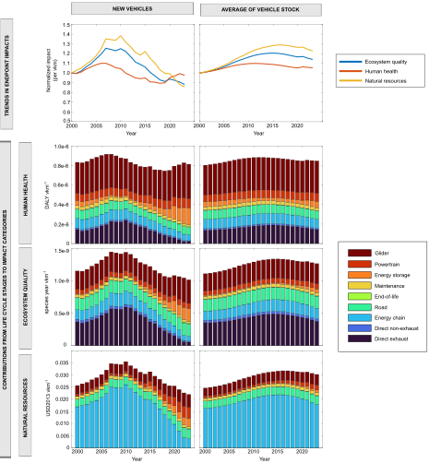

Discussion

References
1. Jaramillo, P. S. et al. Transport. In IPCC, 2022: Climate Change 2022: Mitigation of Climate Change. Contribution of Working Group III to the Sixth Assessment Report of the Intergovernmental Panel on Climate Change. https://doi.org/10.1017/9781009157926.012 (2022).
2. Rogelj, J. et al. Scenarios towards limiting global mean temperature increase below 1.5 °C. Nature Climate Change 8, 325–332 (2018).
3. Sacchi, R., Bauer, C., Cox, B. & Mutel, C. When, where and how can the electrification of passenger cars reduce greenhouse gas emissions? Renewable and Sustainable Energy Reviews 162, 112475 (2022).
4. Rousseau, L. S. A. et al. Norway’s electric vehicle revolution: unveiling greenhouse gas emissions reductions and material use of passenger cars across space and time. Environ. Res. Lett. 20, 084053 (2025).
5. Norsk elbilforening. Juli ga elbilrekord - høyeste elbilandel noensinne | Norsk elbilforening. https://kommunikasjon.ntb.no/pressemelding/18606692/juli-ga-elbilrekord-hoyeste-elbilandel-noensinne?publisherId=15519297&lang=no.
6. Motavelli, J. Norway Is Electric Car Heaven. Car Talk https://www.cartalk.com/content/norway-electric-car-heaven (2013).
7. Wood, R., Stadler, K., Rasul, K. & Hertwich, E. CaFEAN: Carbon Footprint of the Economic Activity of Norway. https://www.miljodirektoratet.no/publikasjoner/2024/januar-2024/cafean-carbon-footprint-of-the-economic-activity-of-norway/ (2023).
8. Horton, D. E. et al. Effect of adoption of electric vehicles on public health and air pollution in China: a modelling study. The Lancet Planetary Health 5, S8 (2021).
9. Garcia, E., Johnston, J., McConnell, R., Palinkas, L. & Eckel, S. P. California’s early transition to electric vehicles: Observed health and air quality co-benefits. Science of The Total Environment 867, 161761 (2023).

