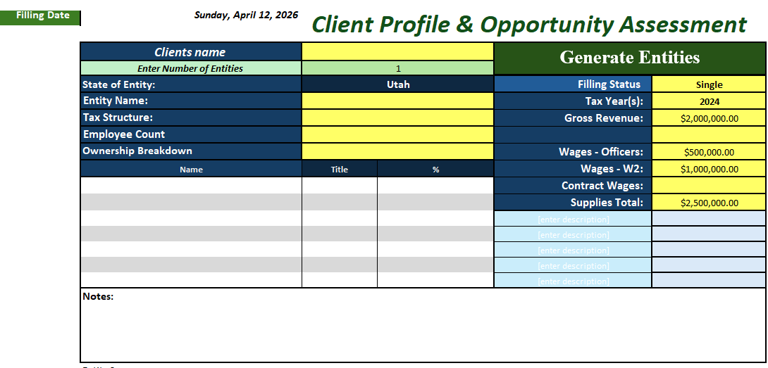

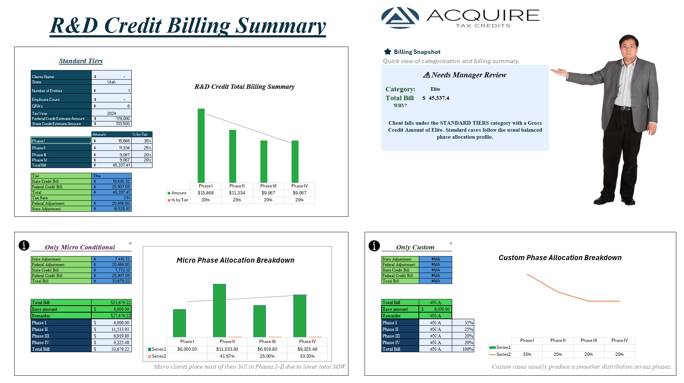

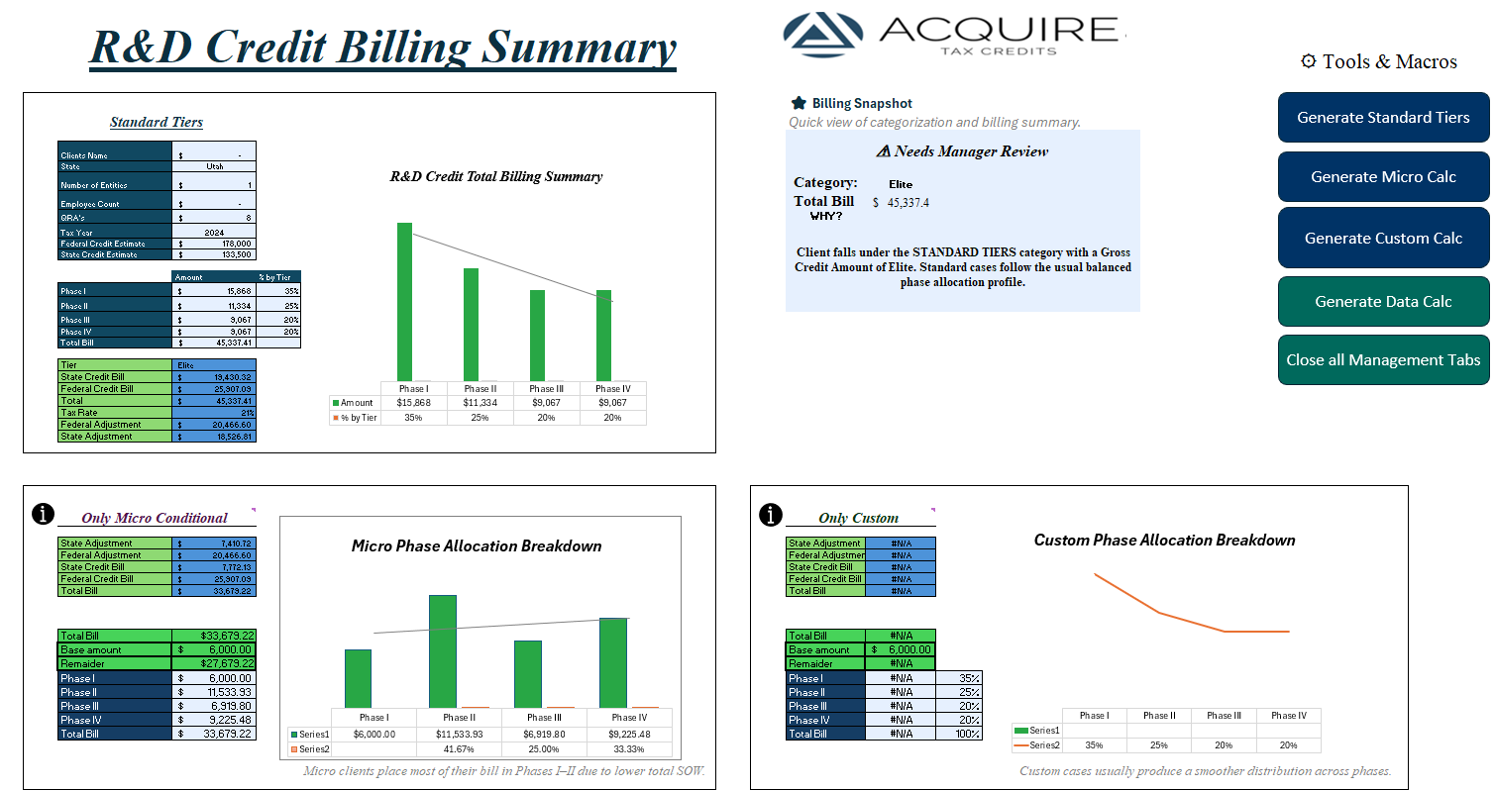

Client Name | ='Sales Tab'!C5
State of entity | ='Sales Tab'!C7
Number of Entities | ='Sales Tab'!C6
Employee Count | ='Sales Tab'!C10
Estimate QRA's | 8
Tax Year | ='Sales Tab'!F8
Gross Credit Amount | =C30
Utilization Cap % | =XLOOKUP(C11,calcu!$D$15:$D$23,calcu!$E$15:$E$23,0)
State Tax Rate | =XLOOKUP($C$11,calcu!$D$15:$D$23,calcu!$F$15:$F$23,0)
Credit Utilization Amount | =C16*C17
Tier Qualification | =IF(C16<6000, "Out of Range", LOOKUP(C16,Table714213[[Min]:[Max ]], Table714213[[Tier ]]))
Tax Rate | =IF('Sales Tab'!F7="Single",21%,IF('Sales Tab'!F7="Married Filling Jointly",35%,IF('Sales Tab'!F7="280 ©",21%,0)))
Fee Breakdown
Target Utilization % | =XLOOKUP($C$20,Table5612192[Tier],Table5612192[%])
2%: | =SUM(C58,F58,I58,L58,O58,R58,U58,X58,AA58,AD58,AG58,AJ58,AM58,AP58,AS58)
3%: | =SUM(C59,F59,I59,L59,O59,R59,U59,X59,AA59,AD59,AG59,AJ59,AM59,AP59,AS59)
50% Test: | =SUM(C60,F60,I60,L60,O60,R60,U60,X60,AA60,AD60,AG60,AJ60,AM60,AP60,AS60)
SOW Estimate: | =MEDIAN(C25:C27)
Weighted SOW | =0.7*C27+0.2*C26+0.1*C25
Adaptive SOW Weighted | =  'Sales Tab'!F11 + 'Sales Tab'!F12 > 0.1 * 'Sales Tab'!F9  C27*0.85 + C26*0.1 + C25*0.05  'Sales Tab'!F13 > 0.4 * ('Sales Tab'!F11 + 'Sales Tab'!F12 + 'Sales Tab'!F13)  C27*0.55 + C26*0.3 + C25*0.15
Adaptive SOW Weighted | =  'Sales Tab'!F12 + 'Sales Tab'!F13 > 0.1 * 'Sales Tab'!F10  C28*0.85 + C27*0.1 + C26*0.05  'Sales Tab'!F14 > 0.4 * ('Sales Tab'!F12 + 'Sales Tab'!F13 + 'Sales Tab'!F14)  C28*0.55 + C27*0.3 + C26*0.15
 |  | `
MANAGER REVIEW
Variance % | =ABS(C30-C27)/(C27)
Status | =IF(UPPER($C$40)="YES",  "Reviewed by Manager",  IF(ABS((C30-C27)/C27) > 0.1,  "⚠ Needs Manager Review",  "✓ OK"  )  )
Reviewed? | No
Date Reviewed | =IF(C40="Yes",NOW(),"")
Hour Review | =IF(C40="Yes", TEXT(NOW(),"hh:mm AM/PM"), "")
Close this calculator? | Yes
Phase BreakDown
Phase I | =IF($F$11<=6000,6000,  6000 + ($F$11-6000) *  IFERROR(  INDEX(calcu!$K$38:$K$47, MATCH(TRIM($C$20), calcu!$J$38:$J$47, 0)),  0  )  ) | =XLOOKUP($C$20,Table613204[[#All],[Column1]],Table613204[[#All],[Phase I]])
Phase II | =IF($F$11<=6000,0,  ($F$11-6000) *  IFERROR(  INDEX(calcu!$L$38:$L$47, MATCH(TRIM($C$20), calcu!$J$38:$J$47, 0)),  0  )  ) | =XLOOKUP($C$20,Table613204[[#All],[Column1]],Table613204[[#All],[Phase II]])
Phase III | =IF($F$11<=6000,0,  ($F$11-6000) *  IFERROR(  INDEX(calcu!$M$38:$M$47, MATCH(TRIM($C$20), calcu!$J$38:$J$47, 0)),  0  )  ) | =XLOOKUP($C$20,Table613204[[#All],[Column1]],Table613204[[#All],[Phase III]])
Phase IV | =IF($F$11<=6000,0,  ($F$11-6000) *  IFERROR(  INDEX(calcu!$N$38:$N$47, MATCH(TRIM($C$20), calcu!$J$38:$J$47, 0)),  0  )  ) | =XLOOKUP($C$20,Table613204[[#All],[Column1]],Table613204[[#All],[Phase IV]])
Total Bill | =SUM(C47:C50)

Federal Final Bill
Federal Adjustment |  | =F32*(1-C21)
Final Bill |  | =C16*C23
Final % of Credit |  | =F11/C16
Explanation |  | =IF(L14>0,"Added "&ROUNDUP(L14/$F$17,0)&" hrs","Removed "&ROUNDUP(ABS(L14)/$F$17,0)&" hrs")
Result Message |  | =IF(F12>=C23,"✅ Within Target Range","⚠️BelowTargetRange")
Core Rate Logic
Hourly Rate |  | =XLOOKUP(C20,calcu!$D$39:$D$47,calcu!$H$39:$H$47)
Effective Hourly Rate |  | =F17*(1-$C$21)+0.25
Billable Hours |  | =F11/F18
Hours Distribution
Entity Hours |  | =$F$19*0.45
Employee Hours |  | =$F$19*0.3
QRA's Hours |  | =$F$19*0.25
Fee Calculations
Entity Fee |  | =F24*F18
Employee Fee |  | =F25*F18
QRA's Fee |  | =F26*F18
Total Fee Amounts |  | =SUM(F29:F31)
State Final Bill
Federal Adjustment | =I32*(1-C18)
Final Bill | =C19*C23
Final % of Credit | =I11/C19
Explanation | =IF(O14>0,"Added "&ROUNDUP(O14/$F$17,0)&" hrs","Removed "&ROUNDUP(ABS(O14)/$F$17,0)&" hrs")
Result Message | =IF(I12>=F22,"✅ Within Target Range","⚠️BelowTargetRange")
Core Rate Logic
Hourly Rate | =XLOOKUP(C20,calcu!$D$39:$D$47,calcu!$H$39:$H$47)
Effective Hourly Rate | =I17*(1-$C$21)+0.25
Billable Hours | =I11/I18
Hours Distribution
Entity Hours | =I19*0.45
Employee Hours | =I19*0.3
QRA's Hours | =I19*0.25
Fee Calculations
Entity Fee | =I24*I18
Employee Fee | =I25*I18
QRA's Fee | =I26*I18
Total Fee Amounts | =SUM(I29:I31)

Entity 1 | 2%: | ='Sales Tab'!F9*0.02 | Enty2 | 2%: | ='Sales Tab'!F28*0.02 | Enty3 | 2%: | ='Sales Tab'!F47*0.02 | Enty4 | 2%: | ='Sales Tab'!F66*0.02 | Enty5 | 2%: | ='Sales Tab'!F85*0.02 | Enty6 | 2%: | ='Sales Tab'!F104*0.02 | Enty7 | 2%: | ='Sales Tab'!F123*0.02 | Enty8 | 2%: | ='Sales Tab'!F142*0.02 | Enty9
 | 3%: | ='Sales Tab'!F9*0.03 |  | 3%: | ='Sales Tab'!F28*0.03 |  | 3%: | ='Sales Tab'!F47*0.03 |  | 3%: | ='Sales Tab'!F66*0.03 |  | 3%: | ='Sales Tab'!F85*0.03 |  | 3%: | ='Sales Tab'!F104*0.03 |  | 3%: | ='Sales Tab'!F123*0.03 |  | 3%: | ='Sales Tab'!F142*0.03
 | 50% Test: | =((('Sales Tab'!F11+'Sales Tab'!F12+'Sales Tab'!F14)*0.5+('Sales Tab'!F13*0.64))*0.1) |  | 50% Test: | =((('Sales Tab'!F30+'Sales Tab'!F31+'Sales Tab'!F33)*0.5+('Sales Tab'!F32*0.64))*0.1) |  | 50% Test: | =IF(I59=0,0,  ((('Sales Tab'!F49+'Sales Tab'!F50+'Sales Tab'!F51)*0.5+('Sales Tab'!F51*0.64))*0.1)  ) |  | 50% Test: | =IF(L59=0,0,  ((('Sales Tab'!F68+'Sales Tab'!F69+'Sales Tab'!F70)*0.5+('Sales Tab'!F70*0.64))*0.1)  ) |  | 50% Test: | =IF(O59=0,0,  ((('Sales Tab'!F87+'Sales Tab'!F88+'Sales Tab'!F89)*0.5+('Sales Tab'!F89*0.64))*0.1)  ) |  | 50% Test: | =IF(R59=0,0,  ((('Sales Tab'!F106+'Sales Tab'!F107+'Sales Tab'!F108)*0.5+('Sales Tab'!F108*0.64))*0.1)) |  | 50% Test: | =IF(U59=0,0,  ((('Sales Tab'!F125+'Sales Tab'!F126+'Sales Tab'!F127)*0.5+('Sales Tab'!F127*0.64))*0.1)  ) |  | 50% Test: | =IF(X59=0,0,  ((('Sales Tab'!F144+'Sales Tab'!F145+'Sales Tab'!F146)*0.5+('Sales Tab'!F32*0.64))*0.1))
 | SOW Estimate: | =SUM(C58:C60)/3 |  | SOW Estimate: | =SUM(F58:F60)/3 |  | SOW Estimate: | =SUM(I58:I60)/3 |  | SOW Estimate: | =SUM(L58:L60)/3 |  | SOW Estimate: | =SUM(O58:O60)/3 |  | SOW Estimate: | =SUM(R58:R60)/3 |  | SOW Estimate: | =SUM(U58:U60)/3 |  | SOW Estimate: | =SUM(X58:X60)/3

Micros Billing Overview & Phase Allocation Summary
Client Info |  |  |  |  |  |  |  |  |  |  | State Final Bill |  |  |  |  |  |  |  |  |  |  |  |  |  | Federal Final Bill
Client Name | ='Sales Tab'!C5 |  |  |  |  |  |  |  |  |  | State Adjustment | =F35*(1-C18) |  |  |  |  |  |  |  |  |  |  |  |  | Federal Adjustment |  | =I35*(1-C21)
State of entity | ='Sales Tab'!C7 |  |  |  |  |  |  |  |  |  | Final Bill | =(C19*C24)*0.4 |  |  |  |  |  |  |  |  |  |  |  |  | Final Bill |  | =(C16*C24)
Number of Entities | ='Sales Tab'!C6 |  |  |  |  |  |  |  |  |  | Final % of Credit | =F11/C16 |  |  |  |  |  |  |  |  |  |  |  |  | Final % of Credit |  | =I11/C16
Employee Count | ='Sales Tab'!C10 |  |  |  |  |  |  |  |  |  | Explanation | =IF(C59>0,"Added "&ROUNDUP(C59/$C$27,0)&" hrs","Removed "&ROUNDUP(ABS(C59)/$C$27,0)&" hrs") |  |  |  |  |  |  |  |  |  |  |  |  | Explanation |  | =IF(I23>0,"Added "&ROUNDUP(I23/$C$27,0)&" hrs","Removed "&ROUNDUP(ABS(I23)/$C$27,0)&" hrs")
Estimate QRA's | 8 |  |  |  |  |  |  |  |  |  | Result Message | =IF(F12>=C24,"✅ Within Target Range","⚠️BelowTargetRange") |  |  |  |  |  |  |  |  |  |  |  |  | Result Message |  | =IF(I12>=F48,"✅ Within Target Range","⚠️BelowTargetRange")
Tax Year | ='Sales Tab'!F8
Gross Credit | =C52
Utilization Cap % | =XLOOKUP(C11,calcu!D15:D23,calcu!E15:E23,0) |  |  |  |  |  |  |  |  |  | Core Rate Logic |  |  |  |  |  |  |  |  |  |  |  |  |  | Core Rate Logic
State Tax Rate | =XLOOKUP($C$11,calcu!D15:D23,calcu!F15:F23,0)
Credit Utilization | =C17*C16
Tier Qualification | =IF(C16<6000, "Out of Range", LOOKUP(C16,Table714213[[Min]:[Max ]], Table714213[[Tier ]])) |  |  |  |  |  |  |  |  |  | Hourly Rate | =XLOOKUP(C20,calcu!$D$39:$D$47,calcu!$H$39:$H$47) |  |  |  |  |  |  |  |  |  |  |  |  | Hourly Rate |  | =XLOOKUP(C20,calcu!$D$39:$D$47,calcu!$H$39:$H$47)
Tax Rate | =IF('Sales Tab'!F7="Single",21%,IF('Sales Tab'!F7="Married Filling Jointly",35%,IF('Sales Tab'!F7="280(c)",21%,0%))) |  |  |  |  |  |  |  |  |  | Effective Hourly Rate | =F20*(1-$C$18)+0.25 |  |  |  |  |  |  |  |  |  |  |  |  | Effective Hourly Rate |  | =I20*(1-$C$21)+0.25
Fee Breakdown |  |  |  |  |  |  |  |  |  |  | Billable Hours | =F11/F21 |  |  |  |  |  |  |  |  |  |  |  |  | Billable Hours |  | =I11/I21
Micro Micro Credit | =LOOKUP(C16,calcu!N27:N33,calcu!M27:M33)
Target Utilization % | =IF($C$19<=25000,$C$23,XLOOKUP($C$20,Table5612192[Tier],Table5612192[%])) |  |  |  |  |  |  |  |  |  | Hours Distribution |  |  |  |  |  |  |  |  |  |  |  |  |  | Hours Distribution
Core Rate Logic |  |  |  |  |  |  |  |  |  |  | Entity Hours | =$F$22*0.45 |  |  |  |  |  |  |  |  |  |  |  |  | Entity Hours |  | =$I$22*0.45
Hourly Rate | =XLOOKUP(C20,calcu!$D$39:$D$47,calcu!$H$39:$H$47) |  |  |  |  |  |  |  |  |  | Employee Hours | =$F$22*0.3 |  |  |  |  |  |  |  |  |  |  |  |  | Employee Hours |  | =$I$22*0.3
Effective Hourly Rate | =C27*(1-$C$21)+0.25 |  |  |  |  |  |  |  |  |  | QRA's Hours | =$F$22*0.25 |  |  |  |  |  |  |  |  |  |  |  |  | QRA's Hours |  | =$I$22*0.25
Billable Hours | =I11/C28
 |  |  |  |  |  |  |  |  |  |  | Fee Calculations |  |  |  |  |  |  |  |  |  |  |  |  |  | Fee Calculations
Hours Distribution
 |  |  |  |  |  |  |  |  |  |  | Entity Fee | =F26*F21 |  |  |  |  |  |  |  |  |  |  |  |  | Entity Fee |  | =I26*I21
Entity Hours | =$C$29*0.45 |  |  |  |  |  |  |  |  |  | Employee Fee | =F27*F21 |  |  |  |  |  |  |  |  |  |  |  |  | Employee Fee |  | =I27*I21
Employee Hours | =$C$29*0.3 |  |  |  |  |  |  |  |  |  | QRA's Fee | =F28*F21 |  |  |  |  |  |  |  |  |  |  |  |  | QRA's Fee |  | =I28*I21
QRA's Hours | =$C$29*0.25 |  |  |  |  |  |  |  |  |  | Total Fee Amounts | =SUM(F32:F34) |  |  |  |  |  |  |  |  |  |  |  |  | Total Fee Amounts |  | =SUM(I32:I34)
Fee Calculations
Entity Fee | =C33*C28 |  |  |  |  |  |  |  |  |  | Phase BreakDown
Employee Fee | =C34*C28
QRA's Fee | =C35*C28 |  |  |  |  |  |  |  |  |  | Total Bill | =SUM(F11+I11)
Total Fee Amounts | =SUM(C39:C41) |  |  |  |  |  |  |  |  |  | Base amount | 6000
 |  |  |  |  |  |  |  |  |  |  | Remaider | =IF(F41-F42<0,0,F41-F42)
 |  |  |  |  |  |  |  |  |  |  | Phase I | =F42
 |  |  |  |  |  |  |  |  |  |  | Phase II | =IF(F43*G45<0, 0, F43*G45) |  |  |  |  |  |  |  |  |  |  |  | 0.4167
Core Info |  |  |  |  |  |  |  |  |  |  | Phase III | =IF(F43*G46<0, 0, F43*G46) |  |  |  |  |  |  |  |  |  |  |  | 0.25
 |  |  |  |  |  |  |  |  |  |  | Phase IV | =IF(F43*G47<0, 0, F43*G47) |  |  |  |  |  |  |  |  |  |  |  | 0.3333
2%: | ='Standard Calc'!C25 |  |  |  |  |  |  |  |  |  | Total Bill | =SUM(F44:F47)
3%: | ='Standard Calc'!C26
50% Test: | ='Standard Calc'!C27 |  |  |  |  |  |  |  |  |  | MANAGER REVIEW
SOW Estimate: | ='Standard Calc'!C28
Adapted SOW | ='Standard Calc'!C30
 |  |  |  |  |  |  |  |  |  |  | Variance % | =ABS(C52-C50)/(C50)
Custom Billing Overview & Phase Allocation Summary
Client Info |  |  |  |  |  |  | State Final Bill |  |  |  |  |  |  |  |  |  |  |  |  |  |  |  |  |  |  | Federal Final Bill
Client Name |  | ='Sales Tab'!C5 |  |  |  |  | State Adjustment | =F35*(1-C18) |  |  |  |  |  |  |  |  |  |  |  |  |  |  |  |  |  | Federal Adjustment |  | =I35*(1-C21)
State of entity |  | ='Sales Tab'!C7 |  |  |  |  | Final Bill | =(C19*C24)*0.4 |  |  |  |  |  |  |  |  |  |  |  |  |  |  |  |  |  | Final Bill |  | =(C16*C24)
Number of Entities |  | ='Sales Tab'!C6 |  |  |  |  | Final % of Credit | =F11/C16 |  |  |  |  |  |  |  |  |  |  |  |  |  |  |  |  |  | Final % of Credit |  | =I11/C16
Employee Count |  | ='Sales Tab'!C10 |  |  |  |  | Explanation | =IF(C59>0,"Added "&ROUNDUP(C59/$C$27,0)&" hrs","Removed "&ROUNDUP(ABS(C59)/$C$27,0)&" hrs") |  |  |  |  |  |  |  |  |  |  |  |  |  |  |  |  |  | Explanation |  | =IF(I23>0,"Added "&ROUNDUP(I23/$C$27,0)&" hrs","Removed "&ROUNDUP(ABS(I23)/$C$27,0)&" hrs")
Estimate QRA's |  | 8 |  |  |  |  | Result Message | =IF(F12>=C24,"✅ Within Target Range","⚠️BelowTargetRange") |  |  |  |  |  |  |  |  |  |  |  |  |  |  |  |  |  | Result Message |  | =IF(I12>=F52,"✅ Within Target Range","⚠️BelowTargetRange")
Tax Year |  | ='Sales Tab'!F8
Gross Credit |  | =C52
Utilization Cap % |  | =XLOOKUP(C11,calcu!D15:D23,calcu!E15:E23,0)
State Tax Rate |  | =XLOOKUP($C$11,calcu!D15:D23,calcu!F15:F23,0)
Credit Utilization |  | =C17*C16 |  |  |  |  | Core Rate Logic |  |  |  |  |  |  |  |  |  |  |  |  |  |  |  |  |  |  | Core Rate Logic
Tier Qualification |  | =IF(C16<6000, "Out of Range", LOOKUP(C16,Table714213[[Min]:[Max ]], Table714213[[Tier ]])) |  |  |  |  | Hourly Rate | =XLOOKUP(C20,calcu!$D$39:$D$47,calcu!$H$39:$H$47) |  |  |  |  |  |  |  |  |  |  |  |  |  |  |  |  |  | Hourly Rate |  | =XLOOKUP(C20,calcu!$D$39:$D$47,calcu!$H$39:$H$47)
Tax Rate |  | =IF('Sales Tab'!F7="Single",21%,IF('Sales Tab'!F7="Married Filling Jointly",35%,IF('Sales Tab'!F7="280(c)",21%,0%))) |  |  |  |  | Effective Hourly Rate | =F20*(1-$C$18)+0.25 |  |  |  |  |  |  |  |  |  |  |  |  |  |  |  |  |  | Effective Hourly Rate |  | =I20*(1-$C$21)+0.25
Fee Breakdown |  |  |  |  |  |  | Billable Hours | =F11/F21 |  |  |  |  |  |  |  |  |  |  |  |  |  |  |  |  |  | Billable Hours |  | =I11/I21
Micro Micro Credit |  | =LOOKUP(C16,calcu!J27:J35,calcu!I27:I35)
Target Utilization % |  | =IF($C$16>=500000,$C$23,XLOOKUP($C$20,calcu!H27:H35,calcu!I27:I35)) |  |  |  |  | Hours Distribution |  |  |  |  |  |  |  |  |  |  |  |  |  |  |  |  |  |  | Hours Distribution
Core Rate Logic |  |  |  |  |  |  | Entity Hours | =$F$22*0.45 |  |  |  |  |  |  |  |  |  |  |  |  |  |  |  |  |  | Entity Hours |  | =$I$22*0.45
Hourly Rate |  | =XLOOKUP(C20,calcu!$D$39:$D$47,calcu!$H$39:$H$47) |  |  |  |  | Employee Hours | =$F$22*0.3 |  |  |  |  |  |  |  |  |  |  |  |  |  |  |  |  |  | Employee Hours |  | =$I$22*0.3
Effective Hourly Rate |  | =C27*(1-$C$21)+0.25 |  |  |  |  | QRA's Hours | =$F$22*0.25 |  |  |  |  |  |  |  |  |  |  |  |  |  |  |  |  |  | QRA's Hours |  | =$I$22*0.25
Billable Hours |  | =I11/C28
 |  |  |  |  |  |  | Fee Calculations |  |  |  |  |  |  |  |  |  |  |  |  |  |  |  |  |  |  | Fee Calculations
Hours Distribution
 |  |  |  |  |  |  | Entity Fee | =F26*F21 |  |  |  |  |  |  |  |  |  |  |  |  |  |  |  |  |  | Entity Fee |  | =I26*I21
Entity Hours |  | =$C$29*0.45 |  |  |  |  | Employee Fee | =F27*F21 |  |  |  |  |  |  |  |  |  |  |  |  |  |  |  |  |  | Employee Fee |  | =I27*I21
Employee Hours |  | =$C$29*0.3 |  |  |  |  | QRA's Fee | =F28*F21 |  |  |  |  |  |  |  |  |  |  |  |  |  |  |  |  |  | QRA's Fee |  | =I28*I21
QRA's Hours |  | =$C$29*0.25 |  |  |  |  | Total Fee Amounts | =SUM(F32:F34) |  |  |  |  |  |  |  |  |  |  |  |  |  |  |  |  |  | Total Fee Amounts |  | =SUM(I32:I34)
Fee Calculations
Entity Fee |  | =C33*C28
Employee Fee |  | =C34*C28 |  |  |  |  | Phase BreakDown
QRA's Fee |  | =C35*C28
Total Fee Amounts |  | =SUM(C39:C41)
 |  |  |  |  |  |  | Co-join % | =F12+I12
 |  |  |  |  |  |  | Total Bill | =SUM(F11+I11)
Core Info |  |  |  |  |  |  | Base amount | 6000
 |  |  |  |  |  |  | Remaider | =IF(F45-F46<0,0,F45-F46)
2%: |  | ='Standard Calc'!C25 |  |  |  |  | Phase I | =F45*G48 |  |  |  |  | =XLOOKUP(C20,Table613204[[#All],[Column1]],Table613204[[#All],[Phase I]])
3%: |  | ='Standard Calc'!C26 |  |  |  |  | Phase II | =IF(F45*G49<0, 0, F45*G49) |  |  |  |  | =XLOOKUP($C$20,Table613204[[#All],[Column1]],Table613204[[#All],[Phase II]])
50% Test: |  | ='Standard Calc'!C27 |  |  |  |  | Phase III | =IF(F45*G50<0, 0, F45*G50) |  |  |  |  | =XLOOKUP($C$20,Table613204[[#All],[Column1]],Table613204[[#All],[Phase III]])
SOW Estimate: |  | ='Standard Calc'!C28 |  |  |  |  | Phase IV | =IF(F45*G51<0, 0, F45*G51) |  |  |  |  | =XLOOKUP($C$20,Table613204[[#All],[Column1]],Table613204[[#All],[Phase IV]])
Adapted SOW |  | ='Standard Calc'!C30 |  |  |  |  | Total Bill | =SUM(F48:F51) |  |  |  |  | =SUM(G48:G51)
Performance & Adjustment Metrics |  |  |  |  |  |  | MANAGER REVIEW
Effective Credit % |  | =F10/C16
Utilization Gap (%) |  | =C24-C57 |  |  |  |  | Variance % | =ABS(C52-C50)/(C50)
Variance Amount (S) |  | =C58*C16 |  |  |  |  | Status | =IF(UPPER($F$60)="YES",  "Reviewed by Manager",  IF(ABS((C52-C50)/C50) > 0.1,  "⚠ Needs Manager Review",  "✓ OK"  )  )
Hours Variance |  | =IFERROR((C29 - (F10 / C28)) / (F10 / C28), 0) |  |  |  |  | Reviewed? | No
Total Check |  | =IF(ABS(SUM(C39:C41)-C42)<0.01,"✓ Balanced","⚠ Review") |  |  |  |  | Date Reviewed | =IF(F60="Yes",NOW(),"")
Minimum Bill Validation |  | =IF(F11<6000,"⚠ Below Minimum Bill","✓ Compliant") |  |  |  |  | Hour Review | =IF(F60="Yes", TEXT(NOW(),"hh:mm AM/PM"), "")
 |  |  |  |  |  |  | Close this calculator? | Yes
Standard Tiers
Clients Name |  |  |  |  |  |  |  |  | ='Sales Tab'!C5
State |  |  |  |  |  |  |  |  | ='Sales Tab'!C7
Number of Entities |  |  |  |  |  |  |  |  | ='Standard Calc'!C12
Employee Count |  |  |  |  |  |  |  |  | ='Standard Calc'!C13
QRA's |  |  |  |  |  |  |  |  | ='Standard Calc'!C14
Tax Year |  |  |  |  |  |  |  |  | ='Sales Tab'!F8
Federal Credit Estimate Amount |  |  |  |  |  |  |  |  | ='Standard Calc'!C16
State Credit Estimate Amount |  |  |  |  |  |  |  |  | ='Standard Calc'!C19
 |  |  |  |  |  |  |  |  | Amount |  |  |  |  |  |  |  |  |  |  |  |  |  |  |  |  |  |  |  | % by Tier
Phase I |  |  |  |  |  |  |  |  | =IFERROR($D$25*E21,0) |  |  |  |  |  |  |  |  |  |  |  |  |  |  |  |  |  |  |  | ='Standard Calc'!D47
Phase II |  |  |  |  |  |  |  |  | =IFERROR($D$25*E22,0) |  |  |  |  |  |  |  |  |  |  |  |  |  |  |  |  |  |  |  | ='Standard Calc'!D48
Phase III |  |  |  |  |  |  |  |  | =IFERROR($D$25*E23,0) |  |  |  |  |  |  |  |  |  |  |  |  |  |  |  |  |  |  |  | ='Standard Calc'!D49
Phase IV |  |  |  |  |  |  |  |  | =IFERROR($D$25*E24,0) |  |  |  |  |  |  |  |  |  |  |  |  |  |  |  |  |  |  |  | ='Standard Calc'!D50
Total Bill |  |  |  |  |  |  |  |  | =SUM(D28,D29)
Tier |  |  |  |  |  |  |  |  | ='Standard Calc'!C20
State Credit Bill |  |  |  |  |  |  |  |  | =IF(  XLOOKUP($D$12, calcu!$A$27:$A$76, calcu!$B$27:$B$76, "No") = "Yes",  IFNA('Standard Calc'!$I$11, 0),  0  )
Federal Credit Bill |  |  |  |  |  |  |  |  | =IFERROR('Standard Calc'!F11,0)
Total |  |  |  |  |  |  |  |  | =SUM(D28:D29)
Tax Rate |  |  |  |  |  |  |  |  | ='Standard Calc'!C21
Federal Adjustment |  |  |  |  |  |  |  |  | =IFERROR('Standard Calc'!F10,0)
State Adjustment |  |  |  |  |  |  |  |  | ='Standard Calc'!I10
Only Micro Conditional
=O42 |  |  |  |  |  |  |  |  | ='Micro Calc'!F10
=O43 |  |  |  |  |  |  |  |  | ='Micro Calc'!I10
=O44 |  |  |  |  |  |  |  |  | ='Micro Calc'!F11
=O45 |  |  |  |  |  |  |  |  | ='Micro Calc'!I11
=O46 |  |  |  |  |  |  |  |  | ='Micro Calc'!F41
='Micro Calc'!E41 |  |  |  |  |  |  |  |  | ='Micro Calc'!F41
='Micro Calc'!E42 |  |  |  |  |  |  |  |  | ='Micro Calc'!F42
='Micro Calc'!E43 |  |  |  |  |  |  |  |  | ='Micro Calc'!F43
='Micro Calc'!E44 |  |  |  |  |  |  |  |  | ='Micro Calc'!F44
='Micro Calc'!E45 |  |  |  |  |  |  |  |  | ='Micro Calc'!F45
='Micro Calc'!E46 |  |  |  |  |  |  |  |  | ='Micro Calc'!F46
='Micro Calc'!E47 |  |  |  |  |  |  |  |  | ='Micro Calc'!F47
='Micro Calc'!E48 |  |  |  |  |  |  |  |  | ='Micro Calc'!F48


Only Custom
State Adjustment |  |  | ='Custom Calc'!F10
Federal Adjustment |  |  | ='Custom Calc'!I10
State Credit Bill |  |  | ='Custom Calc'!F11
Federal Credit Bill |  |  | ='Custom Calc'!I11
Total Bill |  |  | =SUM(P44:P45)
Total Bill |  |  | =IF(P46<0,0,P46)
Base amount |  |  | 6000
Remaider |  |  | =IF(P50-P51<0,0,P50-P51)
Phase I |  |  | =P50*Q53 |  | =XLOOKUP($D$27,Table613204[[#All],[Column1]],Table613204[[#All],[Phase I]])
Phase II |  |  | =IF(P50*Q54<0, 0, P50*Q54) |  | =XLOOKUP($D$27,Table613204[[#All],[Column1]],Table613204[[#All],[Phase II]])
Phase III |  |  | =IF(P50*Q55<0, 0, P50*Q55) |  | =XLOOKUP($D$27,Table613204[[#All],[Column1]],Table613204[[#All],[Phase III]])
Phase IV |  |  | =IF(P50*Q56<0, 0, P50*Q56) |  | =XLOOKUP($D$27,Table613204[[#All],[Column1]],Table613204[[#All],[Phase IV]])
Total Bill |  |  | =SUM(P53:P56) |  | =SUM(Q53:Q56)
=IFERROR('Standard Calc'!C39,0)
Category: |  |  |  | =IF(D17<25001,"Micro",  IF(D17>500000,"Custom",  D27))
Total Bill |  |  |  | =IF(P13="Micro",D50,  IF(P13="Custom",P50,D25))
WHY?
=P13="Micro"
"Client falls under the MICRO category because the Gross Credit Amount (" & TEXT(P13,"$#,##0") &
") is below the $25,001 threshold. Expect billing to be front-loaded in Phases I–II due to lower credit size."

