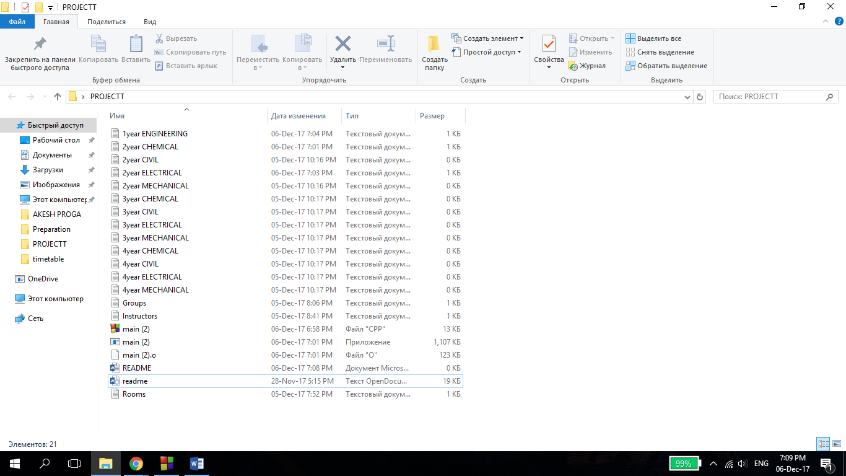**README**

**“SHARK” team**

1. Open the text file corresponding to your year of study and major.

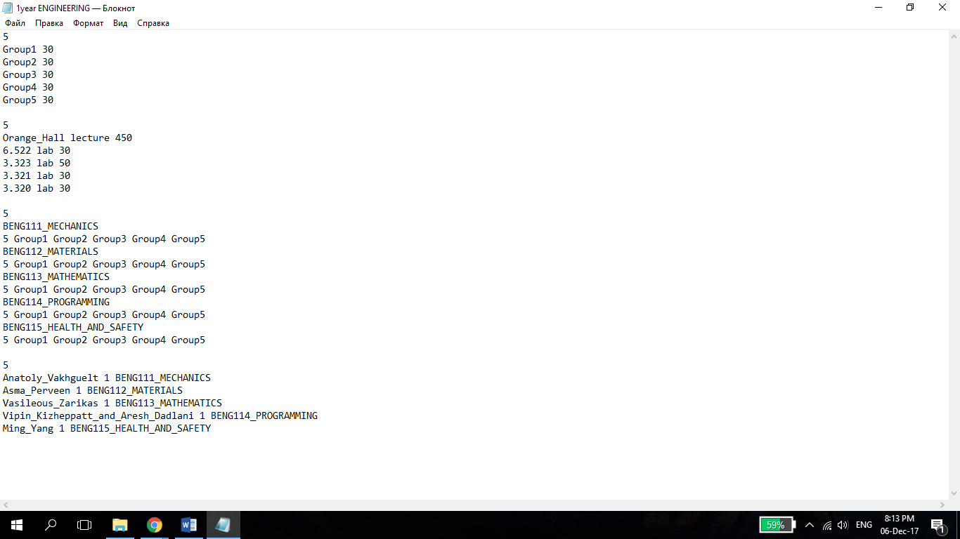2. Enter the number of groups.

3. Enter the name and capacity of groups.

4. Enter the number of rooms.

5. For each room, enter its name, type (lecture/lab) and capacity.

6. Enter the number of courses.

7. For each course, enter the name, number of groups taking it and names of the groups.

8. Enter the number of faculty members.

9. For each professor, enter the number of courses he/she can teach, and list of that courses.

**NOTE: Name of the groups, faculty members, courses and rooms should be entered without whitespace. In addition, room type can only be ‘lecture’ or ‘lab’. When using ‘lab’, we mean lab or tutorial. (Reason for doing it is to simplify the code)

10. Open the Timetable.CPP file and run it.

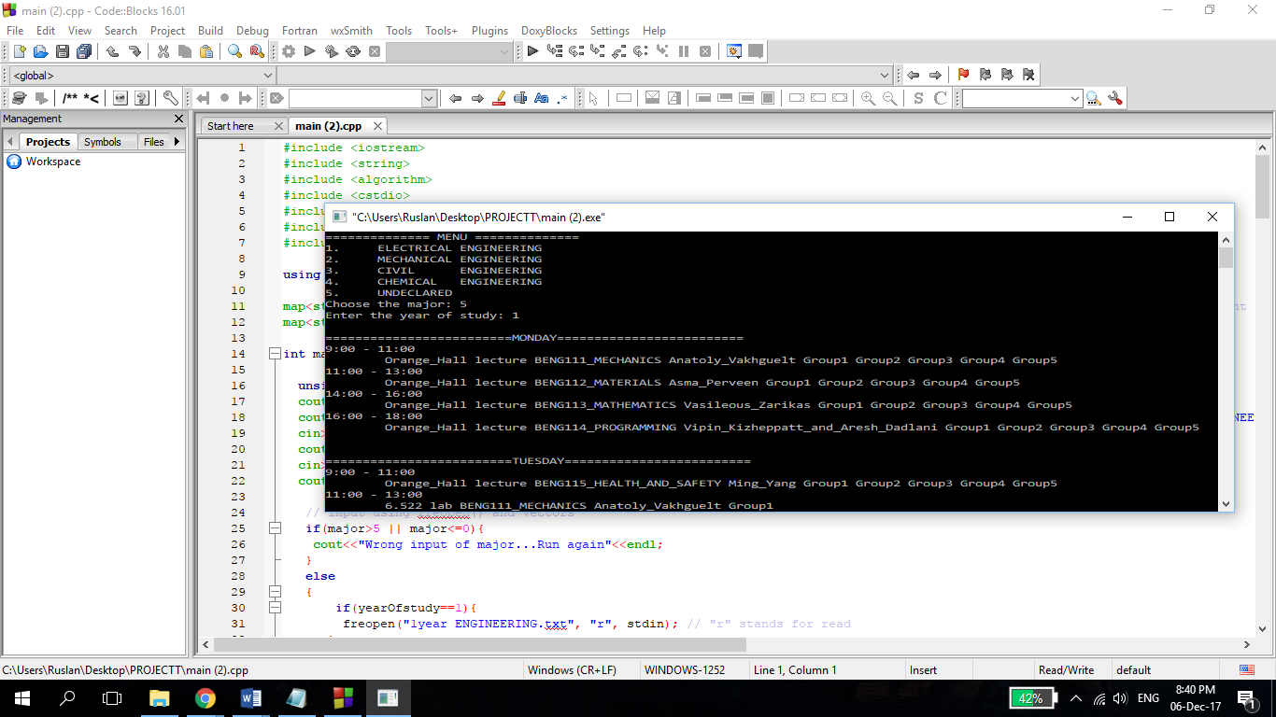  
11. Choose your major and year of study.

12. Get the timetable. ☺