INFORMATION VISUALIZATION ON WILDFIRE TRENDS

1. INTRODUCTION

This part of the project report concentrates on the various trends of wildfires between the year 1992, Jan and 2015, Dec. The work is done in pyspark and visualizations are built in fiona, for the dataset the sqlite dataset of 1.88 million wildfire is selected, which is a huge report from wildfire department of USA.

The dataset has the following features that are of importance to us,
“LATITUDE”: The longitude value of the origin of wildfire
“LONGITUDE”: The latitude value of origin of wildfire
“DISCOVERY_DOY”: discovery date of wildfire 1 for 1st January and so on.
“FIRE_SIZE”: Fire size in Acres
“FIRE_NAME”: The corresponding fire name alloted by department
“FIRE_YEAR”: The year of occurance of wildfire
“STAT_CAUSE_DESCR”: The cause of wildfire
“STATE”: The state where the fire took place

We will furthur discuss the trends of wildfire, including findings about the seasons of the wildfire, regeneration of forests, increase in the wildfires in the years, causes of wildfires, Avoidable wildfire analysis, mapping data to create maps and heatmaps

We will try to answer the following questions:

Q. What is the cycle of wildfires and why so much deviation in the seasons?

Q.What are the net causes of wildfires and how can we categorize them to tackle them safely?

Q.How does demographics and geography affect wildfires?

Q.What are ways to prevent the human caused wildfires, is there a way to predict when they happen?

Q.What are the seasonal trends of wildfires?

Q.How does law and order of a state affect the human related wildfires in that state?

2.AREA BURNED ANALYSIS
The area burned analysis was undertaken to find the amount of area that was burned every year and incidents plot incidents that took place each year
2.1AREA BURNED IN HECTARES EVERY YEAR
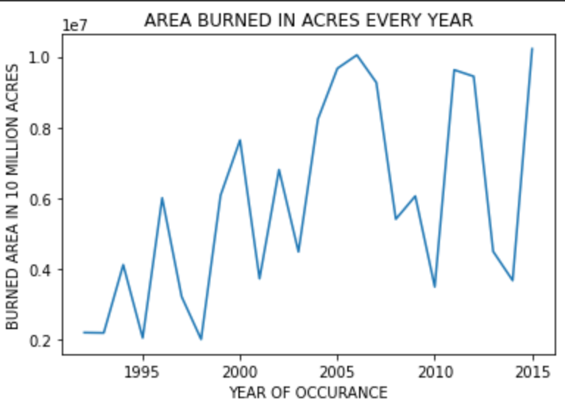
There was a constant increase in the amount of area burned in acres every year from 1992 to 2015 and this is expected to rise higher in the subsequent years.

2.1.1 FOREST RECOVERY MECHANICS

All wildfires have recovery phases where after a season of extreme explicit wildfire the next few years are followed by dormant wildfires due to the fact that new vegetatio has to grow to serve as a fuel.
The forest recovery phase which is denoted here by the downward slope has been reducing compared to the burning phase which is denoted by the upward slope, this difference in the slopes will in our case denote the extent of damage caused to forest between the two phases

2.2 FIRE COUNTS BY YEAR
As indicated by the figure below fire counts have been increasing rapidly which complements the above figure

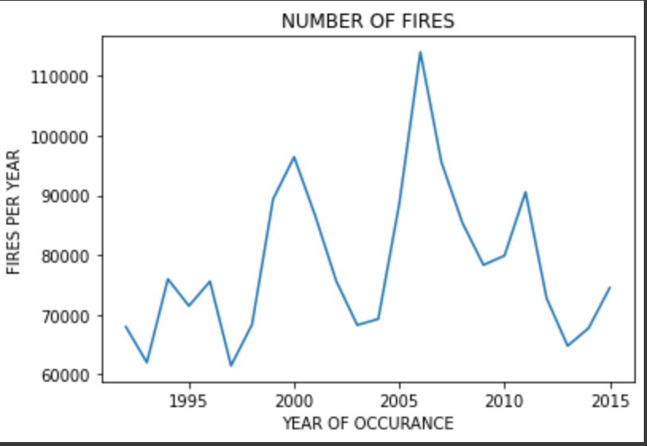

3.AREA BURNED IN ACRES PER CATEGORY

Wildfires can be divided into 2 seperate categories:
1. Human caused wildfires (preventable) e.G. Fireworks, railroads, powerline, smoking
2. Non human caused wildfires (non preventable) e.G. Lightning

While the cause of the natural wildfires may not be many but their impact makes up about 50% of total wildfires at almost 8 million acres of land burnt between 1992 and 2015 these are fires that cannot be prevented.

The major concern is about fires that can be prevented and they include the wildfires caused due to human intervention, a major factor being arson which is 100% preventable if awareness is spread.
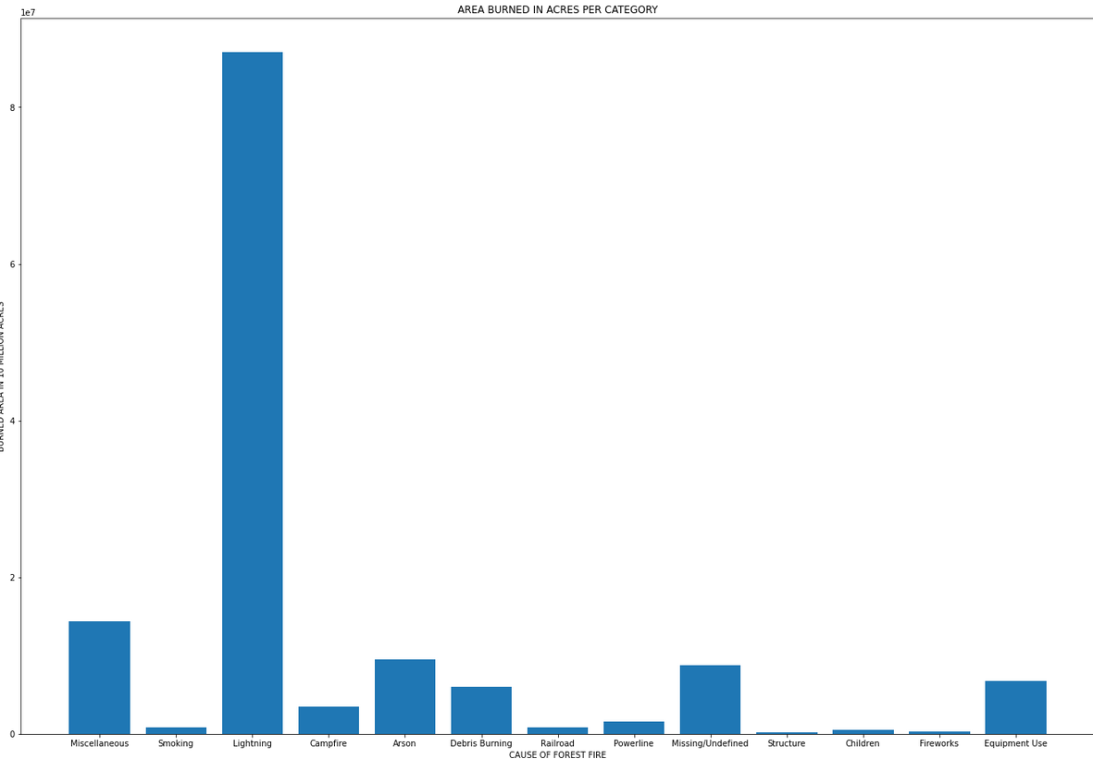

4. TRENDS IN WILDFIRE PER STATE

4.1 NUMBER OF FIRES REPORTED PER STATE

The trend of fires spread per state by count is simple and makes sense where most of warm and dry states like california, georgia, texas, north carolina and florida are top contributors to the number of fires that occured irrespective of size.

Another surprising factor is that most of the top 10 states come from the west coast of usa.

A surprising factor is that california has the same amount of fires as that of the bottom 20 in the list combined

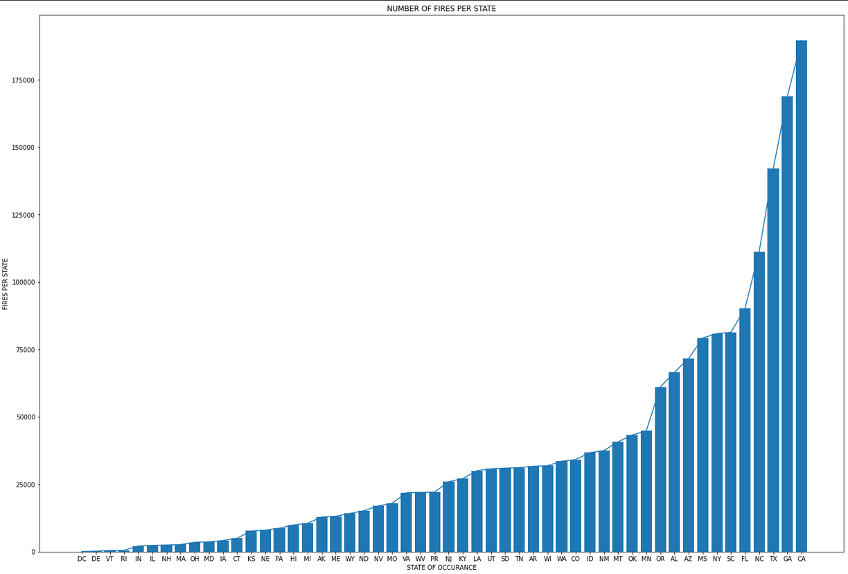

4.2 AREA BURNED IN HECTARES IN EVERY STATE

It is noticed that alaska, idaho, california, texas, nevada are the top 5 contributors of wildfires in usa

Same trend was observed where the west coast contributed to almost all the top 10 contibutors

There was a major surprise that was noticed as a matter of fact alaska with its dry but cold temperature was the largest contributor of wildfires and was able to contribute more area in hectares than that of the next two states (idaho, california) combined.

"From 1950 until 2009, he said, forest fires in alaska have released co2 equal to half of all carbon emissions from the european union."
-https://www.Dw.Com/en/forest-fires-in-alaska-a-ticking-climate-time-bomb/a-18684423
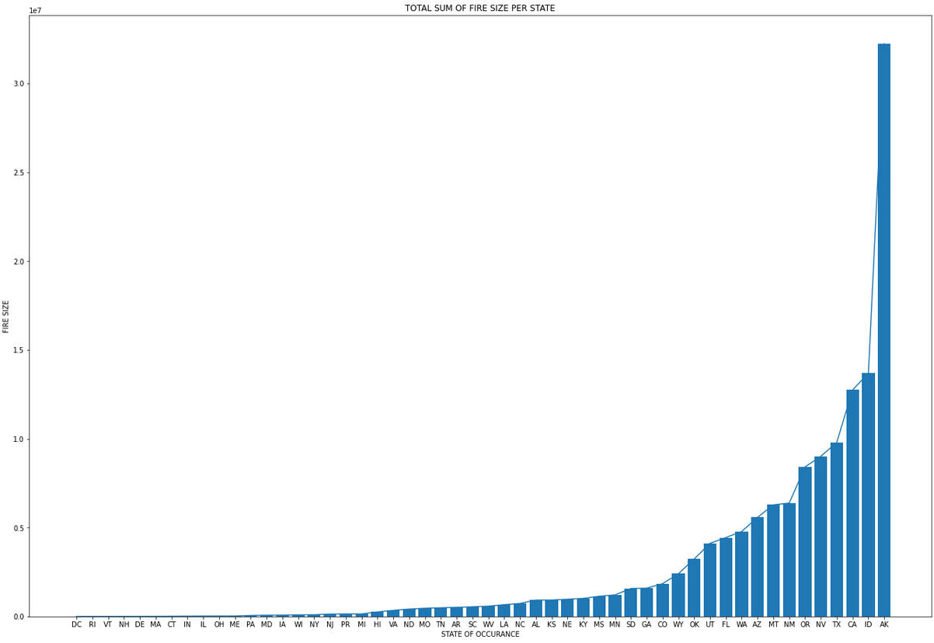

5. SEASONAL TRENDS OF WILDFIRES

5.1 SEASONAL TRENDS OF WILDFIRE BY AREA BURNED IN HECTARES
There is a strict corelation among all the years where the fire season starts from day 150 and lasts until day 250 with wildfires raging at extreme extents. These date to the start of june to mid september

Another observation was made that there was a out of context increse in wildfires in october end(haloween) and january start(new year) and on march mid(texas independance day) and april start (summerfest) corelation between these events and wildfires is studied in detail in following sections.

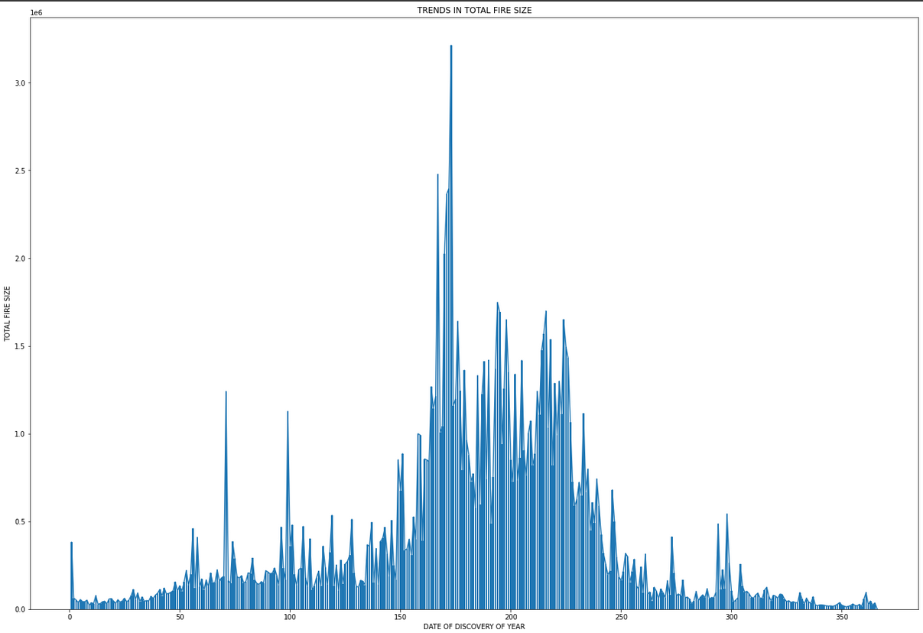
5.2 SEASONAL TRENDS OF WILDFIRE BY NUMBER OF INCIDENTS
Follows the same distribution and confirms to the theory of fireowrk corelation much more robustly

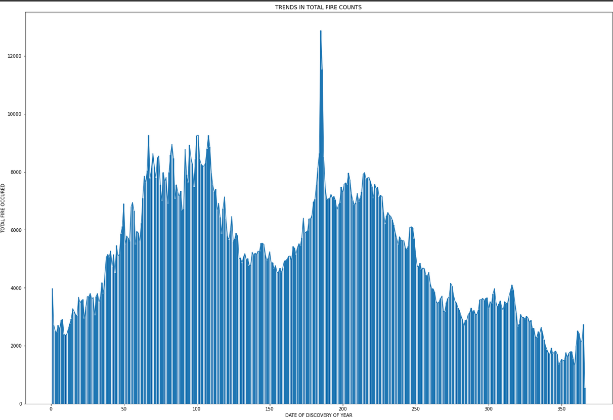

6. TRENDS IN AVOIDABLE WILDFIRES

6.1. TRENDS IN FIREWORK RELATED WILDFIRES BY SIZE IN ACRES

It is clearly visible that inference from the fildfire spread by area burned in hextares is completely true about the firework corelation. It was also noticed that at the start of july there were a lot of wildfires caused due to fireworks, there is a clear corelation with 4th of july and firework incidents as there is a huge peak at that point.

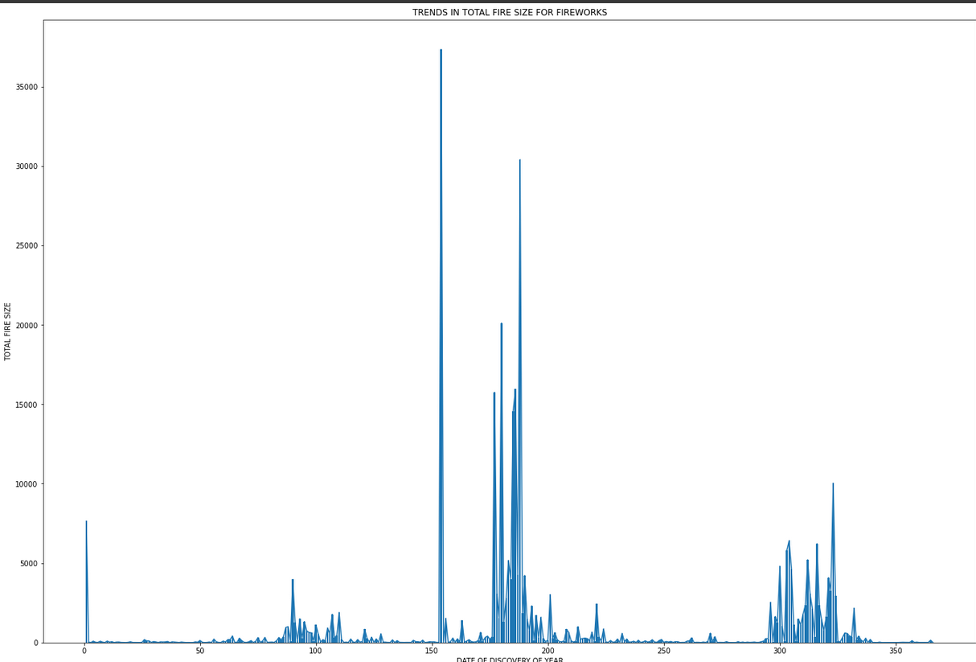

6.2 TRENDS IN COUNTD OF FIRECRAKER RELATED WILDFIRES

There was a clear corelation between fire spread and timespan of late june and mid july, this is the period where firecracker sale is permitted in several states.

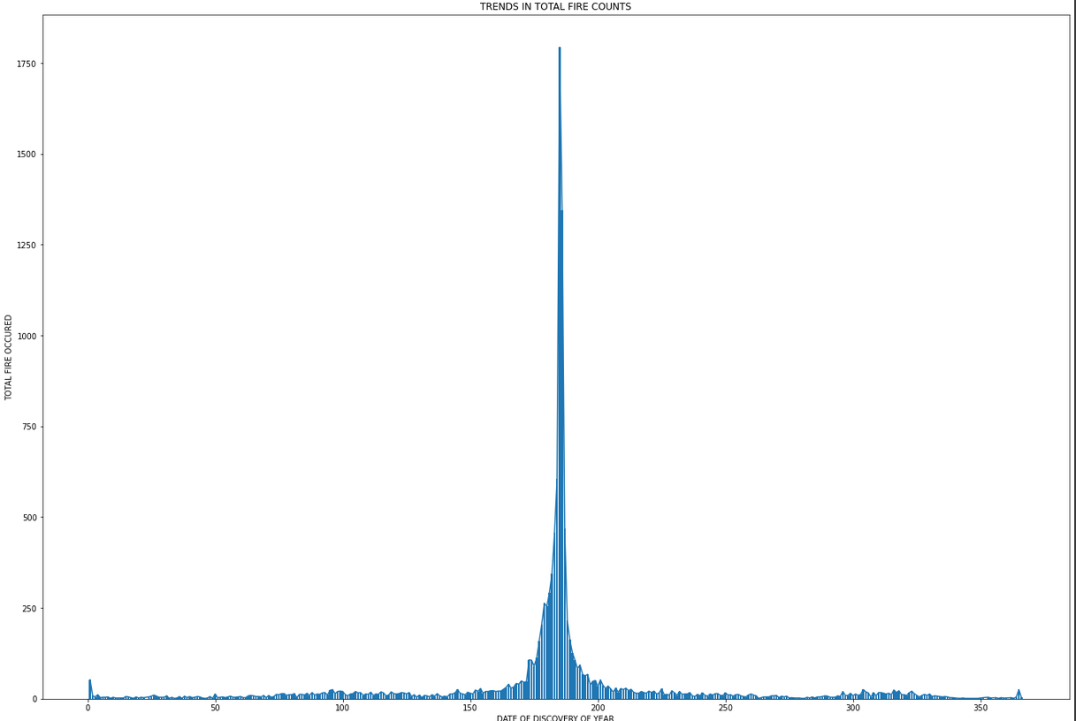

7. TRENDS IN LIGHTNING RELATED WILDFIRES

There is a clear corelation as to why there is an increse in the seasons discussed above. Lightning in the major cause of wildfires and the warm and dry climate serves as the correct starter for oceanic winds to fill up its place bringing rain and lightning, however in arid climates of west coast there is little to no rain, this is a hugely unavoidable problem for the wildfire department.

As is apparant the summer months of july and september are the most potent months with dry and arid weather affecting the sky such that a low pressure environment is established but at the same time that low pressure environment causes clouds to accumulate and these rain bearing clouds if they do not burst into rain may cause dry and potent lightning which leads to random unpredictable fires as it is a part of the natural phenomenon

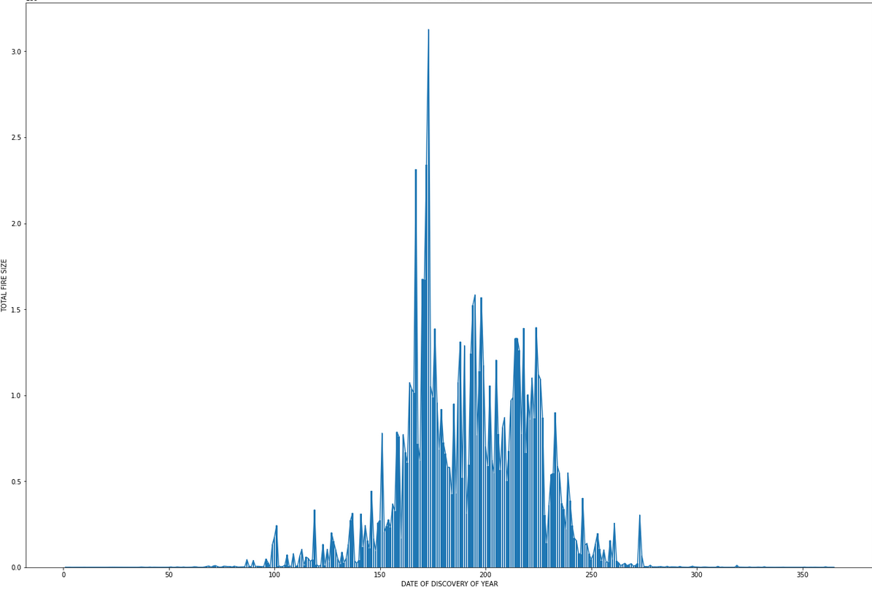

8. FOLIUM MAP FOR DISPLAYING WILDFIRES LARGER THAN 1000 ACRES

The wildfires are categorized accordingly,
Class A: 1000 Acres to 10,000 Acres
Class B: 10,000 Acres to 50,000 Acres
Class C: More than 50,000 Acres

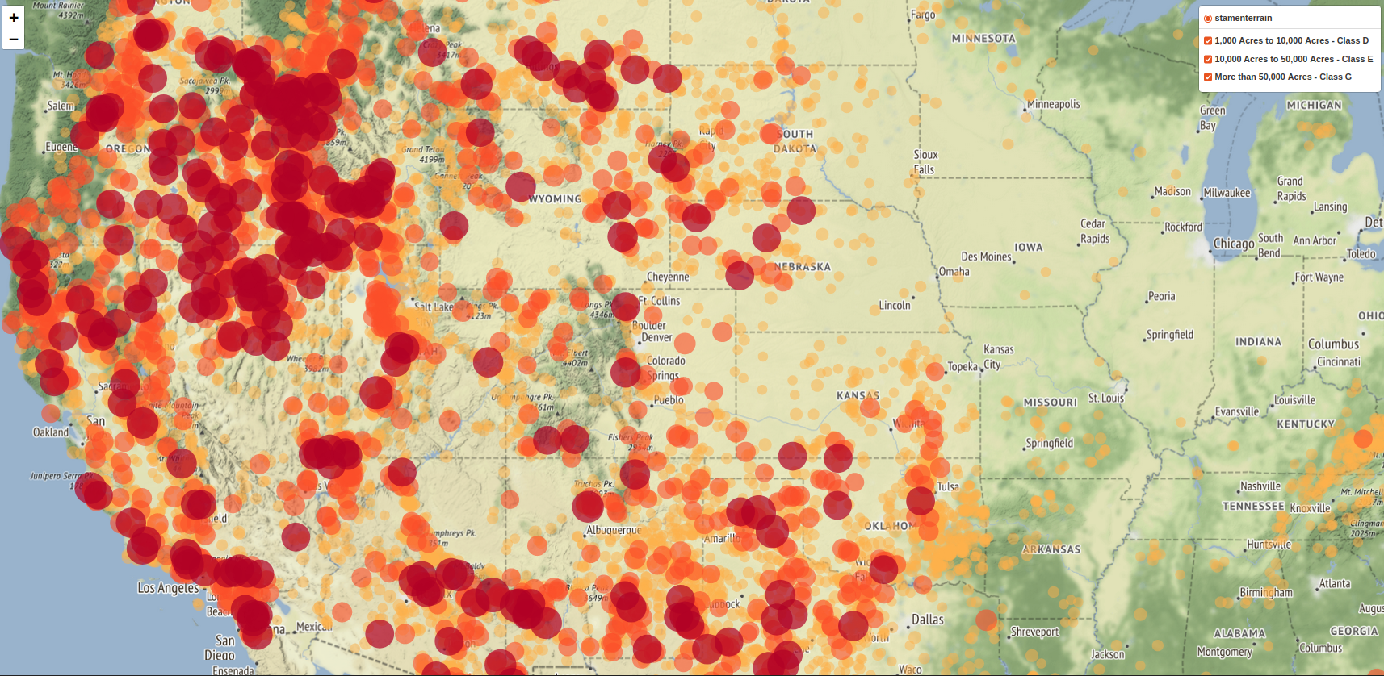

1.Apart from mapping we also make the important finding that most of the wildfires are based on West Coast Region of USA.
2.As we move Eastwards the internsity and occurance of wildfires reduces drastically
3.Florida is only eastern state to contribute as much to wildfires as the other western states
4.Alaska had very few wildfires but most of them were Class C wildfires, due to the bad weather, terrain and infrastructure wildfire control operation in Alaska are very difficult.
5.Hawaii has the highest coverage of wildfire with almost the entire state being burned at some point

9. HEATMAP WITH WILDFIRES OF SIZE 100 ACRES OR MORE

The wildfires were plotted with intensity affirming to heatmap, for proper results zoom into the google colab notebook heatmap.

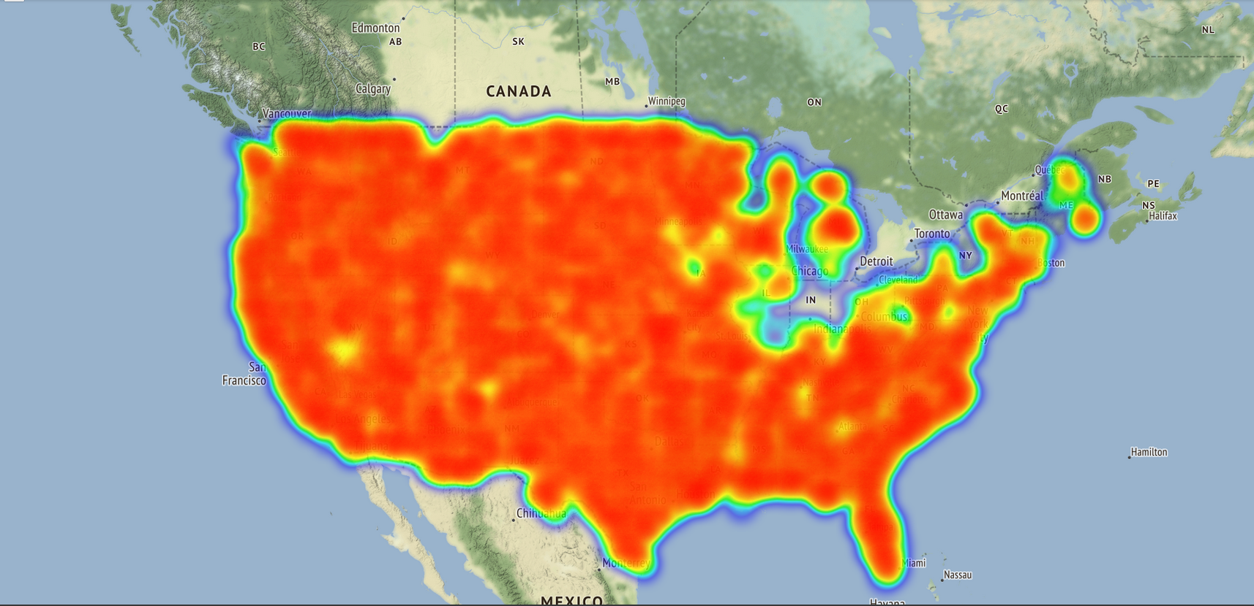

10. HEATMAP WITH WILDFIRES CAUSED DUE TO FIREWORKS

The heatmap of wildfires caused due to firework is as follows

It was noted from the heatmap that state with lax firework policy were having a lot of firework related wildfires.
States like Florida and California with their lax laws allowing purchase unrrestrictedly were reported more damage than states like Conneticut, New York, Illinois


