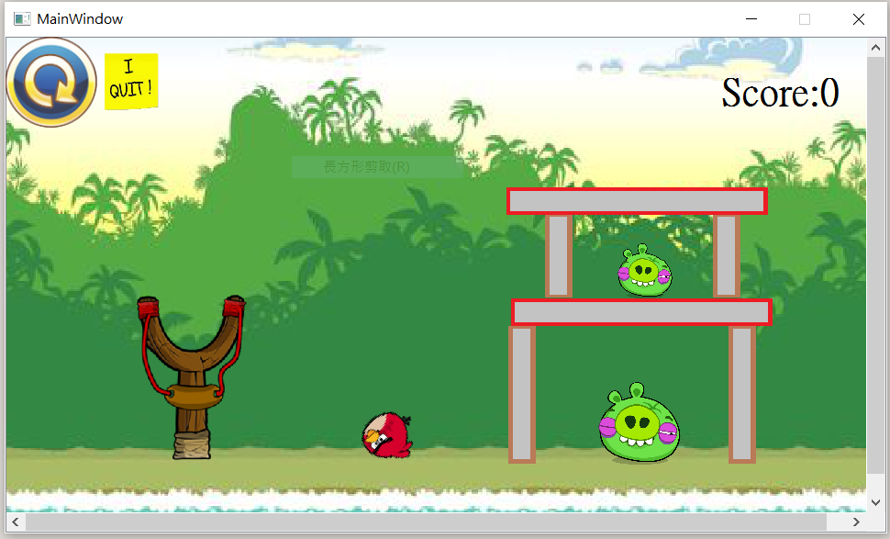

|  |
| --- |
| MainWindow |
| -scene: QgaphicsScene* -x,pressx,y,pressy,r:double  -world: b2world* -allbird[9]:Bird*  -timer: QTimer -bound[4]:Land*  -gamebk: QgaphicsScene* -allpig[2]:pig*  -gamearrow: QgaphicsScene* -win:bool  -wingame: QgaphicsScene* -whichbird:int  -restart:QPushButton -mlisten:mylisten  -quit:QPushButton |

|  |
| --- |
| +<<ecplict>>MainWindow(parent:QWight*=0):void  +~MainWindow()  +showEvent(QShowEvent*):void  +eventFilter(QObject*,event:QEvent):bool  +closeEvent(QCloseEvent*):void  -<<slots>> tick():void  -<<slot>>QUITSLOT():void  +basicgame():void  + freebasicgame():void |

|  |
| --- |
| GameItem |
| #g_body:b2Body*  #g_pixmap: QgaphicsScene*  #g_size:QSizeF  #g_world:b2World*  #g_worldsize:static QSizeF  #g_windowsize:static QSizeF |

|  |
| --- |
| +GameItem(world:b2World*)  +~GameItam()  +setGlobalSize(worldsize:QSizeF,windowsize:QSizeF):static void  +<<slots>>paint():void |

|  |
| --- |
| bird |
| +Bird(x:float,y:float,radius:float,timer:QTimer*,  Pixmap:QPixmap,world:b2World*,  scene:QGraphicScene*)  +setLinearVelocity(velocity:b2Vec2):void  +ability():virtual void |

|  |
| --- |
| yellowbird |
| +yellowbird(x:float,y:float,radius:float,timer:QTimer*,  Pixmap:QPixmap,world:b2World*,  scene:QGraphicScene*)  +ability():virtual void |

|  |
| --- |
| blackbird |
| +blackbird(x:float,y:float,radius:float,  timer:QTimer*,  Pixmap:QPixmap,world:b2World*,  scene:QGraphicScene*)  +ability():virtual void |

|  |
| --- |
| bluebird |
| +greenbird(x:float,y:float,radius:float,timer:QTimer*,  Pixmap:QPixmap,world:b2World*,  scene:QGraphicScene*)  +ability():virtual void |

|  |
| --- |
| land |
| +Land(x:float,y:float,w:float,h:float,  Pixmap:QPixmap,world:b2World*,  scene:QGraphicScene*) |

|  |
| --- |
| pig |
| +pig(x:float,y:float,radius:float,timer:QTimer*,  Pixmap:QPixmap,world:b2World*,  scene:QGraphicScene*)  +setLinearVelocity(velocity:b2Vec2):void  +ability():virtual void |

|  |
| --- |
| obstacle |
| +Obstacle(x:float,y:float,radius:float,  timer:QTimer*,  Pixmap:QPixmap,world:b2World*,  scene:QGraphicScene*)  +setLinearVelocity(velocity:b2Vec2):void  +ability():virtual void |

|  |
| --- |
| collision |
| + BeginContact(b2Contact*contact):void |

玩法: 滑鼠指到bird後按左鍵開始拉，放開就會飛出去，若是紅鳥則沒有技能，有技能的鳥在飛出去後再按一次左鍵使出技能。發射完一個後，按右鍵生成第二隻鳥，總共4隻。 打爆障礙物得20分，打爆豬得100分，得到200分以上則獲勝。