
Pansen Engineering × VMS
Visitor Management System — Administrator SOP
A quick, visual guide. Each red number on a screenshot matches a numbered step below it.
Version 2.2 · 2026-06-11 · Pansen Engineering India Pvt. Ltd.
Field | Value
Document | VMS Administrator SOP
Version | 2.2 (supersedes all earlier copies)
Date | 2026-06-11
Owner | IT / Operations
Audience | VMS administrators, site managers, security
Standards | ISO/IEC 82079-1 · ISO/IEC 27001 access control · India DPDP Act 2023
Site | pansen.vmsys.co

How to read this guide
Every task follows the same three-part pattern, so you always know where to look:
Part | What it is
① ② ③ on the picture | Red circles on the screenshot mark exactly where to click
The step table | The same ① ② ③ numbers, telling you what each one does
The blue note | One tip or warning worth knowing
Golden rule. Red circle ① on the picture = step ① in the table. Always match the numbers.

The visitor journey at a glance
VISITOR GUARD ADMIN
─────── ───── ─────
Register on phone ──▶ Scan QR at gate ──▶ Sees everything,
(photo + OTP) (check in / out) runs reports
│ │ │
▼ ▼ ▼
Gets QR instantly Full profile shows Live on-site count
(no approval wait) on every scan stays accurate
The pass lifecycle — five states, in order:
State | Meaning | Enter?
Issued | Registered; QR is live (happens automatically) | ✅
Checked In | Scanned in at the gate | inside
Checked Out | Scanned out (or auto-closed at day end) | next day (Worker)
Expired | Past its valid-until date | ❌
Cancelled | Withdrawn by an admin | ❌

1 · Sign in
Goal: get into the admin back office.
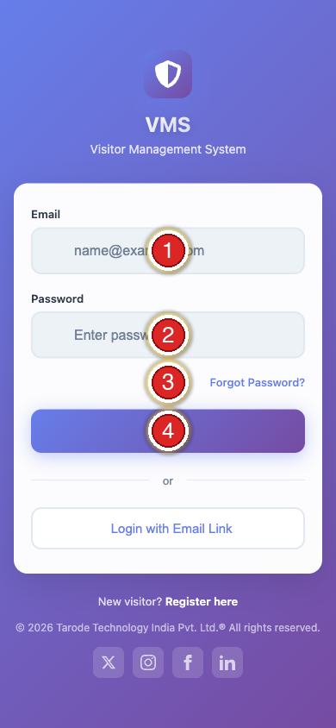
Step | Do this
① | Type your email
② | Type your password
③ | Forgot it? Click Forgot Password
④ | Click Login
Note. One login per person — never share accounts. Every action is traced to you.

2 · The dashboard
Goal: know where everything lives.
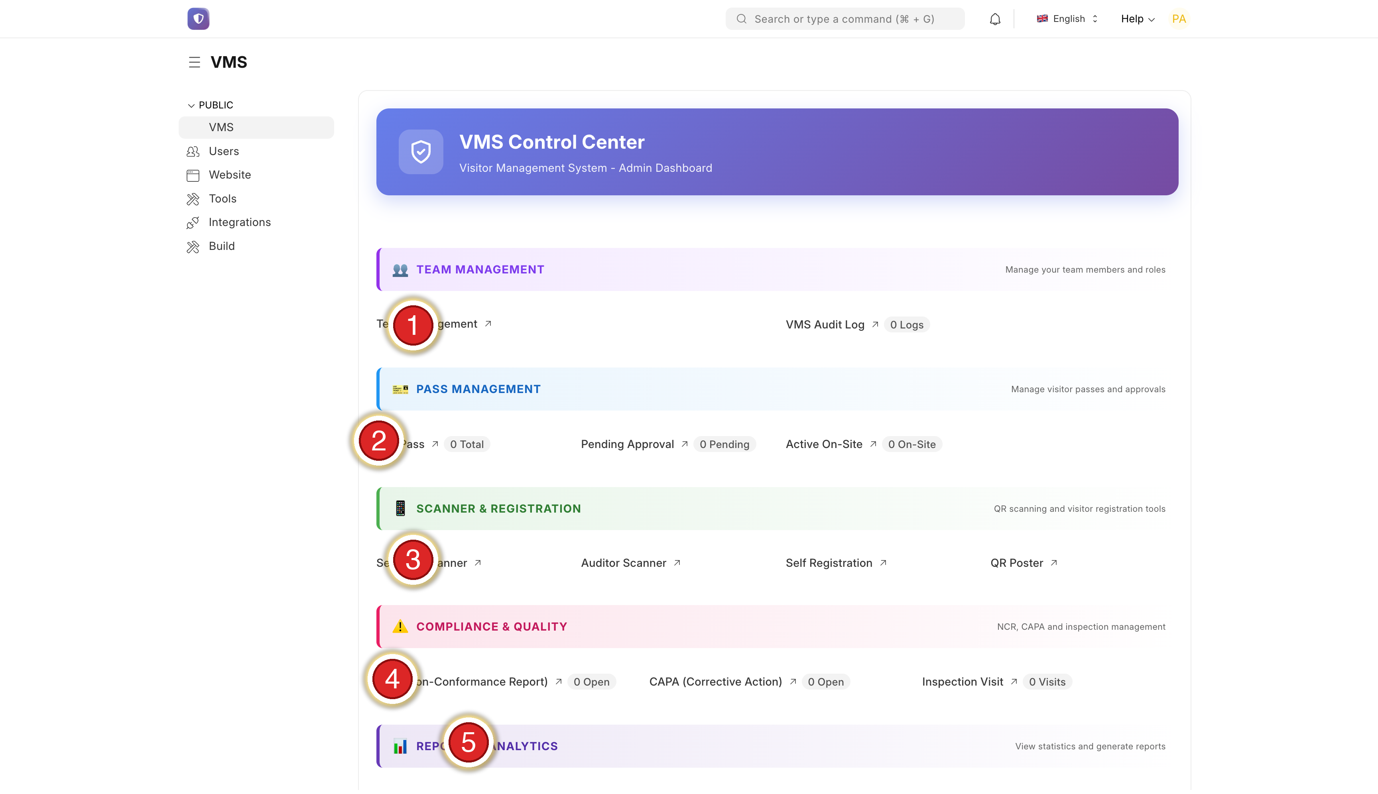
Step | Section | Use it for
① | Team Management | Add / remove staff
② | Pass Management | Create & find passes — daily
③ | Scanner & Registration | Gate scanner + sign-up link — daily
④ | Compliance (NCR) | Quality forms (if used)
⑤ | Reports & Analytics | Stats & exports
Check this first each morning: the On Site number at the top — it shows who is inside right now.

3 · Find a pass
Goal: locate any pass quickly.
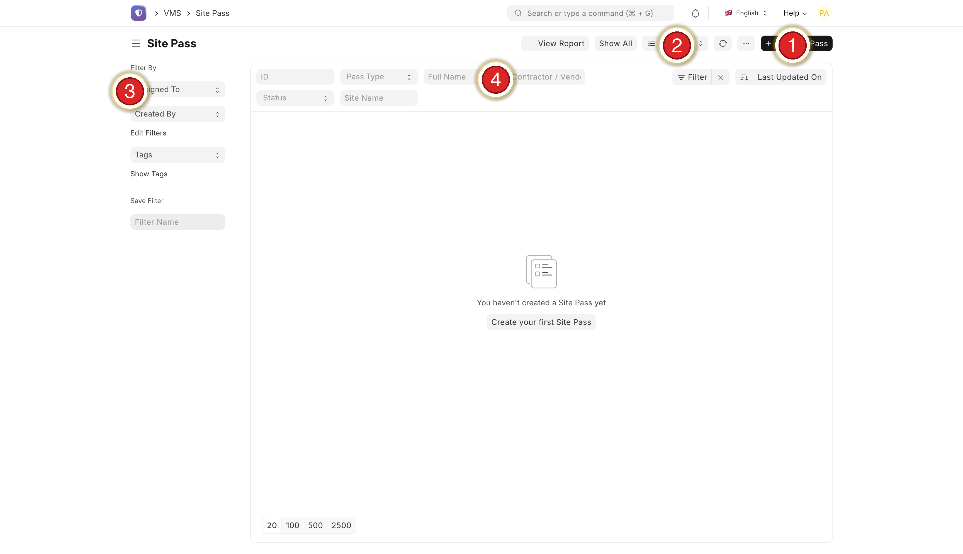
Step | Do this
① | + Add Site Pass — create one by hand (Section 4)
② | Batch Approve — legacy, rarely needed
③ | Left filters — Assigned To, Created By, Tags
④ | Top search — ID, Type, Name, Status, Site
Tip. Click any row to open the pass. Click View Report (top right) for charts.

4 · Create a pass manually
Goal: make a pass for someone who can’t self-register.
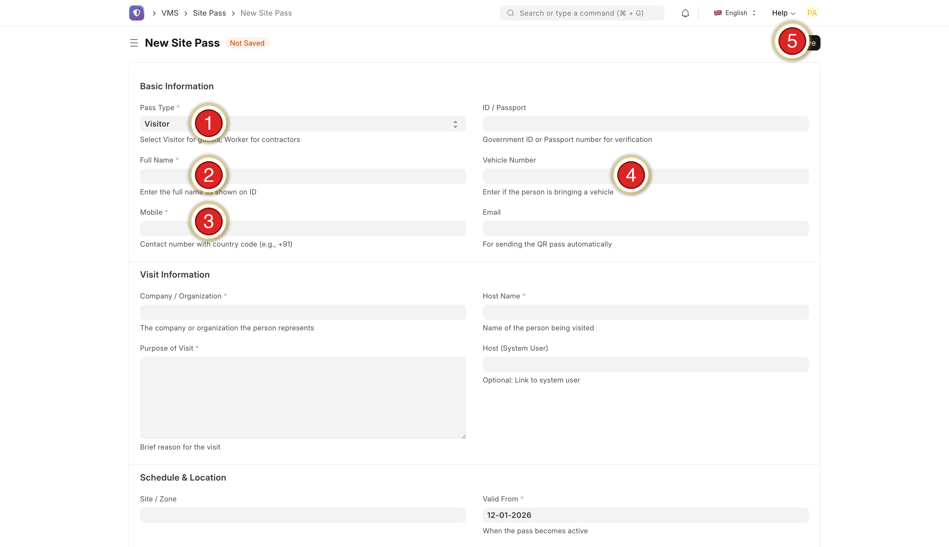
Step | Do this
① | Pass Type — Visitor / Worker / Vendor
② | Full Name — as printed on the ID
③ | Mobile — with country code (+91…)
④ | Email — for QR delivery
⑤ | Save (top right)
Important. A photo is required — the pass will not save without one. Dates must be today → 90 days ahead.

5 · Edit, extend or cancel
Goal: fix or change a pass after it is issued.
If… | Do this
Wrong email | Fix Email → Save → Resend QR
Wrong dates | Change Valid From / Until → Save (QR still works)
Wrong host | Change Host Name → Save
Extend a worker | Change Valid Until (≤ 90 days) → Save
Visit cancelled | Click Cancel at the top
Note. The mobile number can’t be changed after issue — cancel and create a new pass instead.

6 · Visitor self-registration
Goal: let visitors register themselves before they arrive.
Share pansen.vmsys.co/register — print it as a gate poster, email it, or send by WhatsApp.
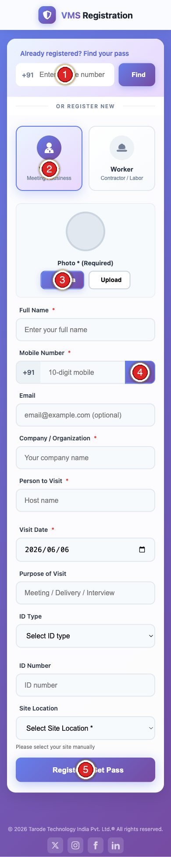
Step | The visitor does this on their phone
① | Returning? Type mobile + Find to reuse a past pass
② | Pick Visitor or Worker
③ | Add a photo — required (Camera or Upload)
④ | Type mobile → tap OTP → enter the SMS code
⑤ | Fill the form → tap Register & Get Pass
Important. No photo = no pass. The pass is issued instantly after they submit — no approval step, no admin action. It appears in your list as Issued.

Verify with Aadhaar + face check (recommended)
Goal: confirm the visitor’s identity from their Aadhaar — offline — and confirm the person registering is the cardholder.
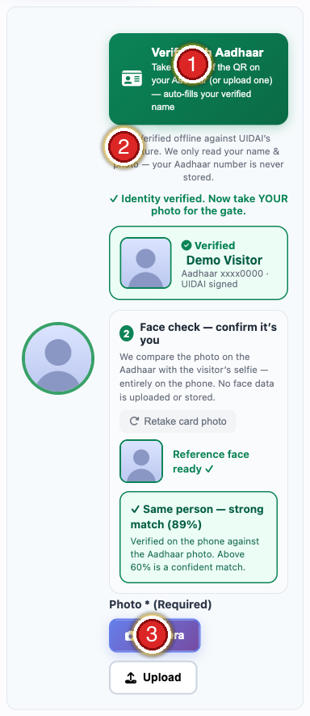
Step | On the registration screen
① | Verify with Aadhaar — tap to start
② | Privacy note — verified offline against UIDAI; the Aadhaar number is never stored
③ | Photo (Required) — the visitor’s live selfie for the gate
What happens, in order:
- Verify the card. Tap Verify with Aadhaar → take a photo of the Secure QR (back of the card), or tap Upload and pick a clear close-up. On success a green ✓ Verified card shows the name and last 4 digits, and the Full Name is filled and locked.
- Face check. A Face check panel then appears. Tap Photograph the FRONT of the Aadhaar (the photo side) → Reference face ready ✓. Then tap Camera below and take the visitor’s live selfie (front camera).
- Result. It shows instantly: ✓ Same person (xx%) in green, or ✗ Faces don’t match in red.
Reading the score. Two photos of the same person are rarely 100%. The threshold is 60% — anything above 60% is a confident match. A no-match is advisory (the visitor can retake the selfie; the guard verifies in person at the gate), not a hard block. The entire face check runs on the phone — no face data is uploaded or stored.
What it does | Detail
Verification | QR checked against UIDAI’s digital signature, fully offline
Auto-fill | Fills and locks the verified name from the card
Face match | Confirms the live selfie is the cardholder — on-device, score shown
Privacy | Only the name is read; the Aadhaar number and face data are never stored
Forgery | A fake or altered QR is rejected (“failed UIDAI verification”)
Turning it on as mandatory. By default Aadhaar verification is optional. To require it (no pass without a verified Aadhaar), your administrator enables it per site. Confirm scanning works on your gate devices first, so genuine visitors are never blocked.

7 · The gate scanner
Goal: check people in and out securely.
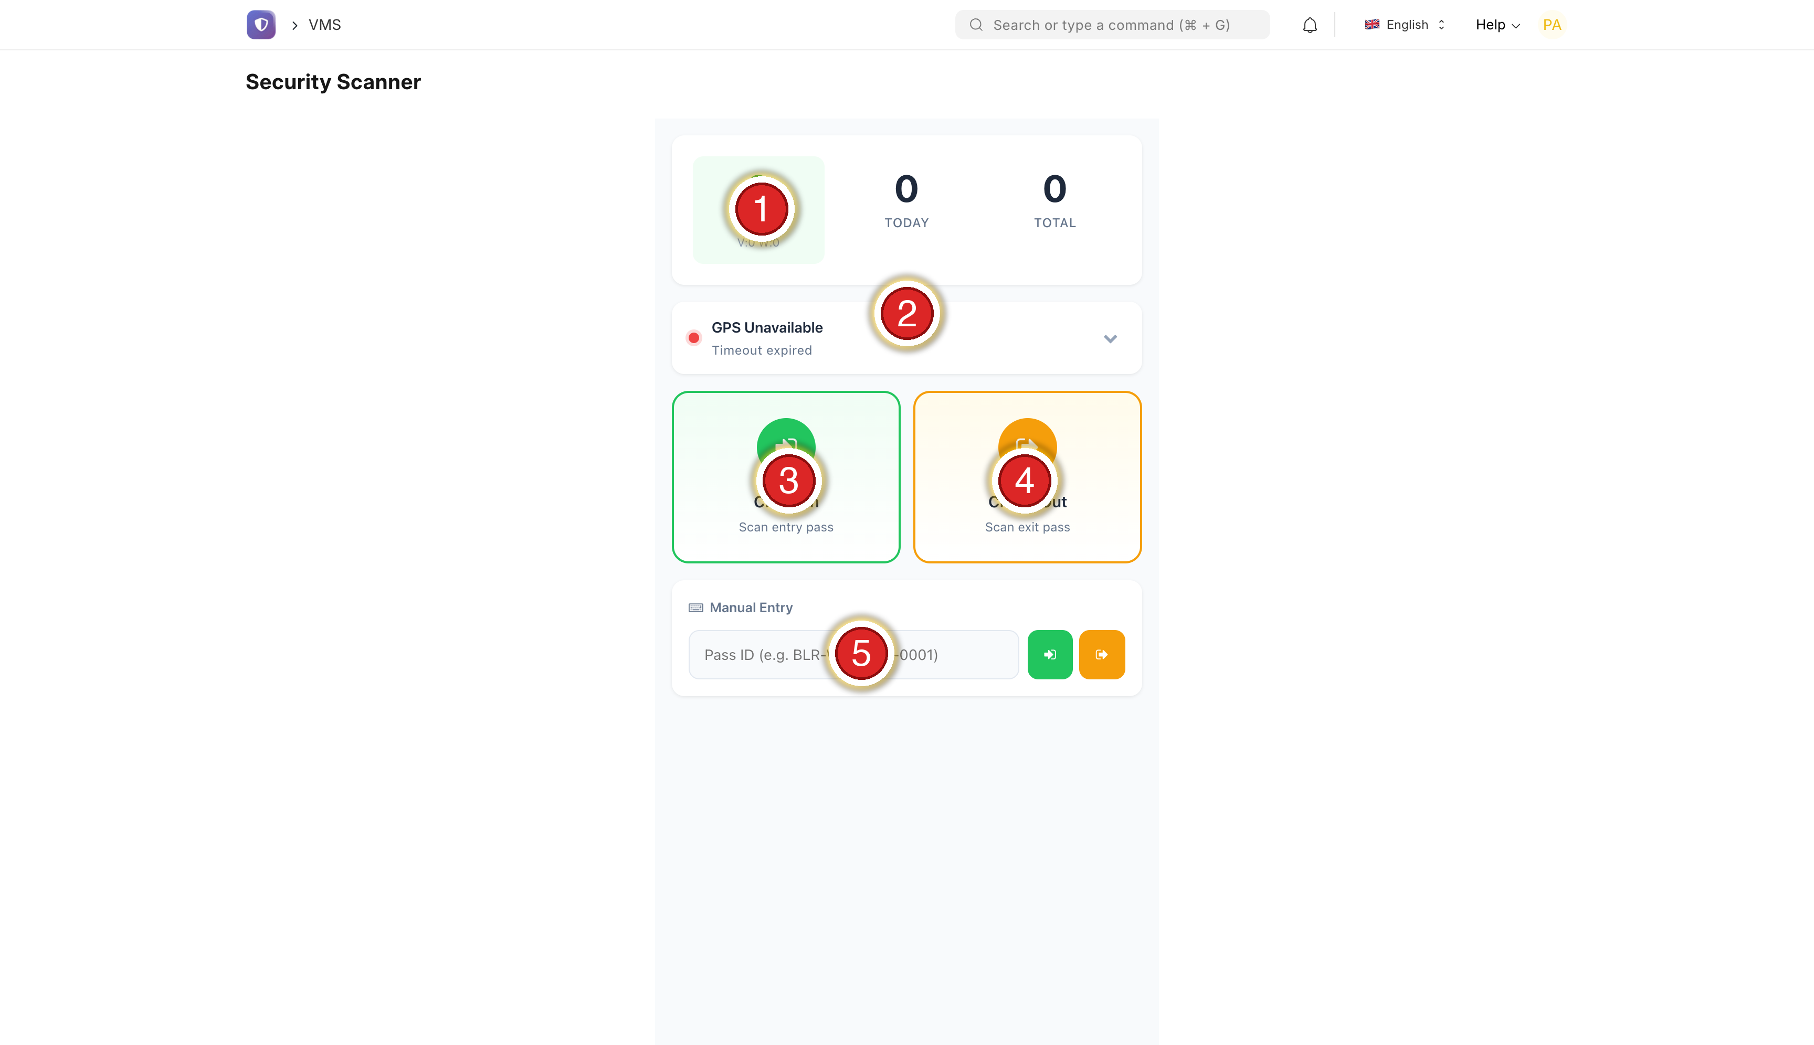
Step | Element
① | ON SITE live count (V = Visitors, W = Workers)
② | GPS status (green = located)
③ | Check In (green) — scan an arrival
④ | Check Out (orange) — scan a departure
⑤ | Manual Entry — type a Pass ID if no camera
Every scan shows the full profile — the guard sees exactly who they admit:
On screen | Photo · Name · Worker/Visitor badge · Company · Mobile · ID number · Validity · Work/Purpose · Vehicle · ID Verified / Not Verified
Scanner colours:
🟢 Green | 🟡 Yellow | 🔴 Red
Welcome / Goodbye — let through | Already checked in — check if re-entering | Expired / invalid — refuse, send to reception
Security. Only the in-app scanner checks people in/out — it needs a guard login, records GPS, and logs who scanned. A plain phone camera or Google Lens cannot check anyone in; use the scanner.

8 · Auto-checkout (runs by itself)
Goal: understand why the on-site count stays honest.
Guards scan people in but often forget to scan them out. So each day the system automatically checks out anyone left in from a previous day.
What it does | Detail
When | Once a day, automatically
Who | Anyone still “Checked In” from a prior day
Exit time | End of the day they entered (not now)
Tag | Marked Auto-checkout (no exit scan) in reports
Today’s arrivals | Left alone — closed tonight
Why it matters. Your On Site number is trustworthy for a fire drill, and multi-day workers aren’t blocked the next morning. You don’t operate this — it just runs.

9 · Manage your team
Goal: give the right people the right access.
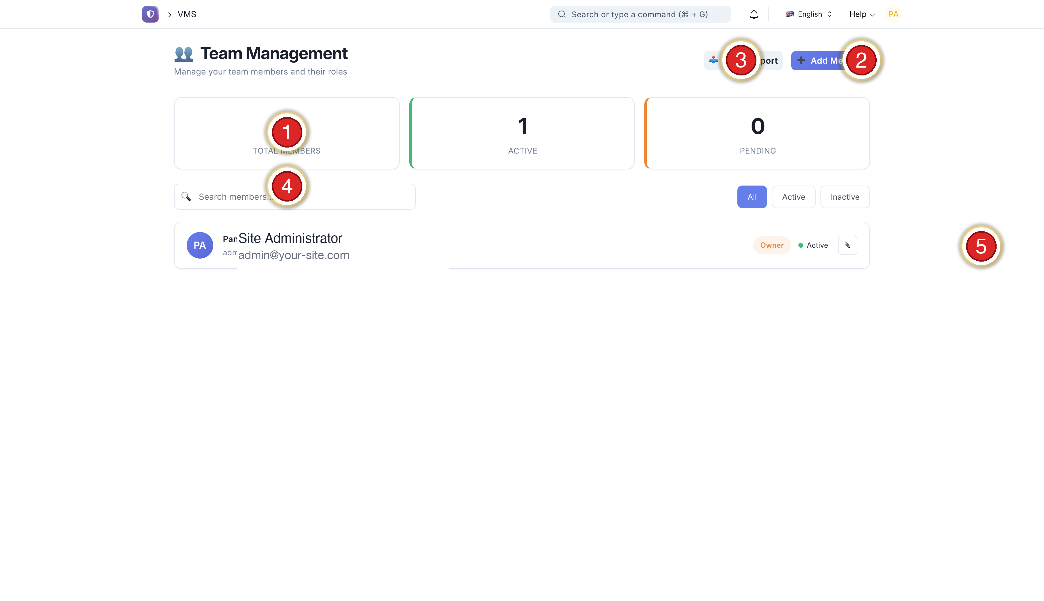
Step | Do this
① | Member counters (Total / Active / Pending)
② | + Add Member — invite a colleague
③ | Batch Import — many users from CSV
④ | Search a member
⑤ | Pencil — edit or disable
The roles (give the least powerful one that does the job):
Role | Can do
VMS Admin | Everything
VMS Site Manager | Create/edit passes, reports
VMS Security | Use the scanner
VMS Auditor | Read-only auditor scanner
VMS Viewer | Dashboards & reports only
Note. To remove someone, set their status to Inactive (you can’t delete — the audit trail must stay). “Same access as X” means copying their role + site access + membership, not just the role.

10 · Reports
Goal: answer “who, when, how long” in seconds.
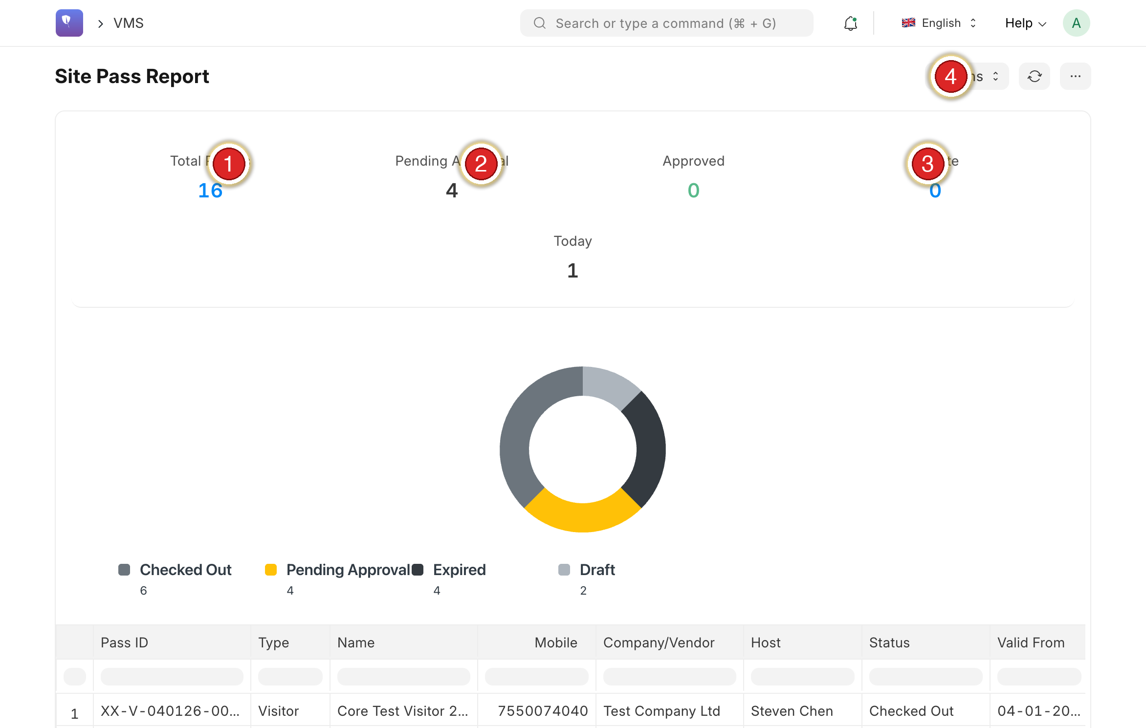
Step | Element
① | Total Passes
② | Pending / On Site
③ | On Site
④ | Actions — export Excel / PDF, refresh
Tip. Set a date range, then Export → Excel for spreadsheets or PDF for management.

11 · The audit log
Goal: see who did what, and when.
Step | Do this
① | Open VMS Audit Log from the dashboard
② | Filter by date and user
③ | Click any entry for full detail
Note. Every registration, edit, sign-in and role change is recorded here.

A · Tips
Tip | Why
One login each | Keeps the audit trail clean and secure
Least privilege | Not everyone needs Admin
Photo is required | No pass is issued without one — tell visitors to allow the camera
Use the in-app scanner | Google Lens / phone camera cannot check people in
Trust the On-Site count | It self-corrects nightly (Section 8)
Push self-registration | No gate queue; the pass issues itself
Laminate Section 7 | Keep the scanner card at the gate for guards
Push Aadhaar verify | Auto-fills the verified name and face-matches the selfie to the card — proves identity, faster than a typed name

B · Troubleshooting
Symptom | Fix
Visitor didn’t get the OTP | Check the number + country code; wait 60 s, Resend. Limit 3 / 10 min. Low signal → try another number, or create the pass manually.
“A photo is required” | Working as intended — add a photo (camera or upload).
QR won’t scan | Raise screen brightness; wipe the lens. “Expired” → register again. Name ≠ person → refuse.
Google Lens shows only text | Expected — use the in-app scanner to check in/out.
Forgot password | Forgot Password on sign-in. Link valid 20 min; weak passwords are rejected; if Update does nothing, the link expired — request a new one.
User can’t sign in | “Invalid” → reset. “Disabled” → reactivate. “Too many attempts” → wait 15 min.
New person sees no data | Role copied but site access wasn’t — ask IT to mirror an existing admin fully.
On-Site looks high mid-day | Normal — self-corrects overnight (Section 8).
QR photo won’t verify | The Secure QR is dense — retake so the QR is sharp, well-lit and fills the frame, or use Upload with a clear close-up.
“Failed UIDAI verification” | The QR isn’t a genuine/intact Aadhaar Secure QR — use the original card, eAadhaar PDF, or mAadhaar.
Face check says “no match” | Retake the selfie facing the camera in good light; make sure the card-front photo clearly shows the face. A no-match does not block the pass — the guard verifies in person.
Face check can’t find a face | Hold the phone steady, fill the frame with the face, avoid backlight/glare; then retake.
Pansen Engineering India Private Limited · Powered by VMS · Administrator SOP v2.1

