
Pansen Engineering × VMS
Responses to Your Questions
A focused guide answering the four points you raised — what the system does today, and how to use it.
Version 1.0 · 2026-06-09 · Pansen Engineering India Pvt. Ltd.
Field | Value
Document | VMS — Responses to Client Questions
Version | 1.0
Date | 2026-06-09
Prepared for | Pansen — Prangyajit & Kaviyarasu
Covers | Worker details on scan · Entry/exit records · ID verification · Mandatory photo
Site | pansen.vmsys.co

Summary — your four points
# | Your question | Status today
1 | Can we see all worker details by scanning the QR? | ✅ Yes — the full profile shows on every scan
2 | Are check-in / check-out recorded? | ✅ Yes — with time, GPS, and daily hours
3 | Why does a pass generate if Aadhaar isn’t verified? | ⚙️ Configurable — we can require verification
4 | Photo must be mandatory — no photo, no pass | ✅ Done — enabled on your site
The pages that follow explain each one.

1 · See all worker details by scanning
Yes. When the guard scans a worker’s QR at the gate, the screen shows the complete profile — so they know exactly who they are admitting.
What appears on every scan:
On screen | Shows
Photo + Name + badge | Who they are; Worker or Visitor
Pass ID | The pass reference
Company / Contractor | Who they work for
Mobile | Contact number
ID number | Aadhaar / ID on file
Valid from – until | Pass validity window
Work / Purpose | Why they are on site
Vehicle | Vehicle number (if given)
ID Verified / Not Verified | Whether the ID was checked
These are the same details captured at registration (next page) — nothing extra to type. The guard sees them instantly, in colour, with the photo for a face match.

2 · Check-in and check-out records
Yes — fully recorded. Every entry and exit is stored automatically.
What is recorded | Detail
Entry time | Exact timestamp when scanned in
Exit time | Exact timestamp when scanned out
GPS location | Where the scan happened (gate)
Daily hours | For workers — total time on site per day
Audit trail | Every scan logged to the guard who did it
Bonus reliability. If a guard forgets to scan someone out, the system auto-closes the visit at the end of that day — so your live “On Site” count stays accurate (useful for a fire drill or headcount). Records export to Excel or PDF any time.

3 · ID (Aadhaar) verification before a pass
Today a pass is issued whether or not the ID was verified — verification is optional, to keep registration fast.
We can change this for you. We can turn on mandatory ID verification, so a pass is only issued once Aadhaar is verified through DigiLocker.
Option | Result
Verification off (current default) | Fast sign-up; pass shows ID: Not Verified on scan
Verification on (we enable) | No pass until Aadhaar is verified
Recommended approach: enable it for Pansen, and confirm together in the training that DigiLocker verification runs smoothly before it becomes a hard requirement, so genuine visitors are never blocked.

4 · Mandatory photo — no photo, no pass
Done and live on your site. A pass can no longer be generated without a photo.
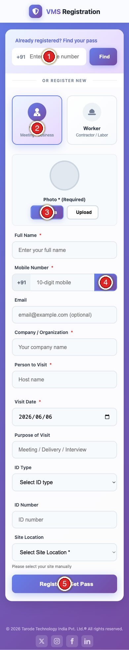
Step | The visitor does this on their phone
① | Returning? Type mobile + Find to reuse a past pass
② | Pick Visitor or Worker
③ | Add a photo — required (Camera or Upload)
④ | Type mobile → tap OTP → enter the SMS code
⑤ | Fill the form → tap Register & Get Pass
The photo field is now labelled “Photo * (Required)”. If the visitor skips it, the form stops them straight away with a clear message — they no longer fill the whole form only to be rejected at the end.

What happens next
Item | Plan
Worker details on scan (1) | Live — we’ll demo it in the training
Entry/exit records (2) | Live — we’ll show you where to view and export
ID verification (3) | We’ll enable and verify DigiLocker together first
Mandatory photo (4) | Live now on your site
A full step-by-step administrator guide (every screen, with marked steps) is provided separately as the VMS Administrator SOP.

Pansen Engineering India Private Limited · Powered by VMS · Responses to Your Questions v1.0

