
Pansen Engineering × VMS
Responses to Your Meeting Questions — Resolved Items
A focused, picture-led guide to the points raised in our review call. Each red number on a screenshot matches a numbered step below it.
Version 1.4 · 2026-06-19 · Pansen Engineering India Pvt. Ltd.
Field | Value
Document | VMS — Meeting Follow-up (Resolved Items)
Version | 1.4
Date | 2026-06-19
Prepared for | Pansen — Masu (HR), Vidhya (IT), Kavi (Site)
Covers | Aadhaar verification · OTP delivery · exceptions · records & data privacy
Site | pansen.vmsys.co

Summary — your points
# | What you raised | Status
1 | A pass was issued even when Aadhaar was not verified | ✅ Fixed — verification is now mandatory
2 | The Aadhaar would not verify on the phone | ✅ Clarified — scan the BACK QR
3 | The SMS OTP does not arrive at the gate | ✅ Email OTP added as a backup
4 | Foreign / Nepal workers have no Aadhaar | ✅ Admin creates the pass manually
5 | Download records with verification details | ✅ Export now shows verification (ID masked)
6 | Store the Aadhaar card in the system | ⚠️ Cannot store the full Aadhaar (law) — see what we keep instead
7 | Can one mobile number be used by many people? | ✅ Clarified — one number = one person
8 | Check-in / check-out must be reliable | ✅ Fixed — nightly auto check-out enabled
9 | Work-hours attendance (time in / out) report | ✅ Done — live now
10 | Who issued / approved each pass | ✅ Done — recorded & exportable
— | Gate-crowd fast flow · contractor batch sign-up | 🔧 Next phase
This document covers the items that are resolved or clarified. The items marked 🔧 are tracked and will follow with their own steps.

1 · Aadhaar verification is now mandatory
Goal: no pass without a verified identity.
Earlier a pass could be issued even if the Aadhaar was not verified — because the “mandatory” setting was off. It is now ON for Pansen.
What it means | Detail
Self-registration | A visitor/worker cannot get a pass unless their Aadhaar Secure QR is verified
A fake / unverified ID | Is rejected — no pass
Exceptions | Foreigners / no-Aadhaar → admin creates the pass (Section 4)
How to confirm it’s working: register on a phone without verifying Aadhaar — it should now stop you. With a verified Aadhaar, it issues the pass as normal.

2 · Scanning the Aadhaar — use the BACK
Goal: get the QR to read first time.
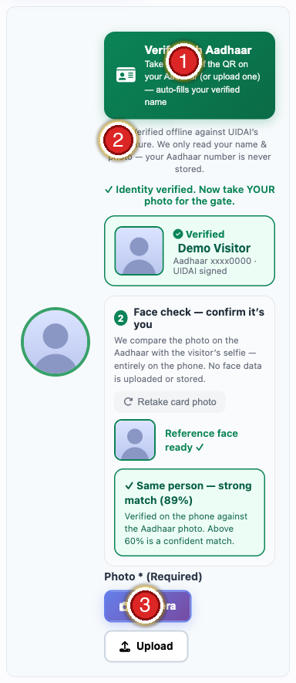
Step | Do this
① | Tap Verify with Aadhaar, then photograph the BACK of the card (the big square QR)
② | It is checked offline against UIDAI — the Aadhaar number is never stored
③ | After it verifies, add the visitor’s photo (Camera / Upload)
The front has no QR — that is why scanning the front failed in our call. Keep the QR sharp, straight and well-lit. The mAadhaar app and eAadhaar PDF also work. Kaviyarasu’s card was tested and verifies correctly.

3 · If the SMS OTP doesn’t arrive → Email OTP
Goal: never let a visitor get stuck waiting for an SMS.
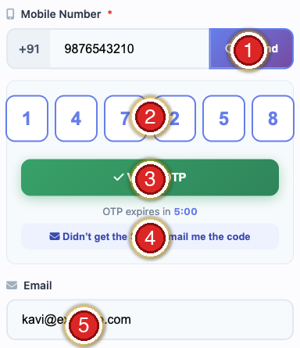
Mark | What it is
① | Mobile number + OTP — sends the SMS code
② | Enter the 6-digit code in these boxes
③ | Verify OTP
④ | “Didn’t get the SMS? Email me the code” — the email backup
⑤ | Email field — where the emailed code is sent
If the SMS doesn’t arrive: make sure ⑤ Email is filled, tap ④, then type the emailed code in ② and tap ③ Verify. (Tell the visitor to check the spam folder.)
For a queue of workers: pre-register (send the link a day before) or have an admin create passes from the back office. A no-OTP supervisor flow is in the next phase.

4 · Foreign / no-Aadhaar workers
Goal: still admit people who can’t verify Aadhaar (e.g. Nepal workers).
Open Pass Management → + Add Site Pass on the computer.
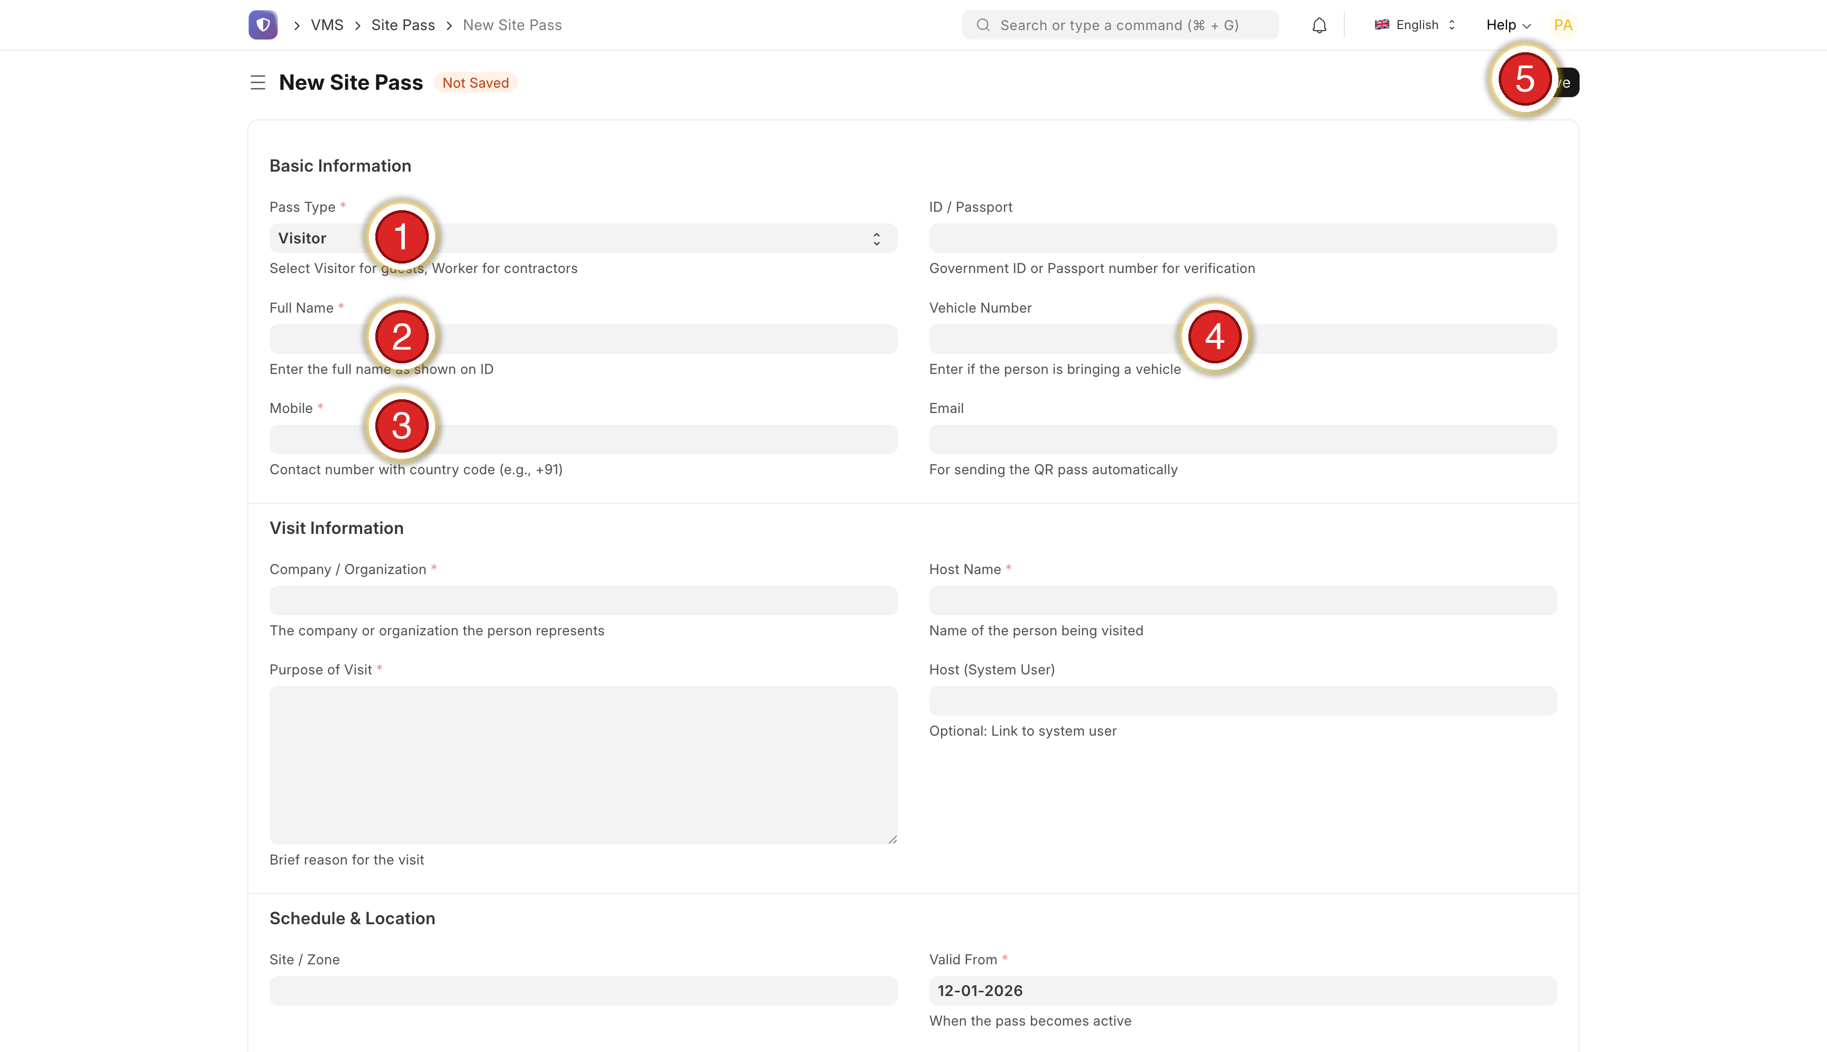
Step | Do this
① | Pass Type — Visitor / Worker
② | Full Name — as printed on the ID
③ | Mobile — with country code (+91…)
④ | Email — for QR delivery
⑤ | Save (top right) — the QR is emailed to them
Admin-created passes are exempt from the Aadhaar requirement, so genuine foreign workers are never blocked.

5 · Records & export (with verification)
Goal: pull a list of who came, when, and whether their ID was verified.
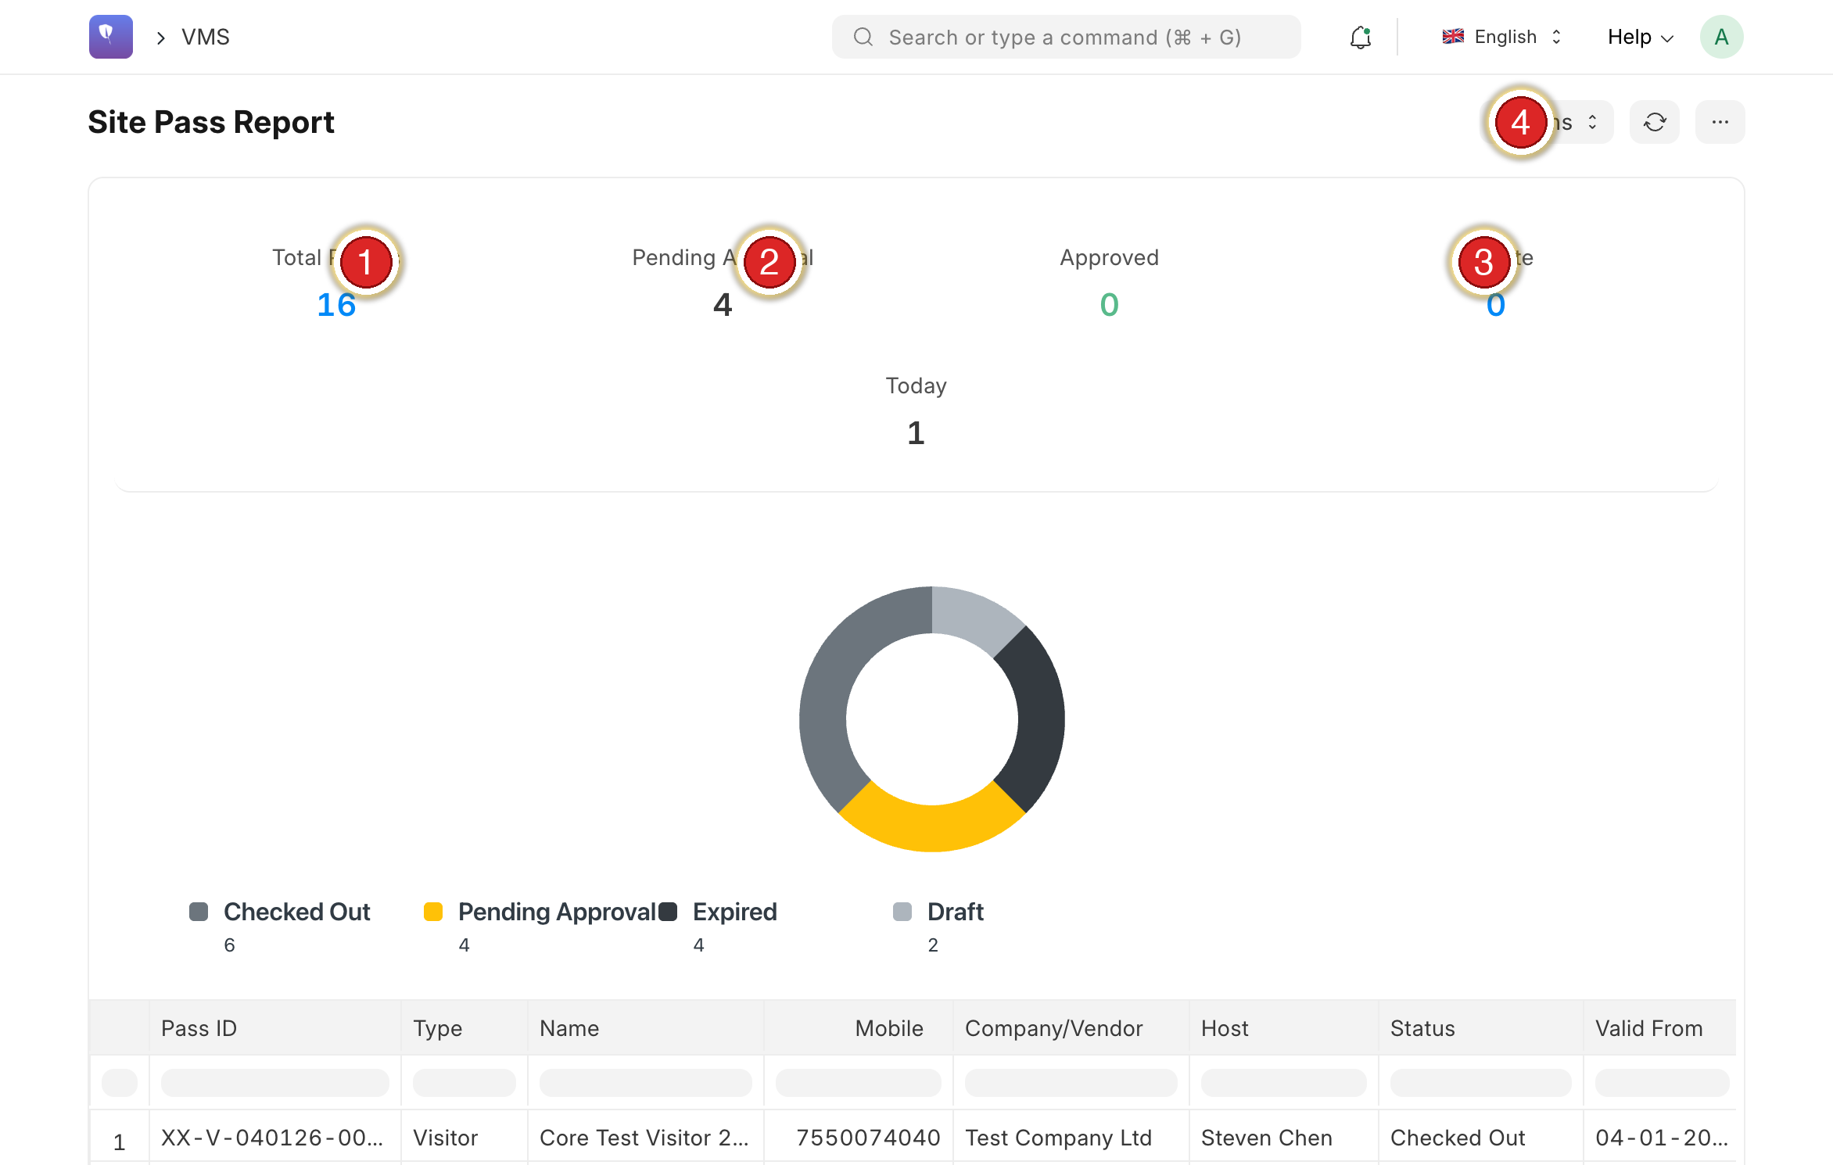
Mark | Element
① | Total Passes
② | Pending / On Site
③ | On Site
④ | Actions → Export Excel / PDF
The exported report now also includes these verification columns:
New column | Shows
ID Verified | Yes / No
ID Type | Aadhaar / PAN / …
ID No. (masked) | only the last 4 digits (e.g. xxxx-6815)
Verified On | date/time of verification
Why the ID is masked. We show only the last 4 digits on purpose — see Section 6.

6 · Why we don’t store the full Aadhaar (and what we keep)
Goal: keep your records and keep Pansen legally safe.
We understand you want a record for safety and any police verification. But under India’s DPDP Act 2023 and the Aadhaar Act, a company must not store the full Aadhaar number or a copy of the card — holding them would put Pansen at legal risk.
Instead, the system keeps (fully compliant) | Why it’s enough
Name + photo | Identifies the person
ID verified ✓ + date | Proves the identity was checked against UIDAI
Masked Aadhaar (last 4) | Links to the person without holding the full number
For a police / audit query this answers “this verified person worked here on this date” — without you having to keep documents you’re not allowed to hold. You get the record and the legal protection.

7 · One mobile number = one person
Goal: avoid two people sharing a pass.
Each mobile number can belong to one person only — the same number cannot register two different people. This keeps every pass tied to a single, verified individual.
For workers who share a phone or have none, the admin creates their passes (Section 4). A contractor batch sign-up is planned for the next phase.

8 · Check-in / check-out — now reliable
Goal: a trustworthy on-site count and smooth re-entry for multi-day workers.
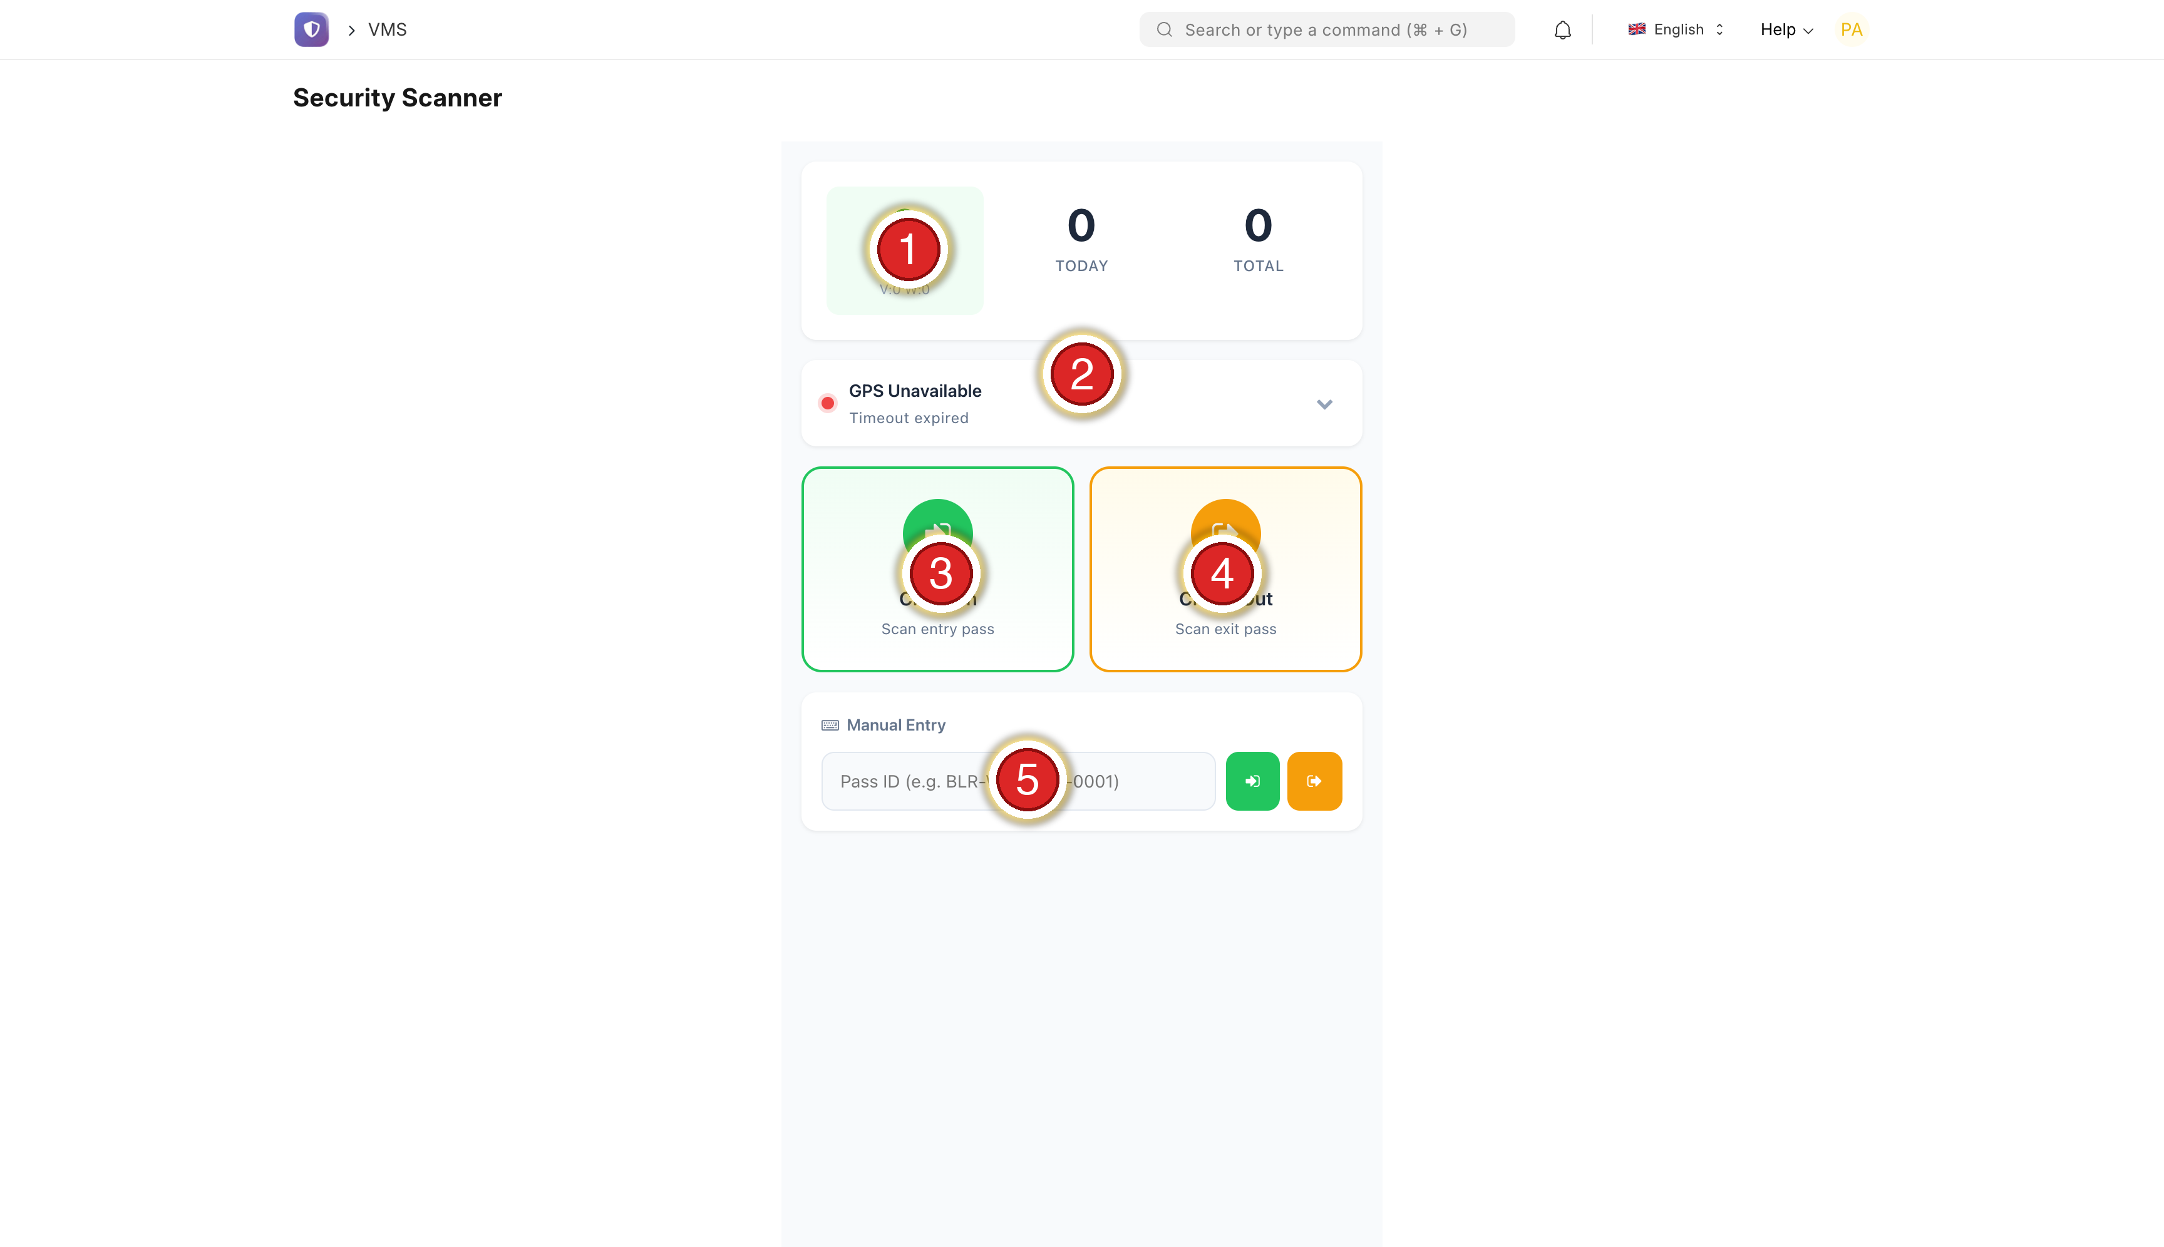
Mark | Element
① | ON SITE live count (V = Visitors, W = Workers) — now accurate
② | GPS status (green = located)
③ | Check In (green) — scan an arrival
④ | Check Out (orange) — scan a departure
⑤ | Manual Entry — type a Pass ID if the camera can’t read it
The scanner itself was working fine. The real issue was that the nightly auto check-out had not been switched on — so anyone a guard forgot to scan out (④) stayed “Checked In” indefinitely. That (a) inflated the ① On-Site count and (b) blocked multi-day workers the next day (“already checked in”).
What we did | Result
Closed all stale “Checked In” passes | On-site count corrected immediately
Enabled the nightly auto check-out | Runs every night from now on — no more build-up
How it works now: if a guard forgets to scan someone out, the system auto-checks-out at the end of that day, so the on-site number stays accurate and the worker can re-enter the next morning.

9 · Work-hours attendance report
Goal: see actual time in / time out and hours per worker per day.
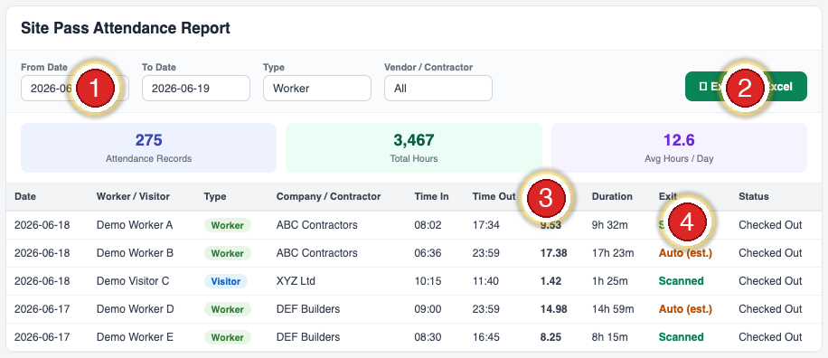
Mark | Element
① | Date range — pick the period (also filter by Type / Contractor)
② | Export to Excel (or PDF)
③ | Hours / Duration — time on site per worker, per day
④ | Exit — Scanned (real check-out) vs Auto (est.) (auto-closed)

Column | Shows
Date · Worker / Visitor · Type · Company | Who, and which day
Time In · Time Out · Hours · Duration | When they were on site
Exit | Scanned = real check-out · Auto (est.) = day-end estimate
Status | Checked In / Checked Out
Read the Hours carefully. Where Exit = “Auto (est.)” the worker was not scanned out, so the hours are an estimate bounded to end-of-day (they read high). Hours are accurate only where Exit = “Scanned”. For true work-hours, train guards to scan workers OUT at the gate.

10 · Who issued / approved each pass
Goal: an accountable, exportable record of who issued every pass.
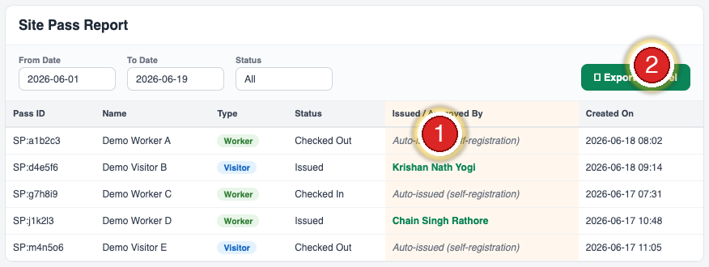
Mark | Element
① | Issued / Approved By — who issued each pass
② | Export to Excel (or PDF)

The value shows | Meaning
A person’s name (e.g. Krishan Nath Yogi) | An admin created / approved that pass in the back office
Auto-issued (self-registration) | The visitor self-registered and the pass issued automatically (after a verified Aadhaar) — no manual approval
Why “Auto-issued” is correct, not a gap. Self-service passes issue automatically once Aadhaar is verified — there is no manual step to slow the gate. The record is honest: it names the admin when a person issued it, and says “Auto-issued” when the system did. Every existing pass was back-filled, so the history is complete.

11 · What’s still coming (next phase)
So you know these are tracked.
Item | Plan
Gate-crowd fast flow | Supervisor issues passes for a line of workers without per-person OTP
Contractor batch sign-up | Register many workers at once
Please drop your full requirement list in the group — we’ll reply to each with timing and a short SOP.

Pansen Engineering India Private Limited · Powered by VMS · Meeting Follow-up v1.4

