**LAPORAN PENGERJAAN UJI KOMPETENSI KEJURUAN**

**SMK MAHARDHIKA BATUJAJAR**

**TAHUN PELAJARAN 2022-2023**

KOMPETENSI KEAHLIAN : Rekayasa Perangkat Lunak

KELAS : XII RPL 1

NAMA LENGKAP :Mega

NIS :

PAKET SOAL : p2

JENIS APLIKASI : Web

ALOKASI WAKTU : 24 jam

**1.PENJADWALAN KEGIATAN**

*Silahkan buat form penjadwalan dengan excel seperti yang pernah dicontohkan*

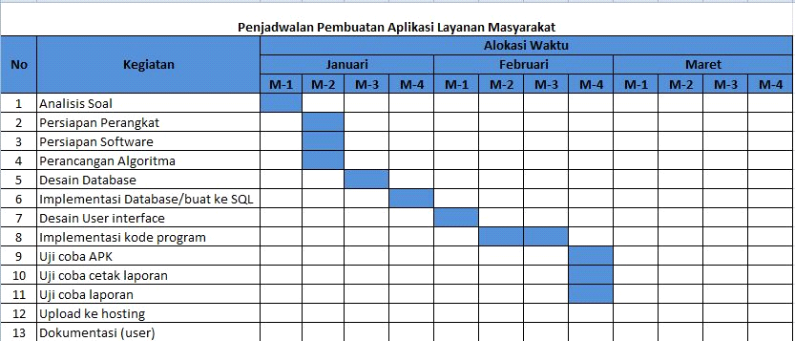

**2.PERSIAPAN PERANGKAT KERAS**

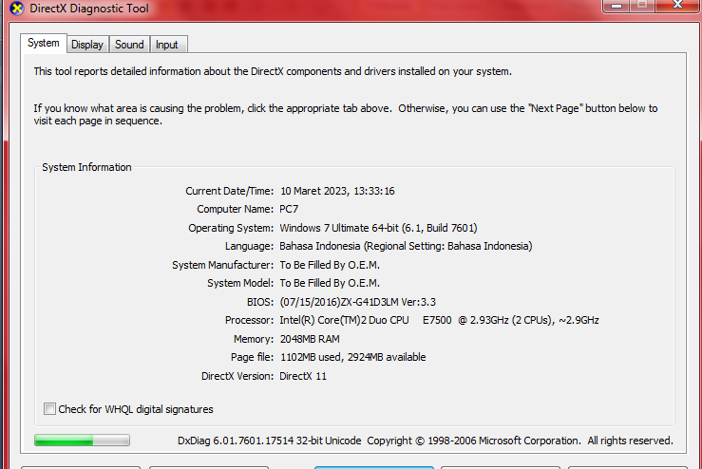

**3.PERSIAPAN PERANGKAT LUNAK**

-xampp

-visual studio code

-chrome

-balsamiq

-astah

-word

**4.PERANCANGAN ALGORITMA APLIKASI**

*Silahkan gambarkan activity diagram aplikasi yang kamu buat*

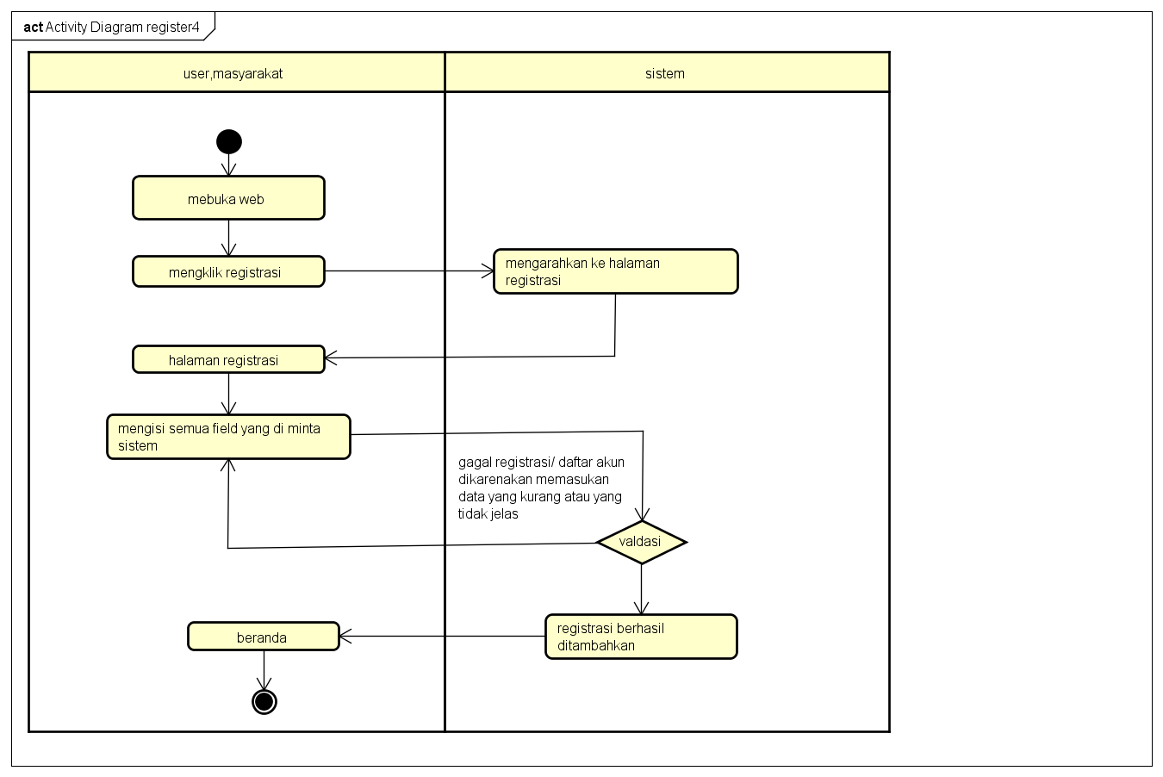

1.1 register



1.2Login

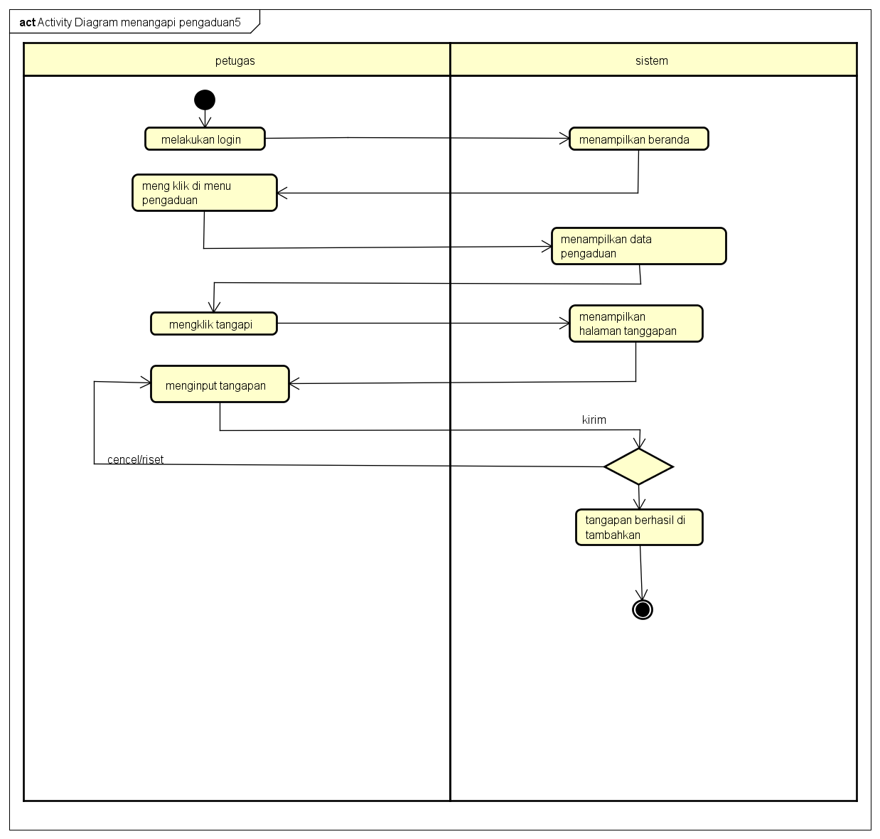

1.3 Menanggapi Laporan

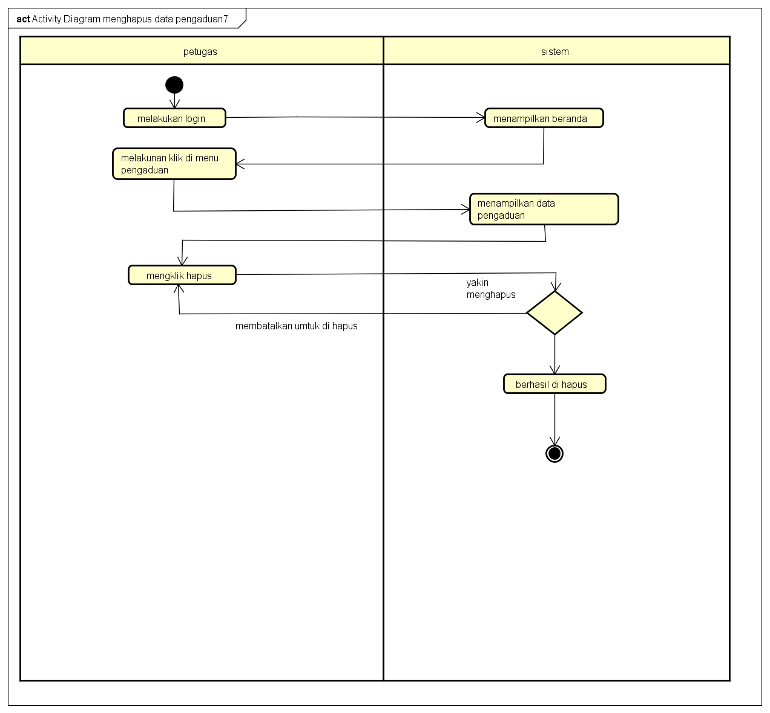

1.4 Menghapus Laporan

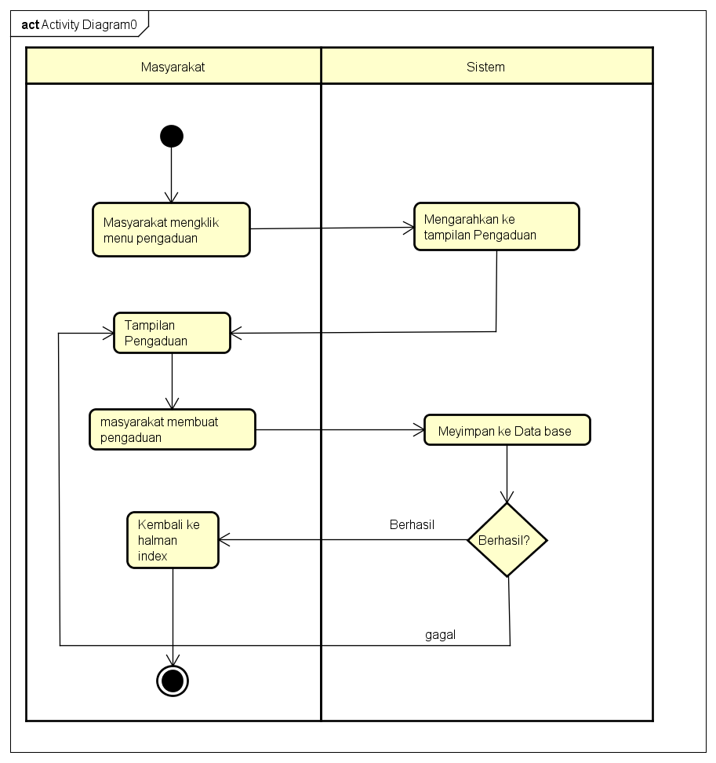

1.5 Pengaduan

**5.PERANCANGAN DESAIN BASIS DATA**

*Silahkan gambarkan ERD/DFD/class diagram atau desain basis data pada phpMyAdmin beserta relasinya*

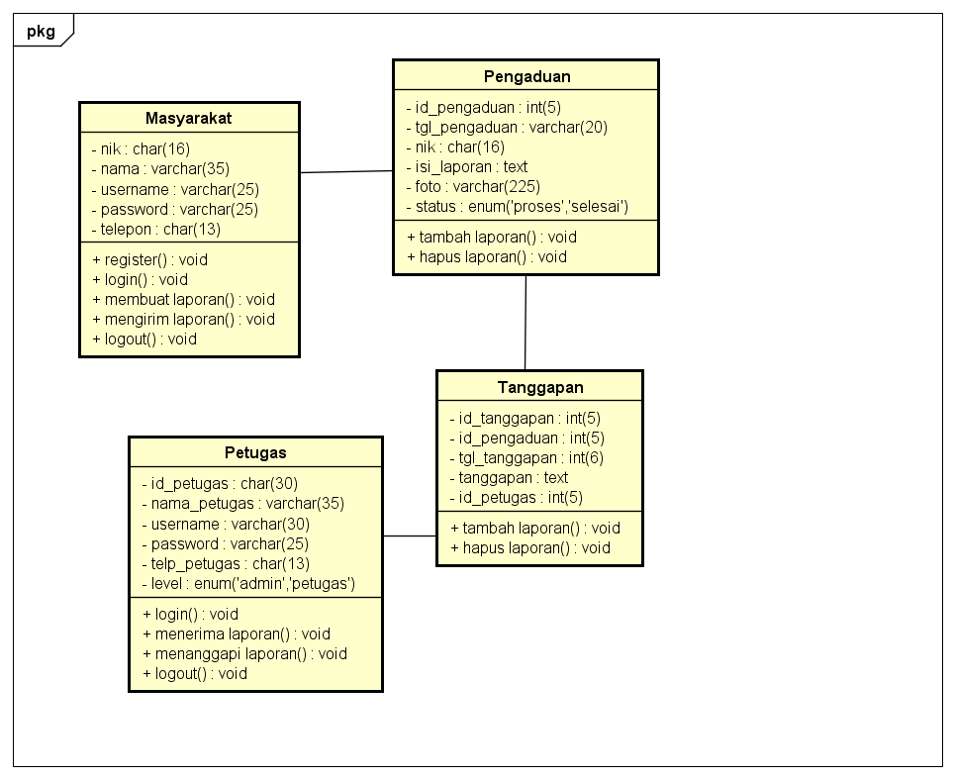

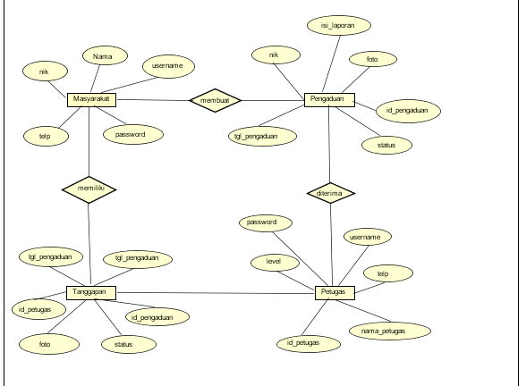

**6.DUMMY DATA**

Data Masyarakat

|  |  |  |  |  |
| --- | --- | --- | --- | --- |
| nik | nama | username | password | telp |
| 3317532353 | Rafi | rarafi8 | 089 | 0898767676 |
| 3325783574 | Sakti | itsak1 | 098 | 0993489878 |
| 3332783532 | Rama | amar66 | 809 | 0893324734 |
| 3337512489 | Riski | iki99 | 908 | 0998987909 |
| 3337634857 | Rifal | ari44 | 008 | 0893323432 |

Data Petugas

|  |  |  |  |  |  |
| --- | --- | --- | --- | --- | --- |
| Id_petugas | nama_petugas | username | password | telp_petugas | level |
| 79764 | Akira | aki11 | 0089 | 089746765 |  |
| 24317 | Cesa | cese23 | 3377 | 089875989 |  |
| 11583 | roni | oni9 | 8768 | 089276548 |  |
| 61947 | Rival | ival0 | 7788 | 089338579 |  |
| 987589 | Amri | amril8 | 5000 | 089876788 |  |

Data Admin

|  |  |  |  |  |  |
| --- | --- | --- | --- | --- | --- |
| Id_admin | nama_admin | username | password | telp_admin | level |
| 99 | Askia | kiasa9 | 111 | 0897625814 |  |
| 100 | Julfan | juflan9 | 222 | 0818748121 |  |
| 111 | Surya | surya7 | 333 | 0818975395 |  |
| 454 | Supta | tapus9 | 444 | 0893983732 |  |
| 676 | Ali | ila66 | 555 | 0894335333 |  |

**7.PEMBUATAN BASIS DATA (MySQL Code)**

Masyarakat

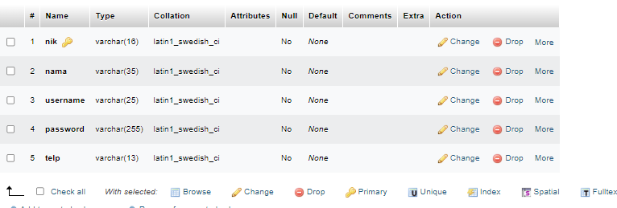

Pengaduan

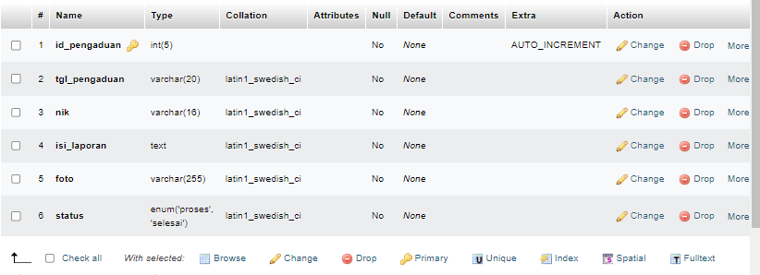

Petugas

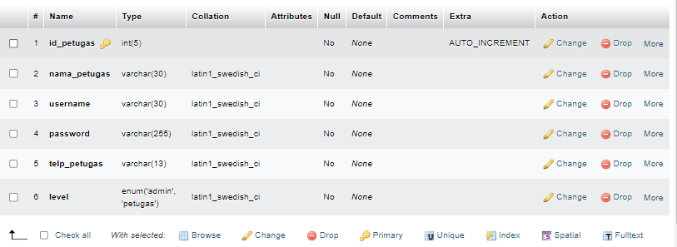

Tanggapan

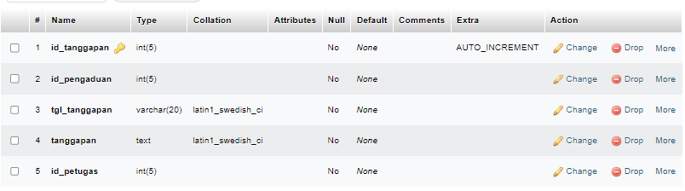

**8.PERANCANGAN TAMPILAN ANTARMUKA (UI) WEB**

**Aplikasi pengaduan masyarakat**

*1.Silahkan gambarkan use case diagram aplikasi yang kamu buat* 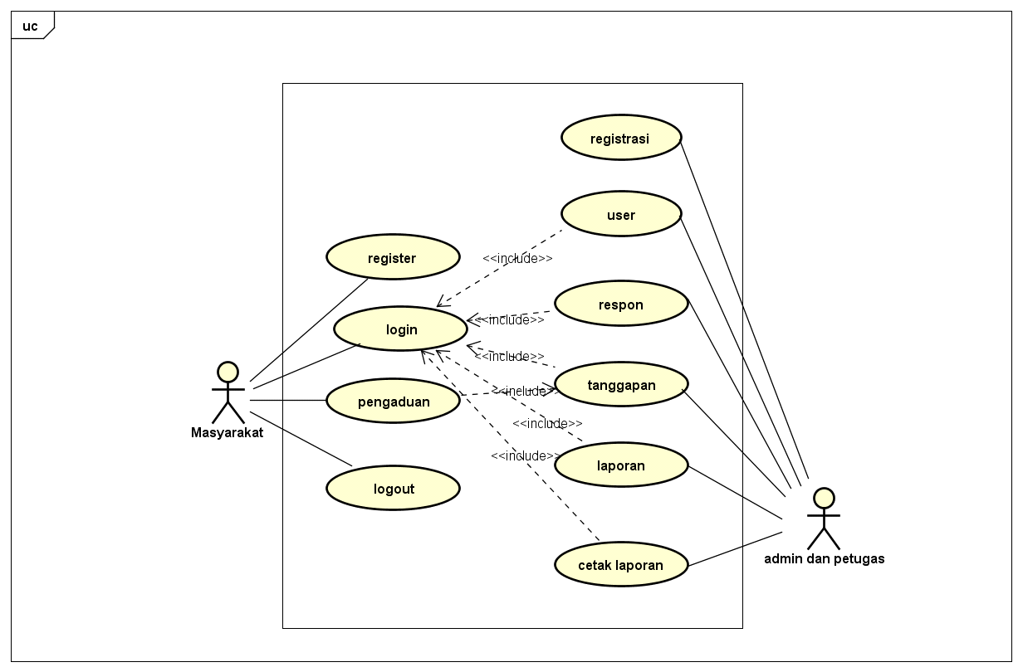

-Admin Dashbord

Tampilan untuk full manage semua data, buatkan sketsa/mockup-nya

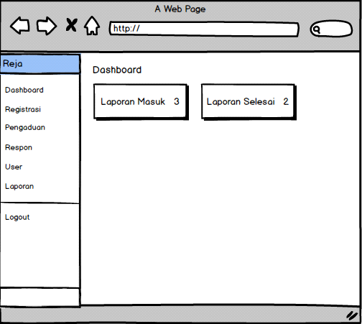

Tampilan Masyarakat

Setiap menu buatkan sketsa/mockup-nya

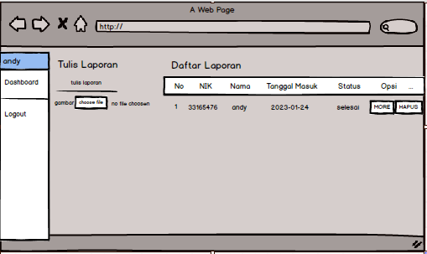

* Tampilan petugas

Setiap menu buatkan sketsa/mockup-nya

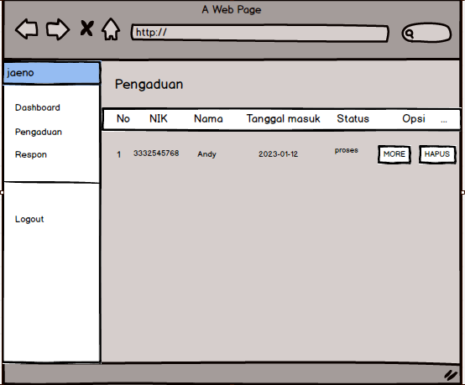

Pengaduan

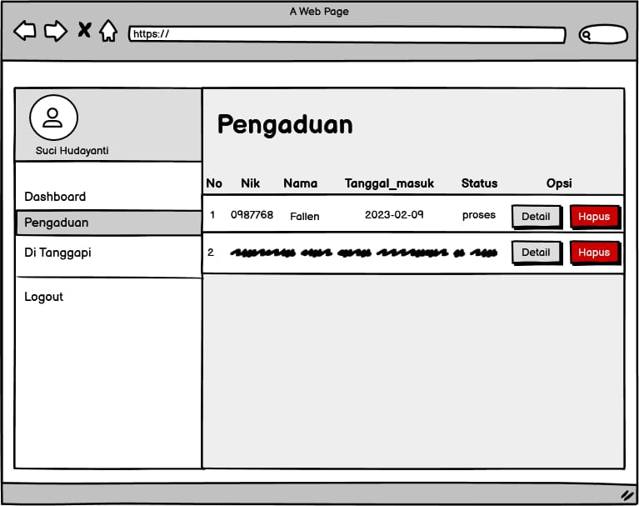

**9.PEMBUATAN STRUKTUR WEB (HTML)**

* PEMBUATAN STYLE WEB (CSS)

File style.css

|  |
| --- |
| html,  body {  height: 100%;  }  body {  display: -ms-flexbox;  display: flex;  -ms-flex-align: center;  align-items: center;  padding-top: 40px;  padding-bottom: 40px;  background-color: #f5f5f5;  }  .form-signin {  width: 100%;  max-width: 330px;  padding: 15px;  margin: auto;  }  .form-signin .checkbox {  font-weight: 400;  }  .form-signin .form-control {  position: relative;  box-sizing: border-box;  height: auto;  padding: 10px;  font-size: 16px;  }  .form-signin .form-control:focus {  z-index: 2;  }  .form-signin input[type="email"] {  margin-bottom: -1px;  border-bottom-right-radius: 0;  border-bottom-left-radius: 0;  }  .form-signin input[type="password"] {  margin-bottom: 10px;  border-top-left-radius: 0;  border-top-right-radius: 0;  } |

* PEMBUATAN KODE WEB (PHP/JS)

File index.php

Index admin

|  |
| --- |
| <?php  session_start();  include '../conn/koneksi.php';  if(!isset($_SESSION['username'])){  header('location:../index.php');  }  elseif($_SESSION['data']['level'] != "admin"){  header('location:../index.php');  }  ?>  <!DOCTYPE html>  <html>  <head>  <title>Aplikasi Pengaduan masyarakat</title>  <!--Import Google Icon Font-->  <link href="https://fonts.googleapis.com/icon?family=Material+Icons" rel="stylesheet">  <!--Import materialize.css-->  <link type="text/css" rel="stylesheet" href="../css/materialize.min.css" media="screen,projection"/>  <!-- Compiled and minified CSS -->  <link rel="stylesheet" href="https://cdnjs.cloudflare.com/ajax/libs/materialize/1.0.0/css/materialize.min.css">  <!-- Compiled and minified JavaScript -->  <script src="https://cdnjs.cloudflare.com/ajax/libs/materialize/1.0.0/js/materialize.min.js"></script>  <script src="https://ajax.googleapis.com/ajax/libs/jquery/3.4.1/jquery.min.js"></script>  <!--Let browser know website is optimized for mobile-->  <meta name="viewport" content="width=device-width, initial-scale=1.0"/>  <link rel="stylesheet" type="text/css" href="https://cdn.datatables.net/1.10.19/css/jquery.dataTables.css">    <script src="https://ajax.googleapis.com/ajax/libs/jquery/3.4.1/jquery.min.js"></script>    <script type="text/javascript" charset="utf8" src="https://cdn.datatables.net/1.10.19/js/jquery.dataTables.js"></script>      <script type="text/javascript">  $(document).ready( function () {  $('#example').DataTable();  $('select').formSelect();  } );    </script>  </head>  <body style="background:url(../img/background.jpg); background-size: cover;">  <div class="row">  <div class="col s12 m3">  <ul id="slide-out" class="sidenav sidenav-fixed">  <li>  <div class="user-view">  <div class="background">  <img src="../img/background.jpg">  </div>  <a href="#user"><img class="circle" src="../img/cs.png"></a>  <a href="#name"><span class="black-text name"><?php echo ucwords($_SESSION['data']['nama_petugas']); ?></span></a>  </div>  </li>  <li><a href="index.php?p=dashboard"><i class="material-icons">dashboard</i>Dashboard</a></li>  <li><a href="index.php?p=registrasi"><i class="material-icons">featured_play_list</i>Registrasi</a></li>  <li><a href="index.php?p=pengaduan"><i class="material-icons">report</i>Pengaduan</a></li>  <li><a href="index.php?p=respon"><i class="material-icons">question_answer</i>Respon</a></li>  <li><a href="index.php?p=user"><i class="material-icons">account_box</i>User</a></li>  <li><a href="index.php?p=laporan"><i class="material-icons">book</i>Laporan</a></li>  <li>  <div class="divider"></div>  </li>  <li><a class="waves-effect" href="../index.php?p=logout"><i class="material-icons">logout</i>Logout</a></li>  </ul>  <a href="#" data-target="slide-out" class="btn sidenav-trigger"><i class="material-icons">menu</i></a>  </div>  <div class="col s12 m9">    <?php  if(@$_GET['p']==""){  include_once 'dashboard.php';  }  elseif(@$_GET['p']=="dashboard"){  include_once 'dashboard.php';  }  elseif(@$_GET['p']=="registrasi"){  include_once 'registrasi.php';  }  elseif(@$_GET['p']=="regis_hapus"){  $query = mysqli_query($koneksi,"DELETE FROM masyarakat WHERE nik='".$_GET['nik']."'");  if($query){  header('location:index.php?p=registrasi');  }  }  elseif(@$_GET['p']=="pengaduan"){  include_once 'pengaduan.php';  }  elseif(@$_GET['p']=="pengaduan_hapus"){  $query=mysqli_query($koneksi,"SELECT * FROM pengaduan WHERE id_pengaduan='".$_GET['id_pengaduan']."'");  $data=mysqli_fetch_assoc($query);  unlink('../img/'.$data['foto']);  if($data['status']=="proses"){  $delete=mysqli_query($koneksi,"DELETE FROM pengaduan WHERE id_pengaduan='".$_GET['id_pengaduan']."'");  header('location:index.php?p=pengaduan');  }  elseif($data['status']=="selesai"){  $delete=mysqli_query($koneksi,"DELETE FROM pengaduan WHERE id_pengaduan='".$_GET['id_pengaduan']."'");  if($delete){  $delete2=mysqli_query($koneksi,"DELETE FROM tanggapan WHERE id_pengaduan='".$_GET['id_pengaduan']."'");  header('location:index.php?p=pengaduan');  }  }  }  elseif(@$_GET['p']=="more"){  include_once 'more.php';  }  elseif(@$_GET['p']=="respon"){  include_once 'respon.php';  }  elseif(@$_GET['p']=="tanggapan_hapus"){    $query = mysqli_query($koneksi,"DELETE FROM tanggapan WHERE id_tanggapan='".$_GET['id_tanggapan']."'");  if($query){  header('location:index.php?p=respon');  }  }  elseif(@$_GET['p']=="user"){  include_once 'user.php';  }  elseif(@$_GET['p']=="user_input"){  include_once 'user_input.php';  }  elseif(@$_GET['p']=="user_edit"){  include_once 'user_edit.php';  }  elseif(@$_GET['p']=="user_hapus"){  $query = mysqli_query($koneksi,"DELETE FROM petugas WHERE id_petugas='".$_GET['id_petugas']."'");  if($query){  header('location:index.php?p=user');  }  }  elseif(@$_GET['p']=="laporan"){  include_once 'laporan.php';  }  ?>  </div>  </div>  <!--JavaScript at end of body for optimized loading-->  <script type="text/javascript" src="../js/materialize.min.js"></script>  <script type="text/javascript" src="https://cdnjs.cloudflare.com/ajax/libs/materialize/1.0.0/js/materialize.min.js"></script>  <script type="text/javascript">  document.addEventListener('DOMContentLoaded', function() {  var elems = document.querySelectorAll('.sidenav');  var instances = M.Sidenav.init(elems);  });  document.addEventListener('DOMContentLoaded', function() {  var elems = document.querySelectorAll('.modal');  var instances = M.Modal.init(elems);  });  </script>  </body>  </html> |

File koneksi.php

|  |
| --- |
| <?php $koneksi=mysqli_connect("localhost","root","","db_pdm1"); ?> |

CRUD file

|  |
| --- |
| <html>  <head>  <title>Aplikasi Pengaduan Masyarakat</title>  <style type="text/css" media="screen">  @import url('https://fonts.googleapis.com/css?family=PT+Sans');  body{  background: url(img/bcregist.jpg);  background-size: cover;  background-position: center;  background-repeat: no-repeat;  font-family: sans-serif;  font-size: 10px  }  h1{  font-size:"10px";  }  h2{  padding-top: 1.5rem;  }  .container{  position: absolute;  left: 50%;  top: 50%;  transform: translate(-50%,-50%);  padding: 40px 100px;  width: 500px;  background-color: #6495ED;  box-shadow: 0 0 20px rgba(255,255,255,.3);    }  font{  font-size: 20px;    }  .submit{  background: black;  color: white;  font-size: 11pt;  width: 50%;  border: none;  border-radius: 20px;  padding: 10px 20px;  }  .reset{  background: black;  color: white;  font-size: 10pt;  width: 50%;  border: none;  border-radius: 20px;  padding: 10px 20px;  }  </style>  </head>  <body background = "langit.jpg">  <div style="border:0; padding:10px; width:760px; height:auto;">  <form class="container" action="proses.php" method="POST" name="proses">  <h1 align="center">DAFTAR AKUN MASYARAKAT </h1>  <table width="760" border="0" align="center" cellpadding="0" cellspacing="0">  <tr height="46">  <td width=""> </td>  <td width=""> </td>  </tr>  <tr height="46" >  <td> </td>  <td><font color="white">NIK</font></td>  <td><input type="text" name="nik" size="23" required/></td>  </tr>  <tr height="46">  <td> </td>  <td><font color="white">Nama</font></td>  <td><input type="text" name="nama" size="23" required/></td>  </tr>    <tr height="46">  <td> </td>  <td><font color="white">Username</font></td>  <td><input type="text" name="username" size="23" required/></td>  </tr>  <tr height="46">  <td> </td>  <td><font color="white">Password</font></td>  <td><input id="password" type="password" name="password" class="material-icons" size="23" required/></td>  </tr>  <tr height="46">  <td> </td>  <td><font color="white">No_Telepon</font></td>  <td><input type="text" name="telp" size="23" required/></td>  </tr>  <tr>  <td></td>  <td><input type="submit" name="Submit" value="Submit" class="Submit" style="width: 25%;" />&nbsp;<input type="reset" value="Reset" class="reset" style="width: 25%;" /></td>  </tr>    </table>  </form>  </div>  </body>  </html> |

12.UJI COBA

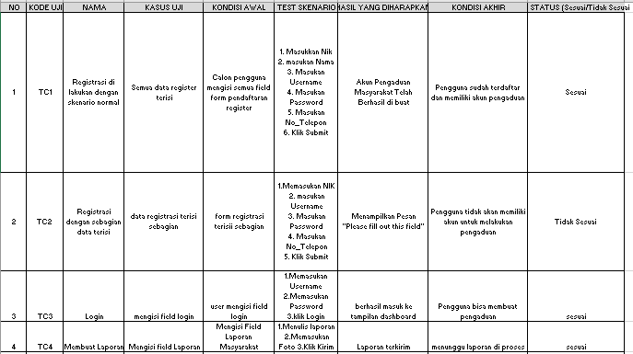

13.REVISI

* PENENTUAN DOMAIN DAN HOSTING

|  |
| --- |
|  |