http://pyqt.sourceforge.net/Docs/PyQt5/

1.

相机参数标定（camera calibration）及标定结果如何使用
https://blog.csdn.net/aoulun/article/details/78768570

２．
安装命令
1949 ./install.sh
1950 sudo ./install.sh
1951 source OpenNIDevEnvironment
1952 ls
1953 cd Samples/
1954 ls
1955 cd SimpleViewer
1956 ls
1957 make
1958 cd Bin/
1959 ls
1960 cd x64-Release/
1961 ls
1962 ./SimpleViewer
1963 ldconfig -p | grep libudev.so.1
1964 cd /lib/x86_64-linux-gnu
1965 ls
1966 ls -l
1967 cd ~/work/projects/RobotArm/OpenNI-Linux-x64-2.3.0.43/Samples/SimpleViewer/Bin
1968 ls
1969 cd x64-Release/
1970 ls
1971 sudo ./SimpleViewer
1972 history

３．
生成ｐｌｙ数据文件

4.
按键
１ ２ ３ Ｍ

５．

OpenNI
https://baike.baidu.com/item/OpenNI/9144945?fr=aladdin
ｓ

６．

谈谈OpenNI 2的第一个程序
https://www.cnblogs.com/yemeishu/archive/2012/12/25/2832024.html

7.
深度图存 ply 文件
彩色图存 二进制文件
８．
fx_l : 578.500977, fy_l : 578.500977, cx_l : 323.388000, cy_l : 252.487000 fx_r : 518.468018, fy_r : 518.468018, cx_r : 312.657990, cy_r : 239.076004 r[0] : 0.999996, r[1] : -0.002270, r[2] : 0.001785 r[3] : 0.002274, r[4] : 0.999995, r[5] : -0.001989 r[6] : -0.001780, r[7] : 0.001993, r[8] : 0.999996 t[0] : -25.179001, t[1] : -0.102628, t[2] : 0.314967 lk[0] : -0.101344, lk[1] : 0.385942, lk[2] : -0.554521, lk[3] : -0.004084, lk[4] : 0.001130 rk[0] : 0.046869, rk[1] : -0.197088, rk[2] : 0.094192, rk[3] : -0.004304, rk[4] : 0.000334

８．

PLY格式介绍与读取
https://blog.csdn.net/my_lord_/article/details/54947939

１０．
ｃ＋＋官网
http://www.cplusplus.com/reference/vector/vector/back/

11.
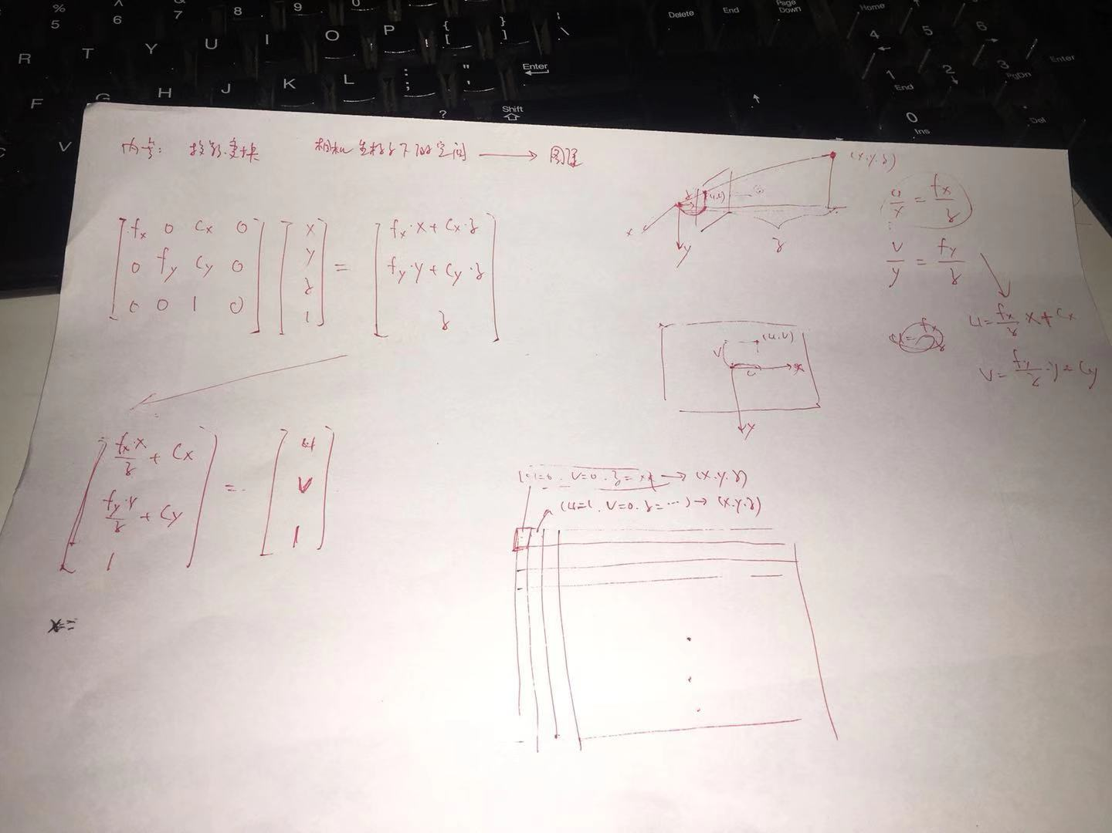
12.
使用ｐｌｙ文件绘制点云图
１３．
CloudCompare
https://www.danielgm.net/cc/
安装
snap install cloudcompare
运行
cloudcompare.CloudCompare

Snap是Canonical推出的一种新的软件打包格式，彻底解决linux依赖性的问题，Snap 软件包拥有更加稳定和安全的特性。snap也就是安装snap软件包的命令

０．６－－８米

１４．
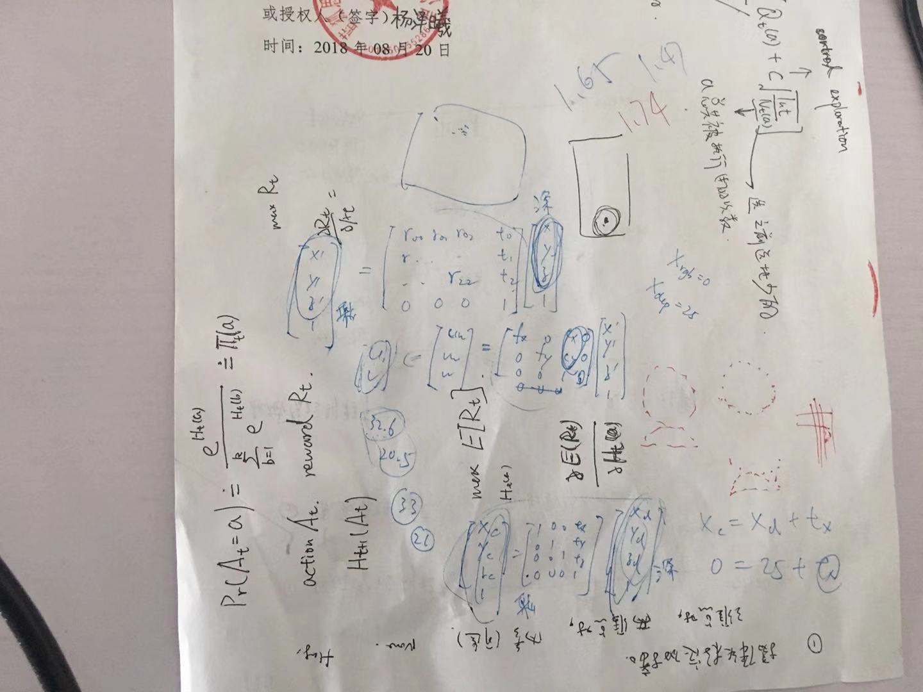
１５．

【OpenGL】glut 消息事件处理函数 glutMainLoop();
https://blog.csdn.net/bill_ming/article/details/7662809

１６．

ubuntu 安装openGL
https://blog.csdn.net/u011961856/article/details/76889625
1999 sudo apt-get install build-essential
2000 sudo apt-get install libgl1-mesa-dev
2001 sudo apt-get install libglu1-mesa-dev
2002 sudo apt-get install libglut-dev
2003 sudo apt-get install freeglut3-dev
2004 gedit example.c
2005 gcc example.c -o example.out -lGL -lGLU -lglut
2006 ls
2007 ./example.out
2008 history

１７．
错误及解决
pengcan@pengcan-System-Product-Name:~/test/3DR$ gcc 3dr.c -o example.out -lGL -lGLU -lglut
3dr.c:11:1: error: unknown type name ‘bool’
bool mouseisdown=false;
^
3dr.c:11:18: error: ‘false’ undeclared here (not in a function)
bool mouseisdown=false;
^
3dr.c:13:1: error: unknown type name ‘bool’
bool loopr=false;
^
3dr.c: In function ‘mouse’:
3dr.c:45:27: error: ‘true’ undeclared (first use in this function)
{ mouseisdown=true; loopr=false;}
^
3dr.c:45:27: note: each undeclared identifier is reported only once for each function it appears in
3dr.c: In function ‘motion’:
3dr.c:67:21: error: ‘true’ undeclared (first use in this function)
if(mouseisdown==true)
^
pengcan@pengcan-System-Product-Name:~/test/3DR$ g++ 3dr.c -o example.out -lGL -lGLU -lglut

１８．
ｏｐｅｎｇｌ头文件目录
sudo find / -name glut.h
/home/pengcan/work/projects/RobotArm/OpenNI-Extension/OpenNI-Extension/windows-x64/ExtendedAPI/3rdparty/OpenGL/Include/GL/glut.h
/home/pengcan/work/projects/RobotArm/OpenNI-Extension/OpenNI-Extension/windows-x86/ExtendedAPI/3rdparty/OpenGL/Include/GL/glut.h
find: `/run/user/1000/gvfs': 权限不够
/usr/include/GL/glut.h

１９．
ｏｐｅｎｇｌ库目录
pengcan@pengcan-System-Product-Name:~$ sudo find / -name *glut*
/usr/lib/x86_64-linux-gnu/libglut.so
/usr/lib/x86_64-linux-gnu/libglut.so.3.9.0
/usr/lib/x86_64-linux-gnu/libglut.so.3
/usr/lib/x86_64-linux-gnu/libglut.a

sudo find / -name *GL*
sudo find / -name *GLU*
sudo find / -name *glut*

/usr/lib/x86_64-linux-gnu/--->

lrwxrwxrwx 1 root root 13 6月 15 02:30 libGL.so -> mesa/libGL.so
-rw-r--r-- 1 root root 911218 10月 24 2015 libGLU.a
lrwxrwxrwx 1 root root 15 10月 24 2015 libGLU.so -> libGLU.so.1.3.1
lrwxrwxrwx 1 root root 15 8月 8 13:06 libGLU.so.1 -> libGLU.so.1.3.1
-rw-r--r-- 1 root root 453352 10月 24 2015 libGLU.so.1.3.1
-rw-r--r-- 1 root root 545460 5月 24 2014 libglut.a
lrwxrwxrwx 1 root root 16 5月 24 2014 libglut.so -> libglut.so.3.9.0
lrwxrwxrwx 1 root root 16 5月 24 2014 libglut.so.3 -> libglut.so.3.9.0
-rw-r--r-- 1 root root 294760 5月 24 2014 libglut.so.3.9.0

20.
g++ 3dr.c -o example.out -lGL -lGLU -lglut
gcc 3dr.c -o example.out -lGL -lGLU -lglut

21.

OpenGL内存泄漏之主循环函数glutMainLoop()
https://blog.csdn.net/ronggang175/article/details/6068854

22.
关键词
opengl ply

２３．

OpenGL读取PLY模型文件并绘制 Read and draw ply model by OpenGL
https://blog.csdn.net/pyang1989/article/details/23799297

２４．

OpenGL读取PLY模型文件并绘制 Read and draw ply model by OpenGL
https://blog.csdn.net/pyang1989/article/details/23799297

25.

关于OpenNI2和OpenCV2的那些事——获取三维点云数据并用OpenGL表示
http://lib.csdn.net/article/opencv/28825

26.
深度摄像头有ｕｖ，彩色摄像头也有自己的ｕｖ
焦距小看的少，看的清晰

２７．
DISPLAY_MODE_OVERLAY模式深度摄像头硬件对齐
硬件对齐：指的是不需要计算颜色坐标系的ｕｖ，直接使用深度坐标系的ｕｖ去取颜色坐标系的的颜色值

28.
ubuntu c++ opencv3.3.0
rsync -avhP fox0@192.168.1.107:~/Downloads/3.3.0.zip ./

29.

ubuntu下安装opencv3.4以及c++编译
https://blog.csdn.net/hjxu2016/article/details/82390434
apt-cache search "^dump$"

30.

编译有opencv的cpp，出现未定义的引用错误
https://blog.csdn.net/cainiaohudi/article/details/80375557

31.
# deb cdrom:[Ubuntu 16.04 LTS _Xenial Xerus_ - Release amd64 (20160420.1)]/ xenial main restricted
deb-src http://archive.ubuntu.com/ubuntu xenial main restricted #Added by software-properties
deb http://mirrors.aliyun.com/ubuntu/ xenial main restricted
deb-src http://mirrors.aliyun.com/ubuntu/ xenial main restricted multiverse universe #Added by software-properties
deb http://mirrors.aliyun.com/ubuntu/ xenial-updates main restricted
deb-src http://mirrors.aliyun.com/ubuntu/ xenial-updates main restricted multiverse universe #Added by software-properties
deb http://mirrors.aliyun.com/ubuntu/ xenial universe
deb http://mirrors.aliyun.com/ubuntu/ xenial-updates universe
deb http://mirrors.aliyun.com/ubuntu/ xenial multiverse
deb http://mirrors.aliyun.com/ubuntu/ xenial-updates multiverse
deb http://mirrors.aliyun.com/ubuntu/ xenial-backports main restricted universe multiverse
deb-src http://mirrors.aliyun.com/ubuntu/ xenial-backports main restricted universe multiverse #Added by software-properties
deb http://archive.canonical.com/ubuntu xenial partner
deb-src http://archive.canonical.com/ubuntu xenial partner
deb http://mirrors.aliyun.com/ubuntu/ xenial-security main restricted
deb-src http://mirrors.aliyun.com/ubuntu/ xenial-security main restricted multiverse universe #Added by software-properties
deb http://mirrors.aliyun.com/ubuntu/ xenial-security universe
deb http://mirrors.aliyun.com/ubuntu/ xenial-security multiverse

32.
opencv去掉ｑｔ编译
cmake -D CMAKE_BUILD_TYPE=RELEASE -D CMAKE_INSTALL_PREFIX=/usr/local -D WITH_TBB=ON -D BUILD_NEW_PYTHON_SUPPORT=ON -D WITH_V4L=ON -D WITH_QT=OFF -D WITH_OPENGL=ON ..

３３．
opencv编译程序命令
g++ main.cpp -o main `pkg-config --libs --cflags opencv` -ldl
３４．

g++ 和 pkg-config 编译opencv项目
https://blog.csdn.net/autoliuweijie/article/details/50950300

３５．
ｏｐｅｎｎｉ利用ｏｐｅｎｃｖ保存图片
看机械臂串口源码
cmake CmakeLists.txt

３６．
cp -R /home/pengcan/work/projects/RobotArm/OpenNI-Linux-x64-2.3.0.43/Redist/* bin/x64-Release
g++ -o bin/x64-Release/simpleViewer ./bin/Intermediate/x64-Release/simpleViewer/Viewer.o ./bin/Intermediate/x64-Release/simpleViewer/main.o -Lbin/x64-Release -lglut -lGL -lOpenNI2 -Wl,-rpath ./

３７．
g++ main.cpp -o main `pkg-config --libs --cflags opencv` -ldl -L/home/pengcan/work/projects/RobotArm/OpenNI-Linux-x64-2.3.0.43/Redist -lglut -lGL -lOpenNI2

3.0.43/Samples/SimpleViewer$ pkg-config --libs --cflags opencv
-I/usr/local/include/opencv -I/usr/local/include -L/usr/local/lib -lopencv_dnn -lopencv_ml -lopencv_objdetect -lopencv_shape -lopencv_stitching -lopencv_superres -lopencv_videostab -lopencv_calib3d -lopencv_features2d -lopencv_highgui -lopencv_videoio -lopencv_imgcodecs -lopencv_video -lopencv_photo -lopencv_imgproc -lopencv_flann -lopencv_core

３８
问题：
//home/pengcan/anaconda3/lib/libpng16.so.16：对‘inflateValidate@ZLIB_1.2.9’未定义的引用
解决：
https://blog.csdn.net/xiangxianghehe/article/details/79125155

39.
暂停/30H---
退出(10H)---
示教(14H)---

40.
wine
https://github.com/wszqkzqk/deepin-wine-ubuntu

41.

Qt 打印调试信息
https://blog.csdn.net/yongan1006/article/details/7109334

QT串口通信
https://www.cnblogs.com/wurenzhong/p/8186437.html

42.

Ubuntu下Qt软件打包流程
https://blog.csdn.net/u013736136/article/details/80404538

43.

python出现'module' object is not callable错误
https://blog.csdn.net/flhsxyz/article/details/79207180

44.

.py与.pyc文件区别
https://www.cnblogs.com/zyy98877/p/8650119.html

45.

PyQt5中QSS设置全局StyleSheet的学习
https://blog.csdn.net/qq_20029329/article/details/73698617

46.

用PyQt5写的第一个程序
http://www.cnblogs.com/archisama/p/5444032.html

47.

pyqt5和qt-designer结合
https://www.cnblogs.com/jmlovepython/p/5699791.html

48.

Android Studio签名打包的两种方式
https://www.cnblogs.com/gao-chun/p/4891275.html

49.
GroupBox添加样式
QGroupBox{
border-width:2px;
border-style:solid;
border-color:#858585;
margin-top:0.5ex;

}

https://www.cnblogs.com/newstart/p/3908265.html

QGroupBox{
border-width:2px;
border-style:solid;
border-color:#858585;
margin-top:0.5ex;

}
QGroupBox::title{
subcontrol-origin:margin;
subcontrol-position:top left;
left:10px;
margin-left:0px;
padding:0 1px;
}

PyQt5实现界面跳转
https://www.cnblogs.com/qdzj/p/8974660.html

50.
pyuic5 -o dialog.py dialog.ui

51.
1.
http://wiki.ros.org/cn/ROS/Tutorials

2.
export | grep ROS
source /opt/ros/kinetic/setup.bash
mkdir -p ~/catkin_ws/src
cd ~/catkin_ws/src
cd ~/catkin_ws/
catkin_make
source ~/catkin_ws/devel/setup.bash
echo $ROS_PACKAGE_PATH
roslaunch gazebo_ros empty_world.launch
roslaunch pr2_gazebo pr2_empty_world.launch

3.

The manifest must not cotain the following tags:run_depend解决方法
https://blog.csdn.net/qq_35239859/article/details/78666805

4.

ROS探索总结（四十八）——ROS机器人实例 （PR2）
http://www.guyuehome.com/1753

5.
问题：

接触rviz
解决：
https://blog.csdn.net/github_34965845/article/details/80591766

6.
机器人之玩转12款Linux开源机器人
http://robot.zhizuobiao.com/robot-18092700070/

7.
pr2
https://www.youtube.com/watch?v=c3Cq0sy4TBs

8.

机器人启蒙（七）——PUMA560运动正逆解教你重新做人！
http://blog.sina.com.cn/s/blog_131fa47b20102whij.html

9.
1.
http://wiki.ros.org/cn/ROS/Tutorials

2.
export | grep ROS
source /opt/ros/kinetic/setup.bash
mkdir -p ~/catkin_ws/src
cd ~/catkin_ws/src
cd ~/catkin_ws/
catkin_make
source ~/catkin_ws/devel/setup.bash
echo $ROS_PACKAGE_PATH
roslaunch gazebo_ros empty_world.launch
roslaunch pr2_gazebo pr2_empty_world.launch
rosrun rviz rviz
roslaunch pr2_teleop teleop_keyboard.launch

3.

The manifest must not cotain the following tags:run_depend解决方法
https://blog.csdn.net/qq_35239859/article/details/78666805

4.

ROS探索总结（四十八）——ROS机器人实例 （PR2）
http://www.guyuehome.com/1753

5.
问题：

接触rviz
解决：
https://blog.csdn.net/github_34965845/article/details/80591766

6.
问题：

W: 无法下载 http://ppa.launchpad.NET/fcitx-team/nightly/ubuntu/dists/jessie/main/binary-amd64/Packages
解决：
https://blog.csdn.net/jay463261929/article/details/53418252

7.

Ubuntu “Failed to fetch”错误的解决方法
https://blog.csdn.net/xueer767/article/details/72864777/
8.

114.114.114.114和8.8.8.8，哪个DNS好？
https://zhidao.baidu.com/question/304558434158495364.html
9.
nameserver 127.0.1.1
nameserver 8.8.8.8
nameserver 114.114.114.114
nameserver 8.8.4.4
nameserver 180.76.76.76
10.
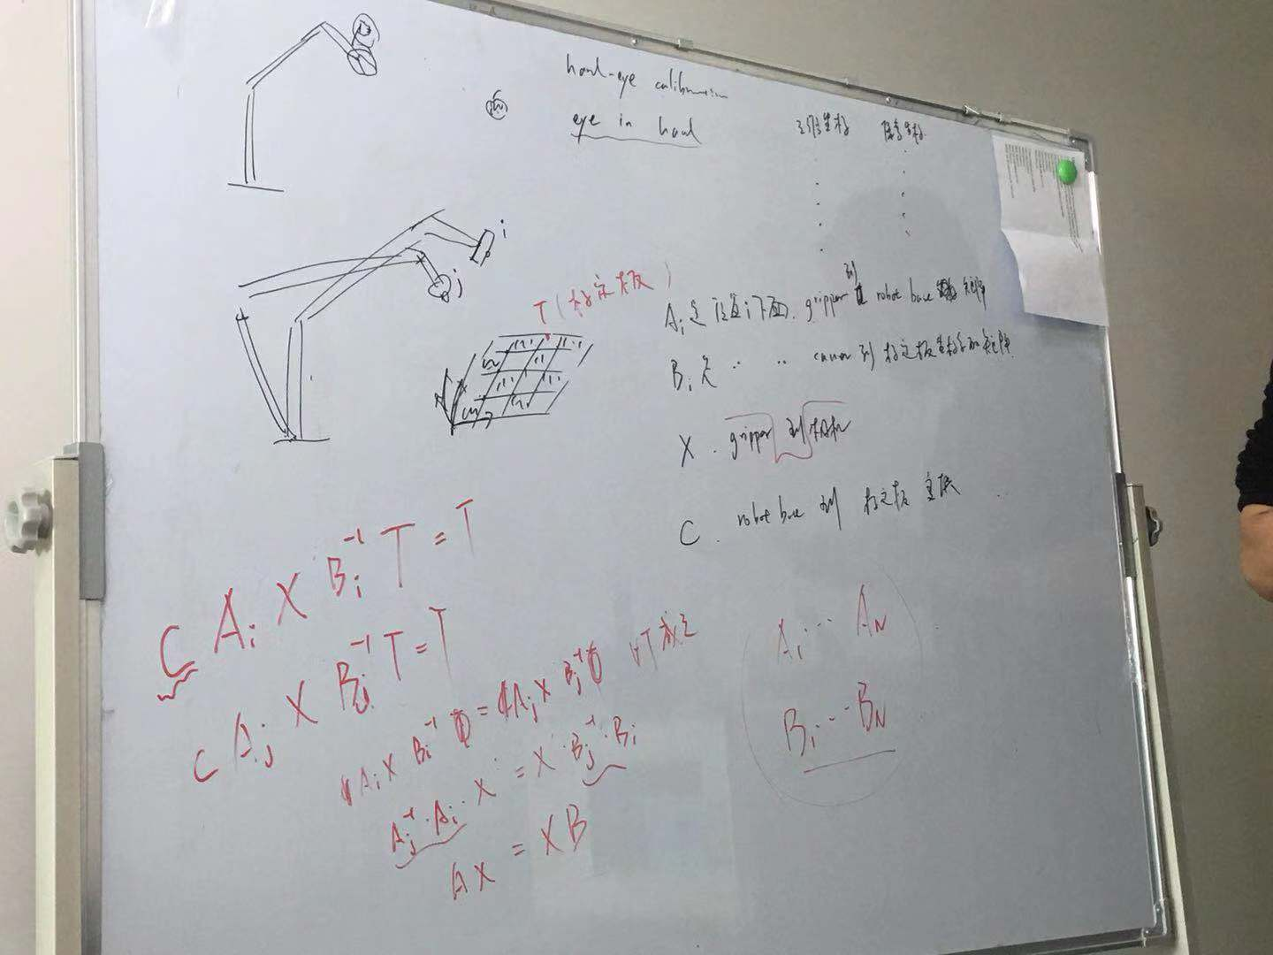

11.
使用Rviz实时显示奥比中光深度摄像头数据，实时显示机械臂状态数据，显示机械臂模型，实时更新机械臂模型
12.
先启动gazabo 在启动Rviz 才能看到pr2的模型在Rviz中显示
13.
netstat -an|grep :22
sudo w
service sshd status

127.0.0.1和0.0.0.0地址的区别
https://blog.csdn.net/u012814696/article/details/55098249

Rviz urdf
标定位置
延时
添加
删除
上移
下移
执行
停止
随机

步长
示教
你想删除
if((-174.8433<j1<177.4608)and(-51.3983<j2<66.5941)and(-133.8578<j3<90.1282)and(-198.7518<j4<141.2906)and(-109.719<j5<81.3522)and(-142.1656<j6<842.1656)):
14.
问题：
ERROR: the config file '/opt/ros/kinetic/share/urdf_tutorial/urdf.vcg' is a .vcg file, which is the old rviz config format.
New config files have a .rviz extension and use YAML formatting. The format changed
between Fuerte and Groovy. There is not (yet) an automated conversion program.
解决：
https://blog.csdn.net/kang732816702/article/details/50463998
15.

GIT 常用命令
http://www.cnblogs.com/chenwolong/p/GIT.html

16.
点动
1969 cd branches/
1970 ls
1971 ls -al
1972 cd ..
1973 ls
1974 vi config
1975 vi description
1976 git init
1977 tree
1978 tree .git
1979 tree .git -al
1980 git init helloworld1
1981 tree helloworld1
1982 cd helloworld1/
1983 ls
1984 tree .git
1985 cd ..
1986 ls
1987 rm helloworld1 -rf
1988 ls
1989 tree .git
1990 git config --list
1991 git config -e
1992 cp *.jpg ~/cali_data/
1993 exit
1994 cp calibrationValueConfig.txt ~/cali_data/cali_imgs/
1995 exit
1996 git config --list
1997 ls
1998 vi helloworld.txt
1999 git commit -m "第10010"
2000 git init helloworld
2001 tree helloworld
2002 cd helloworld/
2003 ls
2004 tree helloworld
2005 tree .git
2006 ls .git -al
2007 ls
2008 vi helloworld.txt
2009 ls
2010 git add helloworld.txt
2011 git commit -m "第一次提交"
2012 git add .
2013 git commit -m "第二次提交"
2014 git status
2015 vim .git/config
2016 git remote add origin https://github.com/pengcan985632236/test_git.git
2017 vim .git/config
2018 git push -u origin master
2019 clear
2020 ls
2021 vim new.py
2022 git status
2023 vim log
2024 clear
2025 ls -l
2026 git status
2027 git add new.py
2028 git commit -m "new python script"
2029 git push origin master
2030 git status
2031 vim .gitignore
2032 git status
2033 vim .gitignore
2034 git add .
2035 git commit -m "edit gitignore|
"
2036 git status
2037 git statu
2038 vim log
2039 git status
2040 vim .gitignore
2041 git status
2042 vim .gitignore
2043 history

