Bootstrap Residuals (large B)

Models

Residuals

Original Sample

b-th Bootstrap Sample Sample

Bootstrap y

$$y=α+\sum_{k=1}^{p}{β_{i}x_{ik}}+ϵ$$

$$(x_{11},{x_{12},⋯,x_{1p},y}_{1})$$

$$(x_{21},{x_{22},⋯,x_{2p},y}_{2})$$

$$(x_{31},{x_{32},⋯,x_{3p},y}_{3})$$

$$(x_{41},{x_{42},⋯,x_{4p},y}_{4})$$

$$(x_{51},{x_{52},⋯,x_{5p},y}_{5})$$

$$⋯$$

$$(x_{n1},{x_{n2},⋯,x_{np},y}_{n})$$

$$(x_{11},x_{12},⋯,x_{1p},{\hat{y}}_{1}^{*(b)})$$

$$(x_{21},x_{22},⋯,x_{2p}, {\hat{y}}_{2}^{*(b)})$$

$$(x_{31},x_{32},⋯,x_{3p},{\hat{y}}_{3}^{*(b)})$$

$$(x_{41},x_{42},⋯,x_{4p},{\hat{y}}_{4}^{*(b)})$$

$$⋯$$

$$(x_{n1},x_{n2},⋯,x_{np},{\hat{y}}_{n}^{*(b)})$$

$$e_{1}$$

$$e_{2}$$

$$e_{3}$$

$$e_{4}$$

$$e_{5}$$

$$⋯$$

$$e_{n}$$

$e_{1}^{*(1)}$, $e_{2}^{*(1)}$, $e_{3}^{*(1)},⋯{,e}_{n}^{*(1)}$ $$e_{1}^{*(1)}$$

$$e_{1}^{*(1)}$$

${\hat{y}}_{i}^{*(b)}=\hat{α}+\sum_{k=1}^{p}{{\hat{β}}_{i}x_{ik}}$ + $e_{i}^{*(b)}$

$$b=1,2,⋯, B.$$

$$i=1,2,⋯,n$$

$e_{1}^{*(2)}$, $e_{2}^{*(2)}$, $e_{3}^{*(2)},⋯{,e}_{n}^{*(2)}$ $$e_{1}^{*(1)}$$

$$e_{1}^{*(1)}$$

$${\hat{y}}_{i}=\hat{α}+\sum_{k=1}^{p}{{\hat{β}}_{i}x_{ik}}$$

$$⋯⋯⋯⋯$$

$e_{1}^{*(B)}$, $e_{2}^{*(B)}$, $e_{3}^{*(B)},⋯{,e}_{n}^{*(B)}$ $$e_{1}^{*(1)}$$

$$e_{1}^{*(1)}$$

$$e_{i}=y_{i}-(\hat{α}+\sum_{k=1}^{p}{{\hat{β}}_{i}x_{ik}})$$

Bootstrap Regression Coefficients

Bootstrap SLR

Original Sample & ID

b-th Bootstrap Sample

Bootstrap ID

$$1$$

$$2$$

$$3$$

$$4$$

$$5$$

$$⋯$$

$$n$$

$${\hat{α}}^{*(1)}$$

$${\hat{α}}^{*(2)}$$

$${\hat{α}}^{*(3)}$$

$${\hat{α}}^{*(4)}$$

$${\hat{α}}^{*(5)}$$

$$⋮$$

$${\hat{α}}^{*(B)}$$

$${\hat{β}}^{*(1)}$$

$${\hat{β}}^{*(2)}$$

$${\hat{β}}^{*\left(3\right)}$$

$${\hat{β}}^{*\left(4\right)}$$

$${\hat{β}}^{*(5)}$$

$$⋮$$

$${\hat{β}}^{*(B)}$$

$$b=1$$

$$(x_{1},y_{1})$$

$$(x_{2},y_{2})$$

$$(x_{3},y_{3})$$

$$(x_{4},y_{4})$$

$$(x_{5},y_{5})$$

$$⋯$$

$$(x_{n},y_{n})$$

$$(x_{{id}_{1}^{*}}^{\left(b\right)}, y_{{id}_{1}^{*}}^{\left(b\right)})$$

$$(x_{{id}_{1}^{*}}^{\left(b\right)}, y_{{id}_{1}^{*}}^{\left(b\right)})$$

$$(x_{{id}_{1}^{*}}^{\left(b\right)}, y_{{id}_{1}^{*}}^{\left(b\right)})$$

$$(x_{{id}_{1}^{*}}^{\left(b\right)}, y_{{id}_{1}^{*}}^{\left(b\right)})$$

$$(x_{{id}_{1}^{*}}^{\left(b\right)}, y_{{id}_{1}^{*}}^{\left(b\right)})$$

$$⋯$$

$$(x_{{id}_{1}^{*}}^{\left(b\right)}, y_{{id}_{1}^{*}}^{\left(b\right)})$$

$$y^{*}={\hat{α}}^{*(1)}+{\hat{β}}^{*(1)}x^{*}$$

$${id}_{1}^{*}$$

$${id}_{2}^{*}$$

$${id}_{3}^{*}$$

$${id}_{4}^{*}$$

$${id}_{5}^{*}$$

$$⋯$$

$${id}_{n}^{*}$$

$$b=2$$

$$y^{*}={\hat{α}}^{*(2)}+{\hat{β}}^{*(2)}x^{*}$$

$$b=3$$

$$y^{*}={\hat{α}}^{*(3)}+{\hat{β}}^{*(3)}x^{*}$$

$$⋯⋯⋯⋯$$

$$b=B$$

$$y^{*}={\hat{α}}^{*(B)}+{\hat{β}}^{*(B)}x^{*}$$

**Linear Regression Modeling and Implementation workflow**

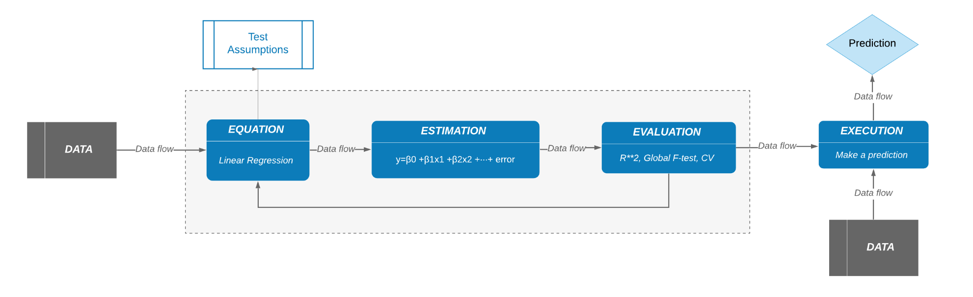

***Variable list MUST be identical!***

**INPUT**

**VARIABLES**

**INPUT**

**VARIABLES**

**INPUT**

**VARIABLES**

Raw data

