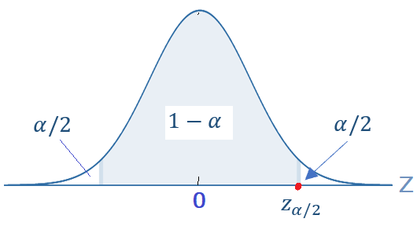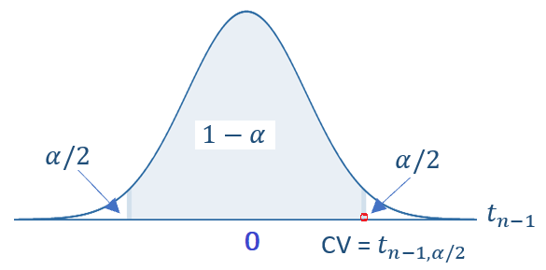
normal pop.
Proportion p
Mean
$$\hat{p}→N\left(p,\sqrt{\frac{p(1-p)}{n}}\right)$$
$$\bar{X}→N\left(μ,\frac{σ}{\sqrt{n}}\right)$$
C.I. ()
C.I. ()
is given
is unknown
$$\bar{X}→N\left(μ,\frac{σ}{\sqrt{n}}\right)$$
C.I. ()
C.I. ()
Interpretation: The confidence interval has 100(1-α) % chance to include the true population mean (proportion).
Sample statistics:
Population parameters
Procedures of Constructing Confidence Intervals for Population Mean and Proportion
Created by C. Peng
$$np>5 \& n\left(1-p\right)>5$$
$$n>30$$

