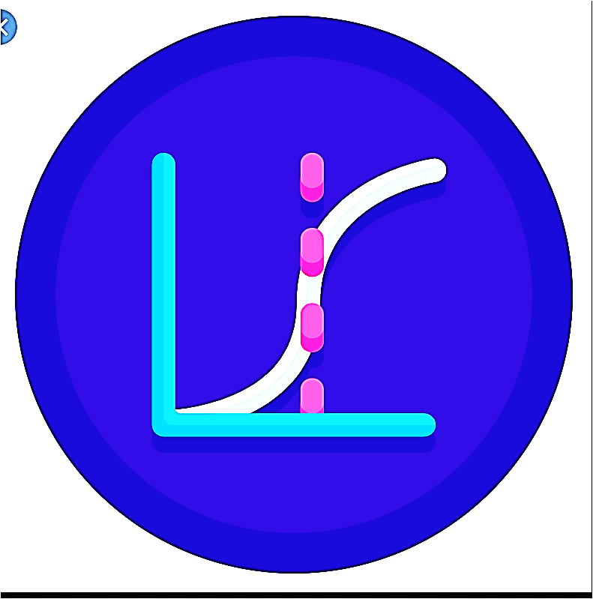

**STA 501**

**Applied Statistics**

**Instr: C. Peng**

**STA 321**

**Topics**

**in Advanced Statistics**

**Instr. C. Peng**

**R**

**STA 501**

**Applied Statistics**

**Instr: C. Peng**

**STA 321**

**Adv. Statistics**

**Instr: C. Peng**