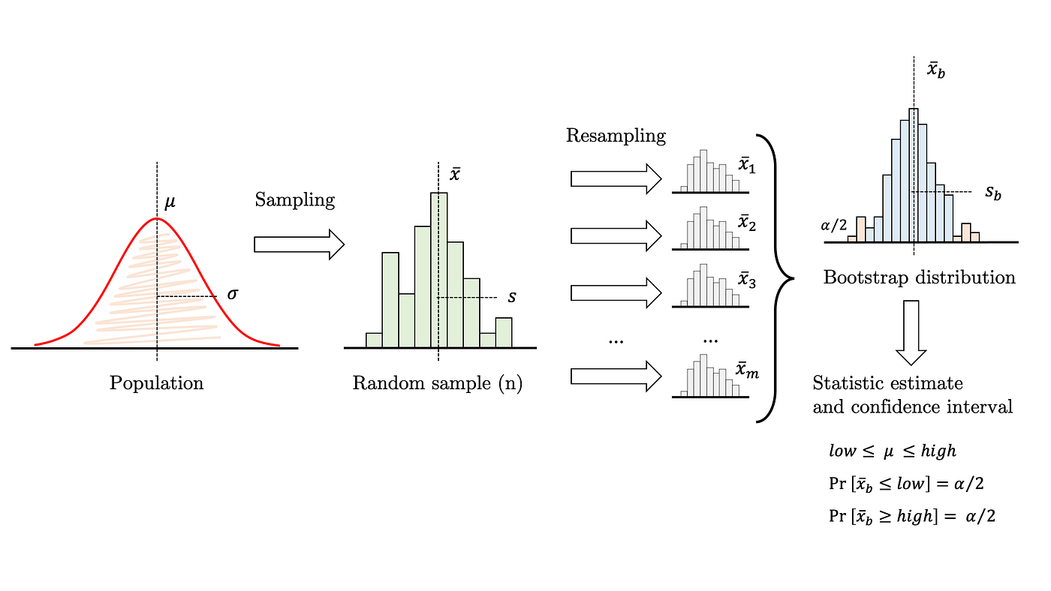

Monte Carlo Sampling Distribution

Bootstrap Sampling Distribution

**Theoretical Distribution**



${\overline{\hat{θ}}}^{*}$

${\hat{θ}}_{0.025}^{*}$ $${\hat{θ}}_{0.975}^{*}$$

$θ$ ${{( \hat{θ}}_{0.975}, \hat{θ}}_{0.975})$ $\overline{\hat{θ}}$

**Random Sample**

**{}**



