Week #12: Time Series Decomposition

Cheng Peng

4/11/2021

Table of Contents

Introduction 1

Classical Decompositions 3

Understanding the Classical Decomposition of Time Series 4

Detect Trend 5

Extracting the Seasonality 7

Extracting Remainder Errors 8

Reconstruct the Original Series / Compose New Series 9

Decomposing Time Series with decompose() 10

Forecasting with Decomposing 12

Forecasting Additive Models with Decomposing 12

Concepts of Seasonal and Trend Decomposition Using Loess (STL) 14

Forecast with STL decomposing 16

Length of Time Series 17

Case Study 17

Data description and 17

Define time series object 18

Forecasting with Decomposing 18

# Introduction

Time series decomposition is a process of splitting a time series into basic components: trend, seasonality random error. The method originated a century ago and new developments in the past few decades.

**Seasonal**: Patterns that repeat with a fixed period. For example, a website might receive more visits during weekends; this would produce data with seasonality of 7 days.

**Trend**: The underlying trend of the metrics. A website increasing in popularity should show a general trend that goes up.

**Random Error**: Also call “noise”, “residual” or “remainder”. This is the residuals of the original time series after the seasonal and trend series are removed.

The objective of time series decomposition is to model the trend and seasonality and estimate the overall time series as a combination of them. A seasonally adjusted value removes the seasonal effect from a value so that trends can be seen more clearly.

The following two working data sets were widely used in different textbooks. We will use them to illustrate some of the concepts.

**Australian Beer Production Data**

The following data gives quarterly beer production figures in Australia from 1956 through the 2nd quarter of 2010. The beer production figure is in megalitres.

ausbeer0=c(284, 213, 227, 308, 262, 228, 236, 320, 272, 233, 237, 313, 261, 227, 250, 314,   
 286, 227, 260, 311, 295, 233, 257, 339, 279, 250, 270, 346, 294, 255, 278, 363,   
 313, 273, 300, 370, 331, 288, 306, 386, 335, 288, 308, 402, 353, 316, 325, 405,   
 393, 319, 327, 442, 383, 332, 361, 446, 387, 357, 374, 466, 410, 370, 379, 487,   
 419, 378, 393, 506, 458, 387, 427, 565, 465, 445, 450, 556, 500, 452, 435, 554,   
 510, 433, 453, 548, 486, 453, 457, 566, 515, 464, 431, 588, 503, 443, 448, 555,   
 513, 427, 473, 526, 548, 440, 469, 575, 493, 433, 480, 576, 475, 405, 435, 535,   
 453, 430, 417, 552, 464, 417, 423, 554, 459, 428, 429, 534, 481, 416, 440, 538,   
 474, 440, 447, 598, 467, 439, 446, 567, 485, 441, 429, 599, 464, 424, 436, 574,   
 443, 410, 420, 532, 433, 421, 410, 512, 449, 381, 423, 531, 426, 408, 416, 520,   
 409, 398, 398, 507, 432, 398, 406, 526, 428, 397, 403, 517, 435, 383, 424, 521,   
 421, 402, 414, 500, 451, 380, 416, 492, 428, 408, 406, 506, 435, 380, 421, 490,   
 435, 390, 412, 454, 416, 403, 408, 482, 438, 386, 405, 491, 427, 383, 394, 473,   
 420, 390, 410)

* **Airline Passengers Data**

This data set records monthly totals of international airline passengers (1949-1960).

AirPassengers0=c(112, 118, 132, 129, 121, 135, 148, 148, 136, 119, 104, 118, 115, 126, 141,   
 135, 125, 149, 170, 170, 158, 133, 114, 140, 145, 150, 178, 163, 172, 178,   
 199, 199, 184, 162, 146, 166, 171, 180, 193, 181, 183, 218, 230, 242, 209,   
 191, 172, 194, 196, 196, 236, 235, 229, 243, 264, 272, 237, 211, 180, 201,   
 204, 188, 235, 227, 234, 264, 302, 293, 259, 229, 203, 229, 242, 233, 267,   
 269, 270, 315, 364, 347, 312, 274, 237, 278, 284, 277, 317, 313, 318, 374,   
 413, 405, 355, 306, 271, 306, 315, 301, 356, 348, 355, 422, 465, 467, 404,   
 347, 305, 336, 340, 318, 362, 348, 363, 435, 491, 505, 404, 359, 310, 337,   
 360, 342, 406, 396, 420, 472, 548, 559, 463, 407, 362, 405, 417, 391, 419,  
 461, 472, 535, 622, 606, 508, 461, 390, 432)

# Classical Decompositions

Classical decomposition was developed about a century ago and is still widely used nowadays. Depending on the types of time series models, there are two basic methods of decomposition: additive and multiplicative.

The following two time series represent the above two basic types of times series models.

ausbeer.ts = ts(ausbeer0[9:72], frequency = 4, start = c(1958, 1))  
AirPassengers.ts = ts(AirPassengers0, frequency = 4, start = c(1949, 1))  
par(mfrow=c(1,2))  
plot(ausbeer.ts, xlab="", ylab="", main = "Additive Model")  
plot(AirPassengers.ts, xlab="", ylab="", main = "Multiplicative Model")

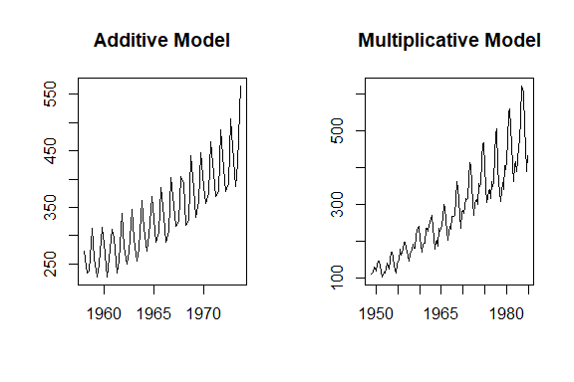

Denote $T=trend$, $S=seasonality$, and $E=error$. With these notations, we can characterize the structure of **additive and multiplicative** time series.

In a **multiplicative time series**, the components multiply together to make the time series. As the time series increases in magnitude, the **seasonal variation** increases as well. The structure of a multiple time series has the following form.

$$y_{t}=T_{t}×S_{t}×E_{t}.$$

In an **additive time series**, the components add together to make the time series. If you have an increasing trend, you still see roughly the same size peaks and troughs throughout the time series. This is often seen in indexed time series where the absolute value is growing but changes stay relative. The structure of an additive time series has the following form

$$y_{t}=T_{t}+S_{t}+E_{t}.$$

For an **additive time series**, the detended additive series has for $D_{t}=y_{t}-T_{t}$. For the multiplicative time series, the detrended time series is calculated by $D_{t}=y_{t}/T_{t}$

# Understanding the Classical Decomposition of Time Series

To understand the structure of additive and multiplication ties series, we decompose these time series by calculating the trend, seasonality, and errors *manually* by writing a basic R script to gain a technical understanding of decomposing a time series. At the very end of this section, we introduce the R function **decompose()** to extract the three components of additive and multiplicative time series.

## Detect Trend

To detect the underlying trend, we use a smoothing technique called **moving average** and its variant **centered moving average**. For a seasonal time series, the width of the moving window must be the same as the seasonality. Therefore, to decompose a time series we need to know the seasonality period: weekly, monthly, etc.

**Example 1**: Australian beer production data has an annual seasonality. Since the data set is quarterly data, the moving average window should be 4.

trend.beer = ma(ausbeer.ts, order = 4, centre = T) # centre = T => centered moving average  
plot(as.ts(ausbeer.ts), xlab="", ylab="", col="darkred", lwd =2)  
title(main = "Extract trend from Australia Beer Production")  
lines(trend.beer, lwd =2, col = "blue")  
legend("topleft", c("original series", "trend curve"), lwd=rep(2,2),  
 col=c("darkred", "blue"), bty="n")

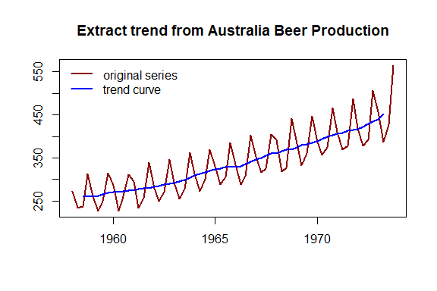

**Example 2**: The airline passenger data were recorded monthly. It has an annual seasonal pattern. We choose a moving average window of 12 to extract the trend from this multiplicative time series.

trend.air = ma(AirPassengers.ts, order = 12, centre = T) # centre = T => centered moving average  
plot(as.ts(AirPassengers.ts), xlab="", ylab="", col="darkred", lwd =2)  
title(main = "Extract trend from Airline Passengers Monthly Data")  
lines(trend.air, lwd =2, col = "blue")  
legend("topleft", c("original series", "trend curve"), lwd=rep(2,2),  
 col=c("darkred", "blue"), bty="n")

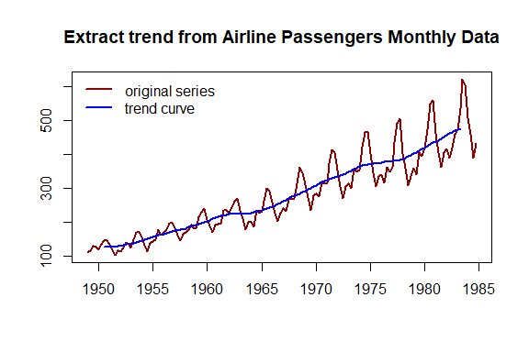

The **moving averages** of both time series are recorded in the above two code chunks and will be used to restore the original series.

The process of removing the trend from a time series is called **detrending** time series.

The way of detrending a time series is dependent on the types of the time series. The following code shows how to calculate the detrended time series.

**Example 3**: We calculate the detrended series use the Australian Beer data and the Airline Passengers data as an example.

detrend.beer = ausbeer.ts - trend.beer  
detrend.air = AirPassengers.ts/trend.air  
par(mfrow=c(2,2))  
plot(ausbeer.ts, xlab="", main = "Australia Beer", col="darkred")  
plot(AirPassengers.ts, xlab="", main = "Air Passengers", col="blue")  
plot(detrend.beer, xlab="", main = "Australia Beer", col="darkred")  
plot(detrend.air, xlab="", main = "Air Passengers", col="blue")

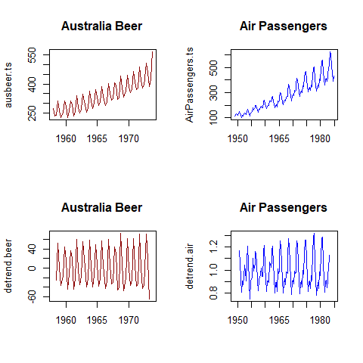

The technique we used in removing the trend from a time series model is a non-parametric smoothing procedure. There are different such techniques in statistics to estimate a curve for a given set. The **moving average** is one of the simplest ones and is widely used in time series.

## Extracting the Seasonality

Similar to the trend in a time series, the seasonality of a time series is also a non-random structural pattern. We can calculate the seasonality from the detrended time series.

The idea is to redefine a **seasonal series** based on the detrended series by replacing all observations taken from the same seasonal period with the average of these observations. This process is called **averaging seasonality**. This idea is implemented in R. Here is how to do it in R.

**Example 4**: We use the **Australian Beer Production Data** and the **Airline Passenger Data** after their trends were removed. The following code illustrates how to calculate and graph the seasonality of both series.

par(mfrow=c(2,1), mar=c(3,2,3,2))  
## Australia Beer  
mtrx.beer = t(matrix(data = detrend.beer, nrow = 4))  
seasonal.beer = colMeans(mtrx.beer, na.rm = T)  
seasonal.beer.ts = as.ts(rep(seasonal.beer,16))  
plot(seasonal.beer.ts, xlab = "", col="darkred", main="Seasonal series of Australia beer")  
##  
mtrx.air = t(matrix(data = detrend.air, nrow = 12))  
seasonal.air = colMeans(mtrx.air, na.rm = T)  
seasonal.air.ts = as.ts(rep(seasonal.air,16))  
plot(seasonal.air.ts, xlab = "", col = "blue", main="Seasonal series of air passengers")

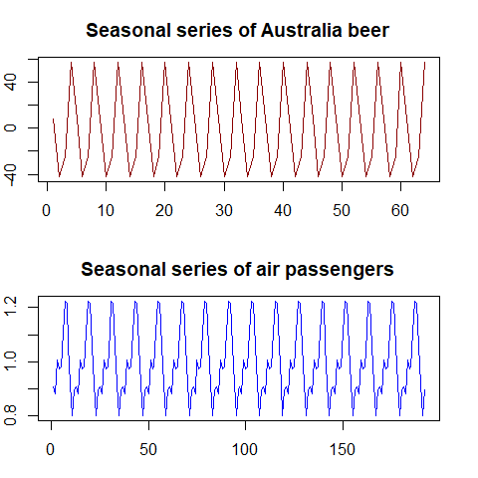

## Extracting Remainder Errors

The **error term** is the random component in the time series. We have already extracted the trend and seasonality from the original time series. Now we extract the “random” noise from a given time series.

In the additive model, the random **error term** is given by $E_{t}=y_{t}-T_{t}-S_{t}$. The **random error** for a multiplicative model is given by $E_{t}=y_{t}/(T_{t}×S_{t})$.

**Example 5**: We use the above formulas to calculate the random error components additive and multiplicative models use the same Australian beer production and Airplane passenger series data.

random.beer = ausbeer.ts - trend.beer - seasonal.beer  
random.air = AirPassengers.ts / (trend.air * seasonal.air)  
##  
par(mfrow=c(2,1), mar=c(3,2,3,2))  
plot(random.beer , xlab = "", col="darkred", main="Random errors of Australia beer")  
plot(random.air, xlab = "", col = "blue", main="Random errors of air passengers")

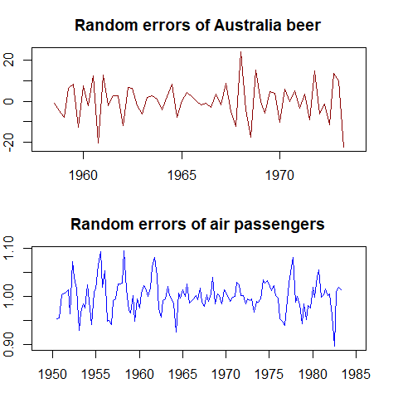

## Reconstruct the Original Series / Compose New Series

We can **reconstruct** the original series by using the decomposed components. Since the **moving average technique** was used detrending series, the resulting **reconstructed** series with $T_{t}$, $S_{t}$, and $E_{t}$ will generate a few missing values in the beginning and the end depending on the width of the **moving average window**.

**Example 6**: We now **reconstruct** the **original** series of Australian beer data and the airline passengers data.

recomposed.beer = trend.beer+seasonal.beer+random.beer  
recomposed.air = trend.air*seasonal.air*random.air  
par(mfrow=c(1,2), mar=c(3,2,3,2))  
plot(ausbeer.ts, col="darkred", lty=1)  
lines(recomposed.beer, col="blue", lty=2, lwd=2)  
legend("topleft", c("original series", "reconstructed series"),   
 col=c("darkred", "blue"), lty=1:2, lwd=1:2, cex=0.8, bty="n")  
title(main="Australian Beer")  
##  
plot(AirPassengers.ts, col="darkred", lty=1)  
lines(recomposed.air, col="blue", lty=2, lwd=2)  
legend("topleft", c("original series", "reconstructed series"),   
 col=c("darkred","blue"), lty=1:2, lwd=1:2, cex=0.8, bty="n")  
title(main="Airline Passengers")

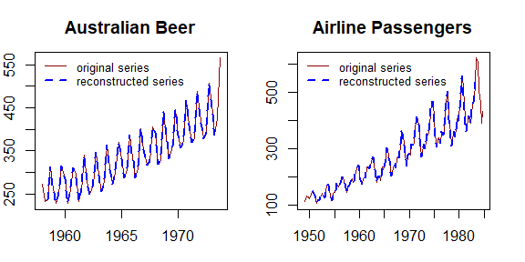

## Decomposing Time Series with decompose()

The R library **forecast** was created by a team led by a leading expert in the discipline. We’ll use the R function **decompose( )** in library{forecast} as a decomposition function to decompose a series into seasonal, trend, and random components. The Australian beer production (additive) and airline passenger numbers (multiplicative) will still be used to illustrate the steps.

**Example 6**: Plot the components of the Australian beer production data.

decomp.beer = decompose(ausbeer.ts, "additive")  
## plot the decomposed components  
plot(decomp.beer, col="darkred")

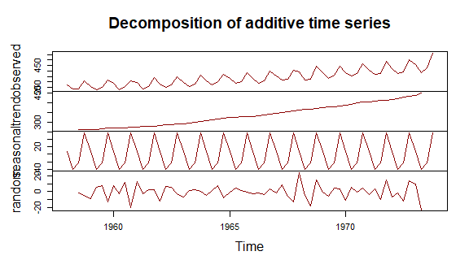

**Example 7**: Plot the components of the Airline Passenger Data.

decomp.air = decompose(AirPassengers.ts, "multiplicative")  
## plot the decomposed components  
plot(decomp.air, col= "navy")

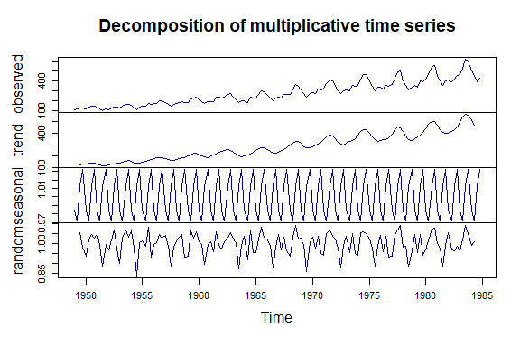

We can also use **decompose()** to extract the individual components from a given additive and multiplicative models using the following code.

**Example 8**: Decomposing Australian beer production data using **decompose()**.

decomp.beer = decompose(ausbeer.ts, "additive")  
# the four components can be extracted by  
seasonal.beer = decomp.beer$seasonal  
trend.beer = decomp.beer$trend  
error.beer = decomp.beer$random

**Example 9**: Decomposing airline passengers data using **decompose()**.

decomp.air = decompose(AirPassengers.ts, "multiplicative")  
# the four components can be extracted by  
seasonal.air = decomp.air$seasonal  
trend.air = decomp.air$trend  
error.air = decomp.air$random

**Concluding Remark**: We introduced the basic decomposition technique. There are other decomposition methods. among them, **X11** is commonly used in econometrics. The recently developed method **STL()** that used LOESS algorithm to estimate the trend can also be used to extract components from more general time series. We will outline this decomposition method to forecast future values.

# Forecasting with Decomposing

We have introduced several benchmark forecasting methods in the previous module. We next use these benchmark methods to forecast the deseasonalized series since the seasonality of a time series is a **scalar**. So we can forecast the deseasonalized series through decomposition and then adjust the forecasted values.

## Forecasting Additive Models with Decomposing

Since the multiplicative models can be converted to an additive model by

$$\text{log}(y_{t})=\text{log}(S_{t})+\text{log}(T_{t})+\text{log}(E_{t}).$$

So we only restrict our discussion in this module to additive models. Assuming an additive decomposition, the decomposed time series can be written as

$$y_{t}={\hat{S}}_{t}+{\hat{A}}_{t}$$

where ${\hat{A}}_{t}=\hat{T}+{\hat{E}}_{t}$ is the seasonally adjusted component. We can forecast the future values based on ${\hat{A}}_{t}$.

**Example 10**: Forecasting based on the seasonally adjusted series with Australian beer production data. We have introduced four benchmark forecasting methods in the previous module. For a time series with a trend, naive, seasonal naive, and drift method is more accurate than the moving average. The issue is that none of the benchmark methods forecasting the trend. As an illustrative example, we use the naive method to forecast the deseasonalized series and then add the seasonal adjustment to the forecast values.

decomp.beer = decompose(ausbeer.ts, "additive")  
# the four components can be extracted by  
seasonal.beer = decomp.beer$seasonal  
trend.beer = decomp.beer$trend  
error.beer = decomp.beer$random  
##  
seasonal.adj = trend.beer + error.beer  
##  
seasonal.adj.pred <- as.data.frame(rwf(na.omit(seasonal.adj), h = 6)) + matrix(rep(seasonal.beer[3:8],5), nco=5, byrow=F)  
##  
kable(seasonal.adj.pred, caption = "Forecasting with decomposing - drift method")

Forecasting with decomposing - drift method

|  |  |  |  |  |  |
| --- | --- | --- | --- | --- | --- |
|  | Point Forecast | Lo 80 | Hi 80 | Lo 95 | Hi 95 |
| 1973 Q3 | 404.7167 | 386.3725 | 423.0608 | 376.6617 | 432.7717 |
| 1973 Q4 | 486.6167 | 460.6741 | 512.5593 | 446.9409 | 526.2924 |
| 1974 Q1 | 437.1500 | 405.3769 | 468.9231 | 388.5573 | 485.7427 |
| 1974 Q2 | 387.0000 | 350.3116 | 423.6884 | 330.8900 | 443.1100 |
| 1974 Q3 | 404.7167 | 363.6978 | 445.7355 | 341.9838 | 467.4496 |
| 1974 Q4 | 486.6167 | 441.6828 | 531.5505 | 417.8962 | 555.3371 |

Since the deseasonalized series has two missing values in the beginning and two in the end. we remove the missing values before using the drift methods to forecast the next 6 periods (qtr3, 1973 - qtr 4, 1874). The forecast values are given in the above table.

plot(1:62, as.vector(ausbeer.ts)[-c(63,64)], type="l", xlim=c(1,70), ylim=c(200, 570))  
lines(62:64, as.vector(ausbeer.ts)[c(62,63,64)], col="red")  
points(62:64, as.vector(ausbeer.ts)[c(62,63,64)], col="red", pch=21)  
lines(63:68,seasonal.adj.pred[,1], col="blue")  
points(63:68,seasonal.adj.pred[,1], col="blue", pch = 16)

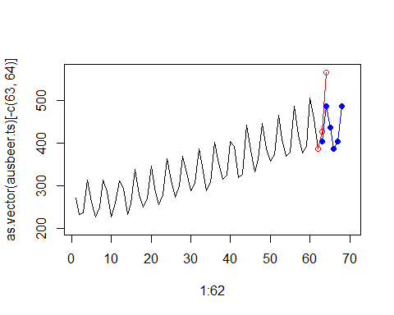

The plot of the forecast values and the original values. The red plot represented quarters 3-4 of 1973 and forecast values in quarters 3 - quarters 4, 1974, are plot in **blue**. We can see that

## Concepts of Seasonal and Trend Decomposition Using Loess (STL)

Seasonal and Trend decomposition using LOESS (STL) combines the classical time series decomposition and the **modern** locally estimated scatterplot smoothing (LOESS). The LOESS has developed about 40 years ago and is a modern computational algorithm. The seasonal trend in a time series is a **fixed** pattern. The real benefit of STL is to use the lOESS to estimate the nonlinear trend more accurately. We will not discuss the technical development of the STL. Instead, we will use its R implementation to decompose time series and use it to forecast future values.

stl.beer = stl(ausbeer.ts, "periodic")  
seasonal.stl.beer <- stl.beer$time.series[,1]  
trend.stl.beer <- stl.beer$time.series[,2]  
random.stl.beer <- stl.beer$time.series[,3]  
###  
par(mfrow=c(4,1), mar=c(2,2,2,2))  
plot(ausbeer.ts)  
plot(as.ts(seasonal.stl.beer))  
plot(trend.stl.beer)  
plot(random.stl.beer)

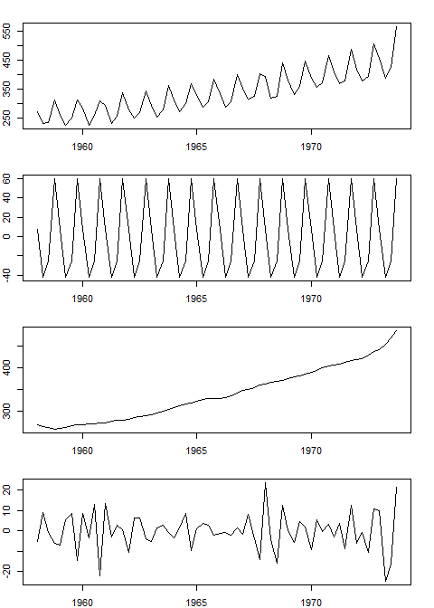

We can also plot the above-decomposed components in a single step as follows with the STL model.

plot(stl.beer)

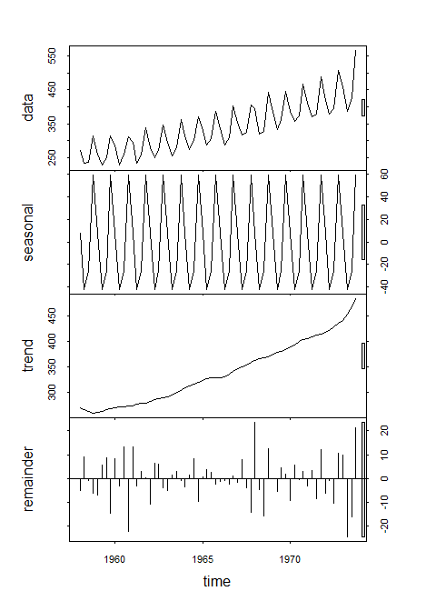

## Forecast with STL decomposing

For the additive model, we can use the R function **stl()** to decompose the series into three components. It uses a more robust non-parametric smoothing method (LOESS) to estimate the nonlinear trend.

fit <- stl(ausbeer.ts,s.window="periodic")  
plot(forecast(fit,h=6, method="rwdrift"))

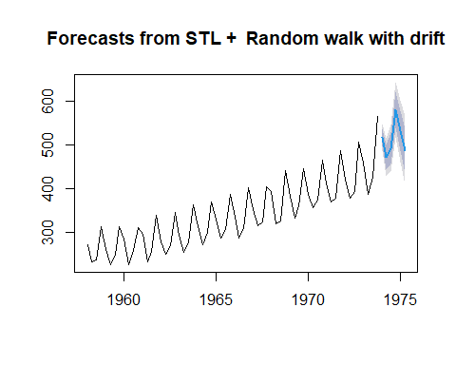

## Length of Time Series

The length of time series impacts the performance of the forecasting. In general, a very long time series (for example, more than 200 observations) usually does not work well for most of the existing models partly because the existing models were not built for **very long** series. Intuitively, the future values are dependent on the recent historical values. If including too old observations that have no predictive power into the model will bring bias and noise to the underlying model and, hence, negative impacts on the performance of the model.

There are a lot of discussions in literature and practice about the minimum size required for building a good time series model. It seems that that 60 is a suggested minimum size. The actual minimum size depends on situations and the level of accuracy.

In this class, we recommend the sample size to be between 60 and 200. Therefore, in the assignment, if the original time series data has more than 200 observations, we can use only 150-200 most recent data values for analysis.

# Case Study

## Data description and

We now choose a time series from <https://datahub.io/search>: 10-year nominal yields on US government bonds from the Federal Reserve. The 10-year government bond yield is considered a standard indicator of long-term interest rates. The data contains monthly rates. There have 808 months of data between April 1943 and July 2020. We only use look at monthly data between January 2008 and July 2020.

us.bond=read.csv("https://datahub.io/core/bond-yields-us-10y/r/monthly.csv")  
n.row = dim(us.bond)[1]  
data.us.bond = us.bond[(n.row-150):n.row, ]

## Define time series object

we define time series object before using models to forecast future values. Since this is monthly data, frequency =12 will be used in the define the time series object.

usbond.ts = ts(data.us.bond[,2], frequency = 12, start = c(2008, 1))  
plot(usbond.ts, main="US Bond Rates Between Jan, 2008 and July, 2020", ylab="Monthly Rate", xlab="")

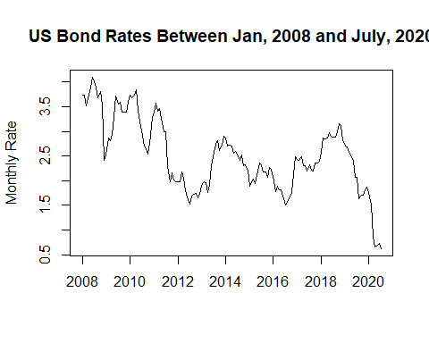

## Forecasting with Decomposing

We introduced forecasting with two methods of decomposition in the previous section. We also know that the classical decomposition method does not work as well as the STL method due to the robustness of the LOESS component.

The different behaviors of the two methods of decomposition are reflected in the following two figures.

cls.decomp = decompose(usbond.ts)  
plot(cls.decomp, xlab="")

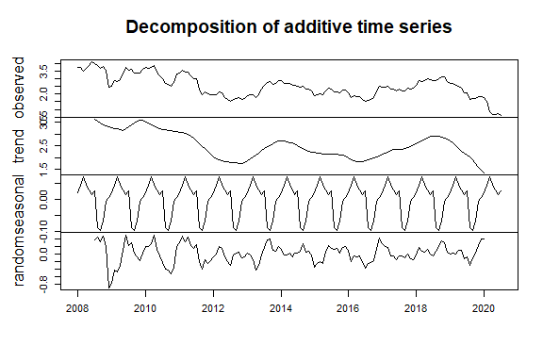

Classical decomposition of additive time series

stl.decomp=stl(usbond.ts, s.window = 12)  
plot(stl.decomp)

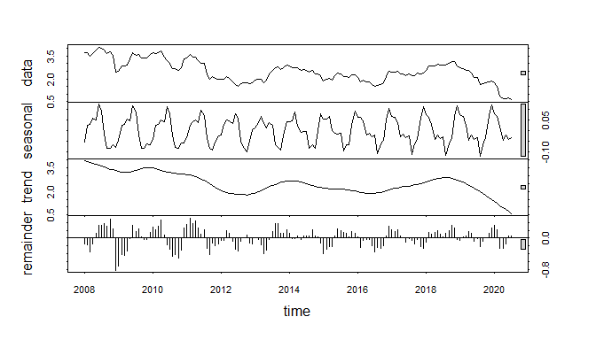

STL decomposition of additive time series

**Training and Testing Data**

We hold up the last 7 periods of data for testing. The rest of the historical data will be used to train the forecast model. We define different training data sets with different sizes and get a rough idea of what sample size yields the best performance. Three training set sizes are 144, 109, 73, and 48. We use the same test set with size 7.

ini.data = data.us.bond[,2]  
n0 = length(ini.data)  
##  
train.data01 = data.us.bond[1:(n0-7), 2]  
train.data02 = data.us.bond[37:(n0-7), 2]  
train.data03 = data.us.bond[73:(n0-7), 2]  
train.data04 = data.us.bond[97:(n0-7), 2]  
## last 7 observations  
test.data = data.us.bond[(n0-6):n0,2]  
##  
train01.ts = ts(train.data01, frequency = 12, start = c(2008, 1))  
train02.ts = ts(train.data02, frequency = 12, start = c(2011, 1))  
train03.ts = ts(train.data03, frequency = 12, start = c(2014, 1))  
train04.ts = ts(train.data04, frequency = 12, start = c(2016, 1))  
##  
stl01 = stl(train01.ts, s.window = 12)  
stl02 = stl(train02.ts, s.window = 12)  
stl03 = stl(train03.ts, s.window = 12)  
stl04 = stl(train04.ts, s.window = 12)  
## forecast with decomposing  
fcst01 = forecast(stl01,h=7, method="naive")  
fcst02 = forecast(stl02,h=7, method="naive")  
fcst03 = forecast(stl03,h=7, method="naive")  
fcst04 = forecast(stl04,h=7, method="naive")

We next perform error analysis.

## To compare different errors, we will not use percentage for MAPE  
PE01=(test.data-fcst01$mean)/fcst01$mean  
PE02=(test.data-fcst02$mean)/fcst02$mean  
PE03=(test.data-fcst03$mean)/fcst03$mean  
PE04=(test.data-fcst04$mean)/fcst04$mean  
###  
MAPE1 = mean(abs(PE01))  
MAPE2 = mean(abs(PE02))  
MAPE3 = mean(abs(PE03))  
MAPE4 = mean(abs(PE04))  
###  
E1=test.data-fcst01$mean  
E2=test.data-fcst02$mean  
E3=test.data-fcst03$mean  
E4=test.data-fcst04$mean  
##  
MSE1=mean(E1^2)  
MSE2=mean(E2^2)  
MSE3=mean(E3^2)  
MSE4=mean(E4^2)  
###  
MSE=c(MSE1, MSE2, MSE3, MSE4)  
MAPE=c(MAPE1, MAPE2, MAPE3, MAPE4)  
accuracy=cbind(MSE=MSE, MAPE=MAPE)  
row.names(accuracy)=c("n.144", "n.109", "n. 73", "n. 48")  
kable(accuracy, caption="Error comparison between forecast results with different sample sizes")

Error comparison between forecast results with different sample sizes

|  |  |  |
| --- | --- | --- |
|  | MSE | MAPE |
| n.144 | 0.7967685 | 0.4518108 |
| n.109 | 0.7718715 | 0.4463052 |
| n. 73 | 0.7665760 | 0.4449924 |
| n. 48 | 0.8055530 | 0.4649921 |

plot(1:4, MSE, type="b", col="darkred", ylab="Error", xlab="",  
 ylim=c(0.4,.85),main="Error Curves", axes=FALSE)  
labs=c("n=144", "n=109", "n=73", "n=48")  
axis(1, at=1:4, label=labs, pos=0.4)  
axis(2)  
lines(1:4, MAPE, type="b", col="blue")  
text(1:4, MAPE+0.03, as.character(round(MAPE,4)), col="blue", cex=0.7)  
text(1:4, MSE-0.03, as.character(round(MSE,4)), col="darkred", cex=0.7)  
legend(1.5, 0.63, c("MSE", "MAPE"), col=c("darkred","blue"), lty=1, bty="n", cex=0.7)

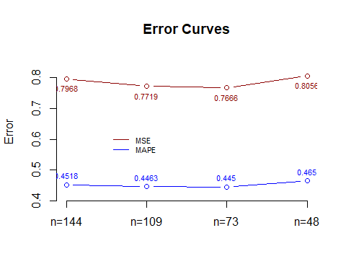

We trained the same algorithm with different sample sizes and compared the resulting accuracy measures. Among four training sizes 144, 109, 73, and 48. training data size 73 yields the best performance.

We point out that a forecast with STL smoothing does not yield decent results. However, our case study accomplishes two analytic goals. (1) learn a non-parametric smoothing forecast method and comparing the different forecasts with the commonly used accuracy measures; (2) use the technique of machine learning to tune the training size to identify the optimal training size to achieve the best accuracy. In this case, the training size is considered as a tuning parameter (hyperparameter).

We will start building actual and practical forecasting models in the next module - exponential smoothing models.