**STA490 Statistics Capstone**

**Effective Written and Oral Communication with Technologies**

**Effective Oral Communication**

**Effective Written Communication**

**Consulting and Job Interviews**

**Oral Presentation**

**Analytics Reports**

**CV & Personal Web Site**

**Statistical Methods and Real-world Applications**

**Using cutting-edge technologies**

SS

**To be Covered in**

**STA 490**

**Covered in STA 319, 320, and 321**

* **Sampling Techniques Survey**
* **Survey Design and Analysis**
* **PCA (CFA) in Survey Analysis**
* **Linear Regression Models**
* **Generalized Linear Models**
* **Time Series Models**

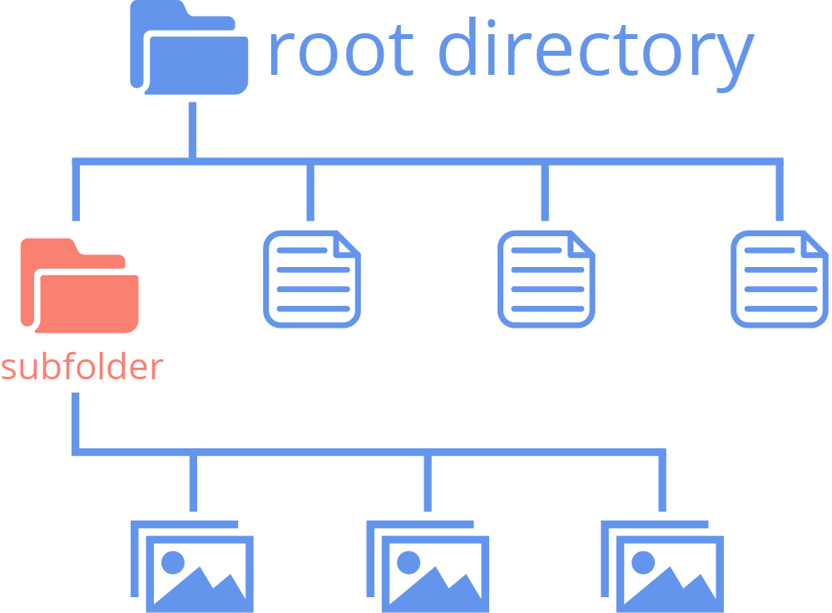

**Index.html**

**Website Directory (GitHub Repository)**

**Your Name**

Contact information

URL link of Your CV (could be more than on page)

Technical Skills (programming and other analytic Skills)

Projects reports (with links to some representative project reports)

Professional Preparation

**Short bio**

Contact information

|  |  |
| --- | --- |
| **Name**  Contact Information | |
|  |  |
|  |  |
|  |  |
|  |  |
|  |  |
|  |  |

