**STA 504 Homework #6**

**Due: Monday, 10/31**

This set of homework problems focuses on setting up the integral limits of double integral. You are expected to draw the integral region on the y1-y2 coordinate plane and set up the limits of the iterative based on the shape of the region.

The following linked page helps set up integral limits of double integrals.

<http://tutorial.math.lamar.edu/Classes/CalcIII/DIGeneralRegion.aspx>

The level of detail (graphs and algebra) in your work should be similar to that in the working examples in the lecture note.

**Problem 1.**

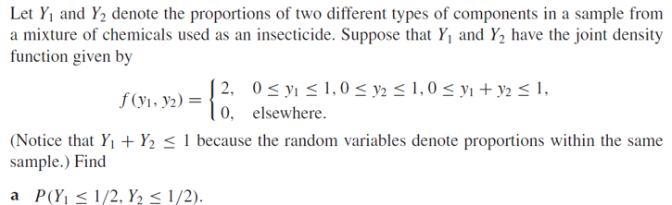

**Problem 2.**

**d.** Find the marginal distributions of *y*1 and *y*2, respectively.

**Problem 3.**

**c.** Find the marginal distributions of *y*1 and *y*2, respectively.