**LOST CAT**

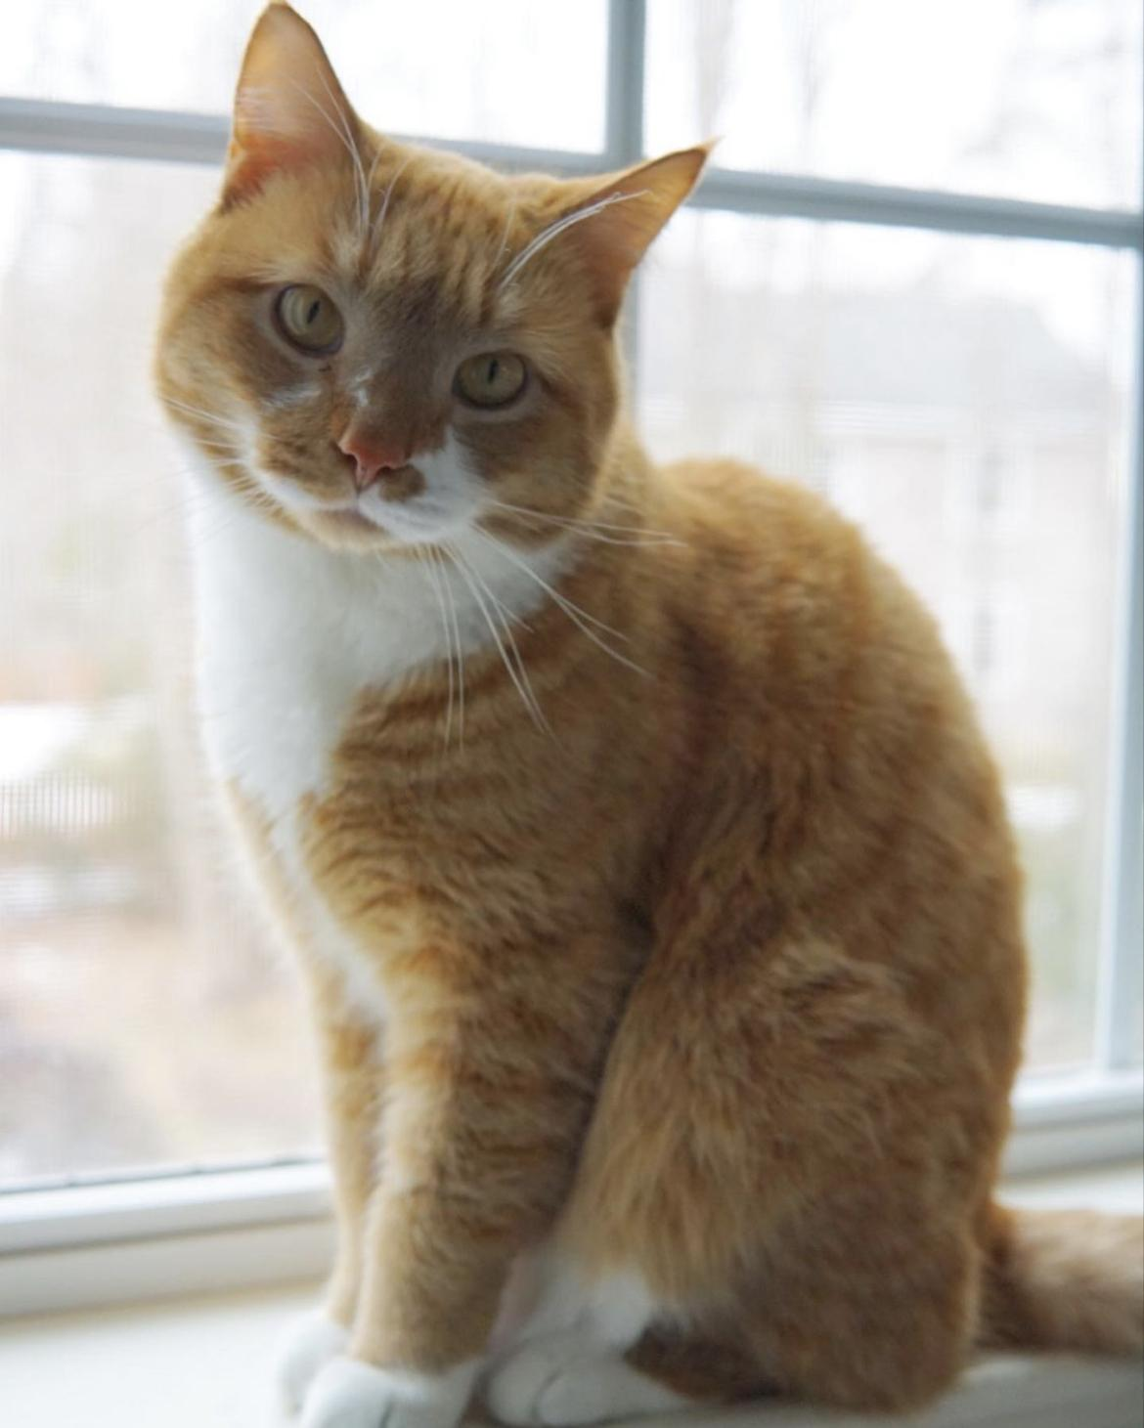

HALO

TIMID AND SHY GINGER TABBY MALE

LAST SEEN AT 11 CHECKERBERRY CIRCLE, SOUTH PORTLAND ON SUNDAY, AUGUST 21 @ 7PM

PLEASE CALL OR TEXT IF SEEN AT (207) 632-2528

$100 REWARD