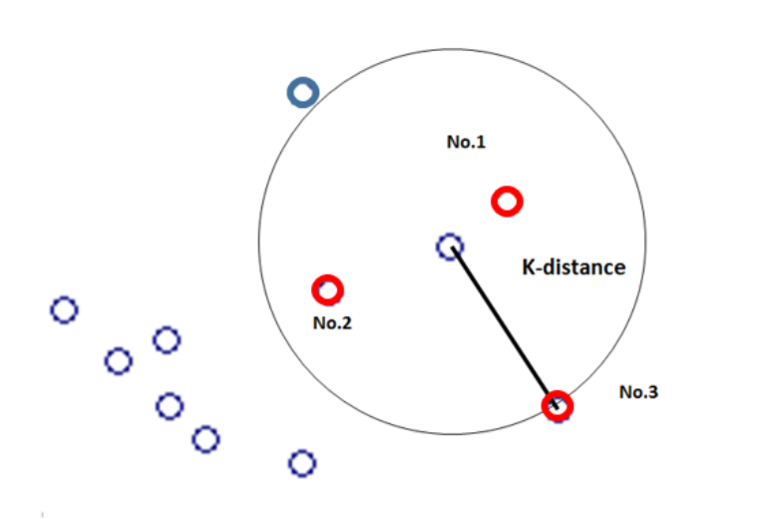


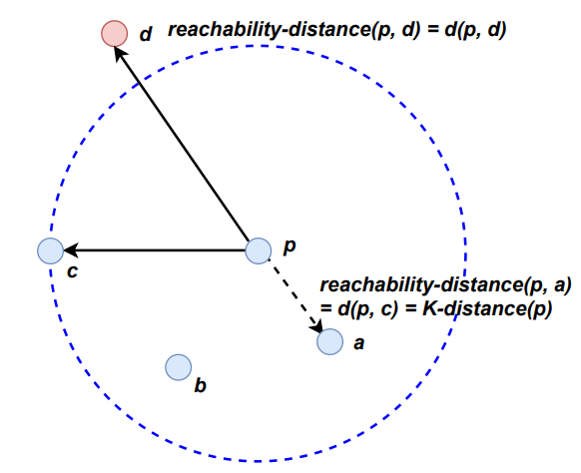

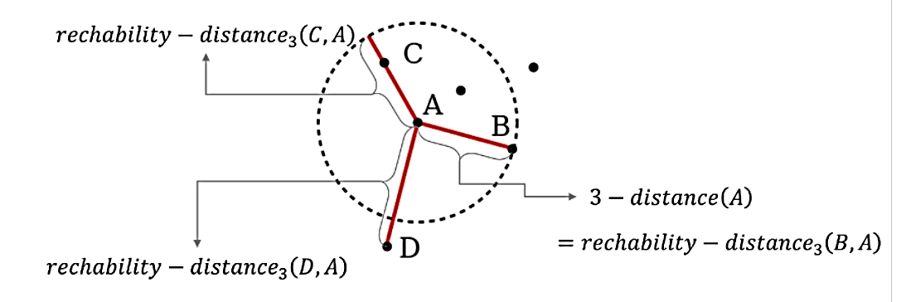

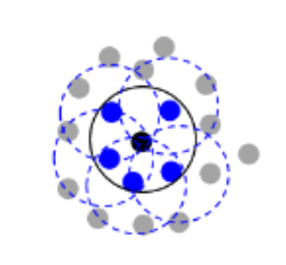
Case 2
Case 1
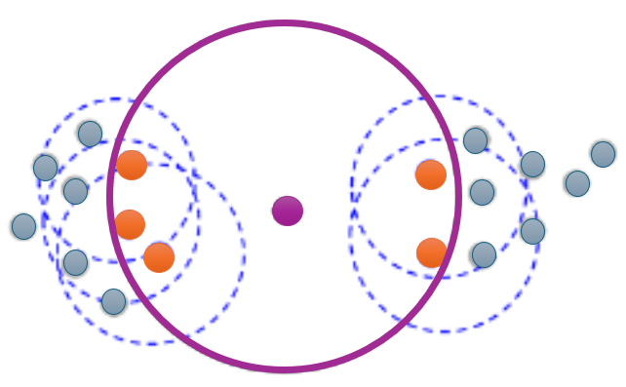
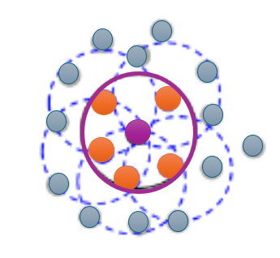

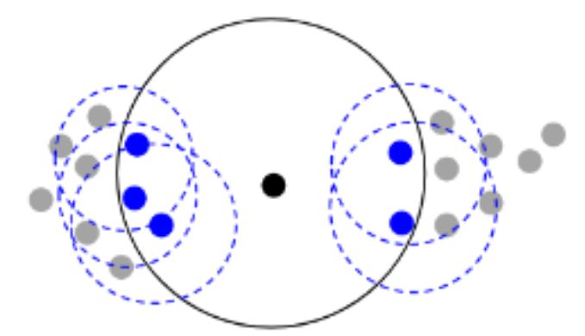

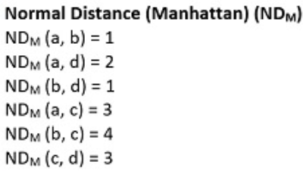
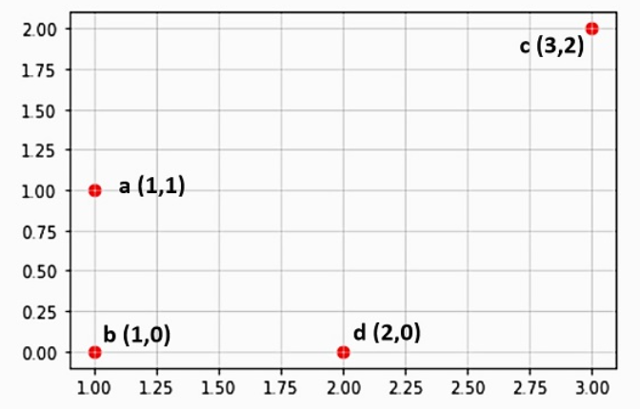
Illustration:
ND_{M}(b, c) = |3 - 1| + |2 – 0| = 4

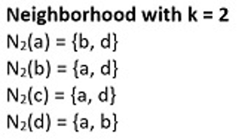
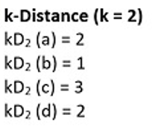
Stay with the Manhattan distance
Neighborhood
of c with k = 2:
N₂(c) = {a, b}
kD₂(c,) = 3

Illustration:
ND_{M}(c, a) = |3 - 1| + |2 – 1| = 3
ND_{M}(c, b) = |3 – 1| + |2 – 0| = 4
ND_{M}(c, d) = |3 – 2| + |2 – 0| = 3

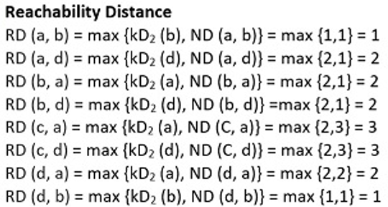
Stay with the Manhattan distance: k =2

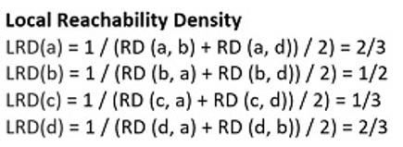
The point that has smallest local reachability density is defined to be the local outlier!

N₂(P)
N₂(P) = Neighborhood containing 2nd nearest neighbors (points)
D
C
B
A
||N₂(P)|| = 4 (>2) since N₂(P) contains 4 neighbors (points)
P
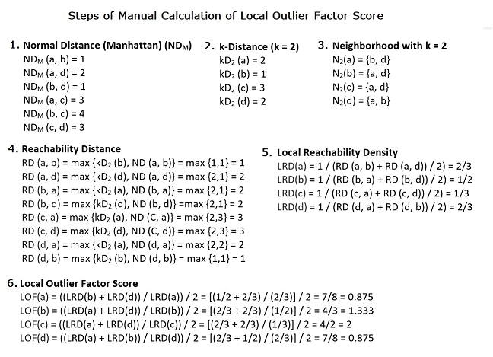

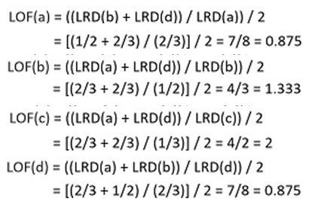
Steps of calculating the local outlier factor (LOF) score: k = 2 LOF

