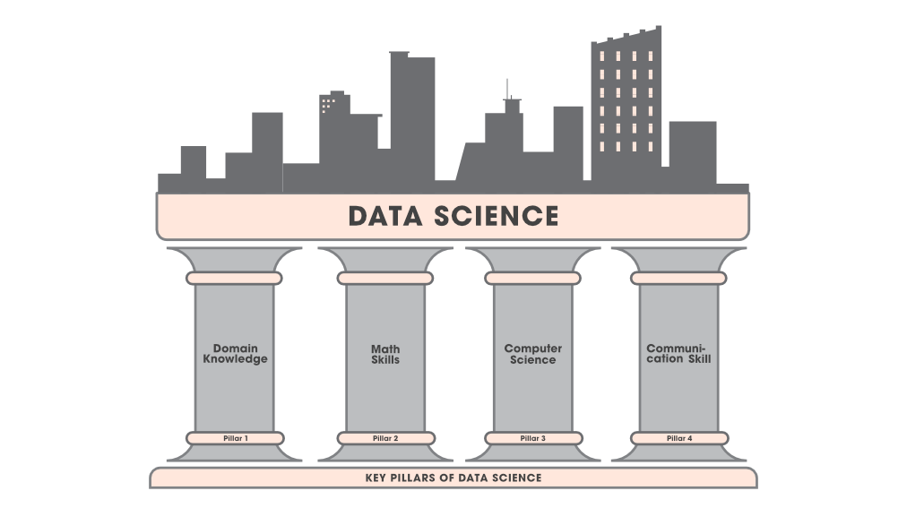

**Communication**

**Skills**

**Domain**

**Knowledge**

**Computer**

**Science**

**Mathematics**

**and Statistics**

Optimization

Matrix Algebra

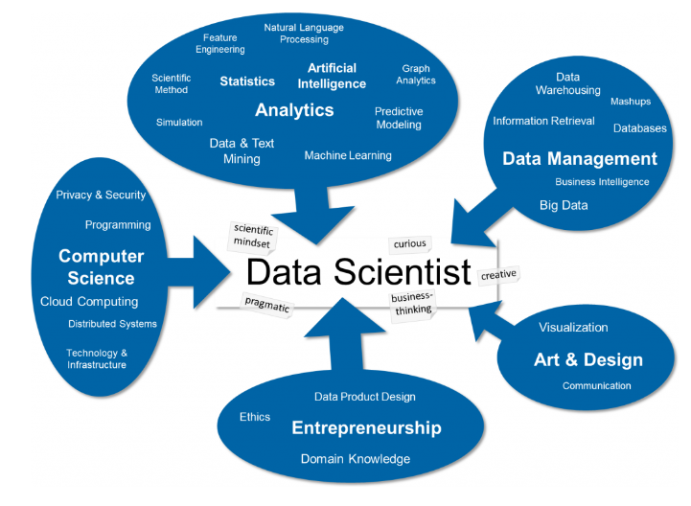

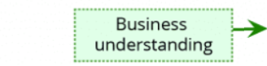

**Question**

